**Cloud Computing – Experiment 2**

**Name: Keyur Patel Roll Number: 16010421073 Batch: A2**

**Results: (Program / Steps with screenshots)**

**Problem: Customer Churn in Subscription-Based Businesses**

**Business Challenge:**

Numerous subscription-based enterprises, such as those in streaming services or software-as-a-service (SaaS), frequently grapple with the issue of customer churn. Customer churn denotes the rate at which subscribers or users terminate their subscription services, resulting in revenue loss and diminished customer loyalty.

**Business Approach/Methodology:**

Businesses contending with customer churn commonly employ machine learning models to anticipate and comprehend factors influencing churn. They scrutinize historical data to detect patterns and signals preceding customer cancellations. Furthermore, sentiment analysis on customer feedback is utilized to grasp user dissatisfaction.

**Required Skills, Infrastructure, and Business Impact During Implementation:**

Skills: Recruiting experts such as data scientists, analysts, and machine learning engineers proficient in predictive modeling, data analysis, and feature engineering.

Infrastructure: Developing or upgrading data infrastructure to manage large-scale data, ensuring data security, and complying with privacy regulations.

Impact: Implementation can result in heightened customer retention, enhanced user experience, and optimized marketing strategies. However, challenges may arise related to data privacy concerns and the ongoing maintenance of the model.

**Similar Approaches Adopted by Other Businesses:**

Diverse industries, encompassing telecommunications, e-commerce, and financial services, have adopted analogous approaches to tackle customer churn. They leverage machine learning algorithms to pinpoint early indications of customer dissatisfaction and implement tailored retention strategies.

**Utilizing Machine Learning Studio for Application Development:**

The streamlined Customer Churn model, inspired by Weehyong Tok's experiment in Azure Machine Learning Studio, functions akin to an intelligent assistant aiding in the prediction of customers likely to discontinue a service. It revolves around utilizing data and patterns to ensure customer satisfaction and engagement.

**Description**

The experiment contains a two-class boosted decision tree and a two-class random forest producing two ROC curves. Hyper parameters are built to push ROC curve far and to compare it with an H2O machine learning project, for real-life usage and better computing performance number of decision trees should be kept under 100. The experiment doesn’t contain data transformation and begins at the data split (default of 50%).

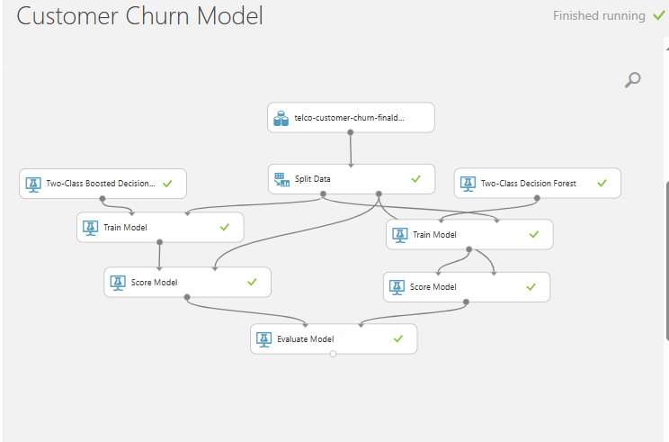

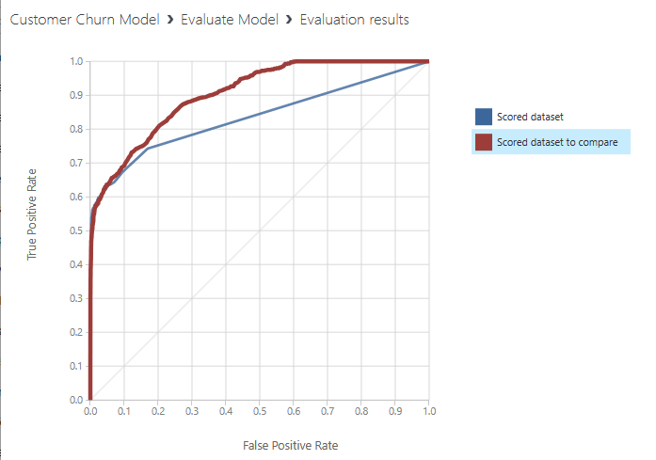

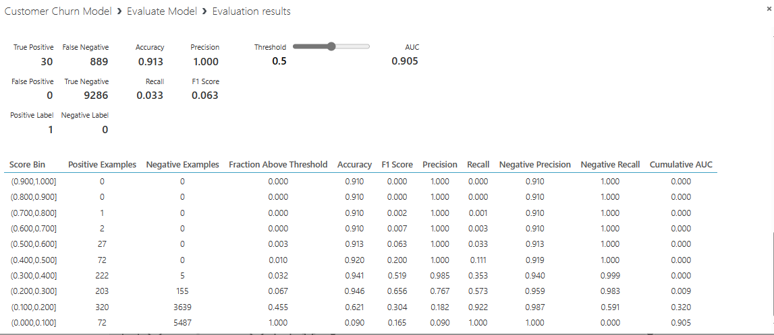

**Questions:**

**Discuss the tangible and intangible benefits the business has observed after the implementation.**

**Ans:**

**Tangible Benefits:**

* **Enhanced Customer Retention:**

The implementation of the customer churn model, enriched with advanced decision trees and random forests, enables businesses to accurately pinpoint customers at the verge of churning. This precision facilitates targeted retention efforts, ultimately elevating overall customer retention rates.

* **Increased Revenue:**

Retaining existing customers proves to be more cost-effective than acquiring new ones. The churn model's effectiveness in preserving current customers directly contributes to heightened revenue by safeguarding subscription or service fees that would otherwise be lost.

* **Optimized Marketing Spend:**

The model empowers businesses to concentrate marketing efforts on the audience more prone to churn, ensuring a more efficient allocation of resources. This optimization leads to a judicious use of marketing budgets, directed toward retaining valuable customers.

* **Data-Driven Decision Making:**

The introduction of machine learning models establishes a data-driven approach to decision-making. Businesses can leverage insights from the model to make informed decisions regarding customer engagement strategies, product enhancements, and overall service improvements.

**Intangible Benefits:**

* **Enhanced Customer Experience:**

Proactively addressing the needs of potential churners contributes to an overall enhancement in customer experience. This proactive approach can result in increased satisfaction, positive word-of-mouth, and a fortified brand image.

* **Competitive Advantage:**

Businesses employing advanced machine learning techniques for customer retention gain a competitive edge. The ability to predict and prevent churn demonstrates a dedication to customer satisfaction and innovation, setting the business apart from competitors.

* **Learning and Adaptation:**

The incorporation of hyperparameters and comparison with an H2O machine learning project signifies a commitment to continuous learning and improvement. This adaptability allows businesses to evolve their strategies based on changing customer behavior, staying ahead of market trends.

* **Employee Morale:**

Successful implementation and utilization of advanced machine learning models can boost employee morale by showcasing the company's commitment to innovation. This fosters a positive work environment where employees feel they are part of a forward-thinking organization.

* **Risk Mitigation:**

Early identification of potential customer churn enables businesses to take preventive measures, mitigating the risk of revenue loss. This risk mitigation is crucial for the long-term sustainability and growth of the business.

**Outcomes:**

**CO2:** Study the evolution of cloud computing and its models

**Conclusion: (Conclusion to be based on the objectives and outcomes achieved)**

We have studied data analytics using Microsoft Azure and implemented Telco’s customer churn model to evaluate the outputs.