**MOD-1**

**MOD-2**

**MOD-3**

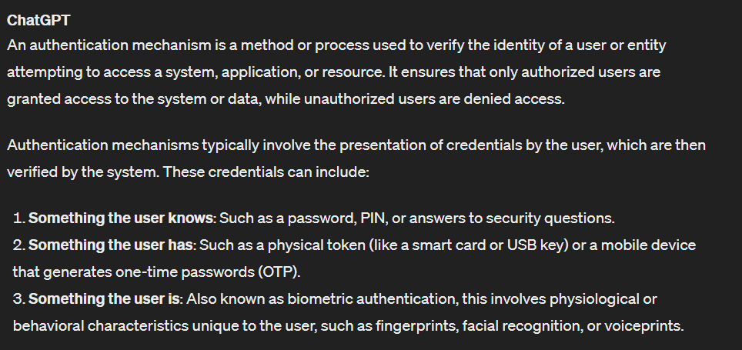

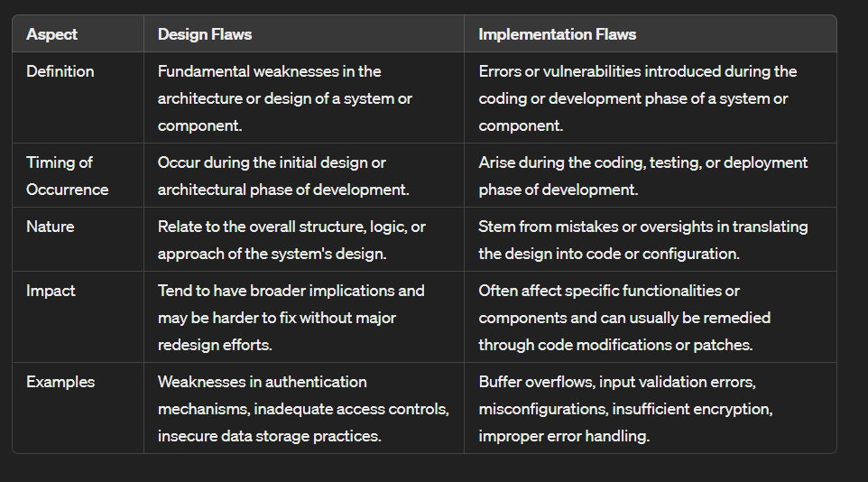

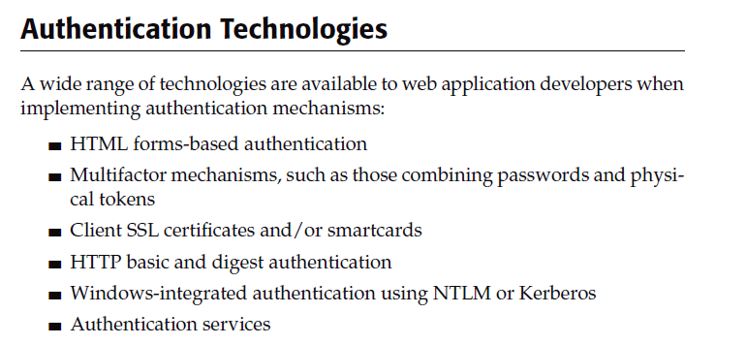

1. Bad Passwords

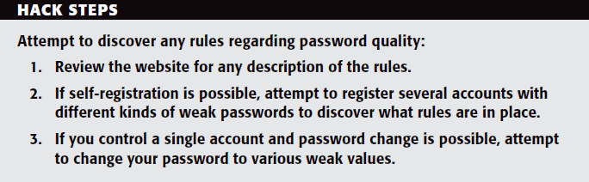

1. Brute-Forcible Login

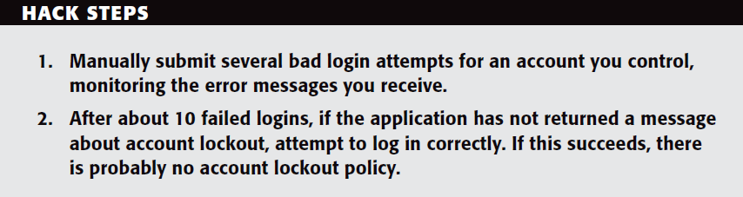

1. Verbose Failure Messages

d. Vulnerable Transmission of Credentials

e. Password Change Functionality

f. Forgotten Password Functionality

g. “Remember Me” Functionality

h. User Impersonation Functionality

i. Incomplete Validation of Credentials

j. Nonunique Usernames

k. Predictable Usernames

***Securing Authentication:***

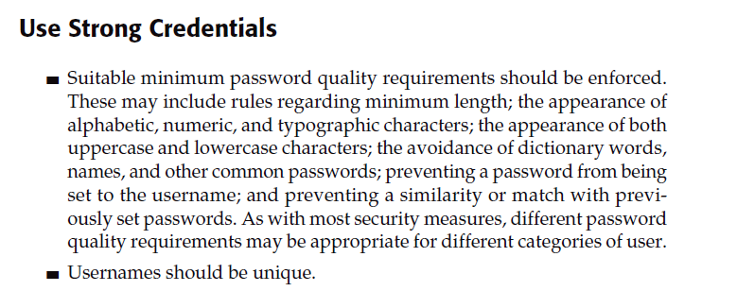

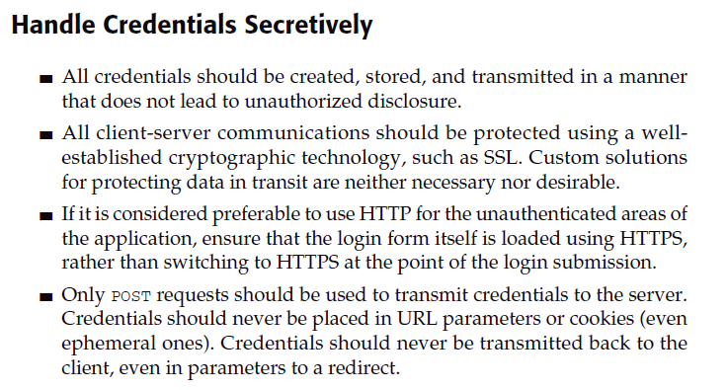

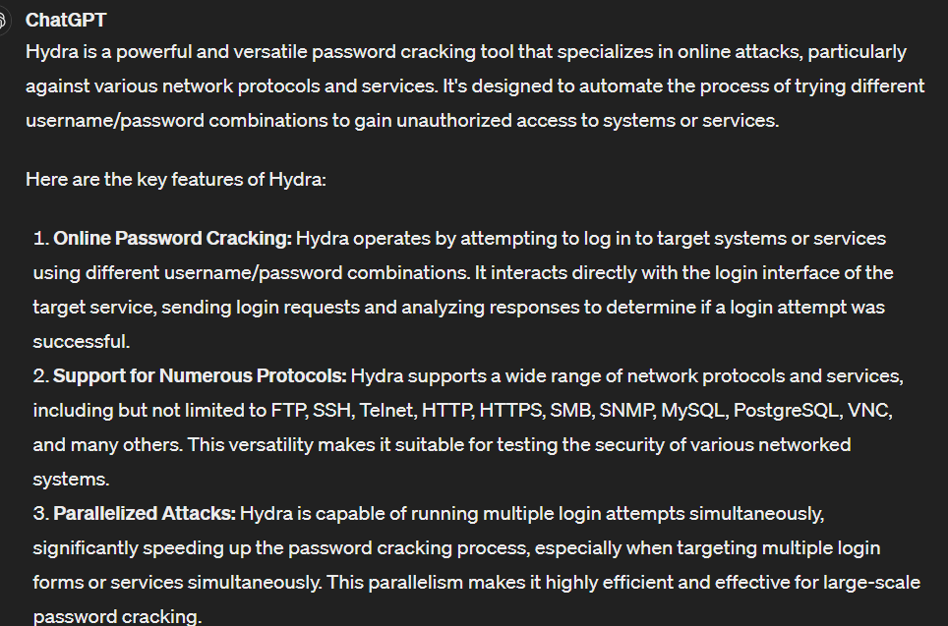

**MOD-4**

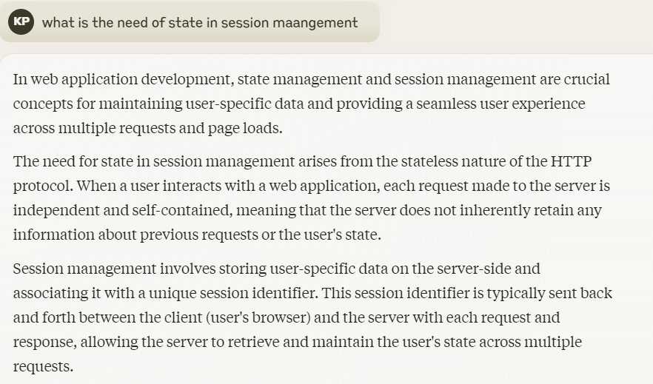

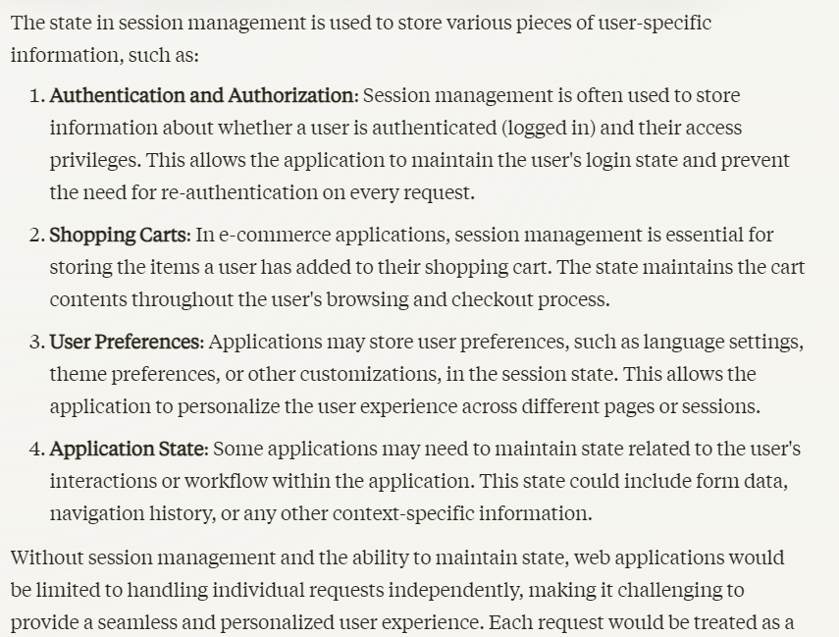

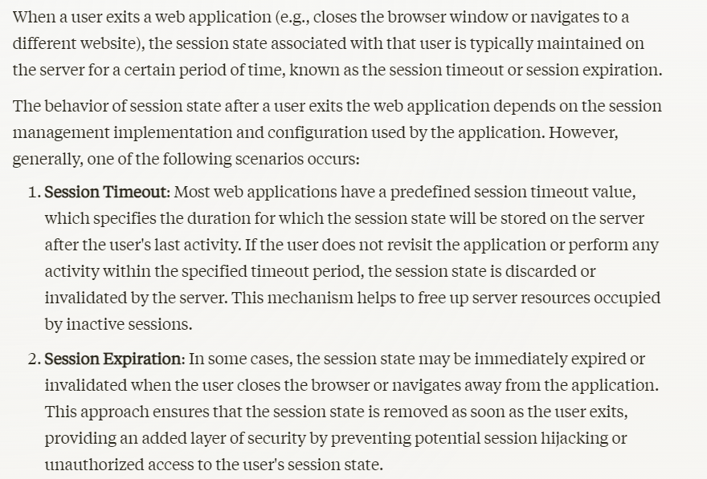

**MOD-5**