**Batch: HO DL 1 Experiment Number: 4**

**Roll Number: 16010421073 Name: Keyur Patel**

**Title of the Experiment: Transfer Learning with CNN**

**Program:**

import tensorflow as tf

from tensorflow.keras.datasets import cifar10

from tensorflow.keras.models import Sequential

from tensorflow.keras.layers import Conv2D, MaxPooling2D, Flatten, Dense, Dropout

from tensorflow.keras.utils import to_categorical

from sklearn.model_selection import train_test_split

from sklearn.metrics import classification_report

import matplotlib.pyplot as plt

import numpy as np

(train_images, train_labels), (_, _) = cifar10.load_data()

num_classes = 10

class_labels = ['airplane', 'automobile', 'bird', 'cat', 'deer', 'dog', 'frog', 'horse', 'ship', 'truck']

class_images = {label: [] for label in class_labels}

for i in range(num_classes):

    class_images[class_labels[i]] = train_images[np.where(train_labels == i)[0]]

plt.figure(figsize=(12, 8))

for i in range(num_classes):

    plt.subplot(2, 5, i + 1)

    random_image_index = np.random.randint(0, len(class_images[class_labels[i]]))

    plt.imshow(class_images[class_labels[i]][random_image_index])

    plt.title(class_labels[i])

    plt.axis('off')

plt.show()

model = Sequential([

    Conv2D(32, (3, 3), activation='relu', input_shape=(32, 32, 3)),

    MaxPooling2D((2, 2)),

    Conv2D(64, (3, 3), activation='relu'),

    MaxPooling2D((2, 2)),

    Flatten(),

    Dense(128, activation='relu'),

    Dropout(0.5),

    Dense(num_classes, activation='softmax')

])

model.summary()

tf.keras.utils.plot_model(model, to_file='model.png', show_shapes=True, show_layer_names=True)

train_images = train_images / 255.0  # Normalize pixel values to [0, 1]

train_labels = to_categorical(train_labels, num_classes)

model.compile(optimizer='adam', loss='categorical_crossentropy', metrics=['accuracy'])

history = model.fit(train_images, train_labels, epochs=10, batch_size=64, validation_split=0.2)

train_accuracy = history.history['accuracy'][-1]

val_accuracy = history.history['val_accuracy'][-1]

print(f"Training Accuracy: {train_accuracy}, Validation Accuracy: {val_accuracy}")

model_regularized = Sequential([

    Conv2D(32, (3, 3), activation='relu', input_shape=(32, 32, 3)),

    MaxPooling2D((2, 2)),

    Conv2D(64, (3, 3), activation='relu'),

    MaxPooling2D((2, 2)),

    Flatten(),

    Dense(128, activation='relu', kernel_regularizer=tf.keras.regularizers.l2(0.001)),

    Dropout(0.5),

    Dense(num_classes, activation='softmax')

])

model_regularized.compile(optimizer='adam', loss='categorical_crossentropy', metrics=['accuracy'])

history_regularized = model_regularized.fit(train_images, train_labels, epochs=10, batch_size=64, validation_split=0.2)

plt.plot(history_regularized.history['loss'], label='Training Loss')

plt.plot(history_regularized.history['val_loss'], label='Validation Loss')

plt.xlabel('Epochs')

plt.ylabel('Loss')

plt.title('Loss Over Time')

plt.legend()

plt.show()

plt.plot(history_regularized.history['accuracy'], label='Training Accuracy')

plt.plot(history_regularized.history['val_accuracy'], label='Validation Accuracy')

plt.xlabel('Epochs')

plt.ylabel('Accuracy')

plt.title('Accuracy Over Time')

plt.legend()

plt.show()

predictions = model_regularized.predict(train_images)

predicted_classes = np.argmax(predictions, axis=1)

print(classification_report(np.argmax(train_labels, axis=1), predicted_classes))

**Output:**

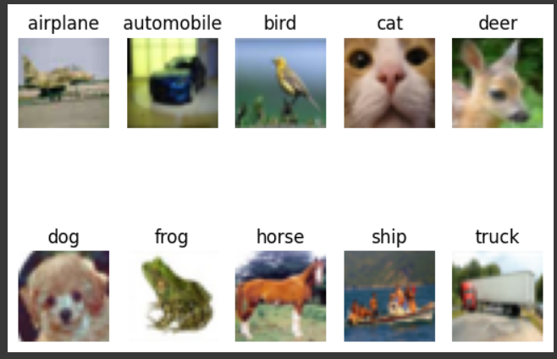

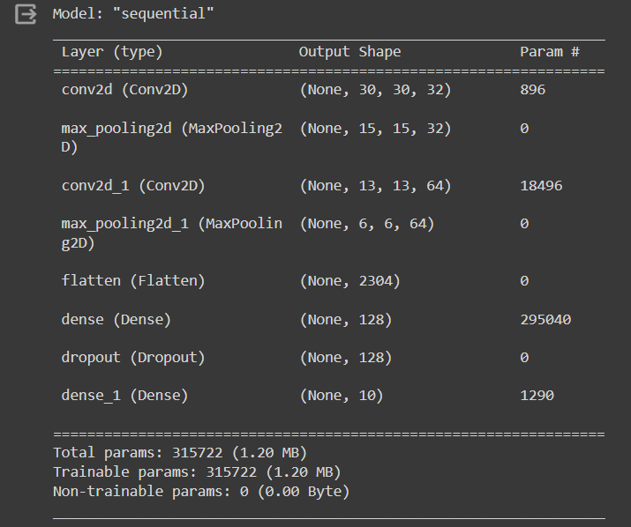

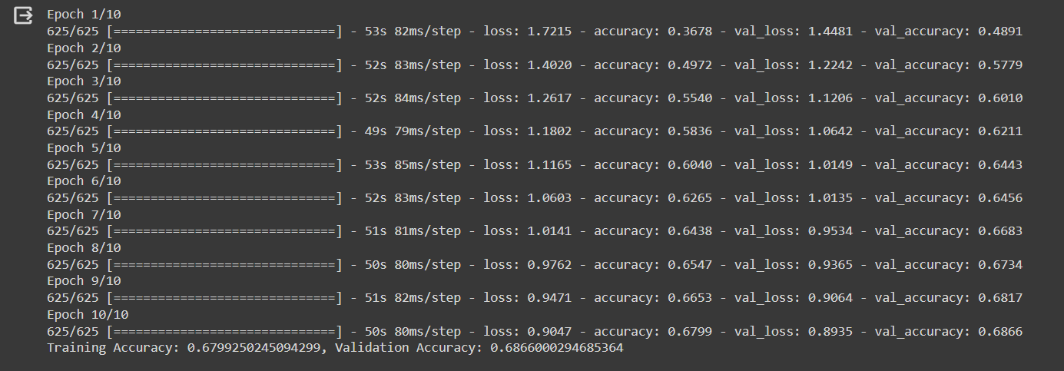

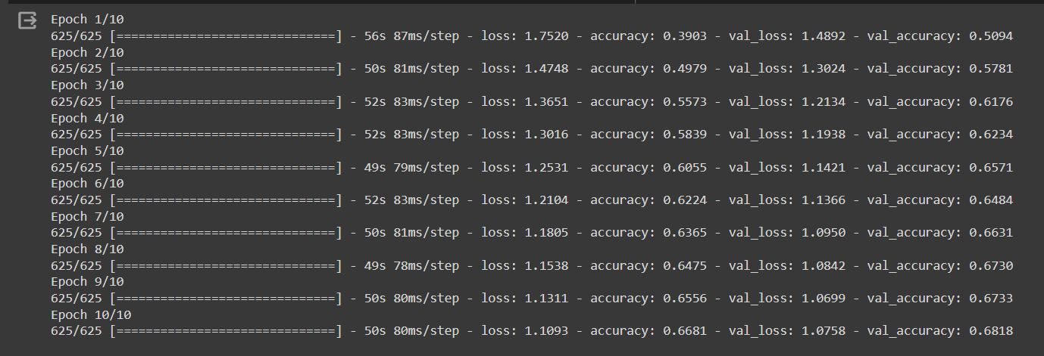

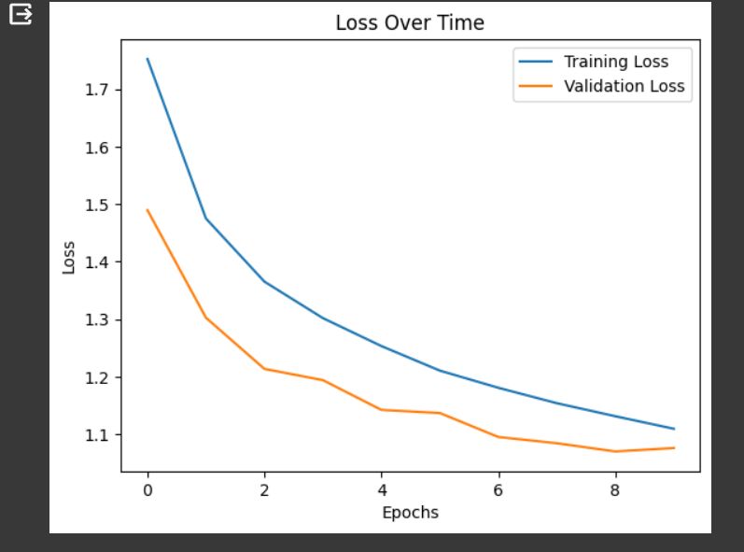

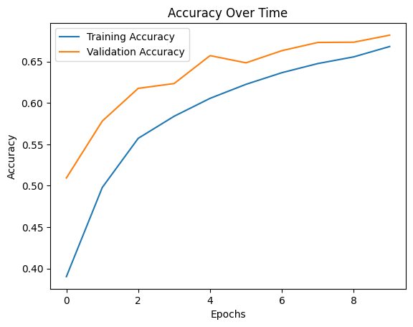

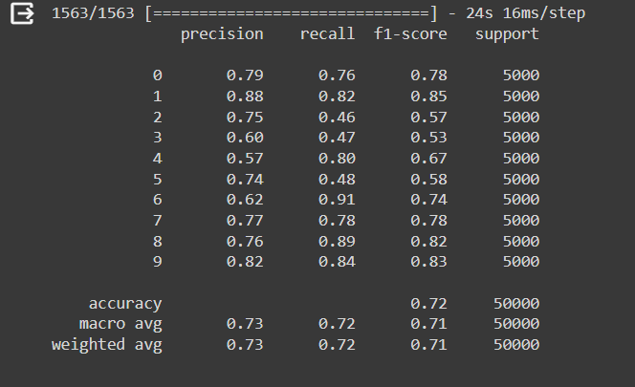

**CO: CO3: Assimilate fundamentals of Convolutional Neural Network.**

**Conclusion:**

In this experiment we learnt about transfer learning with CNN and performed the same. The output of the same has been displayed.