Experiment No.: 7

Title: Preparing Software Design Document (SDD)

Batch: Roll No.: Experiment No.: 7

Aim: To prepare Software Design Document (SDD)
___________________________________________________________________________
Resources needed: Internet Explorer, LaTex Editor ___________________________________________________________________________

Theory
The SDD shows how your software will be structured to satisfy the requirements. It describes the software structure, software components, interfaces, and data necessary for the implementation phase. In a complete SDD, each requirement must be traceable to one or more components.
An SDD is a representation or model of the software system to be created. The model should provide the precise design information needed for planning, analysis, and implementation of the software system. It should represent a partitioning of the system into components and describe the important properties and relationships between them.

SDD Template:
1 INTRODUCTION
1.1 Design Overview
Give a description of the design approach, highlighting essential features that allow the design to meet the stated requirements.
1.2 Requirements Traceability Matrix
Provide a matrix showing where each feature identified in the SRS is supported by the design components.
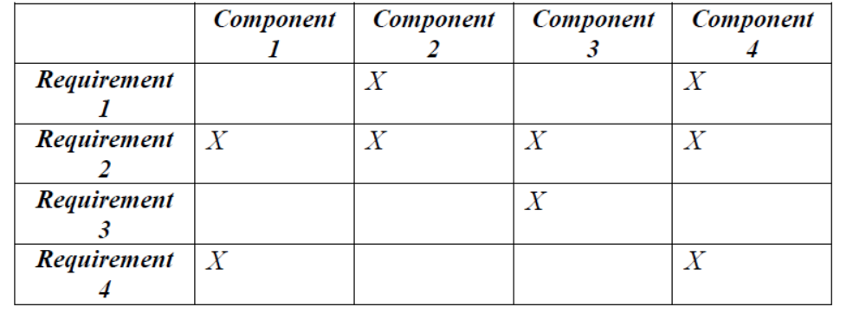

2 SYSTEM ARCHITECTURAL DESIGN
2.1 Chosen System Architecture
Describe the system architectural design, identifying the major component groupings and the interfaces (both internal and external).
Make sure to identify any significant technical risks, and identify contingency plans for each.
2.2 Discussion of Alternative Designs
Discuss in a reasonable level of detail other design options explored, and the reasons for not choosing them.
2.3 System Interface Description
Describe the system interfaces in detail: O/S interface, files, networking, libraries, graphics libraries etc. (*Describe the user interface in section 4.)

3 DETAILED DESCRIPTION OF COMPONENTS
3.n Component-n
For each component, the following items should be described here as appropriate: responsibilities, constraints, composition, interactions, and resources. Use appropriate diagrams or other notation to describe your design.

4 USER INTERFACE DESIGN
In this section describe the design of the user interface in detail.
4.1 Description of the User Interface
4.1.1 Screen Images
Show the design of layout and menus for each screen.
4.1.2 Objects and Actions
Identify all the objects on each screen, and define the actions to be taken by each object for each event.

5. System Architecture
In this section high-level overview of how the functionality and responsibilities of the system were partitioned and then assigned to subsystems or components are provided.
Use cases from the SRS Document

Use Case Specification using template
Use Case ID: | 1
Use Case Name:
Created By: |  | Last Updated By:
Date Created: |  | Date Last Updated:

Primary Actors:
Secondary Actors:
Description:
Trigger:
Preconditions:
Postconditions:
Normal Flow:
Alternative Flows:
Exceptions:
Includes:
Priority:
Frequency of Use:
Business Rules:
Special Requirements:
Open Issues
Assumptions:
Notes and Issues:

6. Data flow specifications
DFD is created from the SRS document provided.
6.1 Level 0 DFD with description
6.2 Level 1 DFD with description

__________________________________________________________________________
Procedure:
1. Prepare SDD document for chosen problem definition in LaTeX.
_______________________________________________________________________

Results: Software Design Document (SDD) in given format
_______________________________________________________________________
Questions:

1. Explain Architecture design patterns and styles with examples.
________________________________________________________________________
Outcomes:
___________________________________________________________________________
Conclusion:

Grade: AA / AB / BB / BC / CC / CD /DD

Signature of faculty in-charge with date

___________________________________________________________________________
References:

Books:
- Roger S. Pressman, Software Engineering: A practitioners Approach, 7th Edition, McGraw Hill, 2010.
- Technical report on Guidelines for Documents Produced by Student Projects In Software Engineering based on IEEE standards
- Timothy C. Lethbridge, Robert Laganiere “ Object-Oriented Software Engineering – A practical software development using UML and Java”, Second Edition, Tata McGraw-Hill, New Delhi,2004

