Experiment No. 1
Title: Random Number Generator

Batch: A2 Roll No.: 16010421073 Experiment No.:1

Aim: To study and implement a PseudoRandom Number Generator (PRNG) using Linear
Congruential Method

Resources needed: Turbo C / Java / python

Theory

Problem Definition:
Write a Program for generating random numbers using Linear Congruential method such that i) Period of the numbers generated is >=100
ii) Density of the numbers generated is maximum (average gap between random numbers is < 0.1).

Concepts:

Random Numbers: Random numbers are a necessary basic ingredient in simulation of almost all discrete systems. Most computer languages have a subroutine, object or function that will generate a random number. A simulation language generates random numbers that are used to generate event times and other random variables.


Properties of random Numbers:
A sequence of random number R1, R2 … must have two important statistical properties, uniformity and independence.
Uniformity :
If the interval (0, 1) is divided into „n‟ classes or subintervals of equal length , the expected number of observations in each interval is N/n, where N is total number of observations. Independence:
The probability of observing a value in a particular interval is independent of the previous drawn value.

Problems faced in generating random numbers:
1. The generated number may not be uniformly distributed.
2. The number may be discrete valued instead of continuous values.
3. The mean of the numbers may be too high or low
4. The variance of the number may be too high or low.
5. The numbers may not be independent e.g. a. Autocorrelation between numbers
b. Numbers successively higher or lower than adjacent numbers.
Criteria for random no. generator:
1. The routine should be fast.
2. The routine should be portable.
3. The routine should have a sufficient long cycle. The cycle length or period represents the length of random number sequence before previous numbers begin to repeat themselves in an earlier order. A special case of cycling is degenerating. A routine degenerates when some number appears repeatedly which is unacceptable.
4. The random number should be replicable.
5. Most important, the generated random numbers should closely approximate to the ideal statistical properties of uniformity and independence.

Procedure / Approach /Algorithm / Activity Diagram:

Linear Congruential Method:
The Linear Congruential method produces a sequence of integers X1, X2,… between 0 and m-1 according to the following recursive relationship.
X i+1= (a X i + c) mod m , i = 0, 1, 2…
The initial value X0 is called the seed, a is constant multiplier, c is the increment and m is the modulus. Maximal period can be achieved by a, c, m, X0 satisfying one of the following conditions
1. For m, a power of 2 (m = 2b) and c≠0 period p = 2b is achieved provided c is relatively
prime to m and a = 1+4k , k = 0,1,2,…
2. For m = 2b and c = 0 , period p = 2b-2 is achieved provided X0 is odd and multiplier a
= 3+8k or a = 5+8k , k = 0,1,2,…
3. For m a prime number and c = 0, period p = m-1 is achieved provided a has the property that the smallest integer is such that a k-1 is divisible by m is k = m-1.

Results: (Program printout with output / Document printout as per the format)

Code:
def linearCongruentialMethod(Xo, m, a, c, randomNums, noOfRandomNums):
# Initialize the seed state
randomNums[0] = Xo
# Traverse to generate required
# numbers of random numbers
for i in range(1, noOfRandomNums):

randomNums[i] = ((randomNums[i - 1] * a) + c) % m

x[0]=randomNums[0]/m
for i in range(1, noOfRandomNums):
x[i]=randomNums[i]/m;

if __name__ == '__main__':
# Seed value
Xo= int(input("Enter seed value(X0) "))

# Modulus parameter
m = int(input('Enter mod value(m) '))

# Multiplier term
a = int(input('Enter multiplier value(a) '))

# Increment term
c = int(input('Enter increment value(c) '))

noOfRandomNums =int(input("Enter the number of random numbers to be generated "))

# To store random numbers
randomNums = [0] * (noOfRandomNums)
x = [0] * (noOfRandomNums)
# Function Call
linearCongruentialMethod(Xo, m, a, c, randomNums, noOfRandomNums)

for i in randomNums:
print(i, end = " ")
print("\nNumbers in range 0 - 1")
for i in x:
print(i, end = " ")

Output:
Case – 1: (x0 = 12, m = 1024,a = 1 + 4k,a=29,c != 0,c = 13)
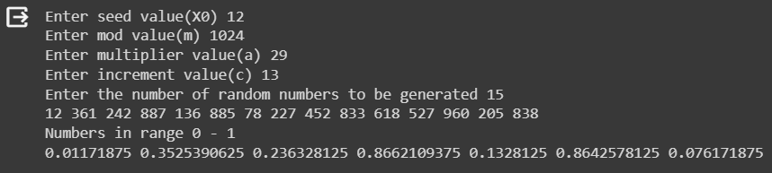

Case -2(x0 = 11[odd no] , m = 1024,a = 5 + 8k,a=35,c=0)
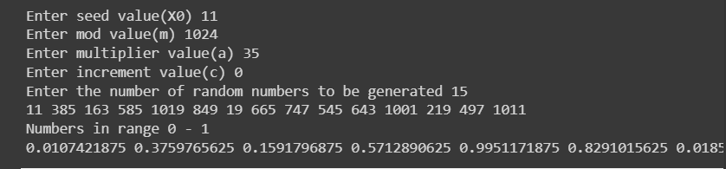

Questions:
- List down a few real life applications using random numbers as input.
Ans:
- Network Security:
Random numbers are crucial in generating cryptographic keys, initialization vectors, and other elements that enhance the security of network communications.
- Gaming and Gambling:
Random numbers are extensively used in gaming and gambling applications to determine outcomes, simulate chance events, and ensure fairness in games.
- Simulation and Modeling:
Random numbers are often used in simulations to model real-world scenarios, such as weather patterns, traffic flow, or financial market movements.
- Random Sampling in Surveys:
Random numbers are used in sampling methods for surveys to ensure representative data. This helps in making statistical inferences about a population based on a smaller sample.

- List the methods for generating random numbers.
Ans:
- Pseudorandom Number Generators (PRNGs):
These algorithms use a deterministic process to produce a sequence of numbers that appears random. However, since they are deterministic, the sequence will eventually repeat. Common PRNGs include the Linear Congruential Generator (LCG) and the Mersenne Twister.
- Seed-Based Generation:
PRNGs can be initialized with a seed value. If the seed is unpredictable, it enhances the randomness of the generated sequence. Seeds can be based on current time, user input, or other sources.
- Hash Function-Based Generators:
Hash functions can be used to generate pseudorandom numbers by hashing a counter or a combination of seed values. This method is often used in applications where cryptographic strength is not required.
- Middle Square Method:
This is a simple PRNG where each number in the sequence is obtained by squaring the previous number and extracting the middle digits. It has limitations in terms of long-term randomness.

Outcomes:
CO2: Generate pseudorandom numbers and perform empirical tests to measure the
quality of a pseudorandom number generator

Conclusion: (Conclusion to be based on outcomes)

Grade: AA / AB / BB / BC / CC / CD /D

Signature of faculty in-charge with date

References:

Books/ Journals/ Websites: Text Book:
Banks J., Carson J. S., Nelson B. L., and Nicol D. M., “Discrete Event System Simulation”,
3rd edition, Pearson Education, 2001.

Websites:

[1] http://en.wikipedia.org/wiki/Pseudorandom_number_generator
[2] http://en.wikipedia.org/wiki/Linear_congruential_generator

.

