Subject : web programming

* First webpage

Code:

<!DOCTYPE html>

<html>

<head>

<link rel="stylesheet" href="https://www.w3schools.com/w3css/4/w3.css">

</head>

<body>

<div class="w3-container w3-red">

<div>

<h1>Enginnering Courses</h1>

<p>Resize this responsible page! </p>

</div>

</div>

<div class="w3-row-padding">

<div class="w3-container w3-col s4">

<h1>Computer Enginnering </h1>

<p>It is so a four year Courses in which your are going to learn about the fundament of machines, computers,

languages, parts,

and materials. After the enginnering you can persue the master in enginnering in any of the perticular

subject or else a topic.

There are many topic of enginnering in which can do our masters. Topic like Cyber, CNC VNC Machines, AR

AR etc in which the

master is possible...

</p>

<p><a href="file:///C:/Users/Hardik%20Fataniya/Desktop/ce%20page.htm">

<img src="https://encrypted-tbn0.gstatic.com/images?q=tbn:ANd9GcSIOJ2rakPGWaNUAFaZ_ros5CT6J1y8HmqKBA&usqp=CAU" alt="google.com">

</a></p>

</div>

<div class="w3-container w3-col s4">

<h1>Mechinical Enginnering</h1>

<p>Mechinical Enginneringis the course in which we learn about the parts and the concepts. Mechanical

engineering requires an understanding of core areas including mechanics, dynamics, thermodynamics,

materials science, structural analysis, and electricity. In addition to these core principles,

mechanical engineers use tools such as computer-aided design (CAD), computer-aided manufacturing (CAM),

and product lifecycle management to design and analyze manufacturing plants, industrial equipment and

machinery, heating and cooling systems, transport systems, aircraft, watercraft, robotics, medical

devices, weapons, and others.[2][3] </p>

<p><a href="file:///C:/Users/Hardik%20Fataniya/Desktop/mechanical.htm">

<img src="https://encrypted-tbn0.gstatic.com/images?q=tbn:ANd9GcRLuhM7BsUrDFu10HRY2VKYoatiOOEHj3tTxQ&usqp=CAU" alt="W3Schools.com">

</a></p>

</div>

<div class="w3-container w3-col s4">

<h1>Civil Enginnering</h1>

<p>Civil engineering is the application of physical and scientific principles for solving the problems of

society, and its history is intricately linked to advances in the understanding of physics and

mathematics throughout history. Because civil engineering is a broad profession, including several

specialized sub-disciplines, its history is linked to knowledge of structures, materials science,

geography, geology, soils, hydrology, environmental science, mechanics, project management, and other

fields.[6]</p>

<p><a href="file:///C:/Users/Hardik%20Fataniya/Desktop/civil.htm">

<img src="https://encrypted-tbn0.gstatic.com/images?q=tbn:ANd9GcRnz18yU_YBilsUUFimwXBUGCzUOGp0FpJu9PV4ujzN2eoyfyrIKqMkjkcBZrM7AWNKPBQ&usqp=CAUs" alt="W3Schools.com">

</a></p>

</div>

</div>

<style>

.footer {

position: fixed;

left: 0;

bottom: 0;

width: 100%;

background-color: red;

color: white;

text-align: center;

}

</style>

<div class="footer">

<p><a href="file:///C:/Users/Hardik%20Fataniya/Desktop/contactus.html">CONTACT US.</a></p>

</div>

</body>

</html>

Screenshot:

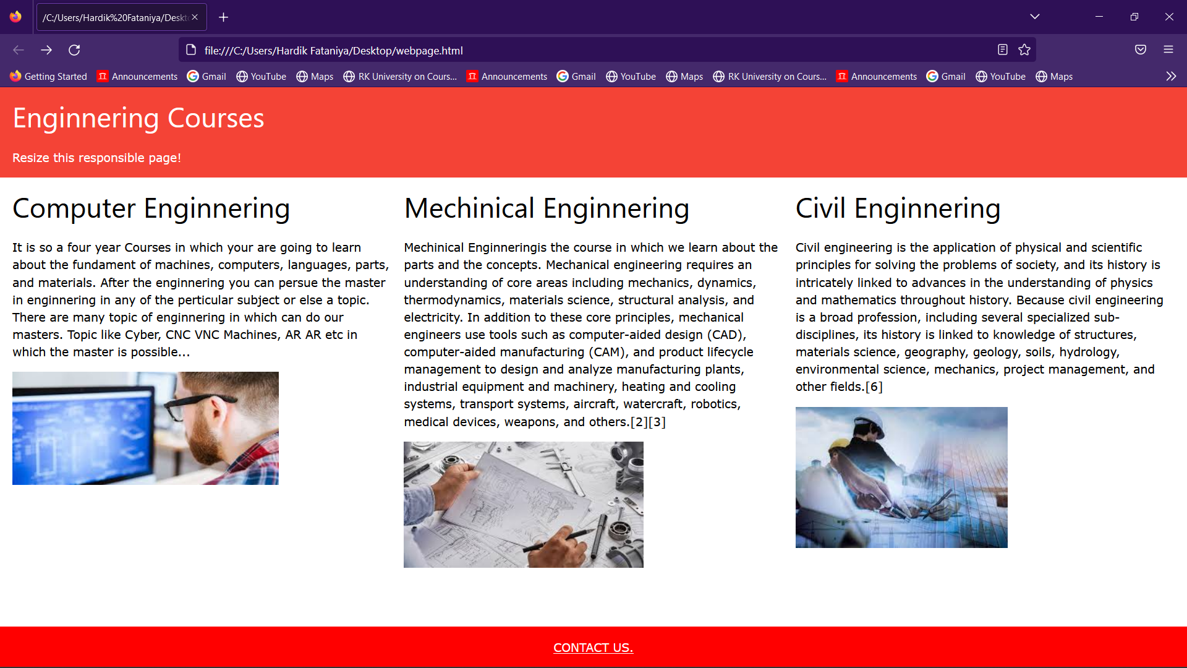

NOTE:Click the photos to more detail about computer engineering course

* Second web page

Code:

<!DOCTYPE html>

<html>

<title>W3.CSS</title>

<meta name="viewport" content="width=device-width, initial-scale=1">

<link rel="stylesheet" href="https://www.w3schools.com/w3css/4/w3.css">

<body>

<div class="w3-container">

<h2>Computer Engineering</h2>

<h4>unordered list:-</h4>

<ul>

<li>Processor design.</li>

<li>Coding, cryptography, and information protection.</li>

<li>Communications and wireless networks.</li>

</ul>

<h4>ordered list:-</h4>

<ol>

<li>Compilers and operating systems.</li>

<li>Computational science and engineering.</li>

<li>Computer networks, mobile computing, and distributed systems.</li>

</ol>

</div>

<div class="w3-container">

<h2>Software of computer engineering with details.</h2>

<table class="w3-table-all">

<thead>

<tr class="w3-light-grey">

<th>Software</th>

<th>Details</th>

</tr>

</thead>

<tr>

<td>Application software</td>

<td>Application software is a computer software package that

performs a specific function for a user, or in some cases,

for another application.</td>

</tr>

<tr>

<td>System software</td>

<td>These software programs are designed to run a computer's

application programs and hardware</td>

</tr>

<tr>

<td>Driver software</td>

<td>Device drivers control the devices and peripherals connected

to a computer, enabling them to perform their specific tasks</td>

</tr>

<tr>

<td>Programming software</td>

<td>Computer programmers use programming software to write code.</td>

</tr>

</table>

</div>

</br>

<style>

.footer {

position: fixed;

left: 0;

bottom: 0;

width: 100%;

background-color: red;

color: white;

text-align: center;

}

</style>

<div class="footer">

<p><a href="file:///C:/Users/Hardik%20Fataniya/Desktop/contactus.html">CONTACT US.</a></p>

</div>

</body>

</html>

Screenshot:

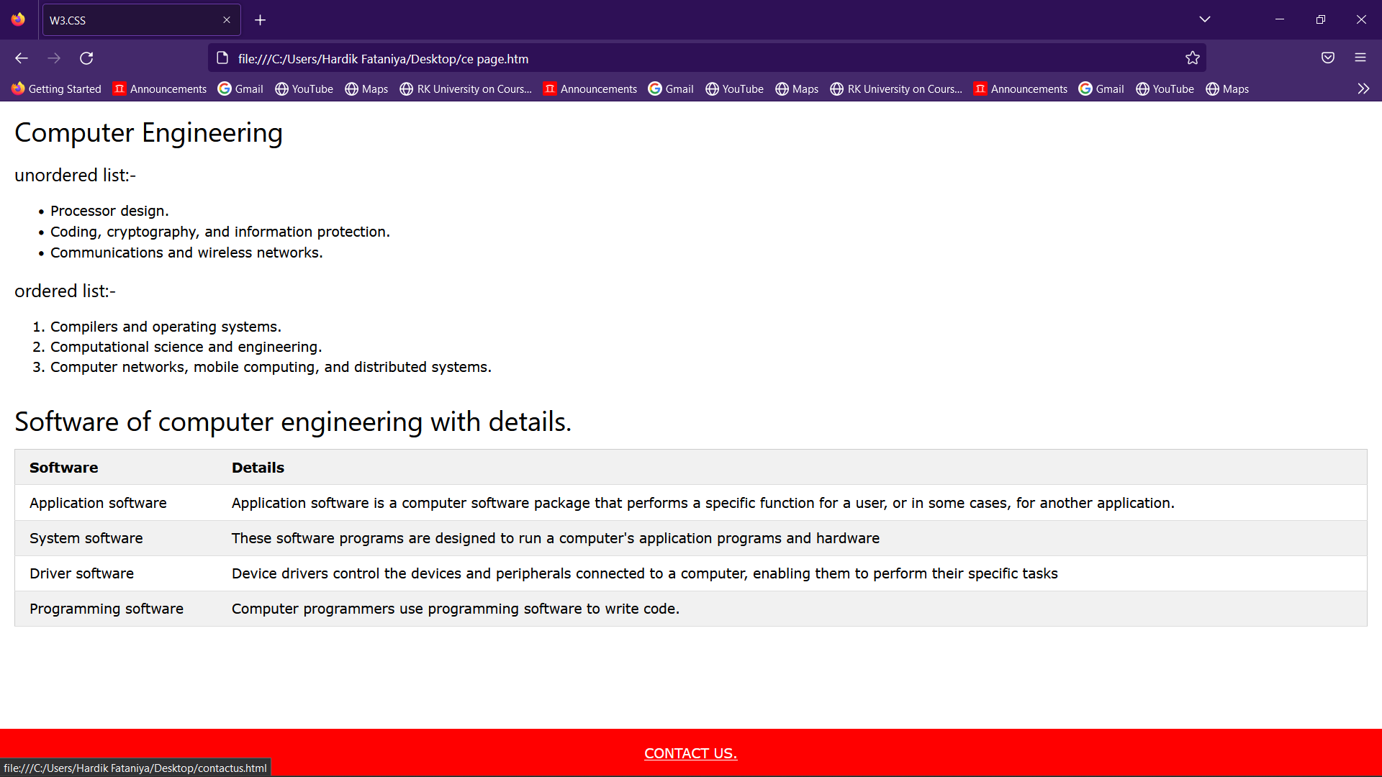

* Third webpage for mechanical engineering

Code:

<!DOCTYPE html>

<html>

<title>W3.CSS</title>

<meta name="viewport" content="width=device-width, initial-scale=1">

<link rel="stylesheet" href="https://www.w3schools.com/w3css/4/w3.css">

<body>

<div class="w3-container">

<h2>Mechanical Engineering</h2>

<h4>unordered list:-</h4>

<ul>

<li>Machinery manufacturing.</li>

<li>Transportation equipment manufacturing.</li>

<li>Problem-solving.</li>

</ul>

<h4>ordered list:-</h4>

<ol>

<li>Computer and electronic product manufacturing.</li>

<li>Scientific research and development services.</li>

<li>Auto research engineers.</li>

</ol>

</div>

<div class="w3-container">

<h2>Equipment of mechanical engineering with details.</h2>

<table class="w3-table-all">

<thead>

<tr class="w3-light-grey">

<th>Equipment</th>

<th>Details</th>

</tr>

</thead>

<tr>

<td>3D printer</td>

<td>A 3D printer is a machine that creates three-dimensional

objects made of plastic or metal based on digital models.</td>

</tr>

<tr>

<td>Digital force gauge</td>

<td>Also called a push pull force gauge, this device can measure

the amount of tension or pressure in an element of a machine.</td>

</tr>

<tr>

<td>Flow meter</td>

<td>A flow meter is an instrument that measures the flow rates of

air or liquid. </td>

</tr>

<tr>

<td>Mirror</td>

<td>A small mirror like the ones a dentist might use can help mechanical

engineers view machinery from different angles and inspect machinery.</td>

</tr>

</table>

</div>

</br>

<style>

.footer {

position: fixed;

left: 0;

bottom: 0;

width: 100%;

background-color: red;

color: white;

text-align: center;

}

</style>

<div class="footer">

<p><a href="file:///C:/Users/Hardik%20Fataniya/Desktop/contactus.html">CONTACT US.</a></p>

</div>

</body>

</html>

Screenshot:

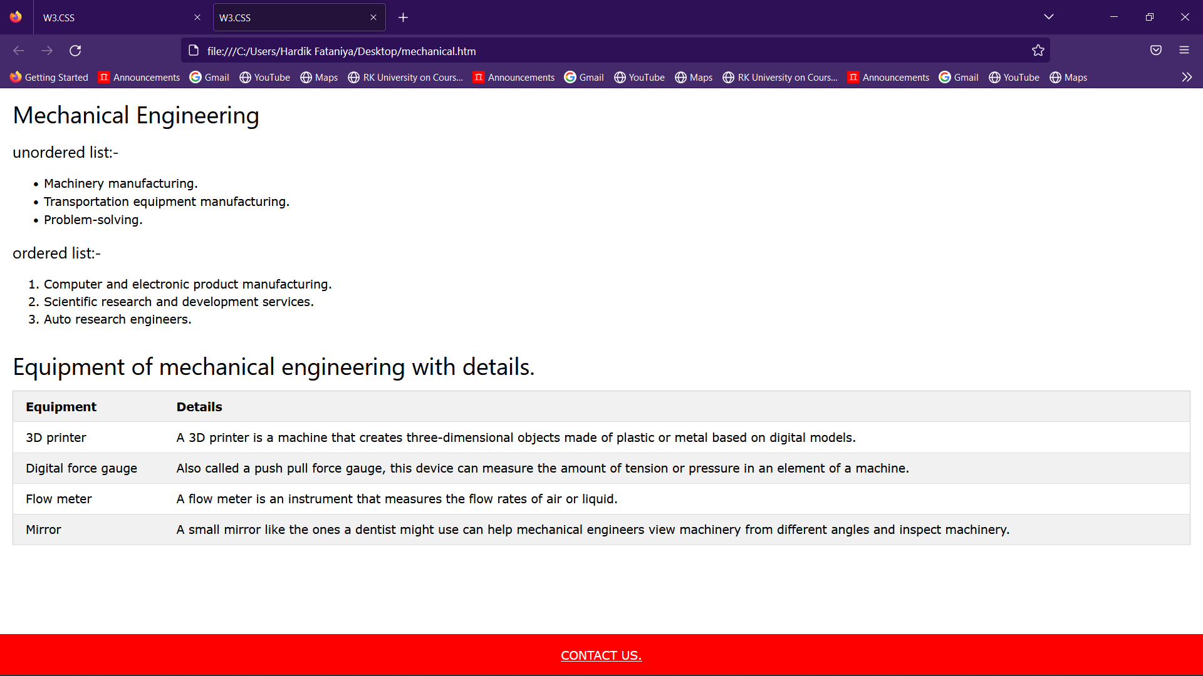

* Fourth webpage for civil engineering

Code:

<!DOCTYPE html>

<html>

<title>W3.CSS</title>

<meta name="viewport" content="width=device-width, initial-scale=1">

<link rel="stylesheet" href="https://www.w3schools.com/w3css/4/w3.css">

<body>

<div class="w3-container">

<h2>Civil Engineering</h2>

<h4>unordered list:-</h4>

<ul>

<li>Infrastructure Engineering.</li>

<li>Structural Engineering.</li>

<li>Environmental Engineering.</li>

</ul>

<h4>ordered list:-</h4>

<ol>

<li>Geotechnical Engineering.</li>

<li>Transportation Engineers.</li>

<li>Planning and Designing.</li>

</ol>

</div>

<div class="w3-container">

<h2>Equipment of civil engineering with details.</h2>

<table class="w3-table-all">

<thead>

<tr class="w3-light-grey">

<th>Equipment</th>

<th>Details</th>

</tr>

</thead>

<tr>

<td>Trowel</td>

<td>Used in masonry and plastering works to place the mortar.</td>

</tr>

<tr>

<td>Gloves</td>

<td>Avoiding to direct contact with dangerous material or machinery.(Hand)</td>

</tr>

<tr>

<td>Bulldozer</td>

<td>A bulldozer is a crawle with a substantial metal plate used fitted to

push large amounts of soil, sand, dirt or other materials when construction

or remodeling and usually push on the back with a claw mechanism to loosen

densely-compacted materials. </td>

</tr>

<tr>

<td>Block Plane</td>

<td>This tool is used in Door and window wood works..</td>

</tr>

</table>

</div>

</br>

<style>

.footer {

position: fixed;

left: 0;

bottom: 0;

width: 100%;

background-color: red;

color: white;

text-align: center;

}

</style>

<div class="footer">

<p><a href="file:///C:/Users/Hardik%20Fataniya/Desktop/contactus.html">CONTACT US.</a></p>

</div> </body>

</html>

Screenshot:

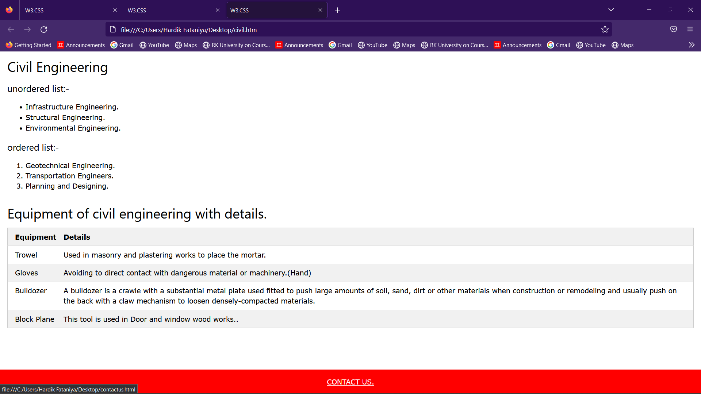

* Last page for contact us form

Note :please click on CONTACT us

Code:

<!DOCTYPE html>

<html>

<title>W3.CSS</title>

<meta name="viewport" content="width=device-width, initial-scale=1">

<link rel="stylesheet" href="https://www.w3schools.com/w3css/4/w3.css">

<link rel="stylesheet" href="https://cdnjs.cloudflare.com/ajax/libs/font-awesome/4.7.0/css/font-awesome.min.css">

<body>

<form action="/action_page.php" class="w3-container w3-card-4 w3-light-grey w3-text-red w3-margin">

<h2 class="w3-center">Contact Us</h2>

<div class="w3-row w3-section">

<div class="w3-col" style="width:50px"><i class="w3-xxlarge fa fa-user"></i></div>

<div class="w3-rest">

<input class="w3-input w3-border" name="first" type="text" placeholder="First Name">

</div>

</div>

<div class="w3-row w3-section">

<div class="w3-col" style="width:50px"><i class="w3-xxlarge fa fa-user"></i></div>

<div class="w3-rest">

<input class="w3-input w3-border" name="last" type="text" placeholder="Last Name">

</div>

</div>

</div>

<div class="w3-row w3-section">

<div class="w3-col" style="width:50px"><i class="w3-xxlarge fa fa-envelope-o"></i></div>

<div class="w3-rest">

<input class="w3-input w3-border" name="email" type="text" placeholder="Email">

</div>

</div>

<div class="w3-row w3-section">

<div class="w3-col" style="width:50px"><i class="w3-xxlarge fa fa-phone"></i></div>

<div class="w3-rest">

<input class="w3-input w3-border" name="phone" type="text" placeholder="Phone">

</div>

</div>

<div class="w3-row w3-section">

<div class="w3-col" style="width:50px"><i class="w3-xxlarge fa fa-pencil"></i></div>

<div class="w3-rest">

<input class="w3-input w3-border" name="message" type="text" placeholder="Message">

</div>

</div>

<button class="w3-button w3-block w3-section w3-red w3-ripple w3-padding">Send your massage</button>

<button class="w3-button w3-block w3-section w3-red w3-ripple w3-padding">reset</button>

</form>

</body>

</html>

Screenshot:

