***Induction Program***

***G.H Patel College of Engineering and Technology***

**Department of Computer Engineering**

**Prepared by-Keyur R. Pandya**

**Enrollment no. 18CP029**

**DAY 1:-**

**10:30 a.m.- 12:30 p.m. : Proficiency Activity(Maths)**

The very first day in Vallabh Vidhyanagar and it starts with the first lecture of the college in which we revised maths, topics included Limits, Continuity & Differentiability .

Along with this, we learned an in-depth analysis of Limits, Continuity & Differentiability. It was a really illuminating and enjoyable experience.

**1:30 p.m. – 2:30 p.m. : Proficiency Activity (Physics)**

In this session, we revised a little and also learned a few Fundamental Definitions of Physics.

As the greatest scientist Albert Einstein had said, “ Education is not the learning of facts, its rather the training of the mind to think.”

Here are a few of the names whose definitions we had learnt :-

* Physics
* Energy
* Oscillations
* Frequency
* Wavelength
* Amplitude
* Newton’s Law

It was a nice experience and nostalgic too.

**2:30 p.m. – 3:30 p.m. : Innovation(Dept.)**

In this session, we were shown videos in the A.V. Room. The videos were related to Start-Ups. It also showed us how to start Start-Ups and why 9 out of 10 Start-Ups fail.

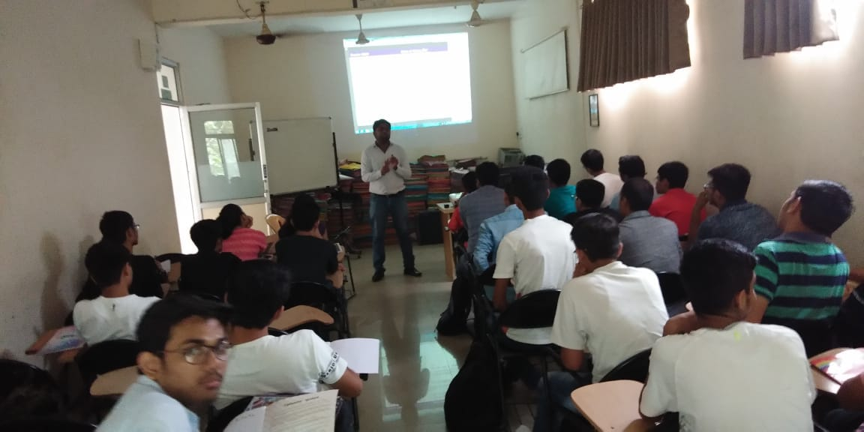

We also learnt a few steps of how to maintain Start-Ups. For eg : We should start our business with a minimum viable project not involving too much investment, instead of going directly to the full project so that we can gauge and improve our product so that we don’t suffer losses.

**DAY 2 :-**

**8:30 a.m. – 12:30 p.m. : Eminent Speaker(Central Activity)(Auditorium)**

In this session, we learnt about Environmental Problems. The speaker in this session was Dhaval Patel and the organization he represented was VNC(Vidyanagar Nature Club).He spoke about the importance of trees and the cutting of trees in residential area for complaints like falling of leaves in the backyard. To quote him,

“After Information-Age, we now live in Garb-age”

He also spoke about afforestation, deforestation and the effects of it and the industries on our environment and our atmosphere. He also encouraged us to take more care on our surroundings.

Hence, we learnt a lot about environment, trees and the effects of industries around us and made us aware of our surroundings.

**DAY 3 :-**

**9:30 a.m. – 12:30 p.m. : Physical Activities Exercise(Yoga)**

We learnt many new Asanas like Vajrasan, Shavasan and also a little bit about meditation and Om-Kar and how Yoga becomes useful to unlock one’s body and mind and how to improve them. It was a really peaceful and helpful experience.

1:30 p.m. – 3:30 p.m. : Literary Activity(English)

This session was held in the seminar hall and it was related to English language.We were advised to :-

* Read as many English newspapers as possible.
* Read the fine print in the products we buy to try and learn new words.
* If possible, communicate with our friends and family in English as ,much as possible.
* Never to think a moment about the negative comments of our society and to always think positive and strive to achieve our goal.

**Day 4 :-**

**10:30 a.m. - 12:30 p.m. : Proficiency Activity(Dept.)**

In this session, we learnt about the basics of Powerpoint Presentation. We had learnt about how to use shapes, lines, colouring and finally, we were asked to draw the Indian Flag in our slides. It was an enjoyable session.

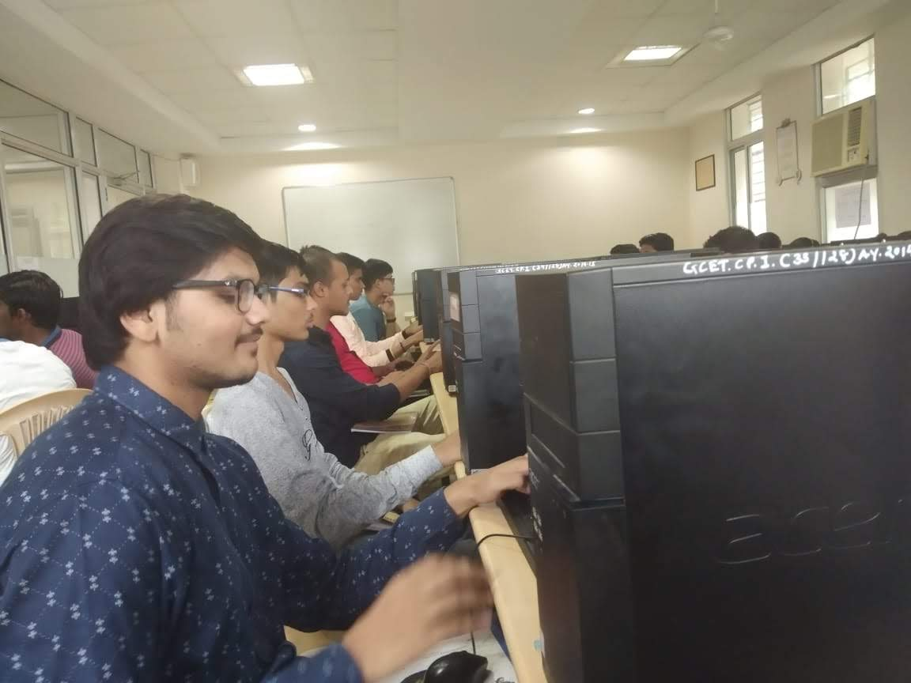

**2:30 p.m. – 5:30 p.m. : Creative Art(Auditorium)**

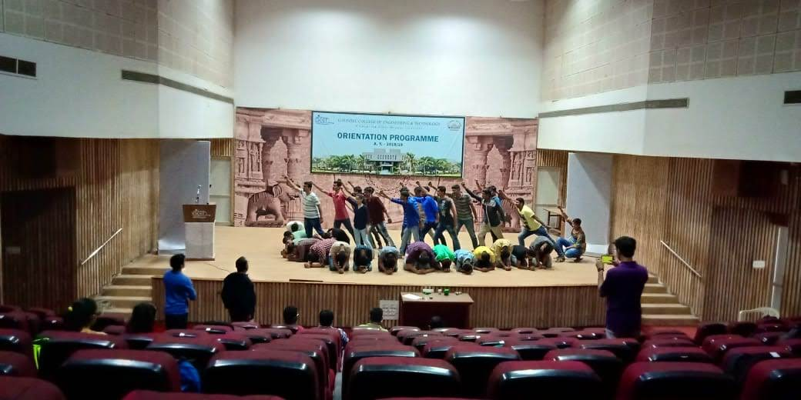

In this session, we were taught a lot of things about Drama/Acting by Jigar Mistri .He taught us about the different types of expressions and styles. We also learnt a little bit of acting by performing on-stage with different expressions but same lines of speech. It helped us overcome stage fear After that, we also created a “Dandi March” scene and also did an “Industry Polluting River” Improv under his guidance. It was a truly memorable experience.It was a great honour to learn from this personality.

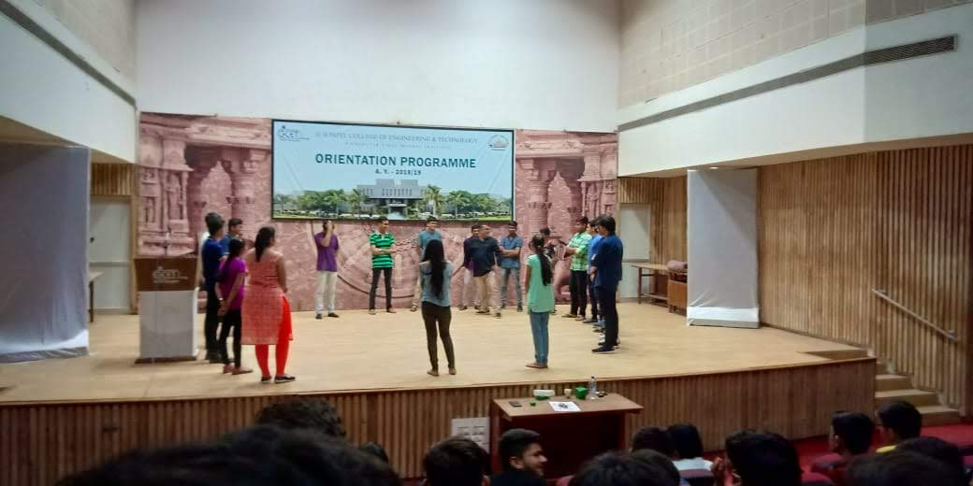

**Day 5 :-**

**Village visit**

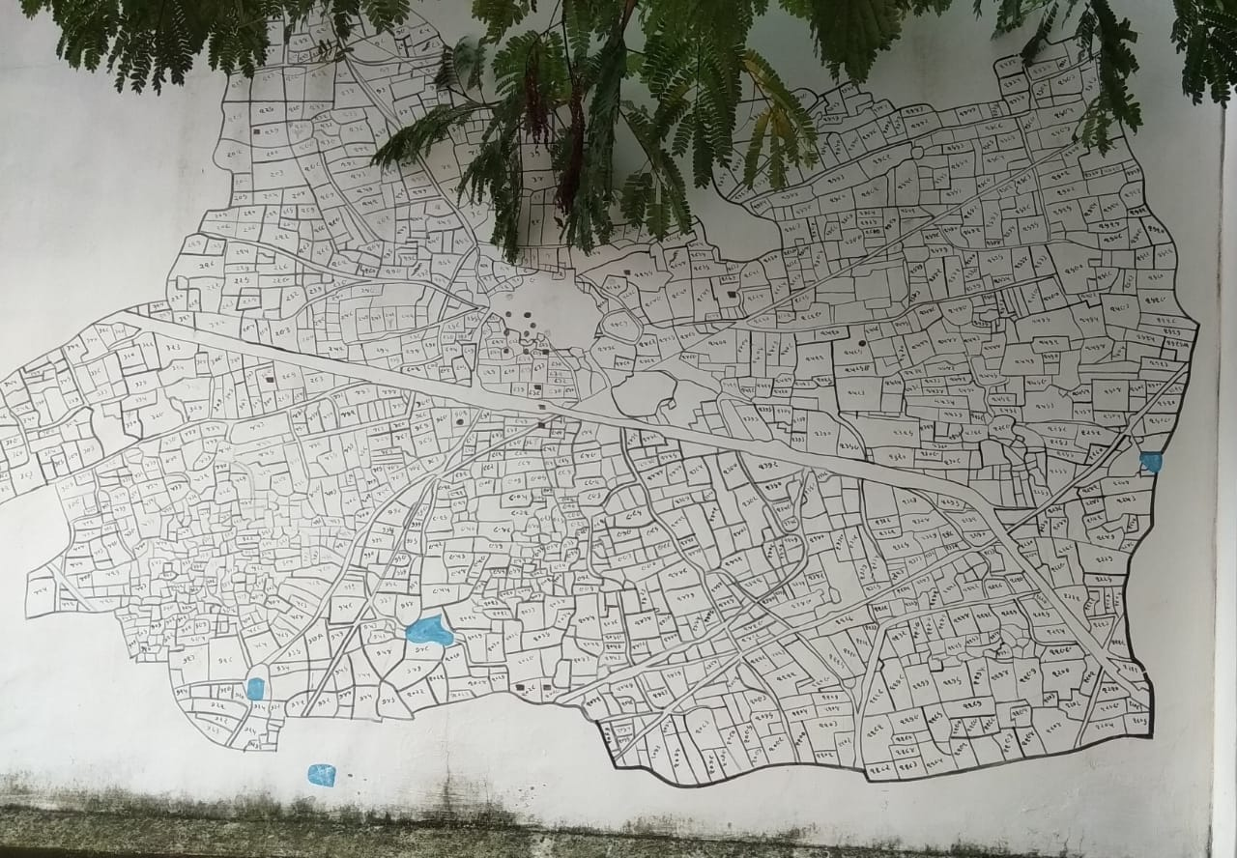

The college had organised visit to samartha village for us. We reached there at around 2pm in groups of 60 lead by 3 teachers. We observed and analysed the whole village visiting every place there. It was a mind blowing experience. We saw their lifestyle, their daily routine, and at last visited the Sarpanch’s office and asked a few doubts of our own.

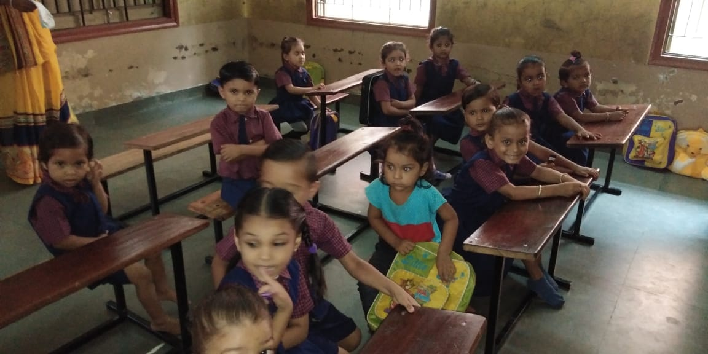

**Day 6 :-**

**9:30 a.m. – 5:30 p.m. : Ordinate Seminar(2018)**

In this Seminar, first of all, Mehul Raval sir – SEO Growth Consultant – spoke about Search Engine Optimization and Digital Marketing. Digital Marketing was first introduced by Marconi in 1896 when he broadcasted a live Opera show.

After this, we learnt about the 7 C of Marketing.

1. Consumers -> Know Their Mindset
2. Content -> It should be Original(Enjoyable), Atomised(Easy to Digest) and Curated(Imported)(Optional)
3. Conversion
4. Context
5. Community
6. Convenience
7. Cohesion

We also learnt about Affiliated Marketing, Search Engine Marketing, Email Marketing and also a few other things like “The Crawler” on Internet and how it works.

After Mr. Mehul Raval sir, Mr. Hem Soparkar sir – Project Lead at Electrobotics – taught us about Drones and how they becoming more and more useful in our day to day lives and how “IOT – Internet of Things” will change lives as we know it.

He told us that when IOT is created, each and everything from our fridge to T.V., everything will be connected. We were shown a video about how a drone replace the ambulance in emergency response by reacting and responding to the site within 2 minutes which is not possible for ambulance.

After that, Mr, Chintan Rathod – Team Lead at Syx Automations Group – taught us about Google Open Source Technologies

**Day 9 :-**

**9:30 a.m. - 12:30 p.m. : Physical Activities Education(Yoga)**

In this session, we learnt a few new Asanas and performed a few physical exercises too, like Crunches, Push-ups. Finally, we ended the session with unique Asanas like .It was a great experience and it also refreshed our body

1:30 p.m. - 3:30 p.m. : Literary Activity (English)

In this session, we leant how to improve our reading of English through a video.Watch motivational videos in English and start reading magazines.

* Reading English Newspapers
* Reading Novels
* Reading English Ads

Also, we learnt a couple of new different techniques of reading like Skimming and Scanning. In scanning, we just try to find a single piece of information from the entire passage while, in skimming, we just try to get the jist of the passage while not reading the whole passage.

**Day 10 :-**

**10:30 a.m. - 11:30 a.m. : Invited Lecture**

In this session, we learnt about the importance of Meditation and how to induce in our so called “busy life”. We also got information about Soft-sk ills and its importance in life and we also got to know about Shri Ravishankar Maharaj.

11:30 a.m. - 12:30 p.m. : Proficiency Activity

In this session, we watched a video. The video was on Anger Management and it was by Sandeep Maheshwari. Sometimes the reasons can be our own but we do not take responsibility and just blame it on others even though it is not their fault.

**1:30 p.m. - 4:30 p.m. : Creative Art**

In this session, we learnt a lot of things about Sitar and Harmonica. We also learnt how different string instruments differ from the Sitar. We also heard a few songs from sir. We also heard some pleasant tunes of Sitar solo and also along with Tabla. It was an enjoyable and melodious session.

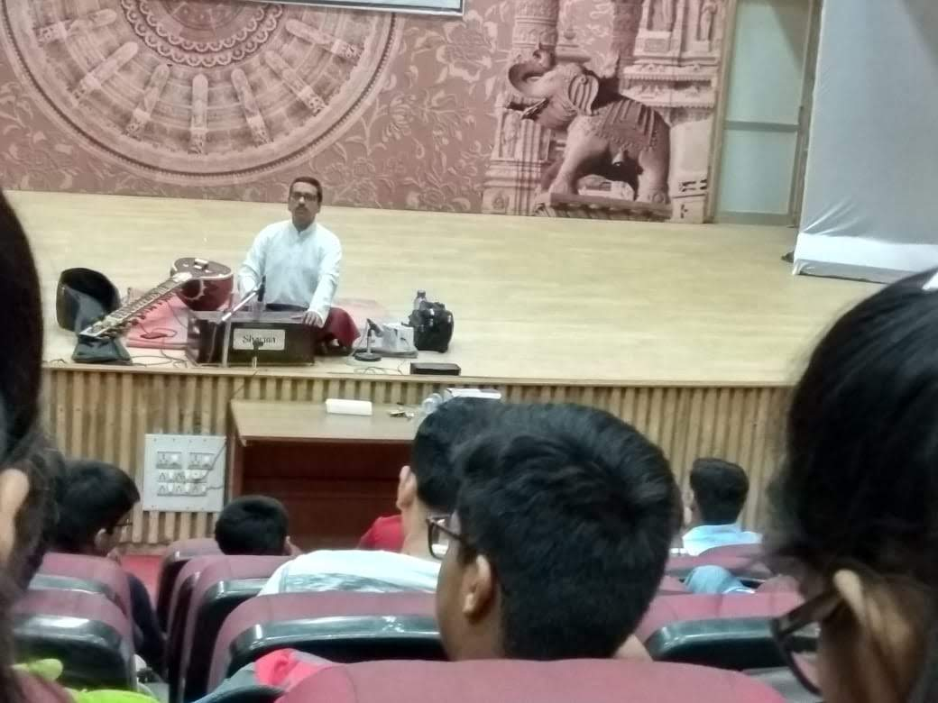

**Day 11 :-**

**9:30 a.m. - 12:30 p.m. : Visit**

**1:30 p.m. - 3:30 p.m. : Literary Activity(ASH)**

In this session, we learnt about Attitude helps us in life by Gyanvatsal Swami through a video. He told us an important fact that – only 10% of what we experience is real, 90% of it is due to our Attitude – which, frankly, is an amazing way to look at it. This session by Gyanvatsal Swami really inspired us to change our attitude towards life.

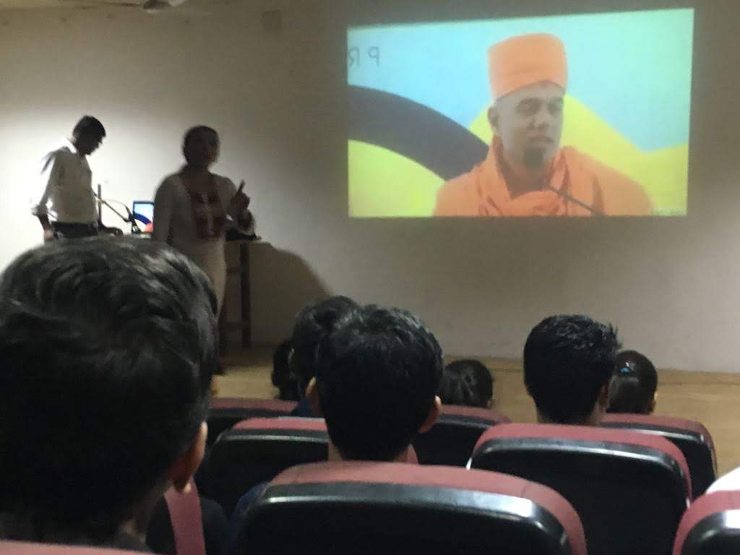

**Day 12 :-**

**10:30 a.m. – 12:30 p.m. : Human Values (Dept.)**

This session was held in the A.V. Room of the College, we were shown a PDF. In this PDF, how ideal Human Beings should be and how a Human should behave and also, how it differs from the animals was shown. It also showed that Inhuman Behaviour was more likely in the Urban area rather than the Rural area.

The priorities in the human life were also question since most people run after Physical/Material Things rather than Relationships and Right Understanding of Self. Giving priority first to Self-Understanding, than to Relations and after that to Physical Facilities gives happiness and prosperity.

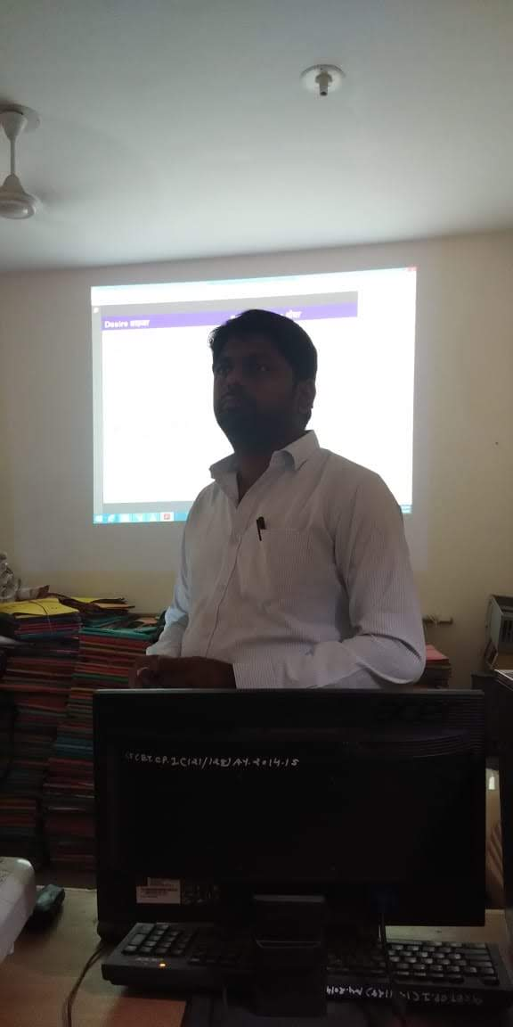

**1:30 p.m. – 3:30 p.m. : Human Values(ASH)**

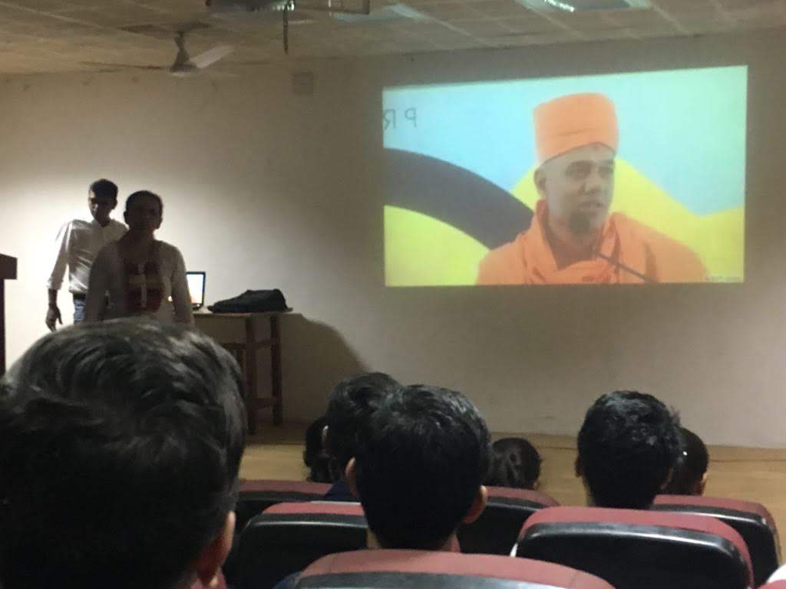

In this session , we were shown a motivational video by Gyanvatsal Swami on the topic ‘Celebrating Existence’. We should celebrate that we have a body that works like a huge machine which even supercomputers cannot work upon.He also quoted that “ Sleep with a dream awake with a dream”. We should not be greedy and create something with what we have.

**3:30 p.m. - 5:30 p.m. : Invited Speaker**

In this session, Colonel Rathod sir delivered a speech on Discipline and Leadership. He taught us about the Importance of Discipline in Life and he also told us about the things that are necessary for Leadership, like we should be knowledgeable and we should be able to get things done and also one who is not that egoistic person. The person should have qualities like Honesty, Aggression, Self-Confidence, Sociable and Adaptability.

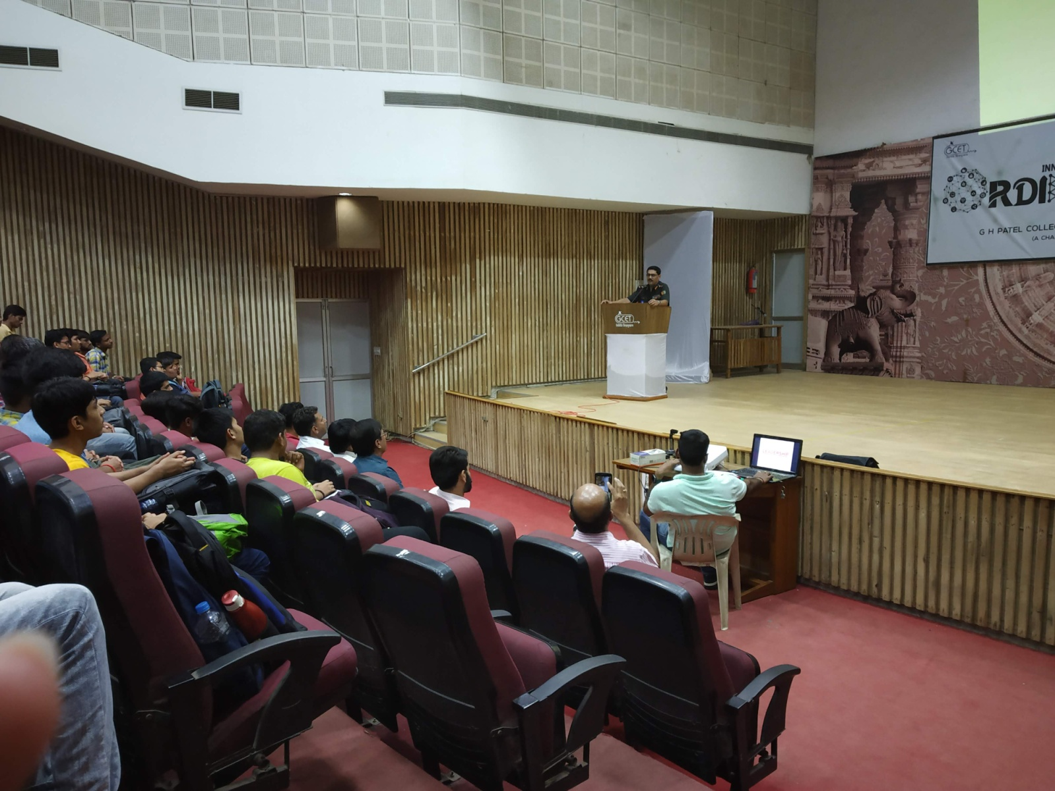

**Day 13 :-**

**11:00 a.m. - 5:00 p.m. : Cyber Talks(Seminar)**

In this Seminar, by Rakshit Tandon sir, he described about Cyber Security and the things that lead to Cyber Crime. He mentioned the technical names of different way to hack like phishing, Trojan, ClickJacking, Waterhole attacks etc.

He also mentioned about the crimes against women due social media and introduction of things like sexting and sharing obscene pictures which leads to blackmailing and harm over just a small thing like break-up.

He also told us about an incident with the Saudi Prince where while dealing with the ONGC company online, someone else created a website with all the similarities while just changing N with G in ONGC website name. As a result of this scam, the Prince lost his 197 Cr. Rupees. Hence, we should also carefully verify the domain name too and secure it, not just the site logo.

He also got us acquainted with a few tips and tricks about how to start learning about Ethical Hacking and using it for good cause rather than doing for money which can relate to crime.

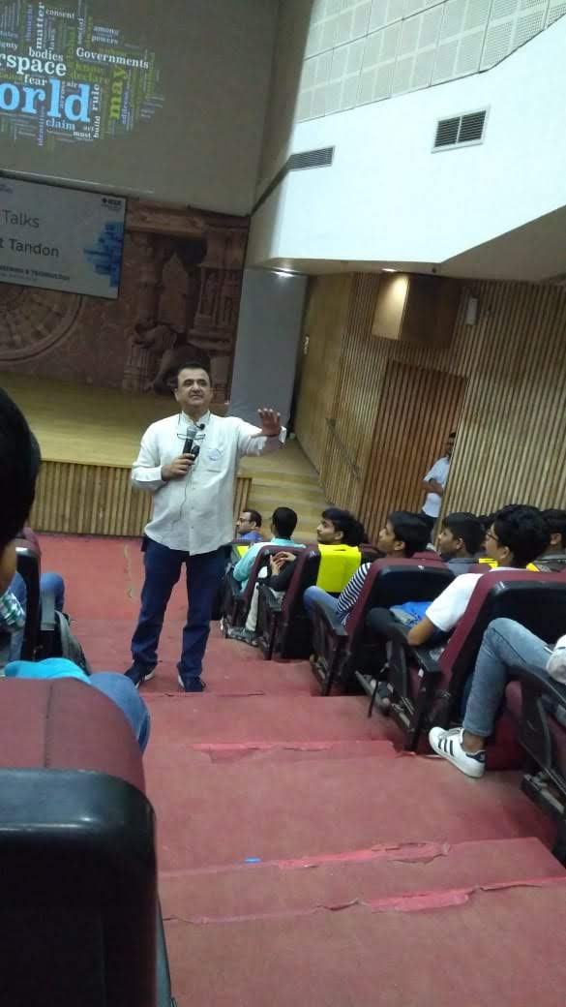

**Day 14 :-**

**9:30 a.m. - 12:30 p.m. : Eminent Speaker(Auditorium)**

In this session, Major Nitin Joshi told us about his inspiring story of how he became to be known as the “Iron Man”, “Ice Man” and “The Gujarati Milkha Singh”. He ran a Marathon and cycled and came in top 10 in a competition with a broken hand. He also ran many other Marathons too and sometimes, that too with an Indian Flag in his hand. He has also broken many records too.As a result, he came to be known as The “Iron Man” and “Gujarati Milkha Singh”

He also won a challenge in which you had to stay inside cold water with ice for as long as possible. Hence, he came to be known as The “Ice Man”. He inspired us that if you strive and work hard enough, you can indeed achieve many things in life.

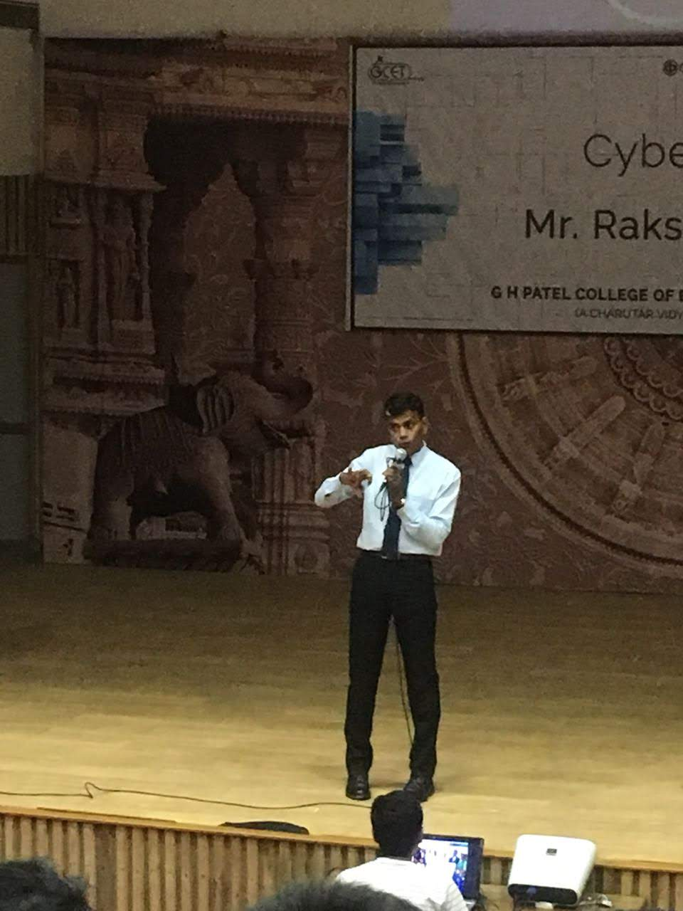

*Education is the most powerful weapon we can use to change the world.*

-Nelson Mandela

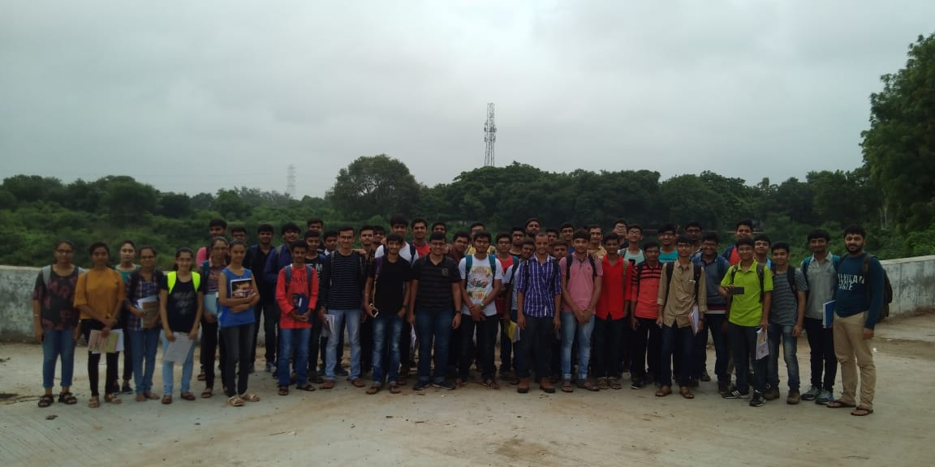

***Thank you!***