INVENTORY MANAGEMENT SYSTEM

A PROJECT REPORT

Submitted by

DOSHI KEYUR

In fulfillment for the award of the degree

Of

BACHELOR OF ENGINEERING

In

Computer Engineering

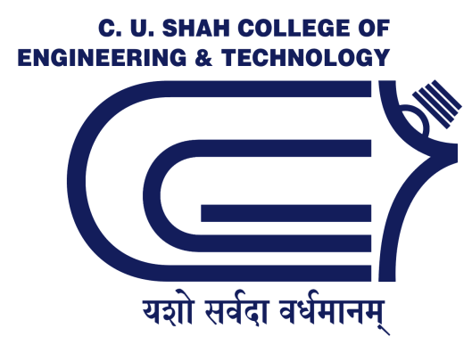

C.U.Shah College of Engineering and Technology, Wadhwan City

Gujarat Technological University, Ahmedabad

May, 2012

C. U. Shah College of Engineering and Technology

Computer Engineering

2012

CERTIFICATE
Date:

This is to certify that the dissertation entitled “INVENTORY MANAGEMENT SYSTEM” has been carried out by DOSHI KEYUR under my guidance in fulfillment of the degree of Bachelor of Engineering in Computer Engineering (8th Semester) of Gujarat Technological University, Ahmedabad during the academic year 2011-12.

Guides:

Internal Guide

(Mr. Avalik Ranpura)

External Guide Head of the Department:

(Mr. Amit Kundalia) (Dr. K.H. Wandra)

