Chapter  8 | SCREENSHOTS
Objectives  - This chapter provides an overview regarding the project implementation. | This Chapter Covers the Following Topics:  - Screenshots of Module

  - Input/output and Interface Design:
- Home Page
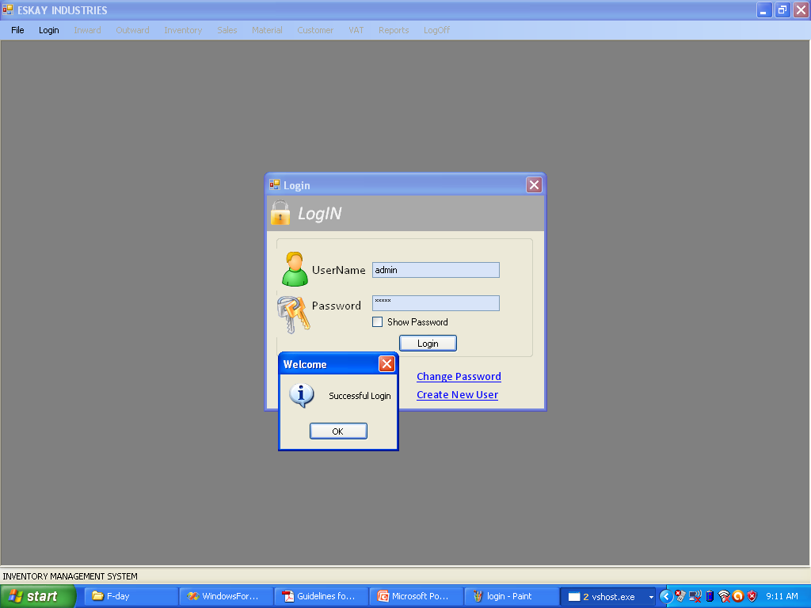
This is the home page of the Application. User will enter the UserName and Password to LogIn into the system. Based on the UserName the Home page is opened i.e for ADMIN Admin_home will be opened and for other Executives Executive_Home will be opened.

- Inward Material Entry Form 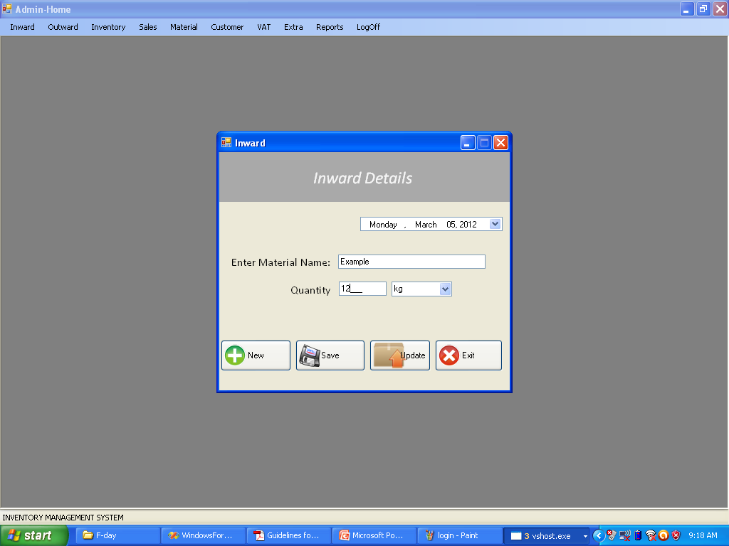
This form will take the Inward Entry. The amount of Raw Material entered into the company is entered using this form.

- Outward Entry Form
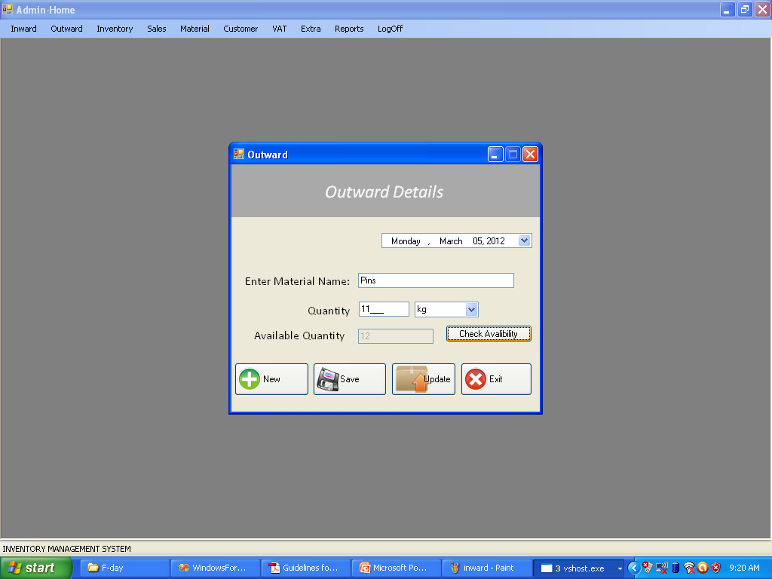
This form will take the entry of the material which are ready to be sold.

- Material Information
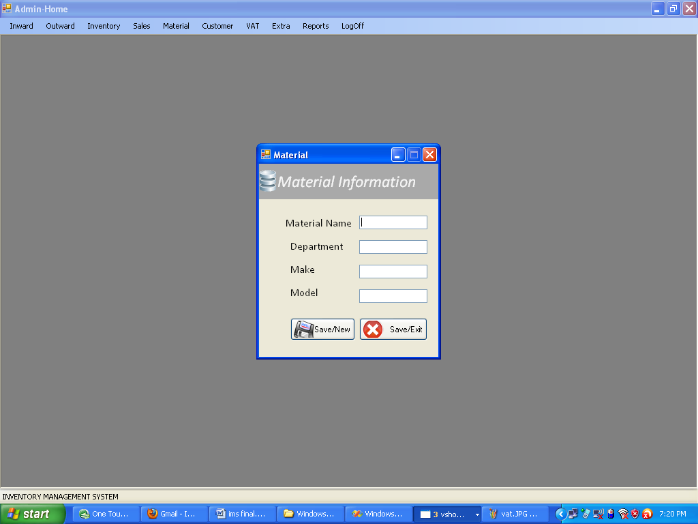
This form will store the Material name along with its details.

- Customer Information
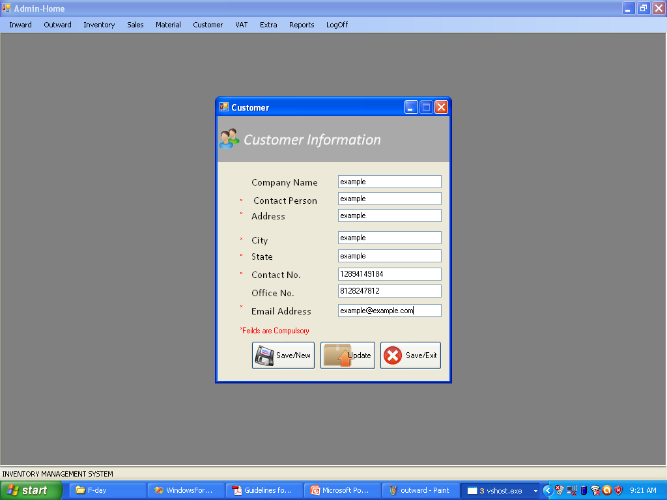

This form will store the Details of the Customer.

- Sales Order
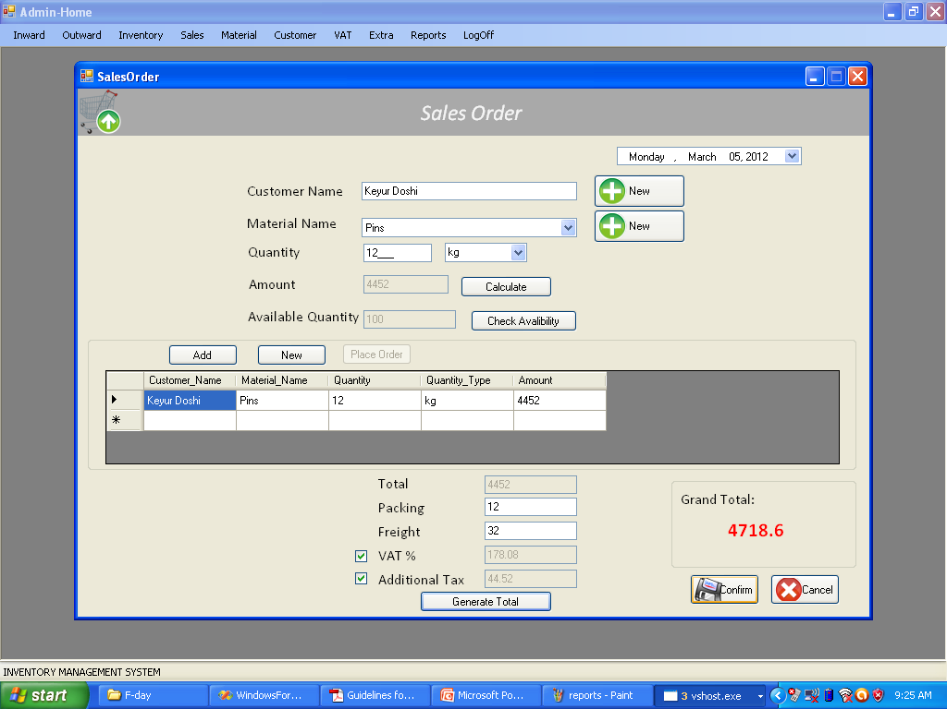
This form is used to Perform the Sales Order which include the Name of the Customer and the Items he/she is purchasing along with the Total Amount, Total Packing and Freight, Additional Tax, VAT and the final Grand Total.

- VAT
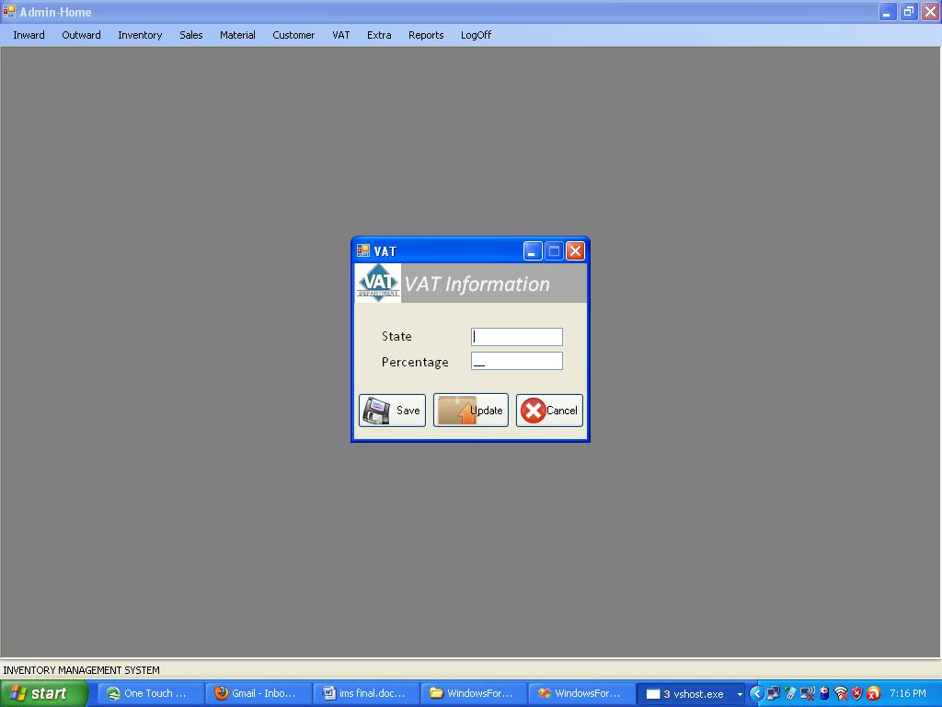
This form is used to store the VAT% of the Respective State.

