Chapter  2 | PROJECT MANAGEMENT
Objectives  - This chapter describes how the project was managed. | This Chapter Covers the Following Topics:  - Project Planning  - Project development Approach and Justification  - Project Plan  - Roles and Responsibilities  - Risk Management  - Risk Identification  - Risk Planning  - Estimation  - Effort Estimation  - Cost Analysis
2.1 Project Development Approach and Justification
Project Development Approach: I have used the Iterative Waterfall Model in my project as a development approach. An iterative lifecycle model does not attempt to start with a full specification of requirements. Instead, development begins by specifying and implementing just part of the software, which can then be reviewed in order to identify further requirements. This process is then repeated, producing a new version of the software for each cycle of the model. Consider an iterative lifecycle model which consists of repeating the following four phases in sequence:
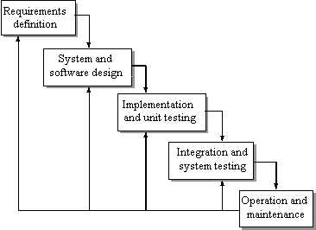
Figure 1.1 Iterative Waterfall Model
Justification: As can be seen from the above diagram, we follow the regular stages of requirement collection, analysis, design, coding, implementation, testing and maintenance in our project. If there is a need to add new requirement or change a present requirement, we can backtrack from our present situation and then follow the similar process of analysis, design and coding.
The different phases in this model are as shown in the figure:
A Requirements phase, in which the requirements for the software are gathered and analyzed. Iteration should eventually result in a requirements phase that produces a complete and final specification of requirements.
A Design phase, in which a software solution to meet the requirements is designed. This may be a new design, or an extension of an earlier.
An Implementation and Test phase, when the software is coded, integrated and tested.
A Operation and Maintenance phase, in which the software is evaluated, the current requirements are reviewed, and changes and additions to requirements proposed.For each cycle of the model, a decision has to be made as to whether the software produced by the cycle will be discarded, or kept as a starting point for the next cycle (sometimes referred to as incremental prototyping). Eventually a point will be reached where the requirements are complete and the software can be delivered, or it becomes impossible to enhance the software as required, and a fresh start has to be made.
The iterative lifecycle model can be likened to producing software by successive approximation. Drawing an analogy with mathematical methods that use successive approximation to arrive at a final solution, the benefit of such methods depends on how rapidly they converge on a solution.
The key to successful use of an iterative software development lifecycle is rigorous validation of requirements, and verification (including testing) of each version of the software against those requirements within each cycle of the model. The first three phases of the example iterative model is in fact an abbreviated form of a sequential V or waterfall lifecycle model. Each cycle of the model produces software that requires testing at the unit level, for software integration, for system integration and for acceptance. As the software evolves through successive cycles, tests have to be repeated and extended to verify each version of the software.

    - Milestones and Deliverables:-

Milestones | Deliverables
Studying various modules of IMS & its problems. Project Planning. Have started collecting the Requirements. | SPMP
Still continue with requirements of organization with regards to user of the system to be included. The chalan master and receipt master are majority of the usage. | SPMP
Gathering the requirements of the project using different fact finding techniques. Requirements of organization demands such as unique party must be assigned to each group but each more than one party can have same group. | Progress Report
Understanding the project in depth and doing the requirement analysis by studying process of creating all masters. | Progress Report  SRS
Requirement Classification & Feasibility Study. Time, Cost, Risk & Work Analysis. Model specification. | Progress Report  SRS
Creating Custom UML design based on analysis. The consideration ranges from hardware installation to outward. | Progress Report
Started System Flow Diagram. | Progress Report
The functional Design of the application that includes 4 master modules and 4 reports. | Detailed Design Document
Completed the Inward side interface design and linked with database such that add, update, delete to the data can be done. | Detailed Design Document
Completed the Outward side interface design and linked with database such that add, update, delete to the data can be done. | Detailed Design Document
Started System Implementation with Module Specification. The first module is Hardware Installation Report creation and then Inward and Outward are implemented where details are inserted and saved and again that can be further modifiable. As well as report generation is going to be considered. | Prototype  &  Progress Report
Started Module coding. Short-term Coding objectives like Form design (Input, Output, Interface, and Implementation) & also Error and Exception Handling.  . | Prototype  &  Progress Report
Have started Module Integration. | Progress Report
Implementation almost finish, so to start unit testing for the same. | Progress Report
Involved in Module Testing by input characters, validations, flow of contents as well as done testing of the system | Software User Manual
Have Completed System Testing. | Progress Report

2.1.2 Roles and Responsibilities: -
RESPONSIBILITIES | MEMBER
Analysis | Doshi Keyur
Design | Doshi Keyur
Coding | Doshi Keyur
Testing | Doshi Keyur
Documentation | Doshi Keyur

2.1.3 Schedule Representation:

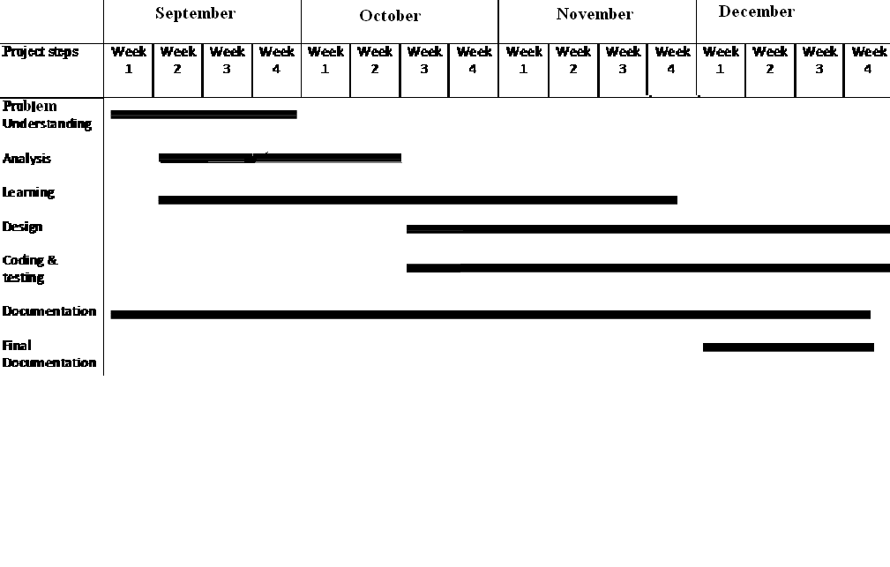
  - RISK MANAGENMENT
Risk management is the human activity which integrates recognition of risk (Identification), risk assessment (Analysis), developing strategies to manage it (Planning) and mitigation of risk using managerial resources. Some categories of risk include product size, business impact, and customer-related process, Technology, Development Environment, Staffing, Schedule and cost.
2.2.1 RISK IDENTIFICATION
All possible risks of IMS are:
Table 4.1 Risk Identification
Risk Type | Description | Possible Risks
Technology | Risk, which derived from software or hardware technology, which are being used as part of system being developed | - The database used in the system cannot process as many transactions as per second expected.  - Software components which should be reused contain defects which limit their functionality.
People | Risks, which are associated with the people in development team. | - If I am ill and unavailable at critical times
Requirements | Risk which derived from changes to the customer requirements and process of managing requirement changes. | - Changes to the requirements which require major design rework are proposed.  - Customer fails to understand the impact of requirements changes.

2.2.2 RISK ANALYSIS
In this process each identified risk is considered in turn and a judgment made about the probability and the seriousness of the risk.
- The probability of the risk might be assessed as very low (less than 10%), low (10-25%), moderate (25-50%), high (50-75%) or very high (greater than 75%).
- The effects of the risk might be assessed as catastrophic, serious, tolerable or insignificant.

Table 4.2 Risk Analysis
Risk | Risk Type | Probability | Effect
Software components which should be reused contain defects which limit their functionality. | Technology | Very Low | Tolerable
The database used in the system cannot process as many transactions per second as expected. | Technology | Very Low | Serious
Organization financial problem force reduction in the project budget. | Organization | Very Low | Catastrophic
It is impossible to recruit staff with the skill required for the project. | Organization | Low | Tolerable
Key staff are ill at critical times in project | People | Moderate | Tolerable
Customer fails to understand the impact of requirement change. | Requirements | High | Tolerable
Changes to requirements which require major design rework are proposed. | Requirements  (Project Risk) | Moderate | Serious
The time required to develop the software is underestimated. | Estimation | Low | Serious
The rate of defect repair is underestimated. | Estimation | Low | Tolerable
The size of software is underestimated. | Estimation | Low | Tolerable

2.2.3 RISK PLANNING
The risk planning process considers each of the key risks, which have been identified, and identifies strategies to manage the risks. It relies on the judgment. There are different strategies for these. These strategies fall into three categories.
These strategies fall into three categories.
- Avoidance strategies: The probability that the risk will arise, will be reduced.
- Minimization strategies: Impact of the risk will be reduced.
- Contingency plans: If the worst happens, you are prepared for it and have a strategy in place to deal with it.

Table 4.3 Risk Planning
Risk | Strategy
Organization restructuring | Prepare a briefing document for senior management showing how the project is making a very important contribution to the goals of the company.
Recruitment problems | Alert customer of potential difficulties and the possibility of delays.
Organization Financial Problem | Prepare a briefing document for senior management showing how the project is making very important contribution to the goal of site.
Defective component | Replace potentially defective components with bought-in components of known reliability.
Requirement change | Derive traceability information to access requirement change impact; maximize information hiding in the design.
Database Performance | Investigate the possibility of buying a higher-performance database.
Underestimated development time | The project is well planned so there is no chance of underestimating of development time. If in case this happens I will increase my work hours so as to overcome this problem.
2.3 ESTIMATION
Effort Estimation

Table - Distribution of Effort
 | COUNT | Average
No. Of External Inputs | 5 | 4 | 20
No. Of External Outputs | 2 | 7 | 14
No. Of External Inquiries | 2 | 4 | 8
No. Of Internal Logical Files | 4 | 10 | 40
No. Of External Interface Files | 0 | 7 | 0
Count = Total |  |  | 82.00

Justification:
- No of External Input
- Set of parameters that generate customer detail
- Set of parameters that generate material detail
- Set of parameters that generate inward material entry
- Set of parameters that generate outward material entry
- Set of parameters that generate in-house material entry
- No of External Output
- Inventory Creation
- Dellivery Challan Report
- No of External Inquiries
- Both reports generated by this system can be asked for decision making purpose as well as to judge overall performance of the enterprise.
- No of Internal Logical Files
- Customer File-Stores information regarding all Customer of the enterprise
- Inward File-Stores information regarding all available Customer, material on which transaction can be performed, of the enterprise
- Inventory File-Stores information regarding all available items of the enterprise
- Dellivery Challan File-Stores information regarding all different Dellivery Challan of the enterprise
- No of External Interface Files
- As now this system is not integrated with any external system so right now no input from this system is going to be store to the data base of other system.

Complexity adjustment values:
Reliable Backup & recovery | 3
Data communication required | 5
Distributed processing functions | 0
Performance criticality | 3
Existing operational environment | 0
On-line data entry | 0
Input transaction over multiple screens | 1
Updating of master files | 4
Complexity of inputs ,outputs, files or inquiries | 3
Complexity of internal processing | 4
Reusability | 3
Conversion/installation in design | 3
Multiple installations | 3
Application designed for change | 2
∑(F_{i}) = | 34
Fi is the sum of the weights assigned to the functions as per its importance in the software.
Now, Technical Complexity Factor (TCF) is calculated as below:
TCF =0.65+0.01*DI
=0.65+0.01*34
=0.99
Finally, the estimated number of FP is derived:
FP_{estimated} = Count Total * TCF
= 82* 0.99
FP_{estimated} = 81.18
Cost Analysis
LOC = FP * Programming Language (Object Oriented =30)
= 81.18* 30
= 2435.4

Cost Analysis
Project Type | a_{b} | b_{b} | c_{b} | d_{b}
Organic | 1.8 | 1.01 | 1.7 | 0.25
Effort (E) = a_{b} (KLOC) b_{b}
= 1.8 * 2.2354 * 1.01
= 4.06
Duration (D) = c_{b} (E) d_{b}
= 1.7 * 4.06* 0.25
= 1.72
Avg. staffing = Effort/ Duration
= 4.06/1.72
= 2.36 persons
Avg. productivity = LOC / Duration
= 2235.4/ 1.72
= 1299 LOC/PM

