Chapter  4 | SYSTEM ANALYSIS
Objectives  - This chapter provides analysis of the system. It discusses all user system requirements and feature of the system.. | This Chapter Covers the Following Topics:  - Study of Current/Existing System  - Problem and Weakness of Current System  - Requirements of the New System  - Feasibility Study  - Requirements Validation  - Functions of System  - Data Modelling  - Functional and Behavioural Modelling  - Main Module of New System  - Selection of Hardware and Software Justification

4.1 STUDY OF CURRENT SYSTEM
The company for which I will make software had not any software which track the material of company and manage inward and outward entry of the material of their company. They kept records of developed project in Microsoft Word or Excel files and for reports of the inward and outward of the material. For example In-house co-coordinator kept all his inward and outward entry in Microsoft Excel, document sheets. The records required for travel allowances and leave taken by employees were also made in Microsoft Excel Sheets.
Each person kept their work details and project related documents separately so other person who want that records then he had to talk with person who made it. The Support coordinator could not easily get the status of the materials.
4.2 PROBLEMS AND WEAKNESS OF CURRENT SYSTEM
Main Problem of the system is:
The main problem is the management of various files and documents. Insecurity of the documents for storage due to any man-made or natural calamities. The current system is quite tedious and time consuming. The current system may not include the high quality software for the transactions and calculations. In the current system files are separated and the data cannot be stored centrally so it takes much more spaces to store the files of tracking records. Daily reports are not automatically generated in current system.

Main Weaknesses of the system are as follows:
- As the whole process is done manually, it is more error prone and time consuming and the speed of work very slow.
- Any kind of insertion, deletion or updating is manually maintained.
- Maintaining such a large number of records is a very difficult job.
- To see documents of other person they had to contact them and it may be possible that at particular time that person not available then he had to wait for that person and it also affect to his work due to delay.

4.3 REQUIREMENTS OF NEW SYSTEM
- Requirements specification is the activity of translating the transformation gathered during the analysis activity into a documented that defines a set of requirements.
- Two types of requirements may be included in this document. User requirements are abstract statements of the system requirements for the users of the system. System requirements are more detailed description of the functionality to be provided.
- System requirements set our system, services and constraints in details.
- User requirements for integrated working support system are collected by questionnaires.
- Fact finding requirements are the specific methods system analyst collecting data about the requirements.
    - User Requirements
For integrated working support system the functional and non functional user requirements are as follows:
User requirements (functional):
Functional requirements:
- The proposed system should retrieve all the information necessary to gain information of the Item starting from Ordered Goods to Bill Payment.
- The information should retrieve at regular interval either monthly or half yearly.
- A facility that allows the administrator to view and sort executive according to the organization.
- As the user doesn’t have any technical knowledge, the user interface is as friendly as possible.
- The system should provide the facility to generate and print different reports as per user’s needs.
- A facility that allows executive to maintain the stock calculations with all the required calculations done accordingly.

User requirements (non-functional):
- Usability
Experience of the executive who will make most of the system. For example date should be displayed in its traditional fashion.
- Efficiency
The system provides easy and fast access without consuming more cost.
- Reliability
Executive should never be surprised by the behavior of the system and it should also provide meaningful feedback.
    - System Requirements(Developer Side)
Hardware & Software –
- Hardware: Pentium 4, 10GB Hard Disk, 1 GB RAM.
- Software: Microsoft Visual Studio 2008 and SQL Server 2005
System Requirements (Client Side)
- Hardware: Pentium 4, 10GB Hard Disk, 1 GB RAM.
- Software: Common Language Runtime

4.4 FEASIBILITY STUDY
Feasibility is the determination of whether or not a project is worth doing. The process followed in making this determination is called a feasibility study. In the conduct of the feasibility study, many types of feasibility study are used. Amongst those, we have confined ourselves in the following types:
- Time Feasibility
Since as a student, we have been given time duration of maximum 4 months so within this time limit, it is considerable to set a scope of the proposed project. Nevertheless we have tried to implement maximum operations held in an organization.
- Operational Feasibility
As it is mainly related to human organizational and political aspect, we have mainly focused on the organizational structures of the company. During fact finding/information gathering activity, we visit the organization for which we make this project. We have not only studied the inter relational working among these department and the services provided to each other but also tried to figure it out the improvements in these services. The overall objective at this activity was to understand the working feasibility of our proposed system.

- Technical feasibility
This is concerned with specifying equipment and software that will successfully satisfy the user requirement. It includes:
- The facility to produce outputs in a given time.
- Ability to process a certain volume of transaction at a particular speed.
- Facility to communicate data to distant location.
Based on the above facts and preliminary investigation, the proposed system is feasible and could be implemented within the time limit given to us. Moreover languages and tools that are being used to develop this project are familiar to us. So overall project’s feasibility is there.

    - Does the system contribute to the overall objectives of the organization?
This product is designed in such a way that if implemented, Support coordinator of the company can easily enter its Daily Reports. This system is windows based system and will be used by the support coordinator of the organization who is implementing Inventory Management System. Maintenance as external user and support coordinator as internal user will be possible without taking much mental strength.
    - Can the system be implemented using the current technology and within the given cost and schedule constraints?
Keeping above points in mind and current technology it is quite clear that there is no technological limitation in developing the proposed system. As most advanced language and tools such as C#.NET and SQL Server are going to be used, there will be no limitation on any features needed to integrate in system being developed. As there is no limitation on technology being used the cost and schedule of the system thus remain inconsistent and depends on the technology being used.
    - Can the system be integrated with other system which is already in place?
There is no existing software system.
4.5 REQUIREMENTS VALIDATION
Requirement Validation examines the specification to ensure that all system requirements have been stated unambiguously; all the inconsistencies, errors have been detected and corrected and the work products conform to the standard. Primary requirements validation mechanism is Formal Technical Review.
    - Requirement Validation Checks
- Validity checks – Our System has diverse users with different needs and any set of requirements inevitably a compromise across the user requirements.
- Consistency checks – Requirements in a document is not conflicting.
- Completeness checks – The requirements document includes requirement, which define all functions, and constraints intended by the system user.
- Realism checks – Using knowledge of existing technology, the requirements are checked to ensure that they could actually be implemented.
- Verifiability – The requirements are given in verifiable manner (e.g.: Using quantifiable measures) to reduce the potential for dispute between customer and us.

    - Requirement Validation Techniques
- Requirement Review –analyzed the requirements systematically.
- Prototyping – In this approach to validation, an executable model of the system is demonstrated to our clients. So by doing this they can check whether the considered requirements satisfy their needs.
- Test-case generation – Requirements should ideally be testable. If a test is difficult or impossible to design, this usually means that the requirements will be difficult to implement and should be reconsider.

  - FEATURES OF THE NEW SYSTEM
- Store details of the Material carried out by company and also details of the clients regarding those Materials.
- Track the Material.
- Store details of the Inward Material.
- Store details for Non-returnable and In-house entry of the materials.
- By using details of Non-returnable and In-house entry it calculates net material available at the end of a particular month.
- Generate reports for entries detail, scheduling, project estimation and actual work.

4.7 USE CASE DIAGRAMS & FUNCTIONS
The use case graphically describes the interaction of the user with different functionalities of the system. A single functionality can have one type of user or more than one type of user.
Notation used and their description
Notation | Description | Symbol
Actor | An actor is one who interacts with the system. The particular actor who interacts with the particular functionality of the system.
Function | Functions are the various facilities provided to the user by the system. They are sometimes common between and also sometime vary from user to user as per requirement of the client.
Interaction | Shows the interaction between the particular user and the particular function.

Table 5.10 Notations of Use Case

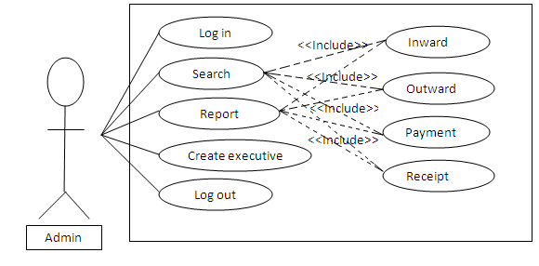

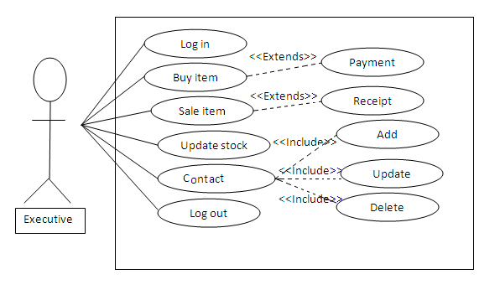

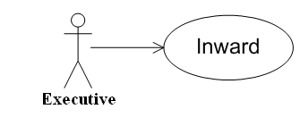
Use Case | Inward
Actor | Executive
Description | Through this module Support coordinator can enter the detail of the material that is been coming in the company premises, and can maintain the stock of the materials.
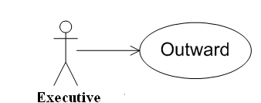
Use Case | Outward
Actor | Executive
Description | In this module the support coordinator make the entry of the material that is shipped from the company and generate the delivery Challan for the same.
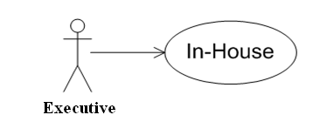

Use Case | In-house
Actor | Executive
Description | With this module the support coordinator can maintain the stock of the material that is used for the company.

Class Diagram
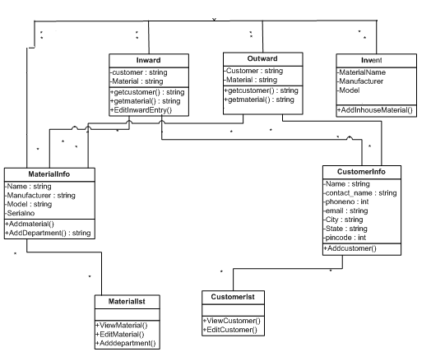

System Activity
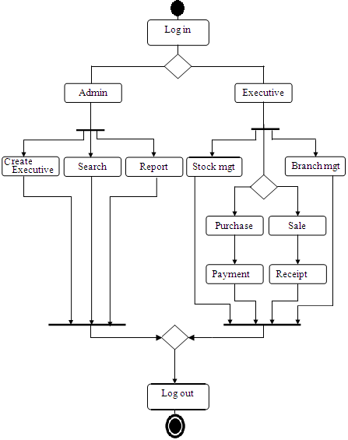

  - Functional and Behavioural Diagram

Context Diagram
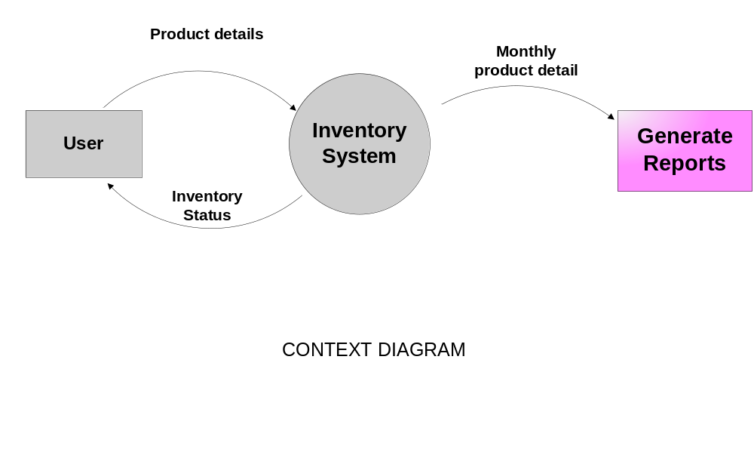

Data Flow Diagram
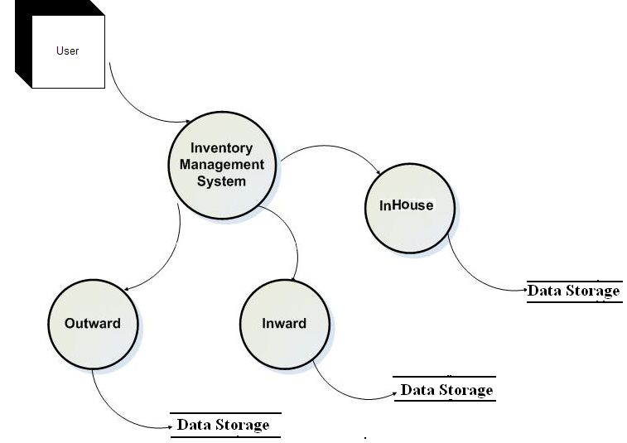
First Level Diagram

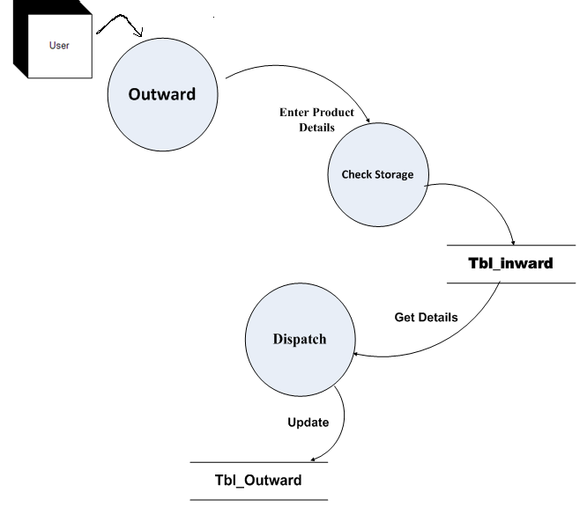

Second Level DFD for Outward

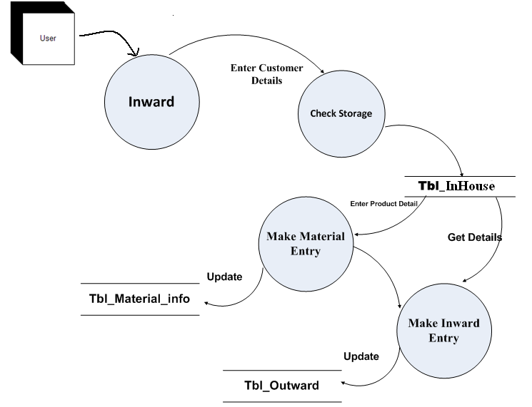

Second Level DFD for Inward

Sequence Diagram
  - The sequence diagram gives pictorial view all the events that are generated whenever a user interacts with the system.

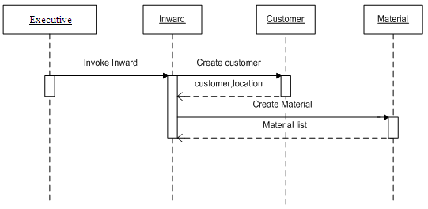
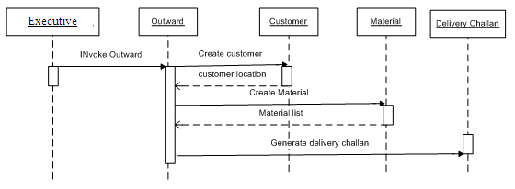
    - PROCESS SPECIFICATION
Login Process:-
If admin enters username and password
Then enter into the system
Else
Invalid admin
End If
If executive enters username and password
Then enter into the system
Else
Invalid executive
End If
Process for purchase:-
While executive views purchase order
If company receives full quantity
Then purchase it & update stock
Else if company receives less quantity
Then update purchase pending and update stock
Else
Not purchase
End while
Process for selling:-
While executive outwards the item
If item is there in stock
Then sell it & update stock
Else if item is not in stock
Then does not allow to sale it
End if
End while
Process for payment:-
While company purchase item
If company pays full amount
Then complete payment
else
update payment pending
end if
End While
Process for receipt:-
While company sell item
If company receives full amount
Then receipt complete
Else
Update receipt pending
End if
End While
4.9 Main Modules of New System:
- Inward
In this module the total amount of raw material entering in company’s premises is stored. The entry in the database is entered by the executive. He can add, delete and update the item. This module indicates the total quantity of raw material entered in the company. The receipt of the same is provided to the vendor.

- Outward
In this module the total amount of finished raw material being sold is calculated. He can add, delete and update the item. This module indicates the total quantity of finished product sold. The executive can add and delete the item. The bill is generated at the end of this process and the bill is given to the Customer.
- Invent
In this module the total amount of finished material available in the company and are ready to be sold are calculated. The amount of raw material entered into the company is converted into the finished product. This module represent the total number of item present in the company.
- Invoice Generation
In this module the bill receipt or Delivery Challan is to be generated based on the amount of finished goods is sold. The bill is generated at the end and is given to the customer.

4.10 SELECTION OF HARDWARE & SOFTWARE JUSTIFICATION
Hardware Justification:
Monitor: - In the Corporate Requirement System’s GUI is a very high, so we need a high resolution monitor. We need a screen resolution of 1024 by 768 pixels and we need a color quality is the highest (32 bit).
Memory: - This site need a at list 128 DDR memory size.
Processor: - In the site need a processor speed is P IV 2Ghz processor.
Hard disk: - In the hard disk we need a free space of at list 5 GB. Because of this site requires a more memory size.
Software Justification:
.NET 2008: Working with .NET 2008 is very easy and also as such .NET 2008 provide users with large number of inbuilt components, hence it is very easy to built up a system using .NET 2008. Moreover because of built – in components it take less time in comparison to other technology to create a complete application.

SQL Server 2005:
Features of SQL Server 2005
- Internet Integration
- Scalability and Availability
- Enterprise – Level database features
- Ease of Installation, deployment, and use
- Data warehousing
Because of the above feature SQL Server 2005 is best to use.

