Chapter  5 | SYSTEM DESIGN
Objectives  - This chapter provides an overview regarding the project and the technology used. | This Chapter Covers the Following Topics:  - Database Design  - System Procedural Design  - Input/output and Interface Design  - System Architecture Design
5.1 Data Structure Design
5.1.1 Tables and Relationship
1. NAME |  | CustomerInfo
DESCRIPTION |  | The table stores the whole information about customer. it contains the contact no, address and other related information of customer
ATTRIBUTES
NAME | TYPE |  | SIZE | CONSTRAINTS | Description
CustomerID | int |  | 8 | P.K
Company Name | Varchar2 |  | 30 |  | Name identification of the company
Contact Name | Varchar2 |  | 25 | Not null | Name of Person available in the company
Address | Varchar2 |  | 30 | Not null | Current location for branch identification
Street | Varchar2 |  | 30 | - | Current location for branch identification
City | Varchar2 |  | 25 | Not null | Current location for branch identification
State | Varchar2 |  | 15 | - | Current location for branch identification
Contact No. | Numeric(18,0) |  | 10 |  | Current phone no of the contact person
Office No. | Numeric(18,0) |  | 20
Email | Varchar2 |  | 40 |  | Email address of the Company to inform them

2. NAME |  | MaterialInfo
DESCRIPTION |  | The table stores the whole information about material. it contains the manufacturer, model and other related information of material
ATTRIBUTES
NAME | TYPE |  | SIZE | CONSTRAINTS | DESCRIPTION
MaterialID | int |  | 8 | P.K | Unique Id
Name | Varchar2 |  | 25 |  | Name of the Material
Department | Varchar2 |  | 30 | Not null | Department in which the material Placed
Description | Varchar2 |  | 30 | - | Information of the Material
Make | Varchar2 |  | 30 | - | Manufacturer of the material
Model | Varchar2 |  | 25 | - | Model no. for identification of the material

3. NAME |  | Inward
DESCRIPTION |  | The table stores the whole information about the material that comes inside the company’s premises.
ATTRIBUTES
NAME | TYPE |  | SIZE | CONSTRAINTS | DESCRIPTION
InwardID | int |  | 8 | P.K | Unique Id
SerialNo | Integer |  |  | Not Null | Serial No. of Item
Date | Datetime |  |  | Not Null | Date of the material arrived
VendorID | Varchar2 |  | 30 | Not Null | Name of a Company
MaterialID | Varchar2 |  | 25 | Not Null | Name of Department
Quantity | Numeric(18,0) |  |  | Not Null | Quantity of Item
QuantityType | Numeric(18,0) |  |  | Not Null | Type of Item

4. NAME |  | Outward
DESCRIPTION |  | The table stores the whole information about the material that is shipped from the company.
ATTRIBUTES
NAME | TYPE |  | SIZE | CONSTRAINTS | DESCRIPTION
OutwardID | int |  | 8 | P.K | Unique Id
Date | Datetime |  |  | Not Null | Date ofdispatches
MaterialID | Varchar2 |  | 15 | Not Null | Name of the Material
Quantity | Numeric(18,0) |  |  | Not Null | Quantity of Item
QuantityType | Numeric(18,0) |  |  | Not Null | Type of Item

5. NAME |  | Invent
DESCRIPTION |  | The table stores the whole information about the material which is used for the company’s purpose only.
ATTRIBUTES
NAME | TYPE |  | SIZE | CONSTRAINTS | DESCRIPTION
Invent ID | int |  | 8 | PK | Invent ID
Material ID | Varchar2 |  | 8 | Not Null | Material ID
Date | Datetime |  |  |  | Date at which stock is present
Quantity | Numeric(18,0) |  | 10 | Not Null | Quantity available in Stock

6. NAME |  | Vendor
DESCRIPTION |  | The table stores the whole information about the vendor from which materials are bought for the company’s purpose only.
ATTRIBUTES
NAME | TYPE |  | SIZE | CONSTRAINTS | DESCRIPTION
Vendor ID | int |  | 8 | PK | Vendor Id
Name | Varchar2 |  | 8 | Not Null | Name of Vendor
Address | Varchar2 |  | 30 | Not null | Current location for branch identification
Street | Varchar2 |  | 30 | - | Current location for branch identification
City | Varchar2 |  | 25 | Not null | Current location for branch identification
State | Varchar2 |  | 15 | - | Current location for branch identification
Contact No. | Numeric(18,0) |  | 10 |  | Current phone no of the contact person
Office No. | Numeric(18,0) |  | 20
Email | Varchar2 |  | 40 |  | Email address of the Company to inform them

7. NAME |  | LogIn
DESCRIPTION |  | The table stores the whole information about the UserName and Password
ATTRIBUTES
NAME | TYPE |  | SIZE | CONSTRAINTS | DESCRIPTION
Username | Int |  | 8 | PK | Name of User
Password | Varchar2 |  | 8 | Not Null | Password Of User
LogInTime | Datetime |  |  |  | Login Time
LogoutTime | Datetime |  |  |  | Logoff Time

8. NAME |  | SalesOrder_Master
DESCRIPTION |  | The table stores the whole information about the Sales
ATTRIBUTES
NAME | TYPE |  | SIZE | CONSTRAINTS | DESCRIPTION
OrderId | Int |  | 8 | PK | Order Id
SerialNo | Int |  |  |  | Serial No.
CustomerName | Varchar2 |  | 8 | Not Null | Customer Name
Date | Datetime |  |  |  | Date

9. NAME |  | SalesOrder_Sub
DESCRIPTION |  | The table stores the whole information about the Sales
ATTRIBUTES
NAME | TYPE |  | SIZE | CONSTRAINTS | DESCRIPTION
OrderId | Int |  | 8 | PK | Order Id
MaterialID | varchar |  |  |  | Material ID
Quantity | Int |  | 8 | Not Null | Quantity
UnitID | varchar |  |  |  | Unit ID
Amount | Float |  |  | Not Null | Item Amount
Total | Float |  |  | Not Null | Total
Packing | Float |  |  |  | Packing Charge
Freight | Float |  |  |  | Freight Charge
VAT | Float |  |  |  | VAT
AddTax | Float |  |  |  | AddTax
GrandTotal | Float |  |  | Not Null | GrandTotal
10. NAME |  | MasterTable
DESCRIPTION |  | The table stores the whole information about the Calculation of VAT
ATTRIBUTES
NAME | TYPE |  | SIZE | CONSTRAINTS | DESCRIPTION
MasterId | Int |  | 8 | PK | MasterId
State | Varchar2 |  | 15 | Not Null | Name of State
VAT_Percentage | Integer |  |  | Not Null | VAT Value

5.1.2 Relationship

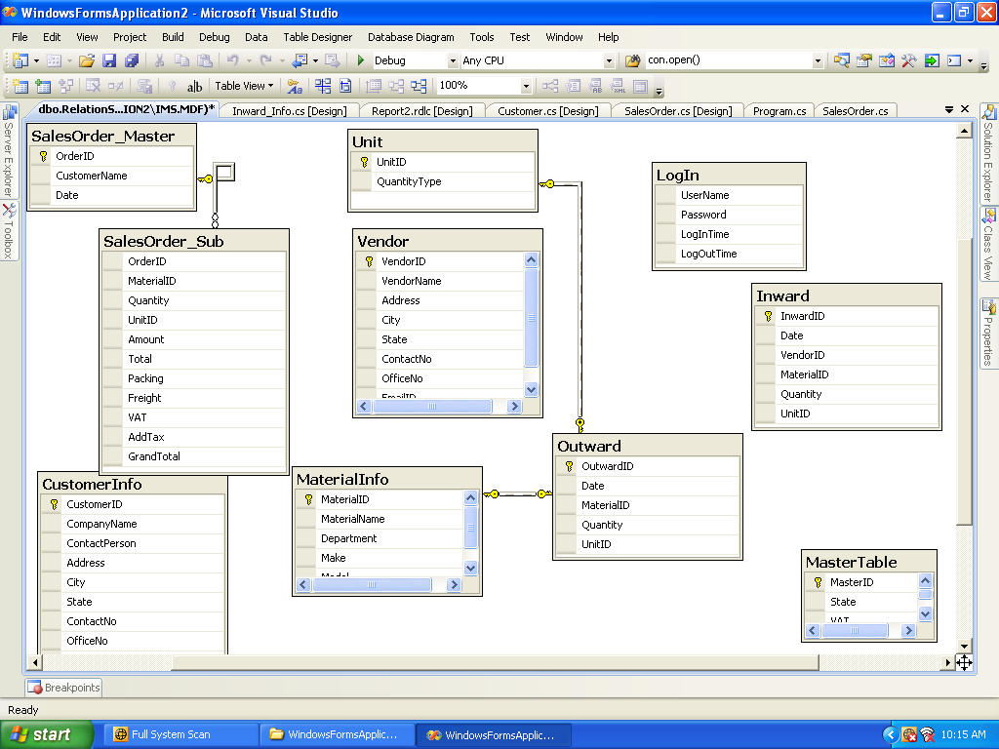

5.1.3 Logical Description of Data

The Inventory Management System is known as IMS. The system controls the entire inventory management including Sales, Purchase, Stock, Bank Transactions etc. The IMS consists of two main modules:1)Admin. 2) Executive. Inventory control is one of the key elements of overhead management, which is a major factor in the net profit of any business. 'Just in Time' ordering and inventory control helps a practice to create an effective step-by-step system, and the top-performing companies worldwide have adopted it, as it is one of the best methods.
Admin will create the executive. He can also perform all the tasks of executive if he wants to do so. Admin can perform various searches related to purchase,sale,payment,receipt etc. He can also create the report for the same and many additional reports and the annual and daily basis.
Executive on the other hand can create item. He actually maintains the overall stock handling and the transactions of the company. He can purchase the items as well as sell the same item according to the stock. The stock is updated according to the purchase and sell of the items. The calculations are performed accordingly. Bills are generated accordingly.
  - System Procedural Design
- Open the Application
- User will enter his/her Username and password
- According to Authentication of user he/she will be redirect to home page and according to authorize settings links and function of application will be visible to user.
- Select appropriate module
- Add/Update/Delete data according to authorization
- If user is Admin then
  - She / He can create executive, search, report and setting.
- If user is Executive then
  - He/She can Add/Update/Delete in masters and do transaction of items and payment. He/she can also view search and reports.
- Logout

  - Input/output and Interface Design:
- Home Page
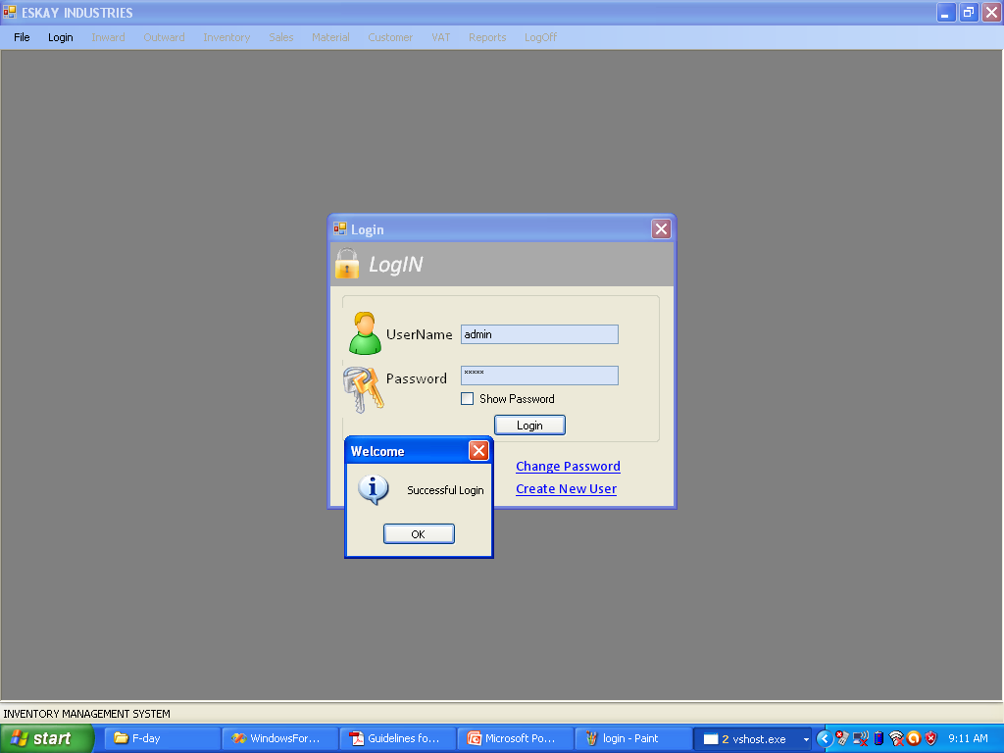
- Inward Material Entry Form 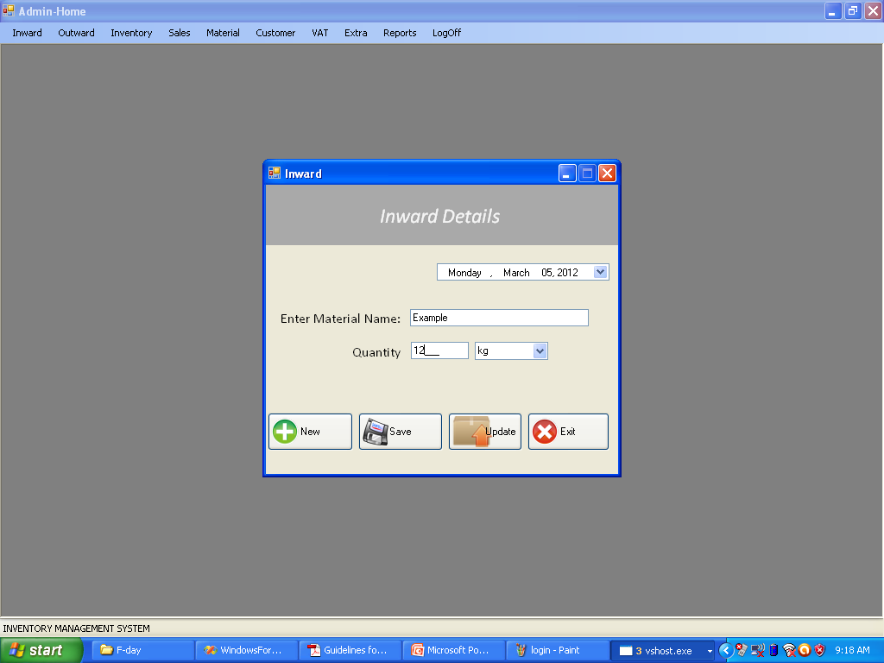
- Outward Entry Form
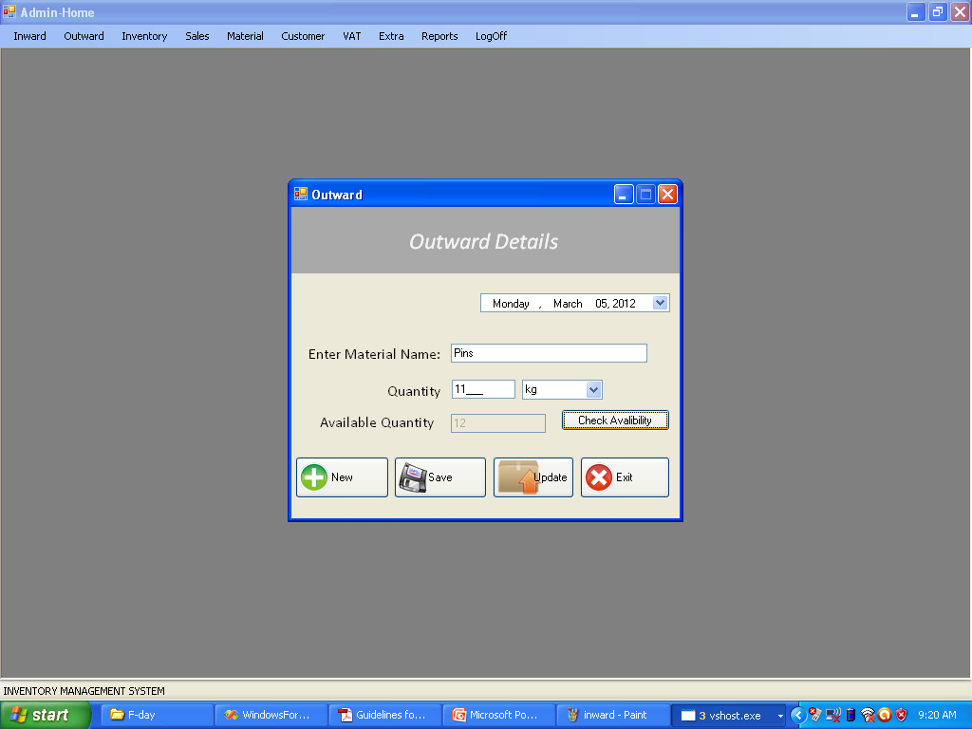

- Material Information
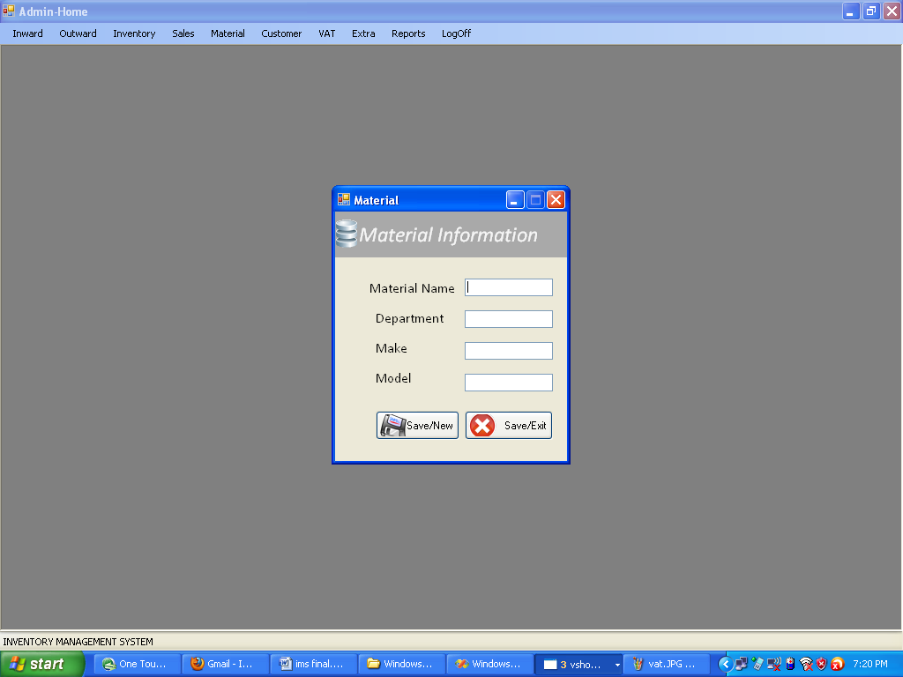

- Customer Information
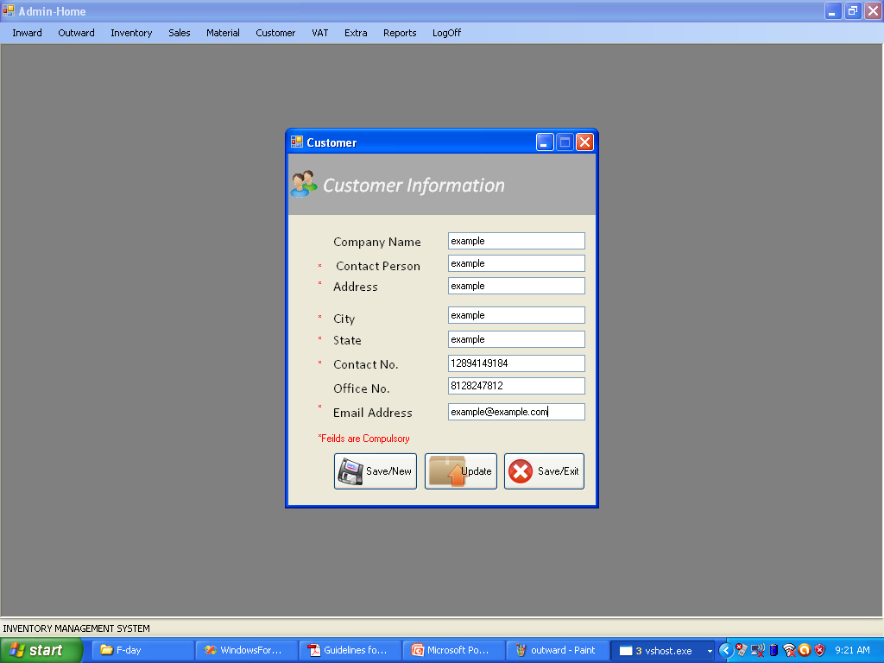

- Sales Order
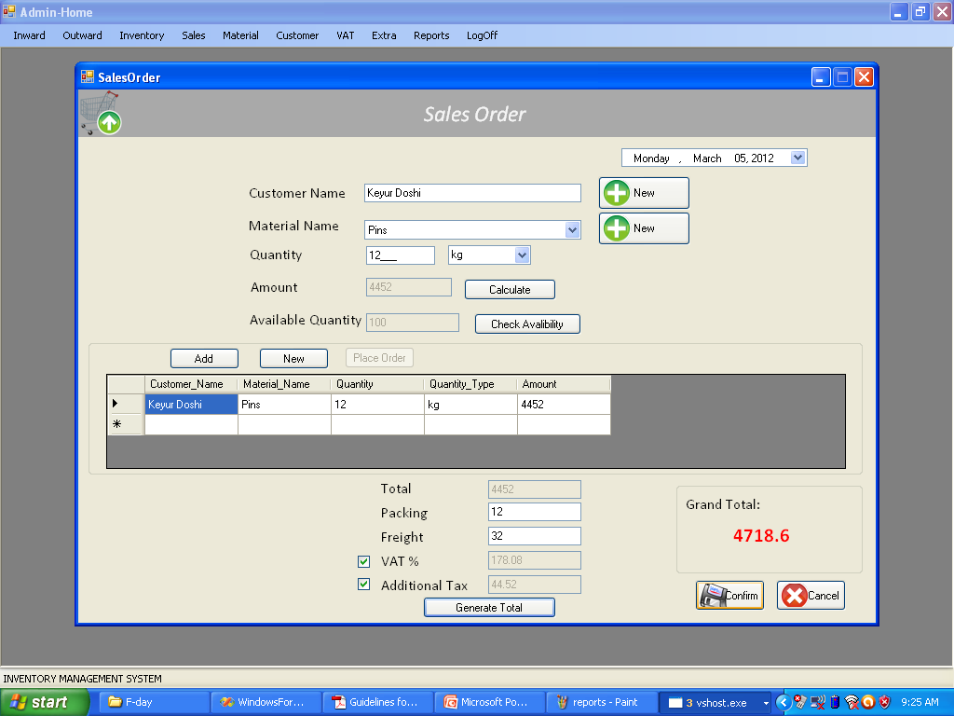

- VAT
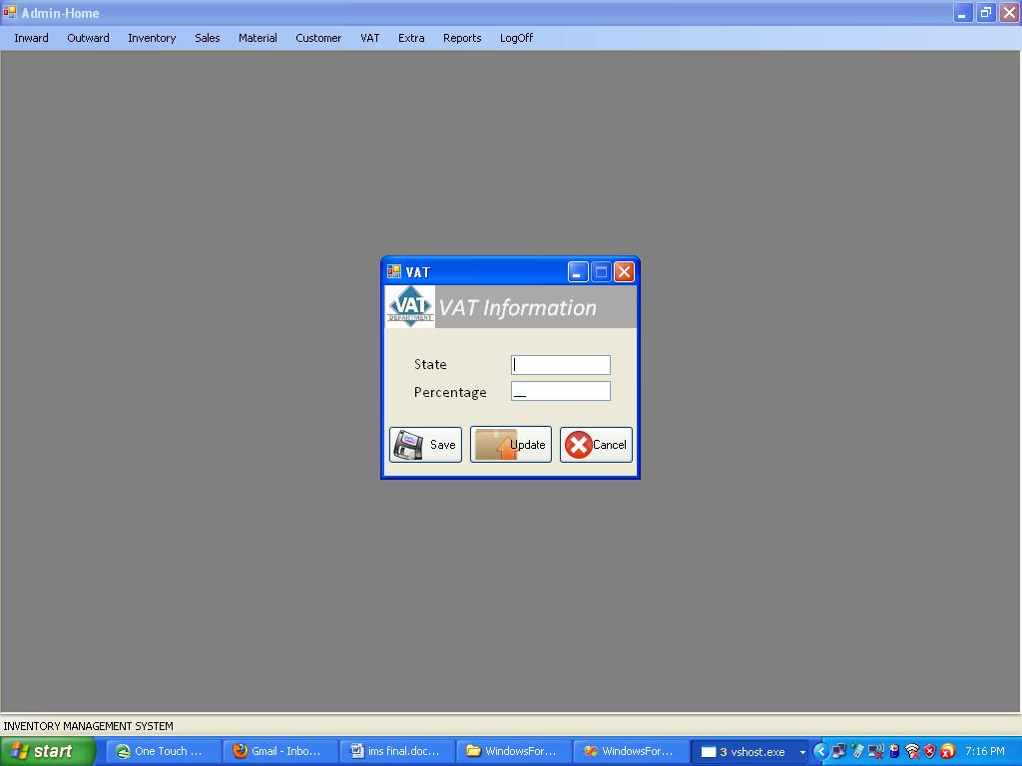

  - System Architecture Design
To successfully implement an Inventory Management System, it is necessary to integrate it within the everyday functions performed by company personnel. That is, when a user wants to order equipment or software, they would call up the Inventory Management System screen associated with Acquisition. The same types of processes should be available for Redeployment and Termination of assets. Should a user request the acquisition of a specific type of asset, then it could be possible for the inventory system to determine if the asset is already in surplus, or if it should be purchased under an existing Volume Purchase Agreement with a vendor.
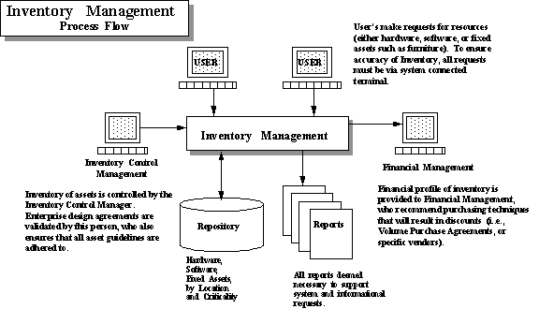
The utilization of Inventory Management Systems to control the purchase and installation of assets can aid in the control of the business environment, while assisting in the assignment of personnel to perform asset related work functions. This methodology will result in a work-flow and asset management system.

