High Performance Scientific Computing

Report On

Homework 1

Submitted By

Keyur Borad

183109009



Indian Institute of Technology Bombay

# Function given for integration:

$$I= \int_{-π/2}^{π/2}{Cos(x)}dx$$

The Exact answer of above integration is,

$$I= \int_{-π/2}^{π/2}{Cos(x)}dx = 2$$

# Convergence study

Convergence study is done for both Trapezoid method and Monte Carlo method of integration for different sample points

## 1. Trapezoidal Rule

For convergence study of Trapezoidal method ranges -90 to 90 is equally spaced divided

|  |  |  |  |  |  |
| --- | --- | --- | --- | --- | --- |
| Equi-spaced divisions | 2 | $$4$$ | $$16$$ | $$256$$ | $$65536$$ |
| Integral | **1.570796** | **1.896119** | **1.994376** | **1.999886** | **1.999948** |

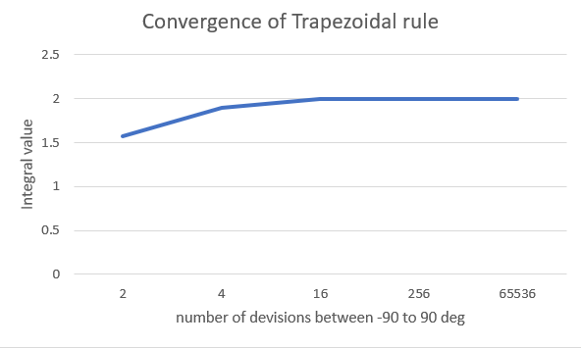

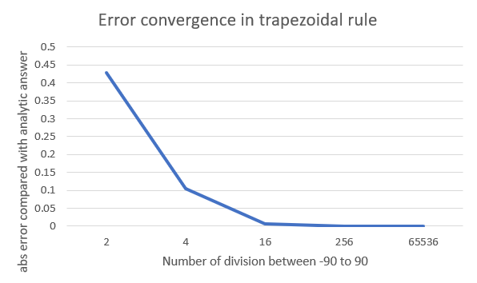

## 2. Monte-Carlo Method

The following table shows the relation between number of sampling points used for calculation of integration and error in integration value calculated with respect to exact value. The error calculated as,

$$Error=abs(Exact integration calculated analytically-Integration calculated Numerically)$$

The error is calculated by taking average of error for five iterations.

|  |  |  |  |  |  |  |  |
| --- | --- | --- | --- | --- | --- | --- | --- |
| No. Sample Points | 2 | $$4$$ | $$16$$ | $$256$$ | $$65536$$ | $${10}^{7}$$ | $${10}^{8}$$ |
| Integral | **1.570796** | **1.570796** | **1.767146** | **1.816233** | **2.01354** | **1.999664** | **1.999925** |
| Error | **0.429204** | **0.429204** | **0.232854** | **0.183767** | **0.01354** | **0.000336** | **7.5E-05** |

For better visualization graph of the Error vs Sampling points is plotted.

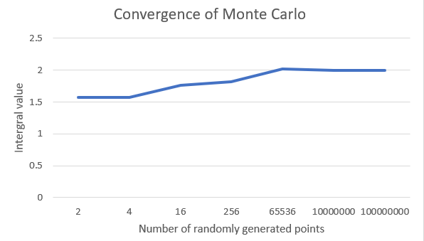

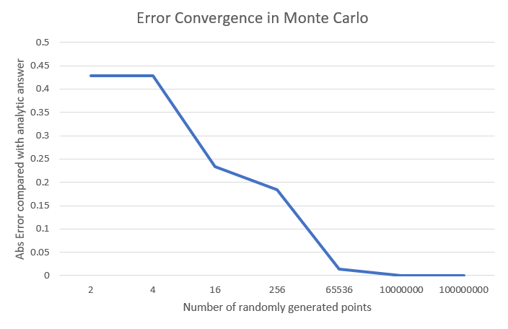

# Time Study

The time study is done for parallel code. The serial code is parallelized with 2, 4, 6 and 8 number of threads.

## 1. Trapezoidal Rule

The following table shows the relation between number of threads used for parallelization and corresponding time taken for calculation of integration. The time is calculated by taking average of time for five iterations. The time is corresponding to $5×{10}^{8}$ number of equispaced divisions.

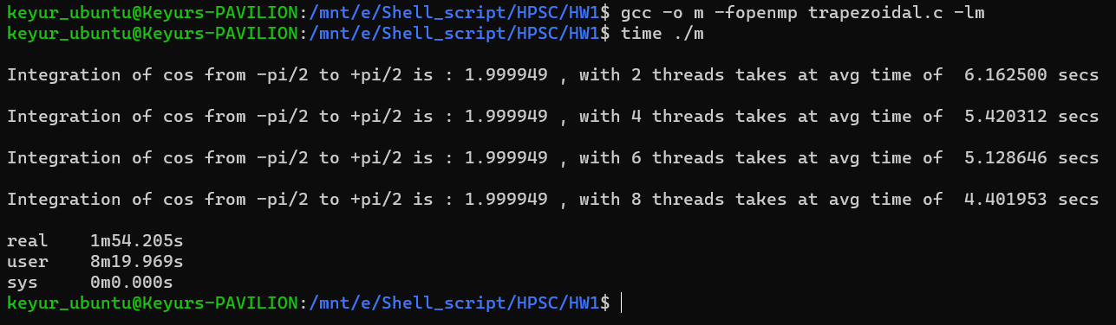

|  |  |  |  |  |
| --- | --- | --- | --- | --- |
| No. of threads | 2 | $$4$$ | $$6$$ | $$8$$ |
| Time(sec) | **6.162** | **5.4203** | **5.128** | **4.4019** |

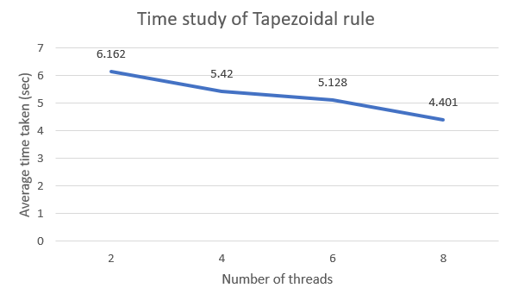

Plot of Time vs Number of threads Trapezoidal Method

## 2. Monte Carlo Method

For time study of Monte Carlo method same number of sample points and threads are considered as that of Trapezoidal method.

The following table shows the relation between number of threads used for parallelization and corresponding time taken for calculation of integration. The time is calculated by taking average of time for five iterations. The time is corresponding to ${10}^{7}$ number of sampling points.

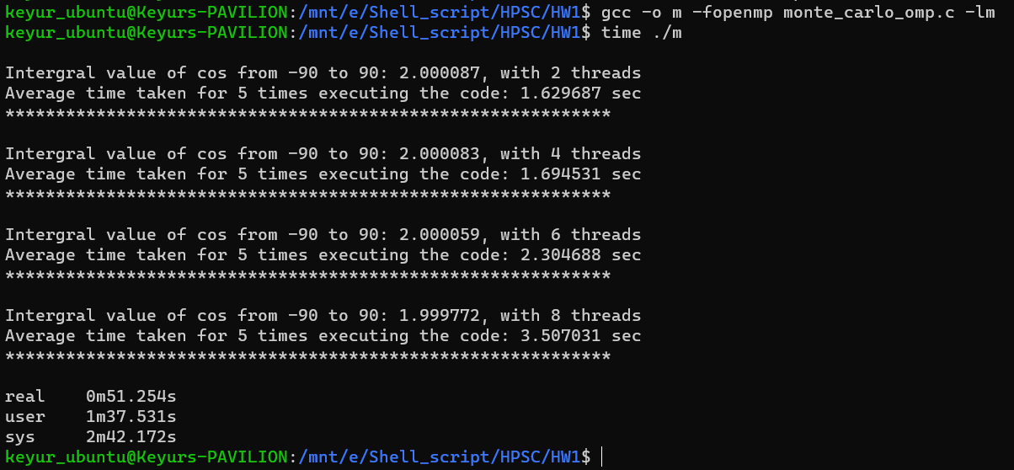

|  |  |  |  |  |
| --- | --- | --- | --- | --- |
| No. of threads | 2 | $$4$$ | $$6$$ | $$8$$ |
| Time(sec) | **1.6296** | **1.6945** | **2.3046** | **3.50703** |

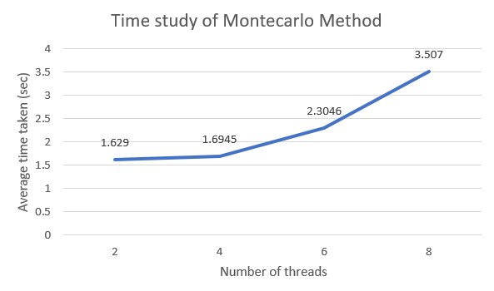

Plot of Time vs Number of threads Monte Carlo Method

# Conclusion

1. Both trapezoidal and montecarlo method converges to the analytical solution as the number divisions(for trapezoidal) and random sample points(for montecarlo) are increased to higher order.
2. It is been noticed that trapezoidal method converges faster than that of Montecarlo method
3. Talking about the **time study**, It is observed in **Trapezoidal rule** code as the number of threads are increased from 2 to 8 consequently **time taken** to run the code is also **reduces**. This has been possible only with the help of openmp library. Clauses used are “Private” and “reduction”.
4. **Time study in Montecarlo** method showed some adverse effect that is as the number of threads are increased from 2 to 8 , the **time taken** for the code to run is also **increases.** And this might be because of the use of the random number generator in c, where it seeds the time and generates the random number. So basically this might force the program to run serially as 2 iterations cannot have the same random number because of the same time stamp.