**Using BigQuery in ML for NCAA Basketball**

Here we are creating a BigQuery ML model for NCAA basketball using the public dataset. We are providing our query details and output screenshots.

First the input features of the model is queried using mbb_teams_games_sr table in the NCAA Basketball public dataset. The input features include the mean and standard deviation of previous game statistics for both home teams and away teams using different time windows. The time windows used are 10, 5 and 1 game before the current game. The team_id and season columns are used for one-hot features. After generating the input features, we will generate training data.

After generating, we will create a linear regression model. The model is used to predict the combined three point field goal attempts based on the previous game statistics. Below is a bigquery to create a linear regression model using three point goal attempts related features.

CREATE OR REPLACE MODEL bqml_tutorial.ncaa_model OPTIONS(

model_type='linear_reg', max_iteration=50) AS

SELECT

* EXCEPT(

game_id, season, scheduled_date,

total_three_points_made,

total_three_points_att),

total_three_points_att as label

FROM

bqml_tutorial.wide_games

WHERE

# remove the game to predict

game_id != 'f1063e80-23c7-486b-9a5e-faa52beb2d83'

On querying it, we get the model:

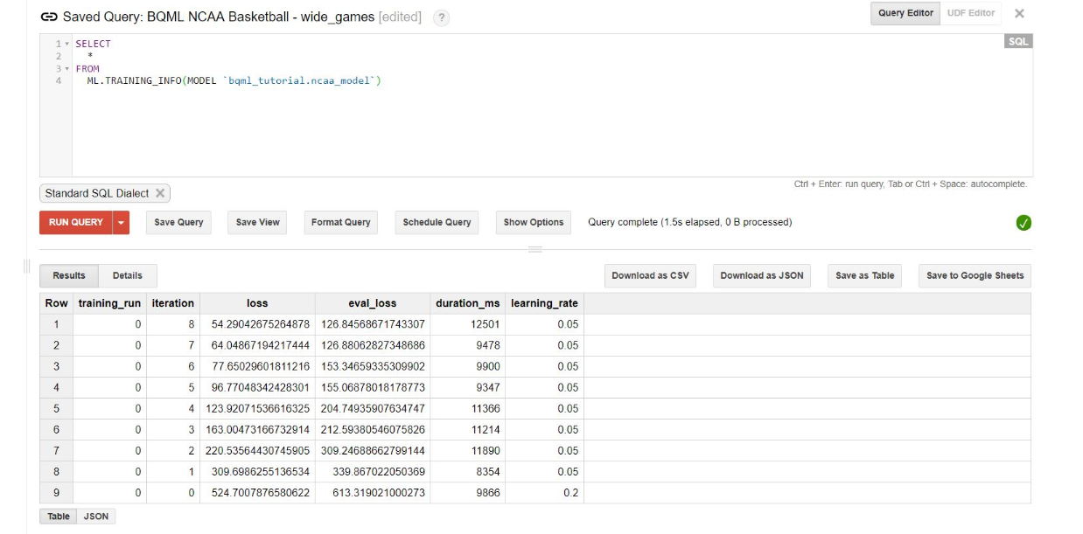

After creating the model, we will evaluate the performance of the model using the ML.EVALUATE function. Below is the query for the same.

WITH eval_table AS (

SELECT *, total_three_points_att AS label FROM `bqml_tutorial.wide_games` )

SELECT * FROM ML.EVALUATE(MODEL `bqml_tutorial.ncaa_model`, TABLE eval_table)

Below is the output we will get after executing the above query.

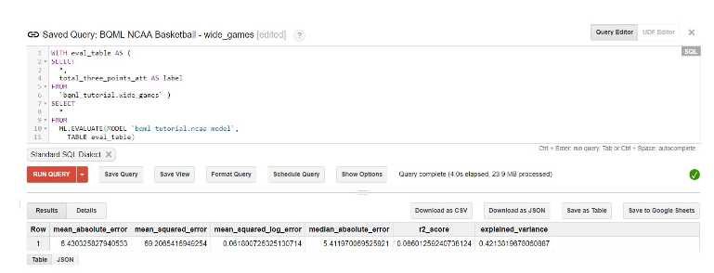

Now that we have evaluated the model, the next step is to use the ML.PREDICT function to predict the total three point field goal attempts in the 2018 NCAA final game: Michigan versus Villanova.

Below is the query for the same.

WITH game_to_predict AS (

SELECT * FROM `bqml_tutorial.wide_games` WHERE game_id='f1063e80-23c7-486b-9a5e-faa52beb2d83' )

SELECT truth.game_id AS game_id, total_three_points_att, predicted_total_three_points_att

FROM (

SELECT game_id, predicted_label AS predicted_total_three_points_att

FROM ML.PREDICT(MODEL `bqml_tutorial.ncaa_model`, table game_to_predict) ) AS predict

JOIN (

SELECT game_id, total_three_points_att AS total_three_points_att

FROM game_to_predict) AS truth ON predict.game_id = truth.game_id

Below is the output we will get after executing the above query.

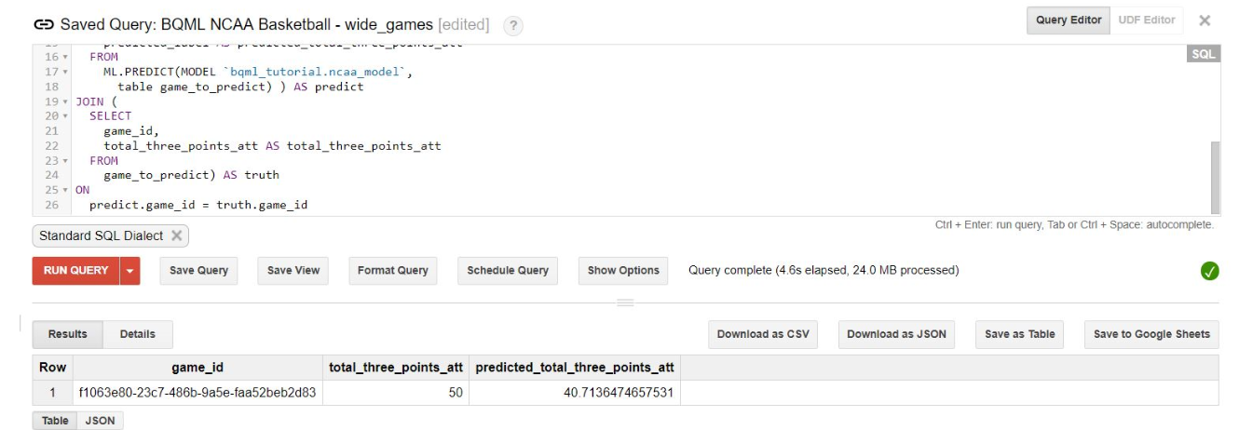

The total_three_points_att value is the actual number of field goals that occurred in the final game – 50. The model’s prediction is 43.41.