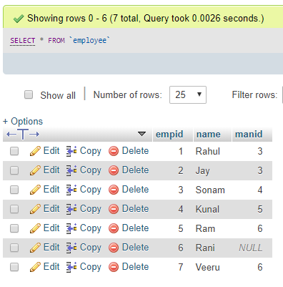
CREATE TABLE `employee` (
`empid` int(11) NOT NULL AUTO_INCREMENT,
`name` varchar(255) DEFAULT NULL,
`manid` int(11) DEFAULT NULL,
PRIMARY KEY (`empid`)
) ENGINE=InnoDB DEFAULT CHARSET=latin1;

INSERT INTO `employee` (`empid`, `name`, `manid`) VALUES
(1, 'Rahul', 3),
(2, 'Jay', 3),
(3, 'Sonam', 4),
(4, 'Kunal', 5),
(5, 'Ram', 6),
(6, 'Rani', NULL),
(7, 'Veeru', 6);
Query1:
select e1.name as employee_name, e2.name as manager_name from employee as e1 left join employee as e2 on e1.manid=e2.empid
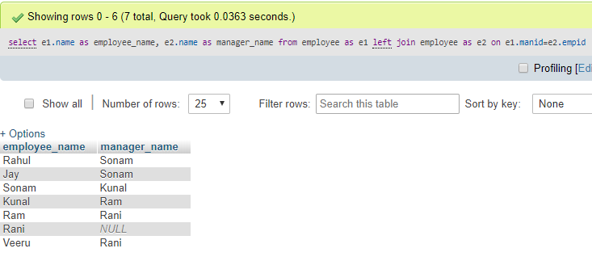
Query2:
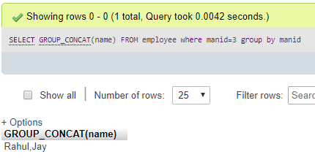
Query3:
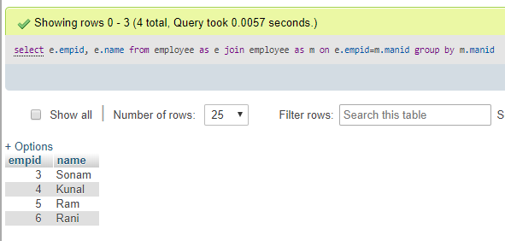

Query4:
select m.name 'Manager Name', GROUP_CONCAT(e.name) 'Employee Names'
from employee e
inner join employee m on e.manid = m.empid
group by m.name;

SELECT e2.NAME AS manager_name,
Group_concat(e1.NAME) AS employee_name
FROM employee AS e1
INNER JOIN employee AS e2
ON e1.manid = e2.empid
GROUP BY e1.manid;

SELECT man.NAME AS manager_name,
Group_concat(emp.NAME) AS employee_name
FROM employee AS emp
INNER JOIN employee AS man
ON emp.manid = man.empid
GROUP BY emp.manid;
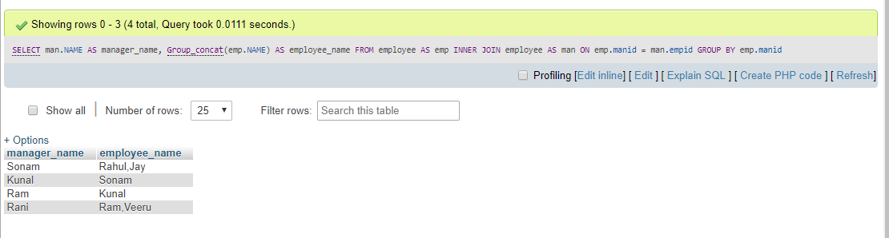

Query5:
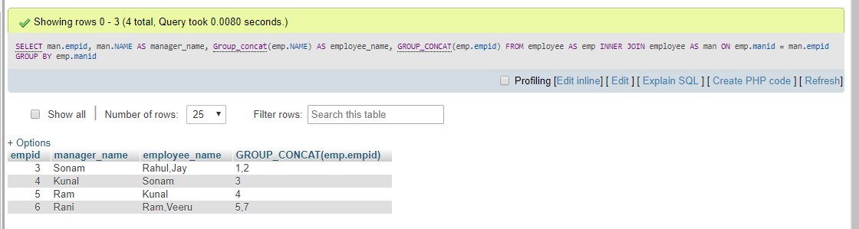

Query6:
CREATE TABLE `student` (
`cid` int(11) NOT NULL AUTO_INCREMENT,
`name` varchar(50) DEFAULT NULL,
`city` varchar(50) DEFAULT NULL,
PRIMARY KEY (`cid`)
) ENGINE=InnoDB DEFAULT CHARSET=latin1;
INSERT INTO `student` (`cid`, `name`, `city`) VALUES
(1, 'Rahul', 'Delhi'),
(2, 'Jay', 'Kol'),
(3, 'Sonam', 'Delhi'),
(4, 'Kunal', 'Hyd'),
(5, 'Ram', 'Delhi'),
(6, 'Rani', 'Patna'),
(7, 'Veeru', 'Kol');
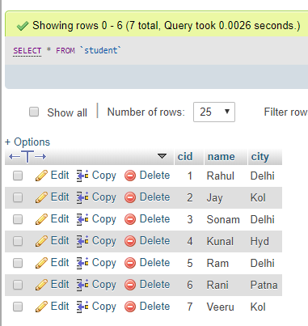
select s2.name, s2.city from student s1 join student s2 on s1.city=s2.city and s1.name='Rahul'
