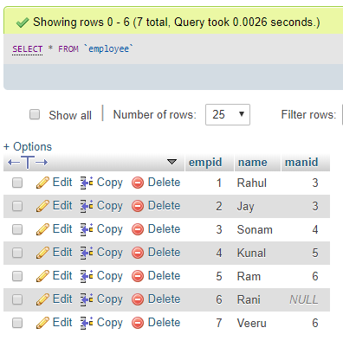

CREATE TABLE `employee` (

`empid` int(11) NOT NULL AUTO_INCREMENT,

`name` varchar(255) DEFAULT NULL,

`manid` int(11) DEFAULT NULL,

PRIMARY KEY (`empid`)

) ENGINE=InnoDB DEFAULT CHARSET=latin1;

INSERT INTO `employee` (`empid`, `name`, `manid`) VALUES

(1, 'Rahul', 3),

(2, 'Jay', 3),

(3, 'Sonam', 4),

(4, 'Kunal', 5),

(5, 'Ram', 6),

(6, 'Rani', NULL),

(7, 'Veeru', 6);

Query1:

select e1.name as employee_name, e2.name as manager_name from employee as e1 left join employee as e2 on e1.manid=e2.empid

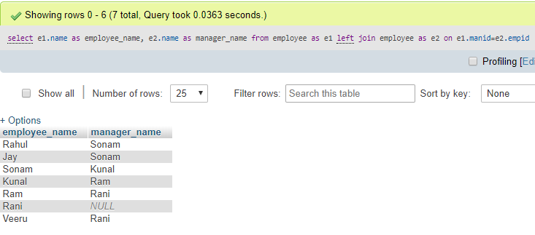

Query2:

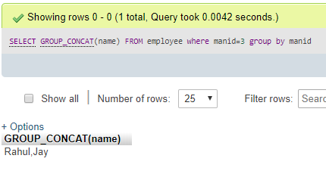

Query3:

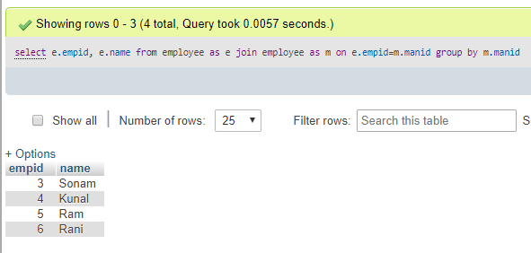

Query4:

select m.name 'Manager Name', GROUP_CONCAT(e.name) 'Employee Names'

from employee e

inner join employee m on e.manid = m.empid

group by m.name;

SELECT e2.NAME AS manager_name,

Group_concat(e1.NAME) AS employee_name

FROM employee AS e1

INNER JOIN employee AS e2

ON e1.manid = e2.empid

GROUP BY e1.manid;

SELECT man.NAME AS manager_name,

Group_concat(emp.NAME) AS employee_name

FROM employee AS emp

INNER JOIN employee AS man

ON emp.manid = man.empid

GROUP BY emp.manid;

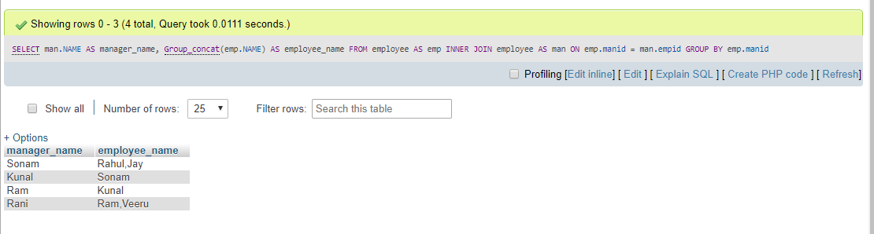

Query5:

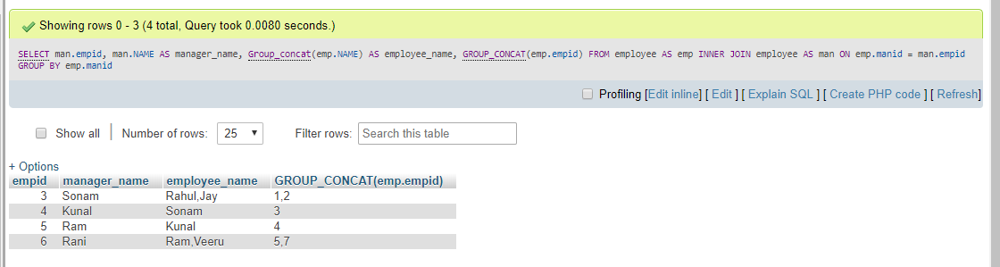

Query6:

CREATE TABLE `student` (

`cid` int(11) NOT NULL AUTO_INCREMENT,

`name` varchar(50) DEFAULT NULL,

`city` varchar(50) DEFAULT NULL,

PRIMARY KEY (`cid`)

) ENGINE=InnoDB DEFAULT CHARSET=latin1;

INSERT INTO `student` (`cid`, `name`, `city`) VALUES

(1, 'Rahul', 'Delhi'),

(2, 'Jay', 'Kol'),

(3, 'Sonam', 'Delhi'),

(4, 'Kunal', 'Hyd'),

(5, 'Ram', 'Delhi'),

(6, 'Rani', 'Patna'),

(7, 'Veeru', 'Kol');

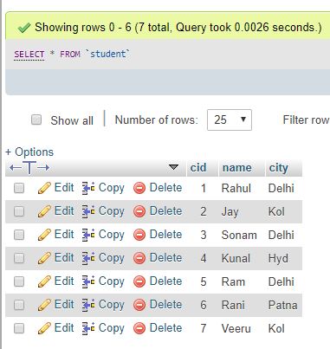

select s2.name, s2.city from student s1 join student s2 on s1.city=s2.city and s1.name='Rahul'

