**A**

**Project Report**

**On**

**"Control home appliances with smart devices”**

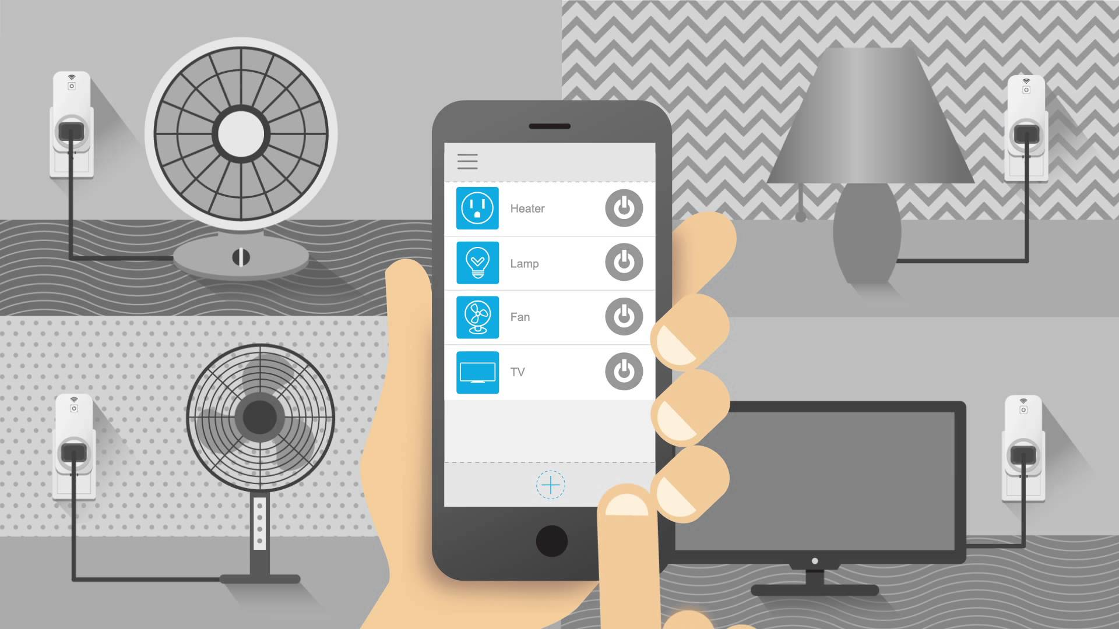

**Prepared by**

Kartik Sutariya(17CE122)

Keyur Talati(17CE124)

Vedanshu Trivedy(17CE129)

**Under the guidance of**

Prof. **Amrin Shaikh**

**Submitted to**

Charotar University of Science & Technology

Degree of Bachelor of Technology

in Computer Engineering

CE244 -Software Group Project

Of 3rd Semester of B.Tech

**Submitted at**



**U. & P. U PATEL DEPARTMENT OF COMPUTER ENGINEERING**

**Faculty of Technology & Engineering, CHARUSAT**

**Chandubhai S. Patel Institute of Technology**

**At: Changa, Dist: Anand – 388421**

**October 2018**



**CERTIFICATE**

This is to certify that the report entitled “**Control home appliances with smart devices**” is a bonafied work carried out by Kartik Sutariya(17CE122),Keyur Talati(17ce124) and Vedanshu Trivedi(17ce129) under the guidance and supervision of **Prof. Amrin Shaikh-Banu** for the subject **Software Group Project (CE244)** of 3rd Semester of Bachelor of Technology in **Computer Engineering** at Faculty of Technology & Engineering (C.S.P.I.T.) – CHARUSAT, Gujarat.

To the best of my knowledge and belief, this work embodies the work of candidate themself, has duly been completed, and fulfills the requirement of the ordinance relating to the B.Tech. Degree of the University and is up to the standard in respect of content, presentation and language for being referred to the examiner.

|  |  |
| --- | --- |
| Under the supervision of,  Prof. Amrin Shaikh-Banu  Assistant Professor,  U. & P U. Patel Dept. of Computer Engg.  C.S.P.I.T., CHARUSAT-Changa. |  |
| Dr. (Prof.) Amit Ganatra  Dean,  Faculty of Technology & Engineering  Head, U. & P U. Patel Department of Computer Engineering  C.S.P.I.T., CHARUSAT- Changa, Gujarat. | |

**Chandubhai S Patel Institute of Technology (C.S.P.I.T.)**

**Faculty of Technology & Engineering, CHARUSAT**

At: Changa, Ta. Petlad, Dist. Anand, PIN: 388 421. Gujarat

**ABSTRACT**

Internet of things (IOT) conceptually the idea of remotely connecting and monitoring real world objects threw the internet .when it comes to our house this concept can be aptly in corporate to make it smarter, safer and automated. This IOT project focuses on building a smart wireless home security system that sends alerts to the owner by using internet in case of any trespass and raises and alarm optionally. Besides the same can also be utilizes for home automation by making users the same sat of sensors.

Now days the people want some comfort, safety, convenient and compatibility. To achieve all of these demands first of user have to download an android application from which he can control electric home appliances like fans and lights.

**ACKNOWLEDGMENT**

It gives us immense pleasure in expressing thanks and profound gratitude to **Prof. Amrin Shaikh-banu**, Assistant Professor, U & P U. Patel Dept. of Engineering, C.S.P.I.T. CHARUSAT for theirvaluable guidance and continual encouragement throughout the project. We are heartily thankful tothem for their precious time, suggestions and sorting out the difficulties of our topic that helped us alot during this study.

We would like to give our special thanks to **Dr. (Prof.) Amit Ganatra**, Head, Department of Computer Engineering, CHARUSAT for giving us such a nice opportunity to work in the great environment.

We would like to thank our friends and colleagues who have been a source of inspiration and motivation that helped us during dissertation period. We would also like to thank all those people who have helped us in our dissertation work in any possible way.

Lastly, We heartily appreciate our family members for their motivation, love and support in fulfilling our academic goals.

**INDEX**

**TABLE OF CONTENTS**

**Name of the topic Page No.**

**Abstract…………………………………………………………………… i**

**Acknowledgement…………………………………………………………… ii**

**List of Figures…………………………………………………………………… iii**

**List of Tables………………………………………………………………… iv**

**Chapter 1 Introduction………………………………………………………………**

**1.1. Project Overview………………………………………………………………….**

**1.2. Purpose……………………………………………………………………………**

**1.3. Scope ……………………………..........................................................................**

**1.4. Objective………………………………………………………………………….**

**1.5. Technology and literature review…………………………………………………**

**Chapter 2 System Analysis…………………………………………………………..**

**2.1 User Characteristics……………………………………………….……………..**

**2.2 Tools & Technology………………………………………………………………**

**Chapter 3 System Design…………………………………………………………….**

**3.1 Flow of System ………………………………………..……………………………**

**3.2 Major Functionality……………………………………………………………….**

**3.3 Data Dictionary(Table & Relationship)/Diagrams………………………………..**

**3.4 GUI Forms(Web/Windows) ………………………………………………………**

**Chapter 4 Implementation…………………………………………………………..**

**4.1 Implementation Environment………………………………………………….**

**4.2 Module Specification…………………………..………………………………….**

**4.3 Coding Standards………………………………………………………………..**

**4.4 Snapshots of project……………………………………………………………….**

**Chapter 5 Constraints and Future Enhancement………………………………….**

**Chapter 6 Conclusion………………………………………….……….................**

**References…………………………………………………………………………….**

**LIST OF FIGURES**

**Figure 1 – Arduino IDE**

**Figure 2 – Mobile Application**

**Figure 3 - NodeMCU**

**Figure 4 – USB cable**

**Figure 5 -Jumper Cables**

**Figure 6 – Bread Board**

**Figure 7 – Relay Module**

**Figure 8 – Circuit Diagram**

**Figure 9 – Flow Chart**

**Figure 10 – NodeMCU Configuration**

**Figure 11 – NodeMCU Pin Configuration**

**Figure 12 – Snapshots Of Project**

**Figure 13 – PIR Sensor**

**Figure 14 – RGB LED**

**Figure 15 – Fan Regulator**

**Figure 16- Light Sensor**

**CHAPTER 1**

**Introduction**

|  |
| --- |
| * 1. **PROJECT OVERVIEW**   Smart home is one of the recent fields in the context of computer  science. The paper named as “Remote mobile control of home appliances”  by F. Meija, M. Nikolova and P. Voorwinden depicts on the home  controlling using WAP protocol. The architecture mentioned by them is  much complex but it gives an initial idea about the remote home appliance  controlling.  Smart home studies sometimes affected by the concern about the  possible harms to the humans’ health. A great research was done by Toril  Laberg, Directorate for Health and Social Affairs of the Delta Centre,  Norway. He later publish in his paper named “Smart Home Technology:  Technology supporting independent living - does it have an impact on  health?” that there is no harm on humans’ health by the technical setup  required to support smart home technologies.  Recently some projects are organized for building the architecture of  controlling home appliance using voice commands. VoiceXML is used for  that purpose.  In this instrutable we will be making a simple IOT project . Web page and android application connroled led using NodeMCU |
| * 1. **PURPOSE**   This section outlines the criteria that will be considered in the  development of the control system.  **1.2.1 FUNCTIONAL REQUIREMENTS**   * The following is a list of functional requirements of the control   unit/module.   * The Cellular Unit will have the ability to connect to the cellular   network automatically  **1.2.2 CONSTRAINT CONSIDERATIONS**  The following is a list of constraint considerations:-   * The controlled appliances will need an electrical control interface. * This simple system is only capable of controlling electrical devices.   **1.2.3 TECHNICAL APPROACH**  Assuming that the control unit is powered and operating properly, the  process of controlling a home device will proceed through the following  steps:-   * The remote user makes a call to the GSM cellular unit and   commands to the receiver.   * GSM receiver receives call automatically from user cell phone by   auto answering mode.   * After receiving call by GSM cellular unit user press the keys on   his cell phone.   * GSM receiver receives the appropriate DTMF tone. * The DTMF decoder IC connected to GSM receiver detects the   pressed DTMF tone & converts it to the 4 bit BCD O/P.   * DTMF decoder IC sends the BCD O/P to the microcontroller. * Microcontroller issues commands to the appliances via relays   connected to its O/P ports. |
| **1.3. SCOPE**  This Project is of area of interest is remote control of home appliances using the internet. This project will focus on the remote control of a fan, a light and a television set (TV). With a fan and a light, switching on and off will be considered. And for a TV, in addition to switching on and off, changing of channels will be considered. |
| **1.4. OBJECTIVE**  To design an internet based home automation system for controlling home appliances.   * To analyze and identify the weaknesses of existing home automation systems * To design a flexible internet based wireless home automation system * To simulate and test the designed system |
| **1.5. TECHNOLOGY AND LITERATURE REVIEW** Home automation Home automation is the residential extension of building automation. It is the automation of the home, housework or household activity. Internet The Internet, sometimes called simply "the Net," is a worldwide system of computer networks - a network of networks in which users at any one computer can, if they have permission, get information from any other computer (and sometimes talk directly to users at other computers). The Internet is now widely used as a connectivity tool for educational, commercial, and personal applications. The Internet is an exciting portal that makes it possible for users to access virtually an infinite supply of information. Remote control Remote control is the control of an activity, process, or machine from a distance, as by radioed instructions or coded signals. |

**CHAPTER 2**

**SYSTEM ANALYSIS**

**2.1 USER CHARACTERISTICS**

* Increase your independence and give you greater control of your home environment.
* Make it easier to communicate with your home appliances
* Save you time and effort.
* Improve your personal safety.
* Alert you audibly and visually to emergency situations.

**2.2 TOOLS & TECHNOLOGY**

Software:-

* Arduino IDE

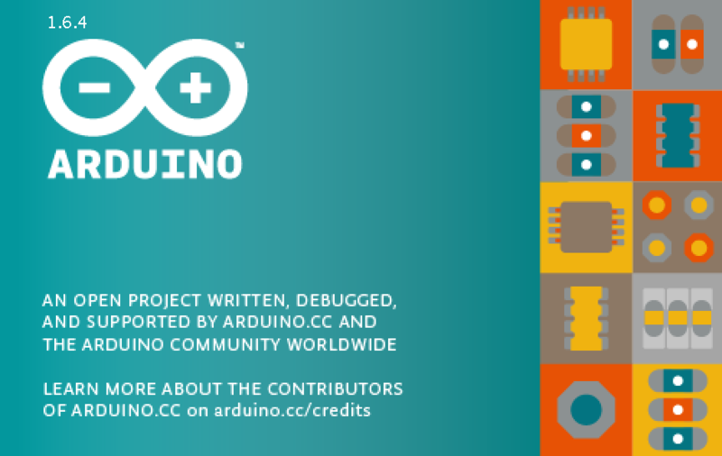

Figure 1 – Arduino IDE

* Mobile Application.

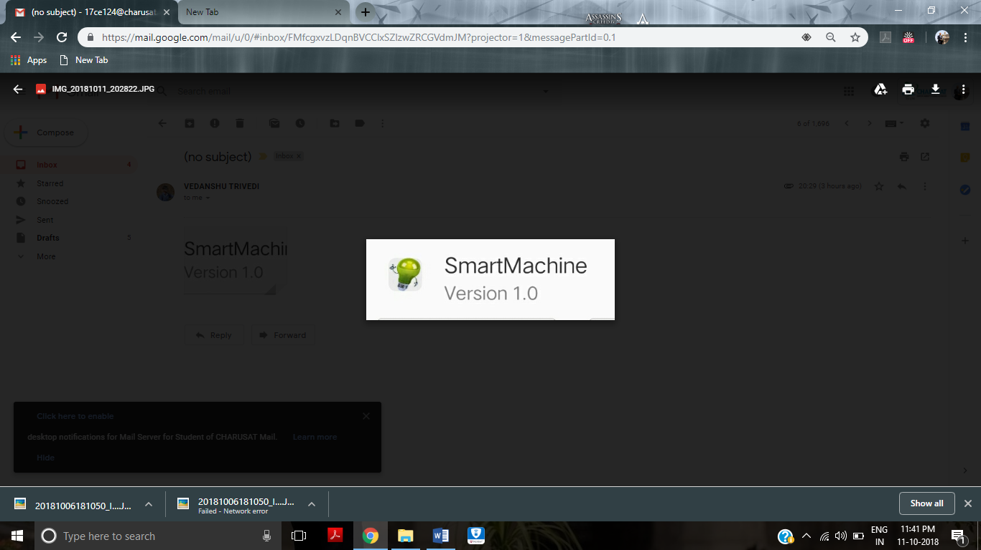

Figure 2 – Mobile Application

We have make our personal android application for this project .

This application made in Mit Inventer and with the help of PHP

-Hardware:

* NodeMCU

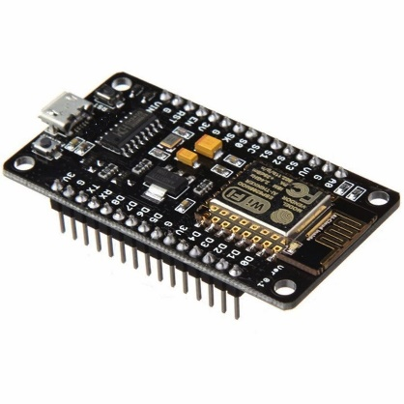

Figure 3 - NodeMCU

* USB cable

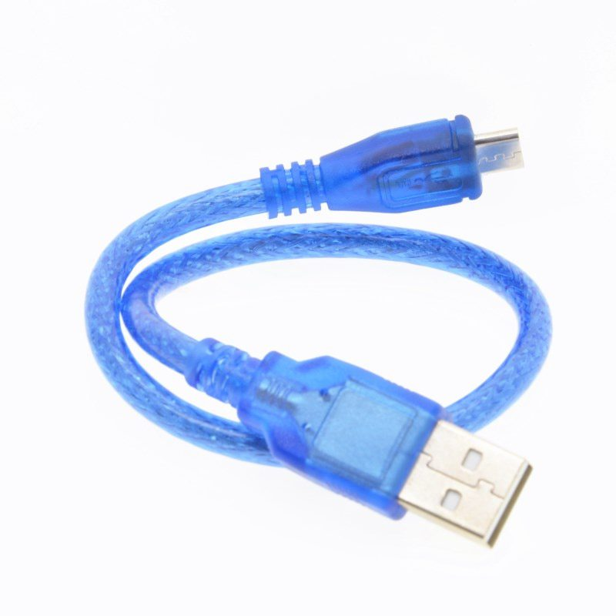

Figure 4 – USB cable

* Jumper Cables

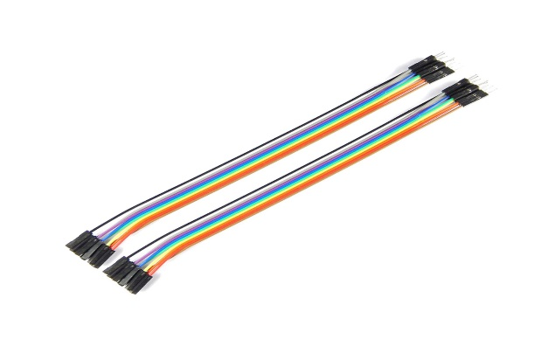

Figure 5 -Jumper Cables

* Regular Size Bread Board

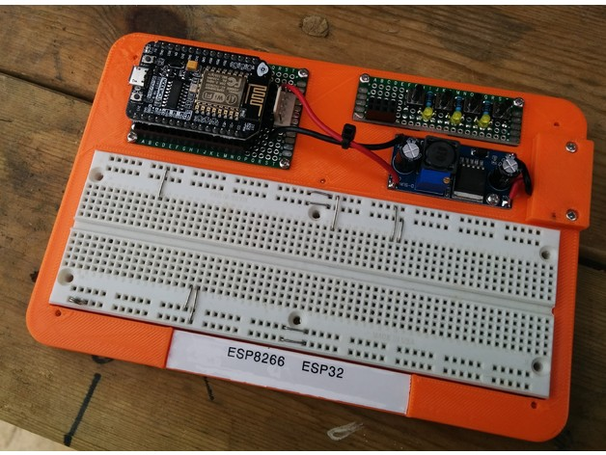

Figure 6 – Bread Board

* Relay module.

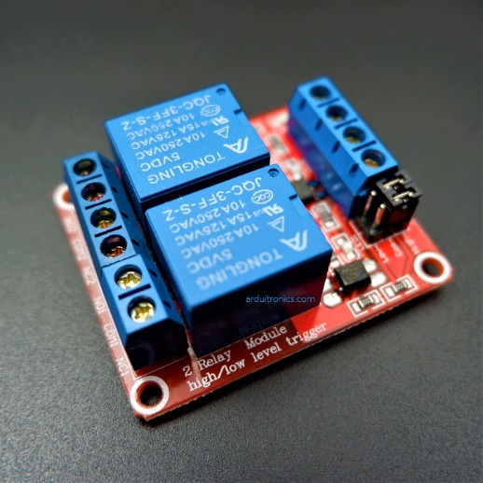

Figure 7 – Relay Module

**CHAPTER 3**

**SYSTEM DESIGN**

**3.1 FLOW OF SYSTEM**

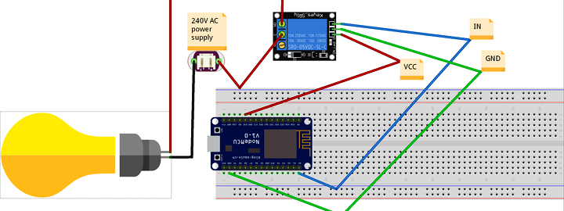

Figure 8 – Circuit Diagram

**3.2 MAJOR FUNCTIONALITY**

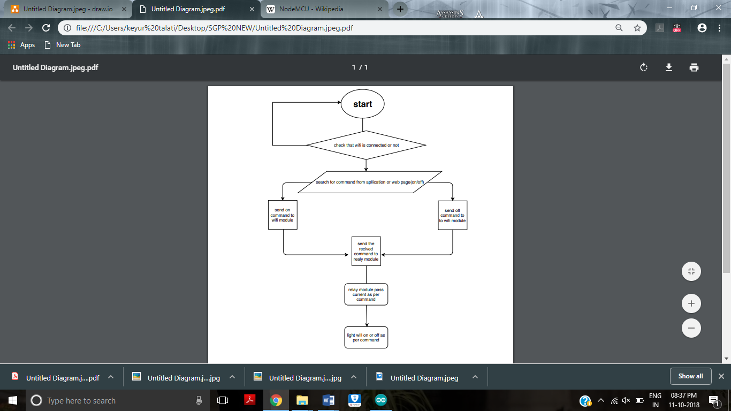

**Figure 9 – Flow Chart**

**3.3 DATA DICTIONARY/DIAGRAMS**

**CHAPTER 4**

**IMPLEMENTATION**

**4.1 IMPLEMENTATION ENVIRONMENT**

This project is single user as well as multiuser nonGUI as command can be sent to one or more owners.

**4.2 MODULE SPECIFICATION**

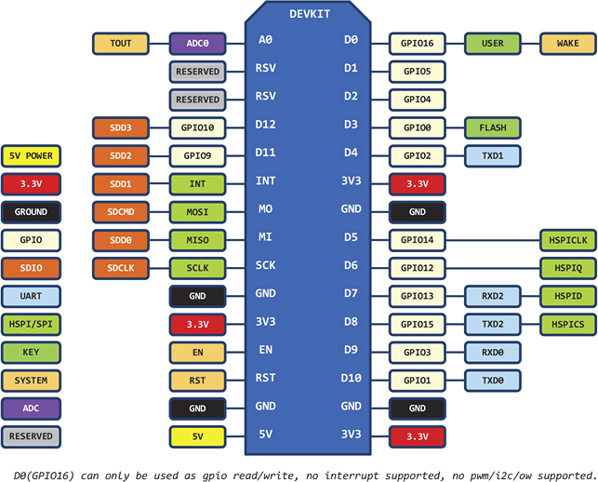

**Figure 10 – NodeMCU Configuration**

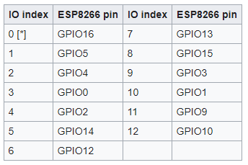

Figure 11 – NodeMCU Pin Configuration

**4.3 CODING SPECIFICATION**

2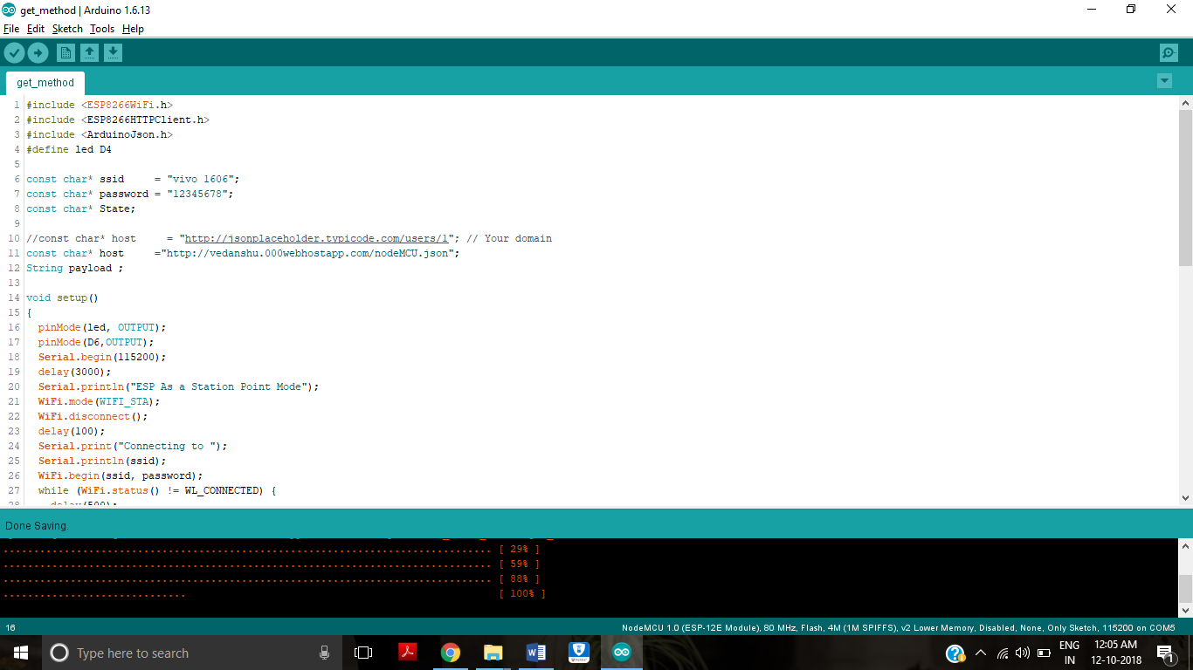

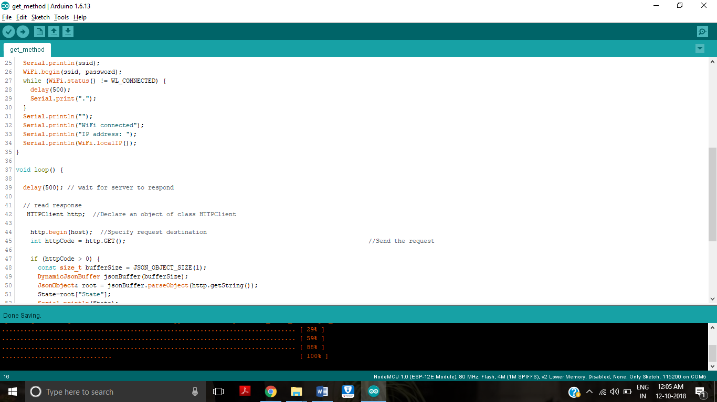

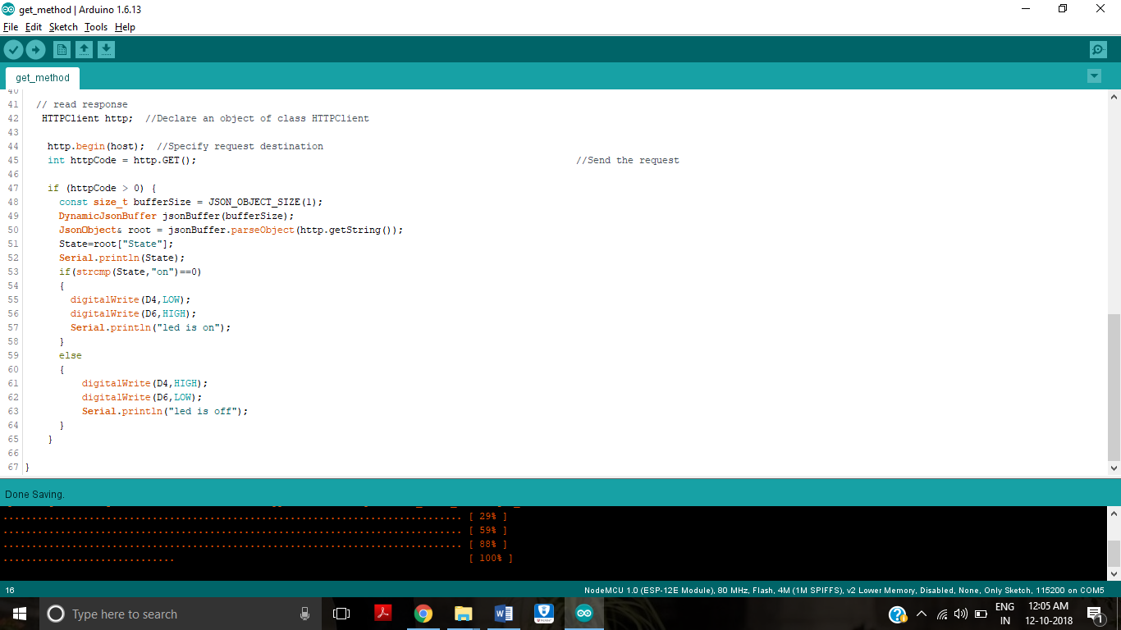

**4.4 SNAPSHOTS OF PROJECT**

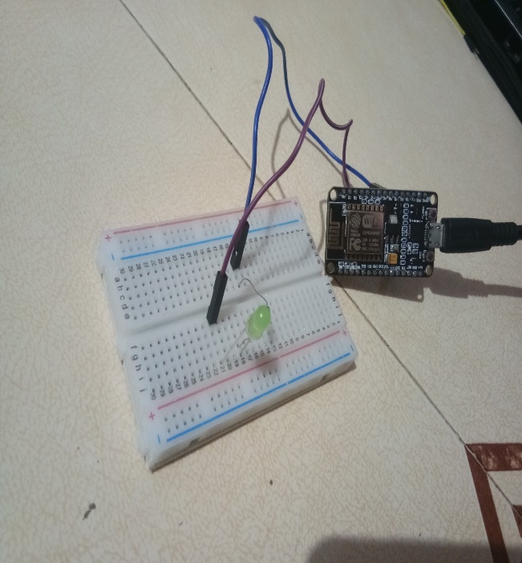 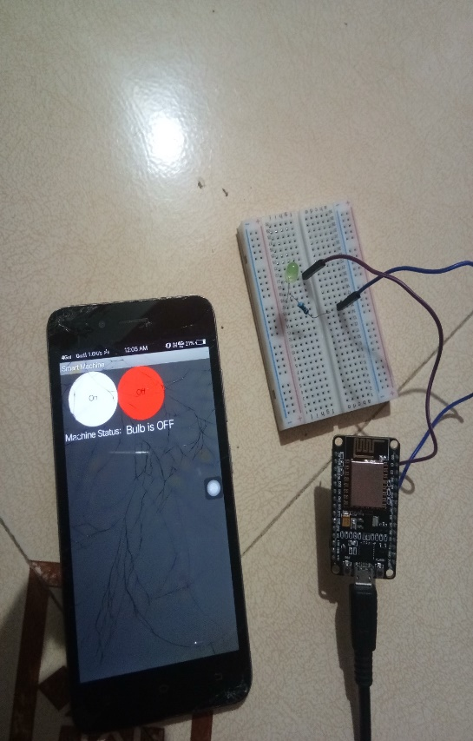

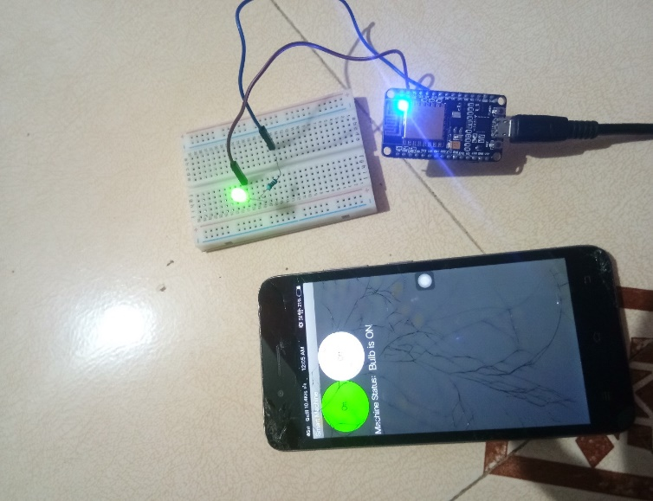 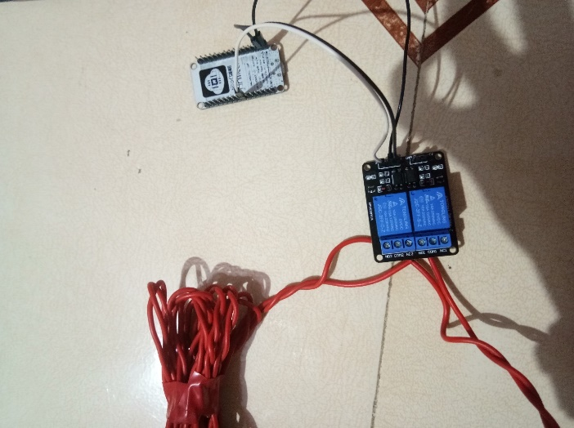

Figure 12 – Snapshots Of Project

**CHAPTER 5**

Constraints and Future Enhancement

1. AUTOMATIC LIGHT ON AND OFF FOR A ROOM {USING SENSOR}

We are trying to add a new flavour in our project that is we try to implement an sensor which is nothing but a PIR sensor. The PIR sensor detect the objects in a room and according to that it will send data to the nod MCU .if there Is no one in the room means there is no person are there in room than it will automatically switched off the lights and fans to save electricity.

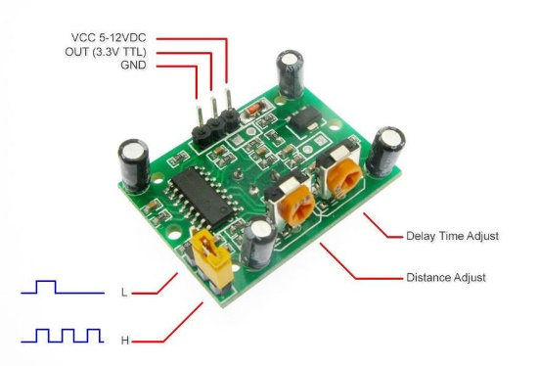

Figure 13 – PIR Sensor

1. CHANGE THE COLOR OF ROOM LIGHTS WITH SMART DEVICES

In this project we will try to insert a new function with light changing capacity with an mobile application. In this method we can use the RGB light and we can control them as a user wants .so that user can set the light as per requiremnts.

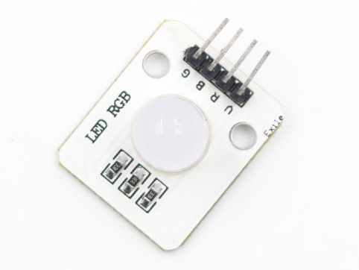

Figure 14 – RGB LED

1. CHANGE FAN SPEED WITH SMART DEVICES

We can also implement an another method which can be helpful to control the speed of fan. We can connect regulator with nod MCU and with the help of that we can adjust the speed of fan as per reqirement

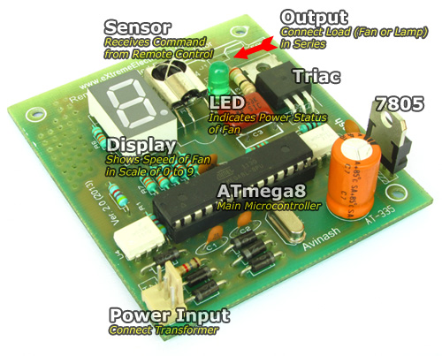

Figure 15 – Fan Regulator

1. AUTOMATIC ON / OFF LIGHTS

With the help of light sensor, we can turn on or turn off the electric light. At the time of evening if there is no sunlight the sensor send the command to nod MCU to turn on the light and same as in morning as the sensor detect the sun light the light will automatically off

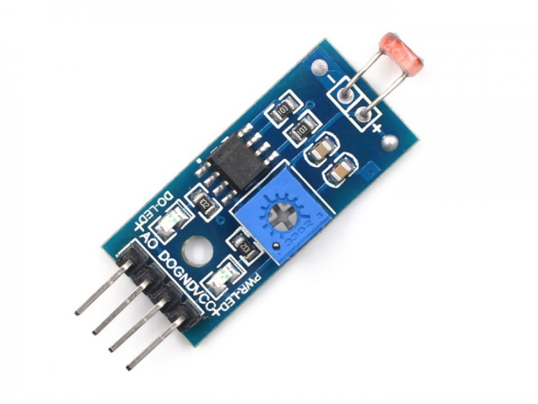

Figure 16- Light Sensor

**CHAPTER 6**

CONCLUSION

Home Automation is undeniably a resource which can make a home environment automated. People can control their electrical devices via these Home Automation devices and set up the controlling actions in the Smart Devices. We think this product have high potential for marketing in the future. At the moment the components are a bit to high to be able to produce these devices for a interesting price.

|  |  |
| --- | --- |
|  |  |

**REFERENCES**

Conte, G., & Scaradozzi, D. (2003). Viewing home automat ion systems as multiple agents

systems. RoboCUP2003, Padova, Italy. Retrieved from http://www.robosiri.it/ROBOCUP_2003/ROBOCUPSITOSIRI/ articles/pdf/Conte.pdf

Ciubotaru-Petrescu, B., Chiciudean, D., Cioarga, R., & Stanescu, D. (2006). Wireless Solutions

for Telemetry in Civil Equipment and Infrastructure Monitoring. 3rd Romanian-Hungarian Joint Symposium on Applied Computational Intelligence (SACI) May 25-26, 2006. Retrieved from http://www.bmf.hu/conferences/saci2006/Ciubotaru.pdf

Delgado, A. R., Picking, R., & Grout, V. (2006) Remote-controlled home automation systems

with different network technologies. Proceedings of the 6th International Network Conference (INC 2006), University of Plymouth, 11-14 July 2006, pp. 357-366. Retrieved from http://www.newi.ac.uk/groutv/papers/p5.pdf

Jawarkar, N. P., Ahmed, V., Ladhake, S. A. & Thakare, R. D. (2008). Micro-controller based Remote Monitoring using Mobile through Spoken Commands. Journal Of Networks, 3(2), 58-63. Retrieved from

http://www.academypublisher.com/jnw/vol03/no02/jnw03025863.pdf

Murthy, M. V. R. (2008). Mobile based primary health care system for rural India. W3C workshop on Role of Mobile Technologies in Fostering Social Development, Jun 2008

Potamitis, I., Georgila, K., Fakotakis, N., & Kokkinakis, G. (2003). An integrated system for

smart-home control of appliances based on remote speech interaction. EUROSPEECH 2003, 8th European Conference on Speech Communication and Technology, pp. 2197-2200, Geneva, Switzerland, Sept. 1-4, 2003. Retrieved from http://www.wcl.ee.upatras.gr/ai/papers/potamit is14.pdf