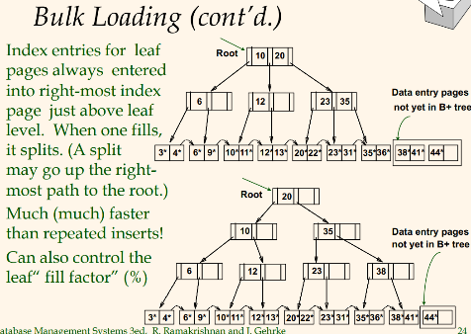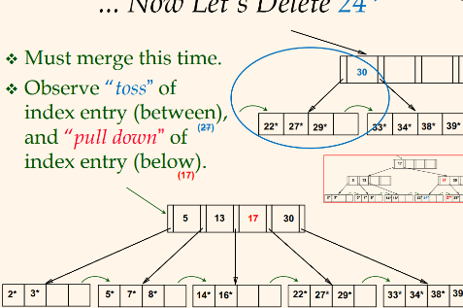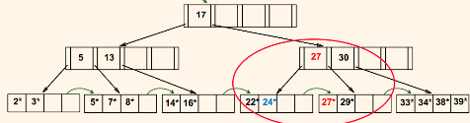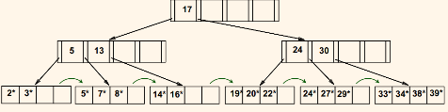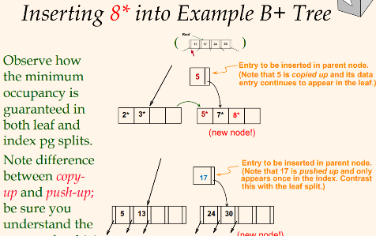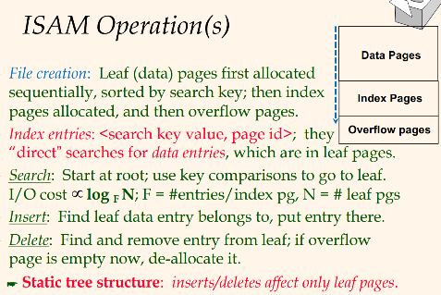V



