HeatCast NCR: Technical Documentation
Next-day heat index level for the 16 cities of Metro Manila
Edrian Tala, Harry Verdeflor, Marc Lawrence David. CCMACLRL Introduction to Machine Learning, Section COM241ML, National University
October 2026

1. What the project does
HeatCast NCR predicts the level of tomorrow’s highest heat index in one of the 16 cities of the National Capital Region (Metro Manila), using today’s weather in that city. The answer is one of the five PAGASA levels: Not Hazardous (below 27 °C), Caution (27 to below 33 °C), Extreme Caution (33 to below 42 °C), Danger (42 to below 52 °C) and Extreme Danger (52 °C and above).
Three traditional algorithms were compared on the same chronological split and the same five time-ordered folds: Logistic Regression, Random Forest and Gradient Boosting. The selected model is a Random Forest (maximum depth 12, at least 5 days per leaf, balanced class weights, 500 trees, random state 42). It is deployed as a Streamlit application:
- Live application: https://heatcast-ncr.streamlit.app/
- Repository: https://github.com/keyyum/heatcast-ncr-simple
The application is a decision aid for schools, employers of outdoor workers and city offices. It is not a PAGASA advisory.

2. Installation
Requirements: Python 3.11 to 3.14 and an internet connection for the first installation. Tested in a clean Python 3.11 environment and with Python 3.13.
git clone https://github.com/keyyum/heatcast-ncr-simple
cd heatcast-ncr-simple
python -m venv .venv
source .venv/bin/activate # Windows: .venv\Scripts\activate
pip install -r requirements.txt
requirements.txt lists exact versions. They matter for the saved model: models/heatcast_random_forest.joblib must be read with the scikit-learn version it was saved with (1.9.1).
Package | Version | Used for
pandas | 3.0.5 | tables
numpy | 2.4.6 | numbers
scikit-learn | 1.9.1 | the three models, preprocessing, folds and scores
joblib | 1.6.0 | saving and loading the model
matplotlib | 3.11.2 | figures in the notebooks
seaborn | 0.13.2 | figures in the EDA notebook
streamlit | 1.65.0 | the application
pydeck | 0.9.3 | the map in the application

3. Folder structure
Folder or file | Contents
app/ | the Streamlit application (streamlit_app.py), its logic (app_logic.py), the city outlines and locations, and sample_inputs_outputs.py
data/original/ | the original dataset (64,240 rows, 26 columns, 2015 to 2025), its data dictionary and SOURCE.md (source, licence, collection)
data/processed/ | ncr_city_daily.csv, the dataset used by the models (29,168 rows, 8 columns, 2021 to 2025)
notebooks/ | 01_eda, 02_logistic_regression, 03_random_forest, 04_gradient_boosting, 05_final_test
src/ | make_dataset.py (original to processed data), common.py (split, folds, preprocessing, scores), final_model.py (saves the selected model), compare_models.py (the three models side by side)
models/ | heatcast_random_forest.joblib, the saved pipeline (preprocessing and Random Forest) that the application loads
results/ | scores, tables and figures of each notebook and script (eda/, random_forest/, comparison/, final_test/)
tests/ | 75 automatic checks: 24 for the data and shared code, 51 for the application
documentation/ | this document, the data dictionary, a plain-language guide, sample inputs and outputs, and screenshots
paper/ | the final paper (DOCX and PDF)
requirements.txt | exact package versions

4. Running the project
All commands run from the project folder.
Step | Command | Time
Rebuild the processed dataset (optional, it is included) | python src/make_dataset.py | seconds
Exploratory data analysis | open notebooks/01_eda.ipynb and run all cells | under a minute
Train and tune each model | run notebooks 02, 03 and 04 | a few minutes each
Compare the three selected settings on the same folds | python src/compare_models.py | about a minute
Final test (done once; do not use it to choose anything) | notebooks/05_final_test.ipynb | under a minute
Save the selected model | python src/final_model.py | about 5 seconds
Start the application | streamlit run app/streamlit_app.py (opens http://localhost:8501) | seconds
Run all tests | python -m unittest discover -s tests -v | about 30 seconds
Sample inputs and outputs | python app/sample_inputs_outputs.py | seconds
Every random step uses random state 42. The split is chronological: training days 2021-01-01 to 2024-12-27 (23,312 rows), one day skipped, test days 2024-12-29 to 2025-12-28 (5,840 rows). Preprocessing is fitted inside each pipeline on the training days of each fold only.

5. Input format
The application asks for one city and five numbers about today in that city.
Input | Unit | Accepted (hard limit) | Range in the training days | Meaning
City | name | one of the 16 cities | 16 cities | Caloocan, Las Piñas, Makati, Malabon, Mandaluyong, Manila, Marikina, Muntinlupa, Navotas, Parañaque, Pasay, Pasig, Quezon, San Juan, Taguig, Valenzuela
Today’s highest heat index | °C | 10 to 60 | 26.13 to 47.63 | the highest “feels-like” temperature of the day
Today’s lowest temperature | °C | 10 to 40 | 22.0 to 30.0 | roughly how warm the night was
Rain today | mm | 0 to 500 | 0 to 175.1 | total rain of the day; 0 means a dry day
Average air pressure today | hPa | 950 to 1050 | 995.2 to 1019.3 | mean sea-level pressure; low values go with storms
Sunshine today | Wh/m² | 0 to 10,000 | 478 to 7,551 | total solar radiation of the day
A value outside the hard limit is refused. A value inside the hard limit but outside the training range is accepted with a warning that the prediction is less reliable. A value on a limit (for example 0 mm or 500 mm of rain) is accepted.

6. Application guide
- Choose the city at the top. It is highlighted in blue on the map.
- Type today’s five weather values. The boxes start empty; a box left empty is reported, never filled in silently.
- Click Guess tomorrow’s level.
- Read the result: the predicted level for tomorrow, the probability of each of the five levels, the level of today’s heat index, and the map with the city in the colour of the predicted level (yellow Caution, orange Extreme Caution, red Danger).
- Open About this model and its limits for the model, its test results and what it cannot do.
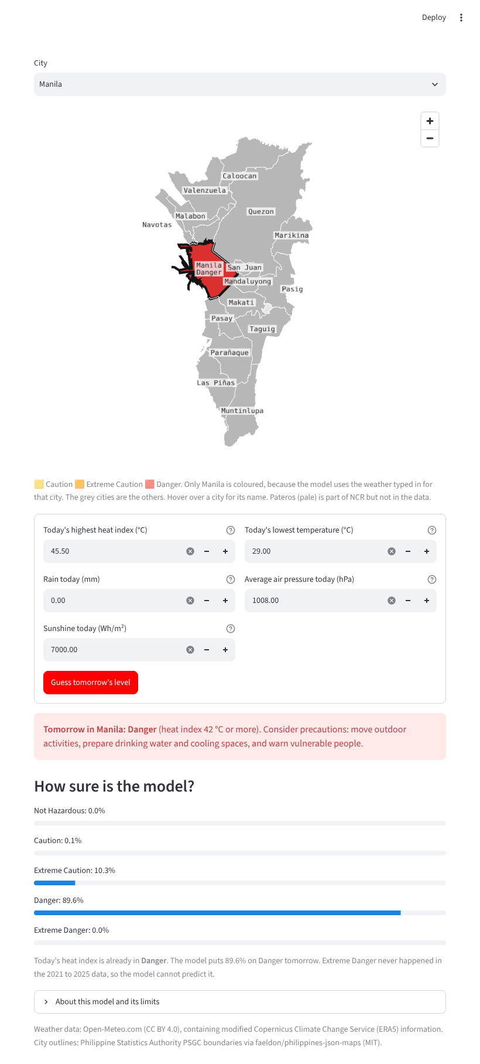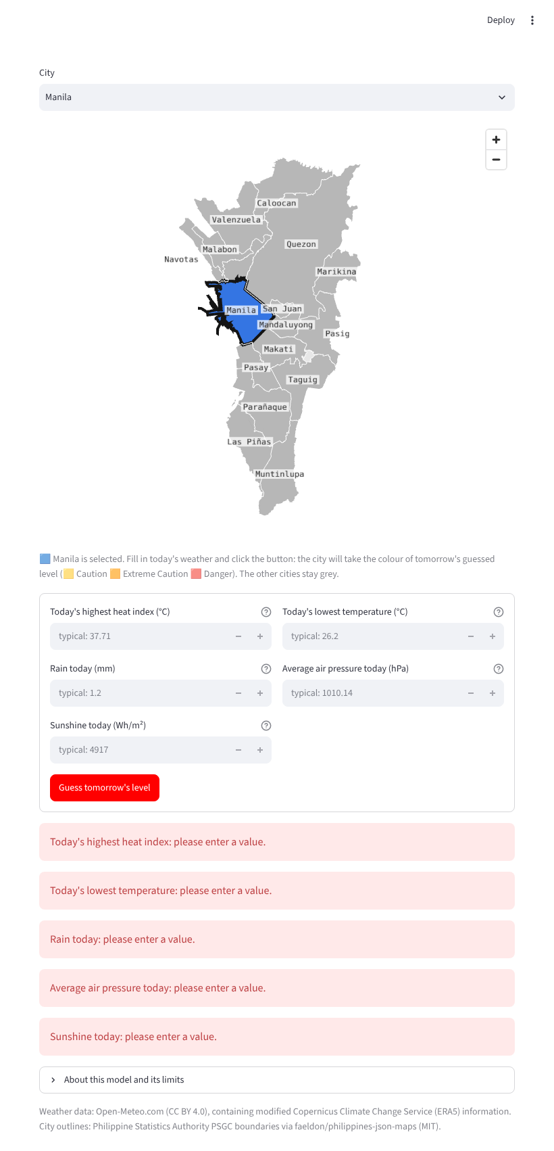
Sample inputs and the application’s answers (from documentation/sample_inputs_outputs.csv):
Type | Case | City | Heat index (°C) | Min. temp. (°C) | Rain (mm) | Pressure (hPa) | Sunshine (Wh/m²) | Output
Valid | normal dry day | Manila | 38.0 | 26.0 | 0 | 1010 | 5000 | Extreme Caution (90%)
Valid | very hot sunny day | Manila | 45.5 | 29.0 | 0 | 1008 | 7000 | Danger (90%)
Valid | cool rainy day | Quezon | 29.0 | 24.0 | 90 | 1003 | 1500 | Caution (55%)
Valid | hot day in a hot city | Malabon | 42.0 | 27.5 | 0 | 1010 | 6500 | Danger (87%)
Boundary | rain at the upper limit | Pasig | 38.0 | 26.0 | 500 | 1010 | 5000 | Extreme Caution (79%), with a warning
Boundary | heat index above the data maximum | Manila | 55.0 | 26.0 | 0 | 1010 | 5000 | Danger (54%), with a warning
Invalid | negative rain | Manila | 38.0 | 26.0 | -5 | 1010 | 5000 | error: “Accepted values are 0 to 500 mm”
Invalid | impossible heat index | Manila | 200 | 26.0 | 0 | 1010 | 5000 | error: “Accepted values are 10 to 60 °C”
Invalid | pressure left empty | Manila | 38.0 | 26.0 | 0 | (empty) | 5000 | error: “please enter a value”
Invalid | text instead of a number | Manila | 38.0 | “warm” | 0 | 1010 | 5000 | error: “not a number”
Invalid | city outside the data | Cebu | 38.0 | 26.0 | 0 | 1010 | 5000 | error: “Choose one of the 16 cities”

7. The model inside the application
The application loads models/heatcast_random_forest.joblib, one scikit-learn pipeline with two steps: the preprocessing (make_preprocess(scale=False): the five weather numbers unchanged, the city as 16 yes/no columns) and the Random Forest. src/final_model.py fits it on the training days and saves it; running it again gives the same file byte for byte. It is the model that notebooks/05_final_test.ipynb evaluated once on the test days, and a test (tests/test_app.py, SavedModel) checks that the saved file gives exactly those results.
Scores | Random Forest | “Copy today” rule
Macro F1 over Caution, Extreme Caution and Danger, five folds | 0.653 ± 0.039 | 0.679 ± 0.051
Macro F1, test days | 0.614 | 0.675
Accuracy, test days | 0.731 | 0.824
Danger recall, test days | 0.844 (293 of 347) | 0.597 (207 of 347)
Danger precision, test days | 0.359 (293 of 816) | 0.597

8. Model limitations
- It does not beat the simple rule “tomorrow’s level is today’s level” on overall score; it only catches more Danger days, at the cost of many false Danger warnings (about 2 in 3 of its Danger warnings were wrong on the test days).
- The weather values and labels are ERA5 reanalysis estimates (about 25 km grid), not PAGASA station readings, and the label is not an official advisory.
- The 16 cities fall in only two ERA5 grid cells, so rain, pressure and sunshine are shared by many cities.
- Not Hazardous (40 rows) and Extreme Danger (none) are too rare to learn; the model will practically never predict them.
- Only today’s five values are used: no month, no trend over several days, no weather forecast, so a storm that is still coming is not seen.
- Danger is seasonal and differs from year to year (4.4% of rows in 2022, 15.7% in 2024), so scores for Danger vary between years.

9. Troubleshooting
Problem | Cause | Fix
pip install fails on numpy or pandas | Python older than 3.11 | install Python 3.11 or newer and create the virtual environment again
The page shows “The saved model file could not be read” | the model file is missing, or scikit-learn is not version 1.9.1 | run pip install -r requirements.txt, then python src/final_model.py; the page still works meanwhile (it trains the same model, about 5 seconds)
ModuleNotFoundError: common in a notebook | the notebook was not started from notebooks/ | open the notebook from the notebooks/ folder, or run sys.path.append("../src") first
streamlit: command not found | the virtual environment is not active | activate it, or run python -m streamlit run app/streamlit_app.py
The map shows outlines but no street map | no internet connection | nothing to fix: the outlines and the prediction work offline
The live application shows an error right after an update | Streamlit Community Cloud kept an old copy of the code in memory | open the app, then Manage app, Reboot app, and wait about a minute
A number box refuses a value | it is outside the hard limit (Section 5) | check the unit (for example hPa, not kPa)

10. Data and licences
Weather data: Open-Meteo Historical Weather API (CC BY 4.0, non-commercial use), containing modified Copernicus Climate Change Service (ERA5) information. City list: Philippine Statistics Authority PSGC via the psgc package (MIT); city coordinates from OCHA/HDX boundaries (CC BY-IGO). City outlines in the application: PSGC 2023 boundaries from faeldon/philippines-json-maps (MIT). Details: data/original/SOURCE.md and documentation/data_dictionary.md.

