HeatCast NCR: Next-Day Maximum Heat Index Risk Classification in Metro Manila Using Traditional Machine Learning
Edrian Tala, Harry Verdeflor, Marc Lawrence David
CCMACLRL Introduction to Machine Learning, Section COM241ML, National University. Instructor: Dr. Armida P. Salazar.

Abstract—Schools, employers of outdoor workers and city offices in Metro Manila need to know a day ahead whether the heat index will reach a level that calls for precautions. This study classifies the next day's highest heat index in each of the 16 cities of the National Capital Region into the five PAGASA levels, using five of today's weather values (highest heat index, lowest temperature, rainfall, mean pressure and solar radiation) and the city. The data are 29,168 city-days from 2021 to 2025, built from hourly ERA5 reanalysis estimates obtained through the Open-Meteo API. Logistic Regression, Random Forest and Gradient Boosting were tuned on five time-ordered cross-validation folds and compared with a persistence rule that copies today's level. No model beat this rule on macro F1 over the three common levels (Caution, Extreme Caution and Danger). The tree models with balanced class weights caught more Danger days than the rule, at the cost of more false alarms. Random Forest was selected by a two-step rule: catch more Danger days than persistence, then have the highest macro F1. On the untouched 2025 test days it caught 293 of 347 Danger days (recall 0.844 against 0.597 for persistence), but only 36% of its Danger predictions were correct, and its macro F1 (0.614) and accuracy (0.731) were below the rule's (0.675 and 0.824). The model is deployed in a Streamlit application with input validation as an early-warning aid, not as a better all-round forecaster.
Index Terms—heat index, Metro Manila, next-day forecasting, multiclass classification, traditional machine learning

I. Introduction
Air temperature alone understates how hot it feels when humidity is high. The heat index combines air temperature and relative humidity into an apparent temperature in °C. The Philippine weather agency PAGASA groups it into advisory levels: Caution (27 to 32 °C), Extreme Caution (33 to 41 °C), Danger (42 to 51 °C) and Extreme Danger (52 °C and above) [1]. The heat index can be computed from hourly temperature and humidity with the equation of the U.S. National Weather Service [2]. Metro Manila, the National Capital Region (NCR), is hot and humid for much of the year and has 16 cities with about 13.9 million residents [3].
The practical problem is advance warning. Schools, employers of outdoor workers, and city disaster risk reduction and health offices need to know the day before whether tomorrow's highest heat index will reach a level that calls for precautions, such as moving outdoor activities, preparing drinking water and cooling spaces, or warning vulnerable residents. A classifier that predicts the level of the next day's highest heat index from today's weather can support that decision.
In the 2021 to 2025 data used here, 78.8% of rows (one city on one day) fall in Extreme Caution and 7.5% in Danger, and 72.8% of the Danger rows occur in April to June. The share of Danger also differs between cities, from 2.0% in Muntinlupa and San Juan to 17.0% in Malabon, Navotas and Valenzuela. Two of the five official levels are almost empty: Not Hazardous occurs in only 40 of the 29,168 rows and Extreme Danger never occurs. This study predicts all five levels but judges the models mainly on the three that occur often: Caution, Extreme Caution and Danger.
Machine learning has been used for closely related forecasts. Han and Randall [4] predicted the next-day heat index in four U.S. cities with Random Forest and a recurrent neural network (a gated recurrent unit). Accuracy was above 80% in three of the four cities, but in the cities with few high heat index days the recall and precision for extreme heat were very low, which shows that accuracy alone can hide poor results on the rare days that matter most. In the Philippines, Gojo Cruz et al. [5] forecast the daily maximum air temperature in Manila and Dagupan City. A multilayer perceptron performed best for Manila, and models trained on Manila data did not transfer well to Dagupan, which supports building models for specific places. Herman and Schumacher [6] compared random forests with logistic regression for forecasting rare, locally extreme precipitation and examined what the trained models had learned. Rasp et al. [7] set out a benchmark for data-driven weather forecasting and argued that, to be useful, a forecast system needs to beat persistence (tomorrow's weather is today's weather) and climatology. This study brings these points together for heat in Metro Manila: it classifies the next day's official PAGASA heat level separately for each of the 16 cities, compares Logistic Regression and two tree ensembles against a persistence rule on the same time-ordered folds, and judges them on the rare Danger level through Danger recall and precision rather than accuracy.
The heat index is a fixed formula of today's temperature and humidity, but tomorrow's value depends on other things such as rain, pressure, sunshine and how warm the night was, and no formula gives it directly. The data are a table of about 29,000 city-days (16 cities on 1,823 days) with nonlinear relationships, which suits traditional machine learning methods.
This study asks whether Logistic Regression, Random Forest and Gradient Boosting, trained on five daily weather values and the city, can classify tomorrow's heat level better than a simple rule that copies today's level, and which of the three is most suitable for deployment. The three algorithms are compared with the same chronological split and the same time-ordered cross-validation folds. The selected model is evaluated once on an untouched test period and deployed in a Streamlit application.
The study covers Metro Manila only, uses weather-model estimates instead of station observations, predicts one day ahead, and covers the last five years (2021 to 2025) with one row per city per day. The paper describes the data and methods, reports the exploratory analysis and the model comparison, and closes with the selected model, its limitations and recommendations.

II. Methods

A. Study area and data sources
The study area is Metro Manila, represented by the 16 cities of the NCR: Caloocan, Las Piñas, Makati, Malabon, Mandaluyong, Manila, Marikina, Muntinlupa, Navotas, Parañaque, Pasay, Pasig, Quezon City (named "Quezon" in the data), San Juan, Taguig and Valenzuela. Pateros is a municipality, not a city, and is excluded.
Hourly weather came from the Open-Meteo Historical Weather API [8], pinned to the ERA5 reanalysis model [9], which has a grid spacing of about 25 km. The period is 2015-01-01 to 2025-12-29 in the Asia/Manila time zone, downloaded on 2026-10-07 with one request per city and year. City names and PSGC codes come from the Philippine Standard Geographic Code as packaged in the psgc library [3]. Each city's coordinates are the population-weighted mean of its barangay centroids, computed from the OCHA/HDX administrative boundaries bundled in that library [10].

B. Ethics and licensing
All data are public, non-personal environmental and administrative data. Open-Meteo data are released under CC BY 4.0, and the free API is for non-commercial use, which covers this course project. The weather data contain modified Copernicus Climate Change Service (ERA5) information. The OCHA/HDX boundaries are CC BY-IGO, the psgc package is MIT licensed, and the PSGC data are public information of the Philippine Statistics Authority. Attribution to each source is kept with the dataset. The city outlines in the application are the 2023 PSGC boundaries published under the MIT licence [11].

C. Dataset construction
For every hour, the heat index was computed from air temperature and relative humidity with the NWS Rothfusz regression and its published adjustments [2], and the highest hourly value of each day and city was kept. The original dataset has one row per city and day (64,240 rows, 26 columns). For this study the last five years were kept (2021-01-01 to 2025-12-28) and every city keeps its own row, with nothing averaged, which gives 29,168 rows (16 cities on 1,823 days) and 8 columns (Appendix C). A script in the project repository makes the table from the original [12], and tests check that it is rebuilt exactly.

D. Target and inputs
The target, HeatLevelTomorrow, is the level of the next day's highest heat index (in the same city, two decimals): Not Hazardous below 27 °C, Caution from 27 to below 33 °C, Extreme Caution from 33 to below 42 °C, Danger from 42 to below 52 °C, and Extreme Danger at 52 °C or above. A value on a boundary goes to the higher level. These are the official PAGASA levels. Not Hazardous occurs in only 40 of the 29,168 rows and Extreme Danger never occurs, so only three levels (Caution, Extreme Caution and Danger) occur often enough to be learned and checked. The label is a fixed grouping of the calculated heat index and is not a PAGASA advisory.
There are five weather inputs, all about today in the city: the day's highest heat index, the day's lowest temperature, rainfall, mean air pressure and total solar radiation. The city name is a sixth input and is encoded as 16 yes/no columns. The weather inputs were chosen on the training days only. Today's heat index has the strongest link to tomorrow's (Spearman correlation 0.83), and each of the other four adds a little beyond it: a linear fit of tomorrow's heat index explains 70% of its variance from today's heat index alone and 72% from all five weather inputs. No value from the following day is used as an input.

E. Data limitations
First, the values are ERA5 reanalysis estimates for grid cells of about 25 km, not station observations, so they can differ from PAGASA station readings, and the labels are not official heat index values. Second, the 16 city coordinates fall into only 2 ERA5 grid cells (10 and 6 cities), so rain, pressure and sunshine are shared by many cities and the 16 rows of one day are not 16 independent observations. The heat index and temperature still differ: on the same day the hottest and coolest city are a median of 1.76 °C apart, and the share of Danger rows (2021 to 2025) ranges from 2.0% to 17.0% between cities, so the cities are kept as separate rows. Third, Danger is rare (7.5% of rows), seasonal and variable between years (4.4% of rows in 2022, 15.6% in 2024), so scores for Danger vary between folds. Not Hazardous (40 rows) and Extreme Danger (none) cannot be learned or checked. Fourth, only five years are used, so the first cross-validation fold learns from 246 days (about 8 months).

F. Exploratory data analysis procedure
The exploratory analysis used the training days only (2021-01-01 to 2024-12-27, 23,312 rows), so that nothing from the test days guided a decision; the test-day counts in Table I are given for completeness. It covered the dimensions and data types of the table, missing values and duplicate rows, the class distribution of the target, the distribution of each input, the relationship of each input with the target, the month, city and year patterns of Danger, and the outliers in rainfall and pressure. Storm days, defined as at least 50 mm of rain or a mean pressure below 1,004 hPa, were checked against the target to decide whether they were errors or real weather. Correlations were measured with Spearman's rank correlation, with the target coded 0 to 3 from Not Hazardous to Danger. Each of the seven figures (Figs. 1 to 7) is followed by a finding and the decision it led to.

G. Preprocessing and split
The original data had no missing values, duplicate rows or impossible values, and the simple table has every day with all 16 cities and no gaps, so no row was repaired or removed. Heavy rain and low pressure were kept because they are real storm days. The five weather numbers are standardized for Logistic Regression only, and the city name is encoded as 16 yes/no columns. Both steps are done inside a model pipeline, so they learn from the training days of each fold only.
Time-ordered data are split chronologically, never randomly. The last 20% of the days (365 days, 2024-12-29 to 2025-12-28, 5,840 rows) form the test set. The first 1,457 days (2021-01-01 to 2024-12-27, 23,312 rows) are used for training and model selection, and one day (2024-12-28) is skipped between them so that the last training label is not the first test day's own heat index. Rows are split by day, so the 16 cities of a day always stay on the same side. Model selection uses five time-ordered cross-validation folds inside the training days (expanding training window, one-day gap, cut by whole days, check blocks of 242 days), the same folds for all three algorithms. Four of the five levels occur in the training days (Extreme Danger never occurs). The three core levels occur in every fold and in the test days. Not Hazardous has 40 rows, all in the training days, and none in the test days. The test set is used once, for the selected model.

H. Algorithms and tuning
Three algorithms are compared: Logistic Regression as a linear baseline, and Random Forest and Gradient Boosting as tree ensembles that capture nonlinear effects and interactions.
Logistic Regression uses standardized inputs, with City encoded as 16 yes/no columns. Both steps are fitted inside a pipeline on each fold's training days only. The regularization strength C was varied over 0.01, 0.1, 1 and 10, and class weights over none and balanced, giving eight settings with at most 1,000 solver iterations. A variant that applies log(1 + x) to rainfall, which has a skewness of 5.45, was also compared. It changed macro F1 over the three core levels by about 0.005 and Danger recall by less than 0.01 at every setting, so the untransformed input was kept. The selected setting is C = 10 with no class weights. It has the highest macro F1 over the three core levels of the eight settings (0.632 ± 0.043 over the five folds), and its Danger recall is 0.276 ± 0.101. Balanced weights raised Danger recall to about 0.87 but lowered Danger precision to about 0.31 and their best macro F1 over the three core levels to 0.612, so they were not selected. All choices used the five training folds; the test days were not used.
Random Forest needs no scaling, so the weather inputs are used unchanged and only City is encoded, inside the pipeline. The maximum tree depth was varied over 4, 8, 12 and no limit, the minimum number of days in a leaf over 5, 20 and 50, and class weights over none and balanced, giving 24 settings with 200 trees each; for the best of these, 100, 200 and 500 trees were then compared. The number of inputs tried at each split was the square root of the number of inputs, and the random state was 42. The selected setting is a maximum depth of 12, at least 5 days per leaf, balanced class weights and 500 trees, with macro F1 over the three core levels of 0.653 ± 0.039 and Danger recall of 0.672 ± 0.193. Class weights made the largest difference: without them, Danger recall was at most 0.22. The selected leaf size is at the edge of the grid, so leaves smaller than 5 days were not checked.
Gradient Boosting also uses the unscaled inputs. The learning rate was varied over 0.05 and 0.1, the tree depth over 2 and 3, the number of trees over 100 and 200, and sample weights over none and balanced, giving 16 settings, with at least 20 days per leaf and a random state of 42. Balanced sample weights are computed from each fold's training labels only. The selected setting is a learning rate of 0.1, depth 2, 200 trees and balanced sample weights, with macro F1 over the three core levels of 0.643 ± 0.045 and Danger recall of 0.670 ± 0.228. As with Random Forest, the weights made the largest difference: without them, Danger recall stayed between 0.24 and 0.27.

I. Evaluation metrics
Accuracy alone is misleading: always predicting Extreme Caution is correct on about 79% of rows. The primary metric is macro F1 over the three levels that occur often (Caution, Extreme Caution and Danger), which weighs each level equally, so a model cannot score well by predicting Extreme Caution. The model is selected with a two-step rule, set before the test days were used: a model must first catch more Danger days than the persistence rule (higher mean Danger recall on the folds), and among the models that pass, the one with the highest core macro F1 is selected. Danger recall comes first because a missed Danger day means no precaution is taken, while a false Danger alarm means a precaution that was not needed. The macro F1 over every level that occurs is also reported, but it varies sharply between folds because Not Hazardous appears in only 2 of the 5 check blocks. Supporting metrics are accuracy, Danger recall and precision, per-class precision, recall and F1, and the confusion matrix, reported for all three algorithms. One reference rule is reported for context and does not replace any of the three models: persistence (tomorrow's level equals today's level in the same city).

J. Deployment
The selected model is deployed as a Streamlit web application at https://heatcast-ncr.streamlit.app/ (code in the app folder of [12]). The user chooses one of the 16 cities and types today's five weather values, and the application returns the predicted level for tomorrow with the probability of each of the five levels. The pipeline (city encoding and Random Forest, with the settings selected in cross-validation) was fitted on the training days only and saved as one file (models/heatcast_random_forest.joblib in [12]); the application loads this file when it starts, so it uses exactly the model that was tested and never sees the test days. Every input is checked before a prediction is made. A missing value, text, infinity or an impossible value (outside fixed limits such as 0 to 500 mm of rain or 10 to 60 °C of heat index) is refused with a message that names the input, and a possible value outside the range of the training days is accepted with a warning that the prediction is less reliable. A map of the 16 cities, drawn from the 2023 PSGC boundaries [11], shows the chosen city and colours it by the predicted level. The page states that the prediction is a decision aid and not a PAGASA advisory.

III. Results

A. Exploratory data analysis
The class distribution of HeatLevelTomorrow is shown in Table I.
Table I. Class distribution of HeatLevelTomorrow (rows)
Class | All rows | Training rows | Test rows
Not Hazardous | 40 (0.1%) | 40 | 0
Caution | 3,954 (13.6%) | 3,135 | 806
Extreme Caution | 22,994 (78.8%) | 18,304 | 4,687
Danger | 2,180 (7.5%) | 1,833 | 347
Extreme Danger | 0 (0%) | 0 | 0
Total | 29,168 | 23,312 | 5,840
The table has 29,168 rows and 8 columns, with all 16 cities present on each of the 1,823 days. Date is converted from text to a date, City has 16 values, the five inputs are decimal numbers and the target is text. There are no missing values and no duplicate rows. On each day, rainfall, pressure and solar radiation take only two values, one per ERA5 grid cell, while the heat index and the lowest temperature take three to eight different values across the 16 cities. These rows are kept, but they are not independent, which is one reason the folds are cut by whole days. Figs. 1 to 7 use the training days only.
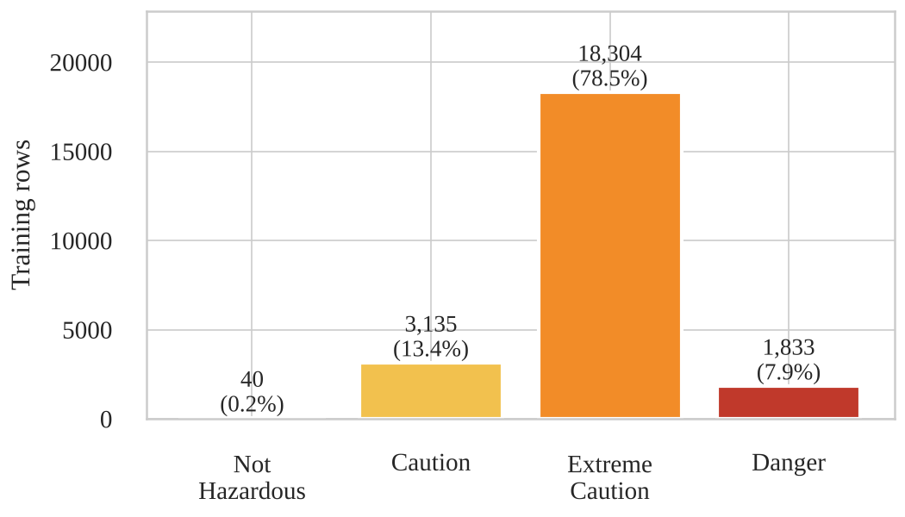
Fig. 1. Number of training rows in each level of HeatLevelTomorrow.
Extreme Caution makes up 78.5% of training rows (18,304), Caution 13.4% (3,135), Danger 7.9% (1,833) and Not Hazardous 0.17% (40); Extreme Danger never occurs. A model that always predicts Extreme Caution would be right on about 78% of rows, so accuracy is not used to choose models. Macro F1 over the three core levels and Danger recall are used instead, and class weights are tested.
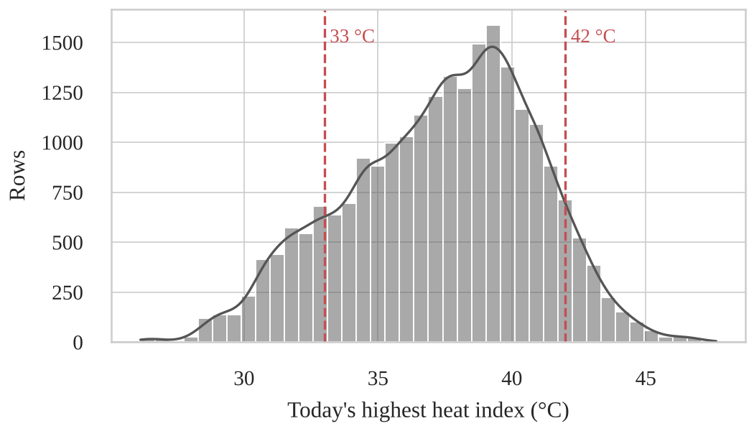
Fig. 2. Distribution of today's highest heat index (training days).
The highest heat index is roughly bell-shaped (mean 37.4 °C, median 37.7 °C, skewness -0.31). Most days fall between 35 and 40 °C, inside Extreme Caution, and only a thin tail lies above 42 °C. No transformation is needed. Danger is a tail event, so Danger recall is checked separately.
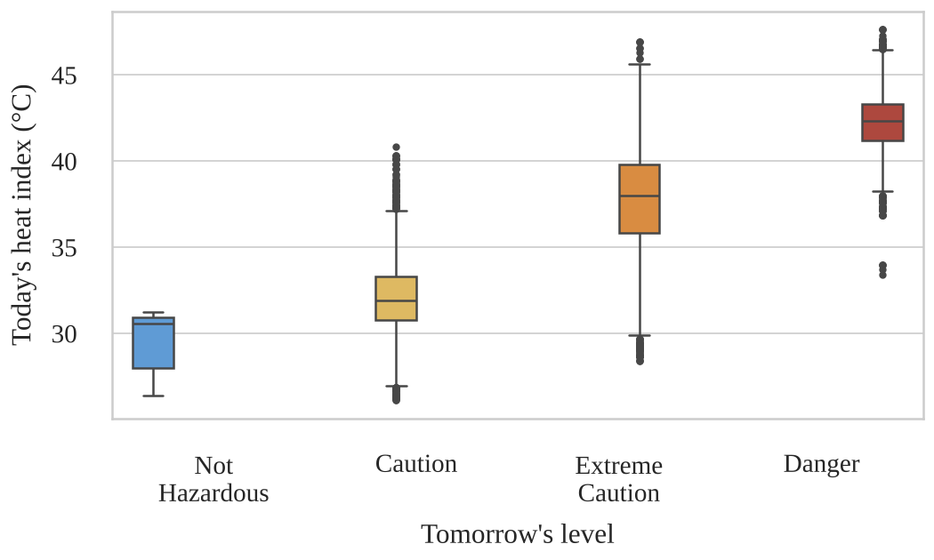
Fig. 3. Today's highest heat index by tomorrow's level.
The median of today's heat index rises with tomorrow's level: 30.6 °C for Not Hazardous, 31.9 °C for Caution, 38.0 °C for Extreme Caution and 42.4 °C for Danger. Today's heat index is therefore the main input. The boxes of neighbouring levels overlap, so it cannot separate the levels alone, and the other four inputs and the city are kept.
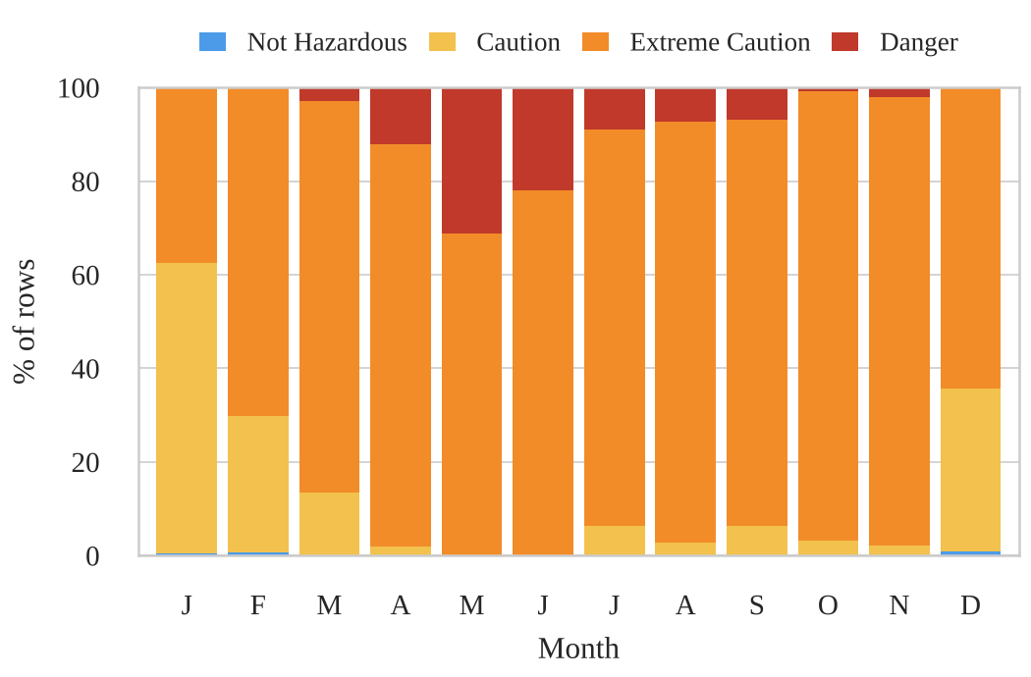
Fig. 4. Share of each level by month (training days).
Danger occurs from March to November and is most common in May (31.1% of May rows), June (21.9%) and April (12.1%); it never occurs in December, January or February. Caution is most common in January (62.0%) and December (34.6%). A month input could add information that the weather inputs do not give, but it was not added, so that all three models use the same five inputs; it is left as a recommendation.
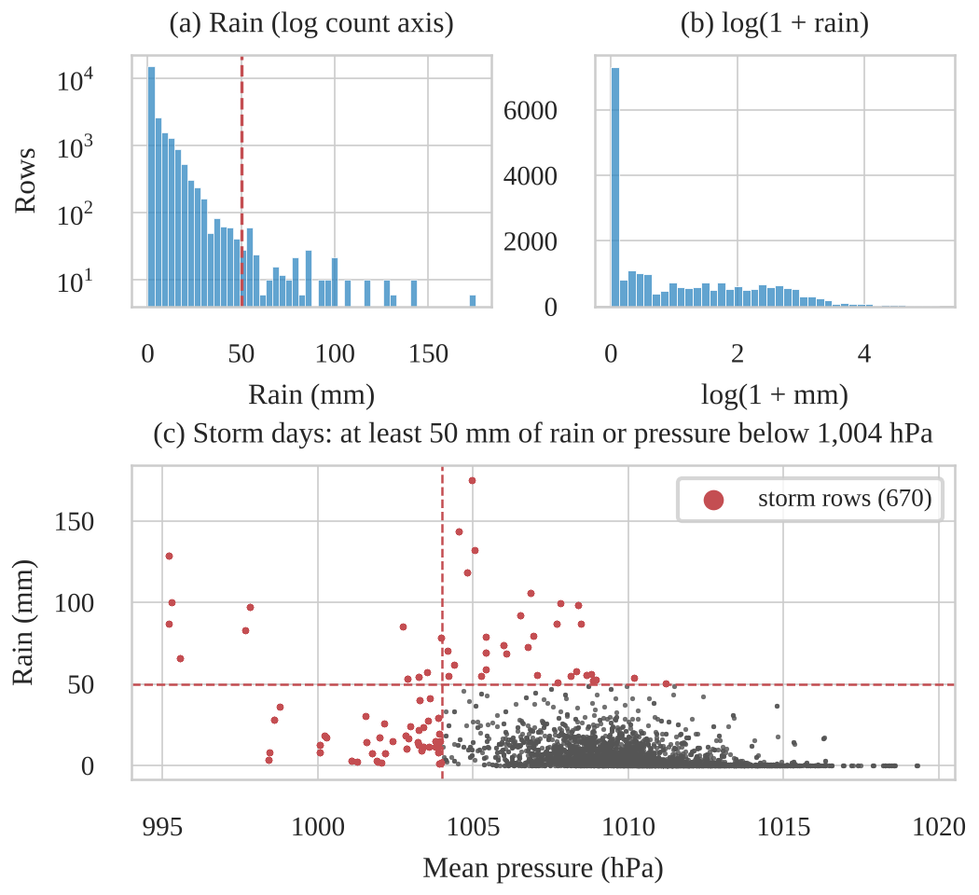
Fig. 5. Distribution of daily rainfall and storm days (training days).
Rainfall is very skewed (skewness 5.45): 26.5% of rows have no rain, the median is 1.2 mm and the maximum is 175.1 mm, and log(1 + x) lowers the skewness to 0.73. Storm days (at least 50 mm of rain or a mean pressure below 1,004 hPa) are 670 rows (2.9%). They are real weather, not errors, and 83.6% of them are followed by Extreme Caution, so they are kept. The log transform was tested for Logistic Regression and changed its scores by less than 0.01, so it was not kept; the tree models do not need it.
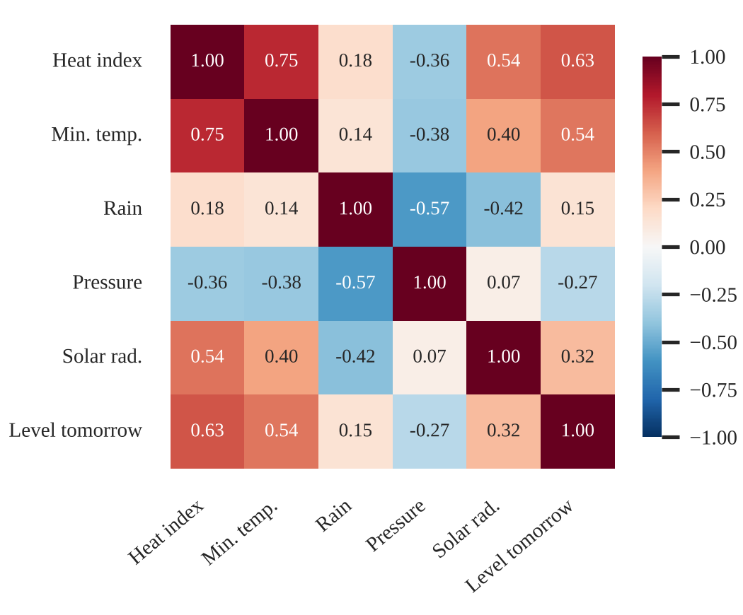
Fig. 6. Spearman correlations between the five inputs and with tomorrow's level.
The correlation with tomorrow's level (coded 0 to 3) is highest for today's heat index (0.63) and lowest temperature (0.54), and lower for solar radiation (0.32), pressure (-0.27) and rainfall (0.15). Among the inputs, the heat index and the lowest temperature are linked at 0.75 and rainfall and pressure at -0.57. No pair is above 0.8, so all five inputs are kept, with standardization and regularization for Logistic Regression.
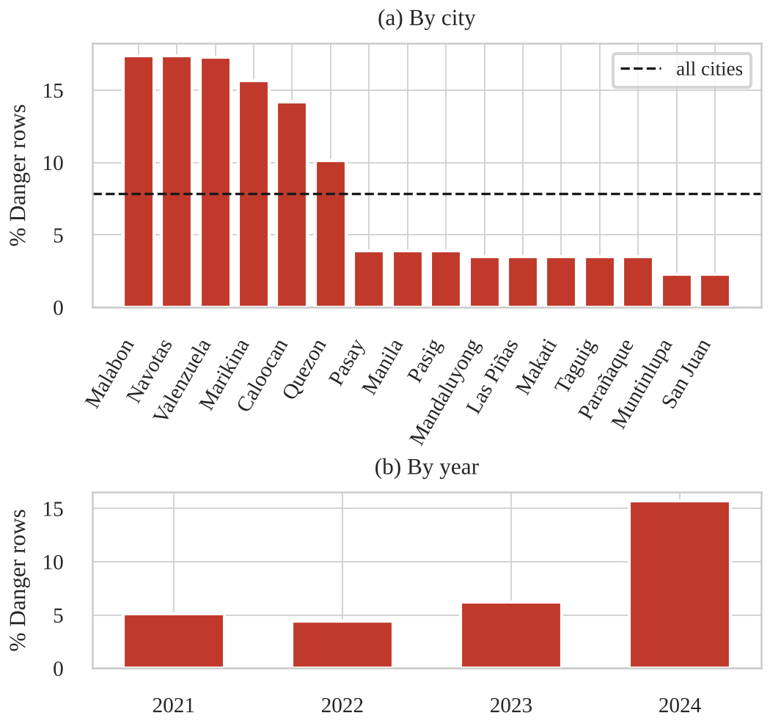
Fig. 7. Share of Danger rows by city and by year (training days).
Danger is concentrated in a few cities: 17.3% to 17.4% of training rows in Malabon, Navotas and Valenzuela, 15.6% in Marikina and 14.2% in Caloocan, against 2.3% to 3.9% in ten other cities. By year it is 5.2% (2021), 4.4% (2022), 6.2% (2023) and 15.7% (2024), so 2024 was much hotter than the other years. City is kept as an input, and the folds are cut by whole days in time order.
Table II summarizes the seven findings and the decision each one led to.
Table II. Exploratory data analysis findings and the decisions they led to (training days)
Fig. | Finding | Decision
1 | Extreme Caution is 78.5% of training rows; Not Hazardous 0.17%; Extreme Danger never occurs | Models chosen on macro F1 over the three core levels and Danger recall, not accuracy; class weights tested
2 | Today's heat index is roughly bell-shaped (skewness -0.31); Danger is a thin tail above 42 °C | No transformation; Danger recall checked separately
3 | Today's heat index rises with tomorrow's level, but neighbouring levels overlap | Heat index is the main input; the other four inputs and the city are kept
4 | Danger occurs only from March to November, mostly in April to June | No month input, so that all models use the same inputs; left as a recommendation
5 | Rain is very skewed (5.45); 670 storm rows (2.9%) are real weather | Storm rows kept; log(1 + rain) tested for Logistic Regression and not kept
6 | No pair of inputs is above 0.8; today's heat index has the strongest link with the target (0.63) | All five inputs kept; standardization and regularization for Logistic Regression
7 | The Danger share differs between cities (2.3% to 17.4%) and years (4.4% to 15.7%) | City kept as an input; folds cut by whole days in time order

B. Reference baseline
The persistence rule scores a macro F1 of 0.620 ± 0.102 on the five folds (0.679 ± 0.051 over Caution, Extreme Caution and Danger), with accuracy 0.846 ± 0.039, Danger recall 0.518 ± 0.153 and Danger precision 0.527 ± 0.153 (mean ± standard deviation over the folds). On the test days, which are used here only as a reference because the rule has no fitted parts, it scores macro F1 0.675, accuracy 0.824 and Danger recall 0.597.

C. Model comparison
Table III. Cross-validation results, mean ± SD over the same five folds
Metric | Persistence rule | Logistic Regression | Random Forest | Gradient Boosting
Macro F1, core 3 | 0.679 ± 0.051 | 0.632 ± 0.043 | 0.653 ± 0.039 | 0.643 ± 0.045
Macro F1, all levels | 0.620 ± 0.102 | 0.569 ± 0.095 | 0.589 ± 0.103 | 0.578 ± 0.092
Accuracy | 0.846 ± 0.039 | 0.858 ± 0.038 | 0.794 ± 0.035 | 0.790 ± 0.037
Danger recall | 0.518 ± 0.153 | 0.276 ± 0.101 | 0.672 ± 0.193 | 0.670 ± 0.228
Danger precision | 0.527 ± 0.153 | 0.655 ± 0.158 | 0.402 ± 0.113 | 0.381 ± 0.108
Pooled over the five check blocks (Table IV), Logistic Regression catches 512 of the 1,553 Danger days (33%), Random Forest 1,171 (75%) and Gradient Boosting 1,190 (77%). The share of Danger predictions that are correct falls the other way: 72%, 44% and 44%.
Table IV. Confusion matrices for the selected setting of each model, summed over the five check blocks (rows: true level; columns: predicted level). Rows with Not Hazardous as the true or predicted level are left out.
Model | True level | Predicted Caution | Predicted Extreme Caution | Predicted Danger
Logistic Regression | Caution | 1,574 | 972 | 0
Logistic Regression | Extreme Caution | 487 | 14,530 | 202
Logistic Regression | Danger | 0 | 1,041 | 512
Random Forest | Caution | 1,990 | 555 | 0
Random Forest | Extreme Caution | 1,530 | 12,216 | 1,473
Random Forest | Danger | 0 | 382 | 1,171
Gradient Boosting | Caution | 1,943 | 598 | 0
Gradient Boosting | Extreme Caution | 1,518 | 12,166 | 1,535
Gradient Boosting | Danger | 0 | 363 | 1,190
Table V gives the precision, recall and F1 of each level for the three models, computed from the summed matrices of Table IV (src/compare_models.py in [12]). Logistic Regression has the highest Danger precision (0.717) but the lowest Danger recall (0.330), while the two tree models give almost the same balance (Danger F1 0.558 and 0.556). Extreme Caution has the highest F1 for every model. None of the models classified any of the 40 Not Hazardous rows correctly, so that level is left out of the table.
Table V. Precision, recall and F1 of each level for the selected setting of each model, from the confusion matrices summed over the five check blocks
Model | Level | Precision | Recall | F1
Logistic Regression | Caution | 0.749 | 0.618 | 0.677
 | Extreme Caution | 0.878 | 0.955 | 0.915
 | Danger | 0.717 | 0.330 | 0.452
Random Forest | Caution | 0.559 | 0.781 | 0.652
 | Extreme Caution | 0.929 | 0.803 | 0.861
 | Danger | 0.443 | 0.754 | 0.558
Gradient Boosting | Caution | 0.555 | 0.763 | 0.642
 | Extreme Caution | 0.927 | 0.799 | 0.858
 | Danger | 0.437 | 0.766 | 0.556

D. Final test evaluation
The selected Random Forest (maximum depth 12, at least 5 days per leaf, balanced class weights, 500 trees) was fitted once on all training days and evaluated once on the 365 test days (2024-12-29 to 2025-12-28, 5,840 rows). Nothing was changed after this evaluation. Table VI gives its scores next to the persistence rule on the same days and next to its own cross-validation scores, and Table VII gives its confusion matrix.
Table VI. Final test results on the untouched test days
Metric | Random Forest, test days | Persistence rule, test days | Random Forest, 5 folds (mean ± SD)
Macro F1 (core 3) | 0.614 | 0.675 | 0.653 ± 0.039
Macro F1 (all levels) | 0.614 | 0.675 | 0.589 ± 0.103
Accuracy | 0.731 | 0.824 | 0.794 ± 0.035
Danger recall | 0.844 | 0.597 | 0.672 ± 0.193
Danger precision | 0.359 | 0.597 | 0.402 ± 0.113
The model caught 293 of the 347 Danger days (recall 0.844), against 207 for the persistence rule (0.597), but only 293 of its 816 Danger predictions were correct (precision 0.359, against 0.597 for the rule). Its core macro F1 (0.614) and accuracy (0.731) are below the rule's (0.675 and 0.824). Its core macro F1 is one fold standard deviation below its cross-validation mean, and its Danger recall is above its cross-validation mean but within the spread between folds. Not Hazardous and Extreme Danger do not occur in the test days, so the macro F1 over all levels equals the core macro F1.
Table VII. Confusion matrix of the selected Random Forest on the test days (rows: true level; columns: predicted level). The model also predicted Not Hazardous for 3 Caution and 15 Extreme Caution days; these are left out.
True / predicted | Caution | Extreme Caution | Danger
Caution | 540 | 263 | 0
Extreme Caution | 713 | 3,436 | 523
Danger | 0 | 54 | 293
Per level, precision and recall are 0.43 and 0.67 for Caution, 0.92 and 0.73 for Extreme Caution, and 0.36 and 0.84 for Danger (F1 0.52, 0.81 and 0.50). No Danger day was predicted as Caution and no Caution day as Danger. The 347 Danger days fall mostly in April to June (317), and 421 of the 523 false Danger predictions fall in the same months.

E. Application evidence
The application (Fig. 8) was tested with valid, invalid and boundary inputs through 51 automated tests, which include runs of the whole page without a browser, and the same cases were repeated by hand in a browser. Appendix D lists twelve of these cases with the application's answers. Valid inputs for any of the 16 cities give a predicted level with the probability of each of the five levels; for example, a heat index of 45.5 °C, a lowest temperature of 29 °C, no rain, 1,008 hPa and 7,000 Wh/m² of solar radiation in Manila give Danger with a probability of about 90%. Invalid inputs (an empty box, text, infinity, rain of -5 mm, a heat index of 200 °C or a city that is not in the list) give an error that names the input, and no prediction. Boundary inputs behave as specified: rain of exactly 0 or 500 mm is accepted, -0.01 or 500.01 mm is refused, a heat index of 55 °C (above the 47.63 °C maximum of the data) gives a prediction with a warning, and today's level changes exactly at 27, 33 and 42 °C. The map shows the chosen city in blue and, after the prediction, in the colour of the predicted level.
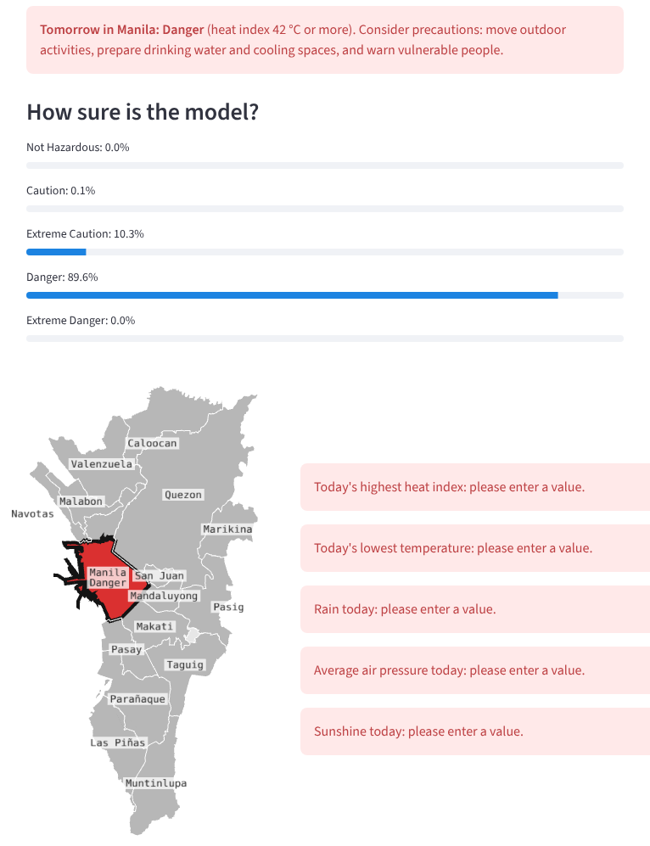
Fig. 8. The HeatCast NCR application. Top: a Danger prediction for Manila with the probability of each level. Bottom left: the map, with Manila in the colour of the predicted level. Bottom right: the error messages when the form is sent with every box empty.

IV. Discussion
No model beat the persistence rule on overall classification. On the folds the best core macro F1 was 0.653 (Random Forest) against 0.679 for the rule, and on the test days the selected model scored 0.614 against 0.675. Tomorrow's heat level is closely tied to today's: a linear fit on today's heat index alone explains 70% of the variance of tomorrow's (Methods), and permutation importance shows that today's heat index is by far the most important input of the Random Forest (shuffling it lowers core macro F1 by 0.267 on the last fold, against 0.086 for the lowest temperature and about 0.01 for the city). With only today's values as inputs, the models have little information beyond what the rule already uses.
What the tree models add is a different balance of errors. With balanced class weights, Random Forest and Gradient Boosting catch more Danger days than the rule (Danger recall about 0.67 on the folds and 0.844 for Random Forest on the test days, against 0.518 and 0.597), while Logistic Regression without weights misses most of them (0.276). The price is false alarms: on the test days the Random Forest made 523 false Danger predictions for 293 correct ones, against 140 false and 207 correct for the rule. Almost all errors are between neighbouring levels, which matches the overlap in Fig. 3, and most false alarms fall in the hot months (421 of 523 in April to June).
Random Forest was selected because it passes the Danger recall check and has the highest core macro F1 of the models that pass. Its lead over Gradient Boosting (0.653 against 0.643) is much smaller than the spread between folds (standard deviation about 0.04), so the two tree models should be treated as equivalent, and Gradient Boosting could replace it with almost no change in the results. The choice depends on how a missed Danger day is weighed against a false alarm. For schools and outdoor work, where a missed Danger day can harm people and a false alarm costs a change of schedule, a model that catches 84% of Danger days at a precision of 36% can be useful. For users who act only on reliable warnings, the persistence rule is the better choice.
Danger scores vary widely between folds (Random Forest recall from 0.36 to 0.81), because Danger is seasonal and differs between years: 2024 had 15.7% Danger rows against 4.4% to 6.2% in 2021 to 2023, and the first fold learns from only about eight months. The test year is a single year with 5.9% Danger rows, so the test scores are one more sample from this spread, not a precise estimate. The 16 cities share two ERA5 grid cells, so the number of independent observations is smaller than the row count suggests.

V. Conclusion and Recommendations
This study asked whether Logistic Regression, Random Forest and Gradient Boosting, trained on five of today's weather values and the city, can classify tomorrow's PAGASA heat level in the 16 cities of Metro Manila better than copying today's level. On overall score they cannot: no model beat the persistence rule on core macro F1 or accuracy, either in cross-validation or on the test year. The selected Random Forest is better than the rule only at catching Danger days (test recall 0.844 against 0.597), and it pays for this with many false alarms (precision 0.359). Its practical value is as an early-warning aid for users who would rather prepare for a Danger day that does not come than miss one. It is deployed in a Streamlit application that validates every input and states that it is not a PAGASA advisory.
The results are limited by the data: weather-model estimates instead of station readings, 16 cities that fall in only two ERA5 grid cells, Danger days that are rare and vary from year to year, and only five years of data.
Realistic improvements are: adding the month and the previous days' heat index as inputs, since season and recent trend carry information that today's values alone do not; adding a numerical weather forecast for tomorrow as an input; training on the full 2015 to 2025 period of the original dataset; checking the labels against PAGASA station readings; and letting users choose the probability threshold for a Danger warning, so that each user sets their own balance between missed Danger days and false alarms.

References
[1] DOST-PAGASA, "iHeatMAP: Interactive Heat Index Monitoring and Prediction," heat index categories. [Online]. Available: https://src.panahon.gov.ph/pubfiles/cad/iaas/ihif_new (accessed Oct. 12, 2026).
[2] NWS Weather Prediction Center, "The Heat Index Equation." [Online]. Available: https://www.wpc.ncep.noaa.gov/html/heatindex_equation.shtml; L. P. Rothfusz, "The Heat Index Equation (or, More Than You Ever Wanted to Know About Heat Index)," NWS Southern Region Technical Attachment SR/SSD 90-23, 1990.
[3] psgc: Philippine Standard Geographic Code with coordinates, v2026.4.13.0. [Online]. Available: https://pypi.org/project/psgc/ and https://github.com/fish-and-bear/psgc
[4] Y. Han and C. Randall, "Machine learning-based prediction of heat index in selected U.S. cities," arXiv:2603.19488 [physics.ao-ph], Mar. 2026. [Online]. Available: https://arxiv.org/abs/2603.19488
[5] J. I. Gojo Cruz, J. M. L. de Vera, and K. E. Pilario, "Machine learning-driven analysis of agro-climatic data for temperature modeling and forecasting in Philippine urban areas," Urban Climate, vol. 60, Art. no. 102339, 2025, doi: 10.1016/j.uclim.2025.102339.
[6] G. R. Herman and R. S. Schumacher, "'Dendrology' in numerical weather prediction: What random forests and logistic regression tell us about forecasting extreme precipitation," Monthly Weather Review, vol. 146, no. 6, pp. 1785–1812, 2018, doi: 10.1175/MWR-D-17-0307.1.
[7] S. Rasp, P. D. Dueben, S. Scher, J. A. Weyn, S. Mouatadid, and N. Thuerey, "WeatherBench: A benchmark data set for data-driven weather forecasting," Journal of Advances in Modeling Earth Systems, vol. 12, no. 11, Art. no. e2020MS002203, 2020, doi: 10.1029/2020MS002203.
[8] Open-Meteo, "Historical Weather API documentation." [Online]. Available: https://open-meteo.com/en/docs/historical-weather-api
[9] Copernicus Climate Change Service, "ERA5 hourly data on single levels." [Online]. Available: https://cds.climate.copernicus.eu/datasets/reanalysis-era5-single-levels
[10] OCHA/HDX, "Philippines Subnational Administrative Boundaries." [Online]. Available: https://data.humdata.org/dataset/cod-ab-phl
[11] J. Faeldon, "Philippines Administrative Boundaries JSON Maps," 2023 PSGC boundaries, MIT licence. [Online]. Available: https://github.com/faeldon/philippines-json-maps
[12] HeatCast NCR (simple version) project repository (original and processed data, code, tests). [Online]. Available: https://github.com/keyyum/heatcast-ncr-simple

Appendices

Appendix A. Contribution record
Member | Assigned responsibility | Model | Actual contribution and evidence | Confirmed
Edrian Tala | Project definition, integration and deployment | Random Forest | Lead for the project definition (Group Workspace Section 1). Built and tuned the Random Forest (26 settings on the five folds) and wrote Group Workspace Section 5.2 and the Random Forest parts of this paper. Ran the single final test of the selected model (Group Workspace Section 6.4; Tables VI and VII). Built, tested and deployed the Streamlit application (input validation, map of the NCR cities, 51 automated tests) and wrote Group Workspace Section 7. Integrated the code in the repository, saved the selected model for the application, and prepared the IEEE layout of this paper with the per-level comparison (Table V) and Appendix D. Evidence: notebooks/03_random_forest.ipynb, notebooks/05_final_test.ipynb, app/ and tests/test_app.py in the repository [12], pull requests #3 to #6 and #8, and edits in both documents (Oct. 11 to 13, 2026).
Harry Verdeflor | Data and technical documentation | Logistic Regression | Checked the dataset documentation (Group Workspace Section 2) against the data and the repository, and corrected figures in the Group Workspace and this paper: the April to June share of Danger rows, the EDA training counts and summary statistics, missing subset labels, and reference [1] (now PAGASA iHeatMAP). Built and tuned the Logistic Regression model (eight settings on the five folds, plus a log(1 + rainfall) variant) and wrote Section 5.1 of the Group Workspace, the Logistic Regression paragraph under Algorithms and tuning, its row in Table III, and the primary metric (Group Workspace Section 6.1). Wrote the related literature in the Introduction (references [4] to [7]) and Table IV, and opened pull request #2 on behalf of Marc Lawrence David. Evidence: notebooks/02_logistic_regression.ipynb, pull requests #1 and #2 (both merged), and edits in both documents (Oct. 11 to 14, 2026).
Marc Lawrence David | EDA, results and testing evidence | Gradient Boosting | Ran the exploratory data analysis: data checks, summary statistics and the seven figures with their findings and decisions (Group Workspace Section 3; Figs. 1 to 7 of this paper). Built and tuned the Gradient Boosting model (16 settings on the five folds) and wrote Group Workspace Section 5.3 and its row in Table III. Evidence: notebooks/01_eda.ipynb (pull request #7) and notebooks/04_gradient_boosting.ipynb (pull request #2, opened by Harry Verdeflor on his behalf) in the repository [12].
[To add before submission: each member's confirmation in the last column.]

Appendix B. Ownership and authorship declaration
[To add before submission: the declaration signed by the instructor and all group members, with the approved project title.]
Ownership and Authorship Declaration
This signed declaration is a required submission document. Complete all fields, obtain the signatures of the instructor and every group member, convert the signed copy to PDF, and include it in the documentation folder and as an appendix to the final paper.
Project Information | Details
Project title | HeatCast NCR
Course and section | CCMACLRL COM241-ML
Group name or number | 9??
Date submitted | October 15, 2026

Declaration Statement
We, Dr. Armida P. Salazar as the course instructor and the undersigned student group members, jointly declare that we are the owners and authors of the submitted project output identified above. The project output includes the application, source code, trained model and saved pipeline, exploratory data analysis, visualizations, technical documentation, research paper, and original materials produced specifically for this course project.
We affirm that the submitted work accurately represents our documented contributions and that all external datasets, software libraries, code, models, frameworks, images, publications, and other third party materials have been properly cited, licensed, or acknowledged using IEEE citation format where applicable. This declaration does not transfer or claim ownership of pre-existing third party or institutional materials and remains subject to applicable National University policies, intellectual property rules, licenses, and Philippine law.
Signatories
Name and Role | Signature | Date
Dr. Armida P. Salazar
Course Instructor
Edrian Tala  Student Group Member |  | October 15, 2026
Harry Verdeflor  Student Group Member |  | October 15, 2026
Marc Lawrence David  Student Group Member |  | October 15, 2026
Claude

Appendix C. Data dictionary
Table VIII. The dataset ncr_city_daily.csv (29,168 rows, one per city per day, 2021 to 2025)
Column | Definition | Unit | Range (min / median / max)
Date | The day of the weather ("today") | YYYY-MM-DD | 2021-01-01 to 2025-12-28
City | The city of Metro Manila (input, encoded as 16 yes/no columns) | name | 16 values
HeatIndex_Max_Today | Today's highest heat index in that city | °C | 26.13 / 37.68 / 47.63
Temp_Min | Today's lowest air temperature | °C | 22.00 / 26.20 / 30.00
Rainfall_Total | Rain during today | mm | 0.0 / 1.3 / 175.1
Pressure_Mean | Average air pressure at sea level today | hPa | 995.20 / 1010.17 / 1019.31
SolarRadiation_Total | Sunshine energy received today | Wh/m² | 478 / 4,830 / 7,551
HeatLevelTomorrow | Level of tomorrow's highest heat index in that city (target) | 5 labels | Not Hazardous, Caution, Extreme Caution, Danger, Extreme Danger

Appendix D. Sample inputs and outputs
Each case was sent through the same input checks and the same saved model as the application (app/sample_inputs_outputs.py in [12]; the results are in documentation/sample_inputs_outputs.csv). The output is the predicted level with its probability, or the message shown instead of a prediction.
Table IX. Sample inputs and the application's answers
Type | Case | City | Heat index (°C) | Min. temp. (°C) | Rain (mm) | Pressure (hPa) | Solar (Wh/m²) | Output
Valid | A normal dry day | Manila | 38 | 26 | 0 | 1010 | 5000 | Extreme Caution (90%)
Valid | A very hot sunny day | Manila | 45.5 | 29 | 0 | 1008 | 7000 | Danger (90%)
Valid | A cool rainy day | Quezon | 29 | 24 | 90 | 1003 | 1500 | Caution (55%)
Valid | A hot day in a hot city | Malabon | 42 | 27.5 | 0 | 1010 | 6500 | Danger (87%)
Boundary | Rain exactly 0 mm (lower limit) | Pasig | 38 | 26 | 0 | 1010 | 5000 | Extreme Caution (90%)
Boundary | Rain exactly 500 mm (upper limit) | Pasig | 38 | 26 | 500 | 1010 | 5000 | Extreme Caution (79%); warning: 500 mm is outside the 0 to 175.1 mm seen in the 2021 to 2024 training days
Boundary | Heat index 55 °C (above the data maximum) | Manila | 55 | 26 | 0 | 1010 | 5000 | Danger (54%); warning: 55 °C is outside the 26.13 to 47.63 °C seen in the 2021 to 2024 training days
Invalid | Rain -5 mm | Manila | 38 | 26 | -5 | 1010 | 5000 | No prediction; error: Rain today: -5 mm is not possible here. Accepted values are 0 to 500 mm.
Invalid | Heat index 200 °C | Manila | 200 | 26 | 0 | 1010 | 5000 | No prediction; error: Today's highest heat index: 200 °C is not possible here. Accepted values are 10 to 60 °C.
Invalid | Pressure left empty | Manila | 38 | 26 | 0 | (empty) | 5000 | No prediction; error: Average air pressure today: please enter a value.
Invalid | Text instead of a number | Manila | 38 | "warm" | 0 | 1010 | 5000 | No prediction; error: Today's lowest temperature: not a number. Enter a number in °C.
Invalid | A city outside the data | Cebu | 38 | 26 | 0 | 1010 | 5000 | No prediction; error: Choose one of the 16 cities.

