Master Development Prompt
Full-Stack Expense Tracker & Personal Finance Management System
Technology stack: React + Vite • Tailwind CSS • FastAPI • SQLAlchemy • PostgreSQL • Supabase | Version 2 (optimized, with light/dark design system)

How to use this document
- Paste everything from “MASTER DEVELOPMENT PROMPT” (next heading) to the end of Section 16 into your AI coding assistant as your first message. It will reply with a plan only, no code.
- Review the plan, then send one short message per phase, for example: “Plan approved. Start Phase 1.” After each phase, run the app yourself. Then reply “Phase 1 verified. Start Phase 2,” or paste the exact error text.
- If the chat gets long or the assistant starts forgetting rules: open a new chat and paste Sections 1–5 and 13, then add: “We are on Phase N. Here is my current folder structure: …”.
- The Appendices (diagrams and change log) are for you. You do not need to paste them.

MASTER DEVELOPMENT PROMPT

1. Your Role
Act as a senior full-stack software engineer, system architect, UI/UX designer, database engineer, and software tester.
Your task is to design and build a production-minded, secure, scalable, and user-friendly expense tracking and personal finance management application.
Do not merely generate a static dashboard or frontend mockup. Build a functional application with a working frontend, backend API, database integration, authentication, transaction management, budget calculations, reporting, and persistent data storage.
Work incrementally, explain important implementation decisions, and ensure that the application runs correctly before proceeding to the next phase.

2. Project Overview
Build a web application that allows individuals to record their income and expenses, manage budgets, monitor cash flow, track multiple financial accounts, upload receipts, analyze spending patterns, and make informed financial decisions.
The application should help users answer questions such as:
- How much money did I earn this month?
- How much money did I spend?
- What is my current financial position?
- Which categories consume most of my money?
- Am I staying within my budget?
- Which bills are due soon?
- How has my spending changed compared with previous months?
- How much can I reasonably save?
- Which spending habits should I review?
The application must be useful even when a user has no bank integration. Manual transaction recording must be fully supported.

Scope tiers
Build in this order. Do not start a later tier until the earlier tier is verified.
Tier | Contents | Phases
MVP | Authentication, categories, basic accounts, transaction CRUD with search/filter/pagination, dashboard, budgets | 1 – 4
V1 | Account transfers, receipts, reports and exports, recurring transactions, bills, notifications | 5 – 6
Hardening | Security review, full test pass, accessibility, deployment, documentation | 7
Later (only if asked) | OCR receipt scanning, AI-generated insights, bank integration, email notifications, currency conversion, mobile app | —

3. Technology Stack

Frontend
- React with Vite.
- JavaScript and JSX, not TypeScript.
- Tailwind CSS for styling, using the design tokens in Section 9.
- React Router for navigation.
- Axios for HTTP requests.
- TanStack Query (React Query) for server-state caching, loading states, and error states.
- Recharts for financial charts.
- React Hook Form where useful for forms.
- Lucide React for icons.
- A reusable component architecture.
- Vitest and React Testing Library for frontend tests.

Backend
- Python 3.12 with FastAPI.
- Pydantic for request validation and response schemas.
- SQLAlchemy 2.x for database operations.
- Alembic for database migrations.
- PostgreSQL as the primary database.
- Supabase Auth for authentication, as decided in Section 4.
- Pytest and httpx for backend tests, using a separate test database.
- slowapi (or equivalent) for rate limiting.

Infrastructure and deployment
- Supabase PostgreSQL for managed database hosting.
- Supabase Storage for private receipt uploads.
- Vercel for frontend deployment.
- Render for the FastAPI API, plus a Render Cron Job for scheduled work.
- Git and GitHub for version control; GitHub Actions to run tests on every push.
- Environment variables for secrets and configuration.
Keep backend database access under the application’s control. Do not expose database credentials or service-role keys to the browser.

4. Fixed Technical Decisions
These decisions are final. Use them consistently. Do not reopen them unless you find a concrete technical blocker, and if so, explain it and ask me first.
Topic | Decision
Authentication | Supabase Auth in the browser (register, login, reset password). FastAPI verifies the access token (JWT) on every private request using Supabase’s published signing keys. The user ID is the token’s sub claim. FastAPI never stores or handles passwords.
Database access | Only FastAPI talks to PostgreSQL, through SQLAlchemy and the Supabase pooled connection string. The browser never queries tables directly. Enable row-level security on every table with no client policies (deny by default) as a second layer; the backend still enforces ownership in every query.
Money storage | Integer minor units (BIGINT; kobo, cents) plus an ISO 4217 currency code. Amounts are always positive; the transaction type decides direction. Use a currency table for decimal places (NGN = 2, JPY = 0). Format only at the UI edge with Intl.NumberFormat. Never use floats.
Currencies | Each account has one currency, and each transaction uses its account’s currency. Totals are computed per currency. No exchange-rate conversion in the MVP, and transfers between different currencies are rejected.
Transaction types | income adds to the account. expense subtracts. refund adds to the account and reduces spending in its category (optionally linked to the original expense). transfer is one row with a source account and a destination account; it is excluded from all income and expense totals.
Deletion | Transactions are soft-deleted (deleted_at), excluded from every calculation, and recorded in the audit log. Accounts with transactions are archived, not deleted. Categories in use cannot be deleted until their transactions are reassigned.
Credit cards | Balance represents money owed (negative). A purchase is an expense on the card account. A repayment is a transfer from a bank or cash account to the card, so it is never counted as an expense.
Time | Store timestamps as UTC (timestamptz). Each transaction also has a transaction_date (DATE in the user’s timezone). All periods, budgets, and reports use the user’s timezone (default Africa/Lagos).
Scheduled work | A Render Cron Job (or GitHub Actions schedule) runs a job entry point daily. Do not rely on an in-process scheduler, because free web services sleep. Idempotency comes from a unique constraint on (recurring_id, occurrence_date).
API conventions | JSON only. Success: { "data": ..., "meta": ... }. Error: { "error": { "code", "message", "details" } }. Pagination: page and page_size (max 100) with meta.total. Money is returned as integer minor units plus currency code.
Duplicate protection | POST /transactions accepts an Idempotency-Key header, stored with a unique (user_id, key) constraint. Repeating a request returns the original result.
Receipts | Max 5 MB; JPEG, PNG, WebP, or PDF; verify file signature (magic bytes) on the server; storage path {user_id}/{transaction_id}/{uuid}.{ext}; signed URLs expire in 60–300 seconds.

5. Application Architecture
- The React frontend displays information, collects user input, and communicates with the API.
- The FastAPI backend validates requests, authenticates users, enforces authorization, performs business calculations, and returns responses.
- PostgreSQL stores persistent application data.
- Private object storage stores receipt files.
- Scheduled background jobs handle reminders and recurring transactions.
- The frontend must never be the authoritative source of financial totals or permissions.
Use a modular backend with these layers, and keep dependencies flowing downward only:
Router -> Schema (Pydantic) -> Service (business rules) -> Repository (SQLAlchemy) -> PostgreSQL
Every private request follows this path: browser sends Authorization: Bearer <JWT> -> middleware (CORS, rate limit, request ID) -> auth dependency verifies the token and yields current_user_id -> router -> service -> repository, where every query is filtered by `user_id` -> response envelope.

6. Core Features

A. Authentication and user accounts
Implement:
- User registration, login, logout, session persistence, and protected routes.
- Password reset through the Supabase-supported flow.
- User profile management, currency preference, timezone preference, and theme preference (light, dark, or system).
- Secure handling of expired or invalid tokens: the client refreshes the session once, then signs the user out.
- Strict separation of each user’s records.
Every API operation involving private data must verify the authenticated user’s identity and ownership of the requested resource. Never rely solely on frontend route protection for security.

B. Transaction management
Implement complete CRUD functionality: create, read, update, and delete (soft delete). Every transaction should support:
- Unique transaction ID and user ID.
- Transaction date and time.
- Amount (integer minor units) and currency.
- Transaction type: income, expense, refund, or transfer.
- Category and optional subcategory.
- Account and payment method (cash, bank transfer, debit card, credit card, mobile wallet).
- Vendor or recipient and description.
- Optional tags, project/context, and receipt attachment.
- Creation, update, and deletion timestamps.
Provide transaction form validation; search by vendor, description, and category; filtering by date, amount, type, category, account, and payment method; sorting and pagination; editing and deletion with confirmation; useful empty states and error messages; and duplicate-submission protection (Section 4).
Follow the money, refund, transfer, and deletion rules in Section 4 exactly. Document them in the README.

C. Categories and subcategories
Create default categories that users can customize.
- Suggested expense categories: housing and rent; food and groceries; restaurants; transportation; utilities; healthcare; education; entertainment; shopping; debt repayments; savings and investments; personal care; family expenses; business expenses; other expenses.
- Suggested income categories: salary; freelance income; business income; gifts; interest; other income.
Users should be able to create, edit, and organize categories and subcategories. Prevent deletion of categories that are still referenced by transactions unless the user first reassigns those transactions.

D. Dashboard
Create a polished, responsive dashboard with: total income, total expenses, net cash flow, current account balances, budget utilization, recent transactions, spending by category, income-versus-expense chart, monthly spending trend, upcoming bills, relevant budget alerts, and savings progress where applicable.
Allow users to change the reporting period: this month, last month, last 30 days, quarter, year, and custom date range. All displayed totals must be derived from actual database records and calculated by the backend using consistent rules. Show helpful onboarding instructions when a new user has no transactions.

E. Budget management
Allow users to create budgets with a name, category or overall spending limit, amount, currency, start date, end date or recurrence rule, period (monthly or other supported period), and optional notification thresholds.
Display planned budget, actual spending, remaining budget, percentage used, progress bar, and a status of on track, approaching limit, or over budget. Make thresholds configurable (default: warn at 80% and 90%, exceeded above 100%).
Calculate actual spending from eligible transactions (expenses minus refunds, excluding transfers and deleted rows) rather than storing a separate spending total. Handle budget periods, category changes, and timezones consistently.

F. Reports and analytics
Implement reports for: daily, weekly, monthly, quarterly, and annual cash flow; income versus expenses; spending by category and subcategory; account activity; budget versus actual; largest expenses; spending trends; and savings trends where data exists.
Include clear date filters, chart labels, currency formatting, and transaction counts. Allow users to export filtered transactions to CSV and generate printable or downloadable PDF summaries. Reports must reconcile with the underlying transactions. Do not fabricate analytics or show sample data as if it were real.

G. Receipt management
Allow users to attach, replace, and remove receipts on transactions, following the limits in Section 4. Validate type and size on the server. Use private storage and restrict access to the owner. Deliver files only through expiring signed URLs created by the backend. Store file metadata and storage paths in PostgreSQL. Never expose storage secrets or public links.
Design the receipt table and upload service so OCR can be added later without a major rewrite.

H. Multiple financial accounts
Allow users to create cash wallets, bank accounts, savings accounts, debit cards, credit cards, and mobile wallets. Each account has a name, type, currency, opening balance, and active status. Balance = opening balance + eligible transactions, calculated on the backend.
Support transfers between accounts (V1), validating that both accounts belong to the user and share a currency. Transfers are not income or expenses. Follow the credit card rules in Section 4.

I. Recurring transactions and bills
Support recurring income, expenses, subscriptions, rent, utilities, and other scheduled items. Users specify frequency, start date, optional end date, next occurrence, reminder preference, and active or paused status.
Model it in two parts: recurring_transactions are templates, and bills (scheduled occurrences) are individual upcoming instances with status pending, paid, skipped, or overdue. Prevent duplicate generation with idempotent jobs and the unique constraint in Section 4. Never record a scheduled payment as a completed transaction before the user confirms it or it actually occurs.

J. Notifications
Implement in-app notifications for budget thresholds, upcoming bills, overdue bills, recurring transaction events, and important account events. Provide notification preferences. Use the scheduled job from Section 4, not a browser tab. Email delivery is a later enhancement; keep any credentials in environment variables.

K. Personal financial insights
Create an insights section that generates evidence-based observations from the user’s actual records. Examples:
- Spending on transport increased compared with the previous month.
- Grocery spending has reached 85% of the current budget.
- A recurring subscription is due soon.
- Net cash flow was negative during the selected period.
- Spending in a category is trending upward.
Every insight must be traceable to data or a documented calculation. Use clear language, distinguish historical facts from forecasts, and do not claim guaranteed predictions or professional financial advice. AI-generated analysis is optional and deferred until basic reporting is reliable.

7. Database Design
Design a normalized relational schema with foreign keys, indexes, uniqueness constraints, and timestamps. At minimum, include these tables:
- profiles (linked to the Supabase user ID) and user_preferences (currency, timezone, theme, notification settings)
- accounts, categories, transactions
- budgets, savings_goals
- receipts, tags, transaction_tags
- recurring_transactions (templates) and bills (scheduled occurrences)
- notifications
- audit_logs (who changed what, and when, for financial records)
- idempotency_keys
- currencies (code, decimal places)
Required constraints and indexes:
- Every user-owned table has a non-null user_id with a foreign key. Transfers must reference two accounts owned by the same user.
- CHECK (amount_minor > 0) on transactions; a CHECK that transfers have a destination account and other types do not.
- Index on transactions (user_id, transaction_date DESC) plus indexes for category, account, and deleted_at filtering.
- Unique (user_id, key) on idempotency keys; unique (recurring_id, occurrence_date) on bills.
Use Alembic migrations, not automatic table creation. Define transaction types, currency handling, deletion rules, and balance calculations before building the main endpoints. Avoid storing derived values such as budget utilization or account balances unless there is a measured performance need and a reliable synchronization strategy.

8. API Design
Create versioned REST endpoints under /api/v1 for: user profile and preferences, accounts, transactions, categories, tags, budgets, receipts, reports and analytics, recurring transactions, bills, notifications, and data export.
Use standard HTTP methods and meaningful status codes (200, 201, 204, 401, 403, 404, 409, 422, 429). Implement request and response schemas, pagination and filtering, the consistent response and error envelopes from Section 4, ownership checks for every private resource, database transactions for multi-step financial operations, OpenAPI documentation via FastAPI, and rate limits on sensitive or abuse-prone operations.
Never allow the client to submit a user ID and treat it as proof of ownership. Return 404 (not 403) for resources that belong to another user, so IDs cannot be probed.

9. User Interface and Design
Create a clean, professional financial dashboard.

Design direction
- Modern, minimalist interface with neutral backgrounds and clear typography.
- Full light and dark mode. Default to the operating system setting, let the user override it (Light / Dark / System) in Settings, and remember the choice.
- Green for positive financial indicators, red for overspending or negative values, amber for warnings.
- Never use color alone. Pair it with a sign (+ / −), an arrow icon, or a text label so the interface works for color-blind users.
- Consistent spacing, reusable components, and clear visual hierarchy without excessive cards or animations.
- WCAG AA contrast (4.5:1 for text) in both themes, visible keyboard focus, and keyboard navigation.
- Responsive layouts for desktop, tablet, and mobile.

9.1 Color system (design tokens)
Use exactly these tokens. All text colors below pass WCAG AA on both the page background and card surface in their own theme. Never hardcode hex values inside components; use the token names.
Token | Used for | Light mode | Dark mode
bg | Page background | #F8FAFC | #0B1220
surface | Cards, tables, dialogs | #FFFFFF | #111A2C
surface-raised | Hover rows, menus, inputs | #F1F5F9 | #182338
border | Dividers, outlines | #CBD5E1 | #2B3A55
text | Primary text | #0F172A | #E5E7EB
text-muted | Secondary text, labels | #475569 | #9CA3AF
primary | Buttons, links, active nav, focus ring | #0F766E | #2DD4BF
on-primary | Text on primary buttons | #FFFFFF | #042F2E
income | Income, positive change, on track | #15803D | #4ADE80
expense | Expenses, negative values, over budget | #B91C1C | #F87171
warning | Approaching limit, due soon | #B45309 | #FBBF24
info | Neutral notices, links to help | #1D4ED8 | #60A5FA
income-soft | Badge/background tint for income | #DCFCE7 | #14301F
expense-soft | Badge/background tint for expense | #FEE2E2 | #3B1618
warning-soft | Badge/background tint for warnings | #FEF3C7 | #3A2A0A

Chart palette (categories)
Use these eight colors in order for category charts. Always add data labels or a legend with values so meaning never depends on color alone.
Token | Used for | Light mode | Dark mode
chart-1 | Series 1 | #0F766E | #2DD4BF
chart-2 | Series 2 | #2563EB | #60A5FA
chart-3 | Series 3 | #D97706 | #FBBF24
chart-4 | Series 4 | #7C3AED | #A78BFA
chart-5 | Series 5 | #DB2777 | #F472B6
chart-6 | Series 6 | #65A30D | #A3E635
chart-7 | Series 7 | #0891B2 | #22D3EE
chart-8 | Series 8 | #64748B | #94A3B8

How to implement the theme
1. Define the tokens as CSS variables in src/index.css. The .dark class swaps the values, so components never need dark: prefixes:
:root {
--bg:#F8FAFC; --surface:#FFFFFF; --surface-raised:#F1F5F9; --border:#CBD5E1;
--text:#0F172A; --text-muted:#475569; --primary:#0F766E; --on-primary:#FFFFFF;
--income:#15803D; --expense:#B91C1C; --warning:#B45309; --info:#1D4ED8;
--income-soft:#DCFCE7; --expense-soft:#FEE2E2; --warning-soft:#FEF3C7;
--chart-1:#0F766E; --chart-2:#2563EB; --chart-3:#D97706; --chart-4:#7C3AED;
--chart-5:#DB2777; --chart-6:#65A30D; --chart-7:#0891B2; --chart-8:#64748B;
color-scheme: light;
}
.dark {
--bg:#0B1220; --surface:#111A2C; --surface-raised:#182338; --border:#2B3A55;
--text:#E5E7EB; --text-muted:#9CA3AF; --primary:#2DD4BF; --on-primary:#042F2E;
--income:#4ADE80; --expense:#F87171; --warning:#FBBF24; --info:#60A5FA;
--income-soft:#14301F; --expense-soft:#3B1618; --warning-soft:#3A2A0A;
--chart-1:#2DD4BF; --chart-2:#60A5FA; --chart-3:#FBBF24; --chart-4:#A78BFA;
--chart-5:#F472B6; --chart-6:#A3E635; --chart-7:#22D3EE; --chart-8:#94A3B8;
color-scheme: dark;
}
body { background: var(--bg); color: var(--text); }
2. Map the tokens in tailwind.config.js (set darkMode: "class"), so you can write classes like bg-surface text-text-muted border-border:
export default {
darkMode: 'class',
content: ['./index.html', './src/**/*.{js,jsx}'],
theme: { extend: { colors: {
bg: 'var(--bg)', surface: 'var(--surface)', 'surface-raised': 'var(--surface-raised)',
border: 'var(--border)', text: 'var(--text)', 'text-muted': 'var(--text-muted)',
primary: 'var(--primary)', 'on-primary': 'var(--on-primary)',
income: 'var(--income)', expense: 'var(--expense)', warning: 'var(--warning)', info: 'var(--info)',
'income-soft': 'var(--income-soft)', 'expense-soft': 'var(--expense-soft)', 'warning-soft': 'var(--warning-soft)',
} } },
};
3. Add this tiny script to the <head> of index.html so the correct theme is applied before the page paints (no white flash in dark mode):
<script>
(function () {
try {
var t = localStorage.getItem('theme'); // 'light' | 'dark' | null = system
var dark = t ? t === 'dark' : matchMedia('(prefers-color-scheme: dark)').matches;
document.documentElement.classList.toggle('dark', dark);
} catch (e) {}
})();
</script>
4. Build a ThemeToggle component (Light / Dark / System) that updates the dark class, saves to localStorage, and also saves to user_preferences.theme so the choice follows the user across devices. Recharts cannot read Tailwind classes, so read colors from the CSS variables with getComputedStyle(document.documentElement).getPropertyValue("--chart-1") and re-read them when the theme changes.

Pages
Create these pages: Login and registration; Dashboard; Transactions; Add or edit transaction; Accounts; Budgets; Reports; Recurring transactions and bills; Notifications; Categories and tags; User settings (profile, currency, timezone, theme, notification preferences, data export, account deletion).
Include loading indicators, empty states, success messages, validation errors, confirmation dialogs, and recovery options. Use realistic formatting for Nigerian naira (₦, en-NG), and support other currencies through user settings. Do not use hardcoded financial figures as production dashboard data.

10. Security and Reliability
Implement security as a core requirement.
- Secure authentication and server-side authorization on every private route.
- Input validation and parameterized database operations through the ORM.
- Strict CORS (only the deployed frontend origin and localhost for development) and HTTPS in production.
- Secure secret management; never commit secrets.
- File upload restrictions and private receipt storage (Section 4).
- Rate limiting on login-adjacent, upload, and export endpoints.
- Database backups and a documented recovery plan.
- Audit logging for important financial changes.
- Privacy-conscious logs that never include amounts, tokens, or personal data.
- Account deletion and user data export.
- Dependency management and regular security updates.
- Row-level security enabled with no client policies on all tables (Section 4), with ownership checks in the backend as well.
Never expose database passwords, private API keys, service-role keys, signing secrets, or unrestricted database connections in frontend code or committed files. Use test data rather than real financial information during development.

11. Testing Requirements

Backend tests (pytest + httpx, separate test database)
- Authentication integration and rejection of expired or invalid tokens.
- Transaction CRUD; invalid amounts, dates, and types.
- User isolation: user A can never read, edit, or delete user B’s records (test every resource type).
- Budget calculations, including refunds and category changes.
- Monthly report totals reconcile with raw transactions.
- Refunds, account transfers, and credit card repayments are not double-counted.
- Currency rules (cross-currency transfer rejected, totals separated per currency).
- Idempotency: a repeated POST creates one transaction.
- Recurring job run twice creates no duplicates.
- Receipt permissions and signed URL expiry.
- Pagination, filters, and consistent error responses.

Frontend tests (Vitest + React Testing Library)
- Form validation; navigation and protected pages.
- Transaction creation and editing.
- Dashboard rendering from API data.
- Budget progress indicators and status labels.
- Loading and error states.
- Theme toggle switches the dark class and persists the choice.

Integration tests
Verify that frontend requests, backend validation, database persistence, and returned calculations work together. Do not claim that tests passed unless you actually ran them and verified the results.

12. Development Workflow

Phase 1: Planning and project setup
- Inspect the existing project before changing files. If the folder is empty, say so and continue.
- Confirm installed versions (Python 3.12, Node.js LTS, Git).
- Set up frontend and backend folders, dependencies, and the theme tokens (CSS variables, Tailwind config, theme script).
- Add a useful README and .env.example.
- Verify that the frontend and backend both start, and that /health and /docs respond.

Phase 2: Database and authentication
- Configure Supabase PostgreSQL and the SQLAlchemy connection.
- Implement models and Alembic migrations.
- Implement Supabase Auth in the frontend and JWT verification in FastAPI.
- Establish user ownership and authorization helpers.
- Write tests for data isolation.

Phase 3: Categories, accounts, and transactions
- Build categories (with defaults) and basic accounts (create, edit, archive, balance).
- Implement transaction CRUD with search, filtering, pagination, and idempotency.
- Verify that data persists after restarting the application.
- Test monetary arithmetic and transaction edge cases.

Phase 4: Dashboard and budgets
- Implement authoritative reporting queries.
- Build dashboard cards and charts, in both light and dark mode.
- Implement budgets and thresholds.
- Test that displayed totals match database records.
- MVP checkpoint: confirm the Definition of Done (Section 15) for the MVP before continuing.

Phase 5: Transfers and receipts
- Add transfers and credit card handling.
- Add private receipt storage with signed URLs.
- Test balance calculations and file permissions.

Phase 6: Reports, recurring transactions, and notifications
- Add historical reports and CSV/PDF exports.
- Implement recurring templates, bills, reminders, and notifications via the scheduled job.
- Test scheduling and duplicate prevention.

Phase 7: Security, accessibility, and deployment
- Review authentication and authorization on every endpoint.
- Run all automated tests and fix discovered bugs.
- Check mobile responsiveness, keyboard navigation, and contrast in both themes.
- Deploy to Vercel, Render, and Supabase; verify production configuration.
- Document setup, testing, backup, and deployment procedures.
Phase gate (applies to every phase): run the app, run the tests, summarize what was done, and wait for my approval. Do not skip ahead when a phase has unresolved errors affecting the next phase.

13. Coding Rules
- Use readable, maintainable code with clear names and useful comments.
- Keep components small and reusable.
- Separate API routes, schemas, models, database configuration, services, and business logic. Do not put all backend functionality in one file.
- Never hardcode secrets or production financial records.
- Avoid unnecessary dependencies; justify any new one in a sentence.
- Handle errors explicitly and use a consistent API response format.
- Use database migrations for every schema change.
- Never use raw hex colors or arbitrary Tailwind color values in components; use the design tokens.
- Do not silently replace existing files or configurations; show what will change first.
- Do not claim a feature works until it has been implemented and tested.
- If a requirement is ambiguous, state your assumption and choose a safe, practical default unless clarification is essential.
- Do not generate the entire application as one enormous, unverified code dump. Send at most 3–5 files per message.
- Explain commands, setup steps, and decisions in beginner-friendly language.

14. Required Deliverables
- A working React frontend with light and dark mode.
- A working FastAPI backend.
- A PostgreSQL schema and Alembic migrations.
- Authentication and authorization.
- Functional transaction management.
- A dashboard with real calculations.
- Budget management.
- Accounts and transfers.
- Receipt upload support.
- Reports and exports.
- Recurring transactions and notifications.
- Automated tests, with the real results of running them.
- An .env.example file with placeholder values only.
- A comprehensive README that includes an architecture diagram (Mermaid) and the money, refund, transfer, and credit card rules.
- Local installation instructions for Windows, commands to start the frontend and backend, Supabase setup instructions, and deployment instructions.
- A list of completed features and known limitations.

15. Definition of Done
The project is not complete merely because the UI looks good.

MVP is complete only when:
- A user can register and securely access their own account.
- A user can create, edit, view, and (soft) delete transactions.
- Transactions persist in PostgreSQL.
- Dashboard totals match the underlying transactions.
- Budgets display correct actual spending and remaining amounts.
- Filters and date ranges return the correct records.
- Users cannot access another user’s financial records.
- Invalid data is rejected safely.
- The interface is usable and readable in both light and dark mode.
- Automated tests cover the important business rules.
- The application can be run using the documented setup instructions.

V1 is complete only when, in addition:
- Transfers and credit card repayments do not inflate income or expenses.
- Receipts are private and accessible only through short-lived signed URLs.
- Recurring transactions never create duplicates, even if the job runs twice.
- Reports reconcile with raw transactions and export correctly.

16. Your First Task
Do not write any application code in your first response. Provide only the plan:
- A concise architecture overview.
- The proposed folder structure for React and FastAPI.
- The database schema and relationships.
- The initial API endpoint list.
- The environment variables and external services required.
- A phased implementation checklist.
- Windows prerequisites (Python 3.12, Node.js LTS, Git, VS Code) and the exact PowerShell commands to create and run the project, including how to activate the Python virtual environment (.\.venv\Scripts\Activate.ps1) and, if blocked, Set-ExecutionPolicy -Scope CurrentUser RemoteSigned.
- Any assumptions you made, and at most three questions you genuinely need answered.
Then stop and wait for my approval. Assume the developer is learning full-stack development and uses Windows with VS Code.
After I approve, begin Phase 1. Work file by file, identify exact file paths, explain where each code block belongs, and provide commands to run and test it. At the end of each phase, summarize what was implemented, what was tested (and the actual results), remaining issues, and the exact next step.
Build a secure, reliable, genuinely useful application, not merely a demonstration dashboard.

APPENDIX A: REFERENCE DIAGRAMS (FOR YOU, NOT PART OF THE PROMPT)

A1. System architecture
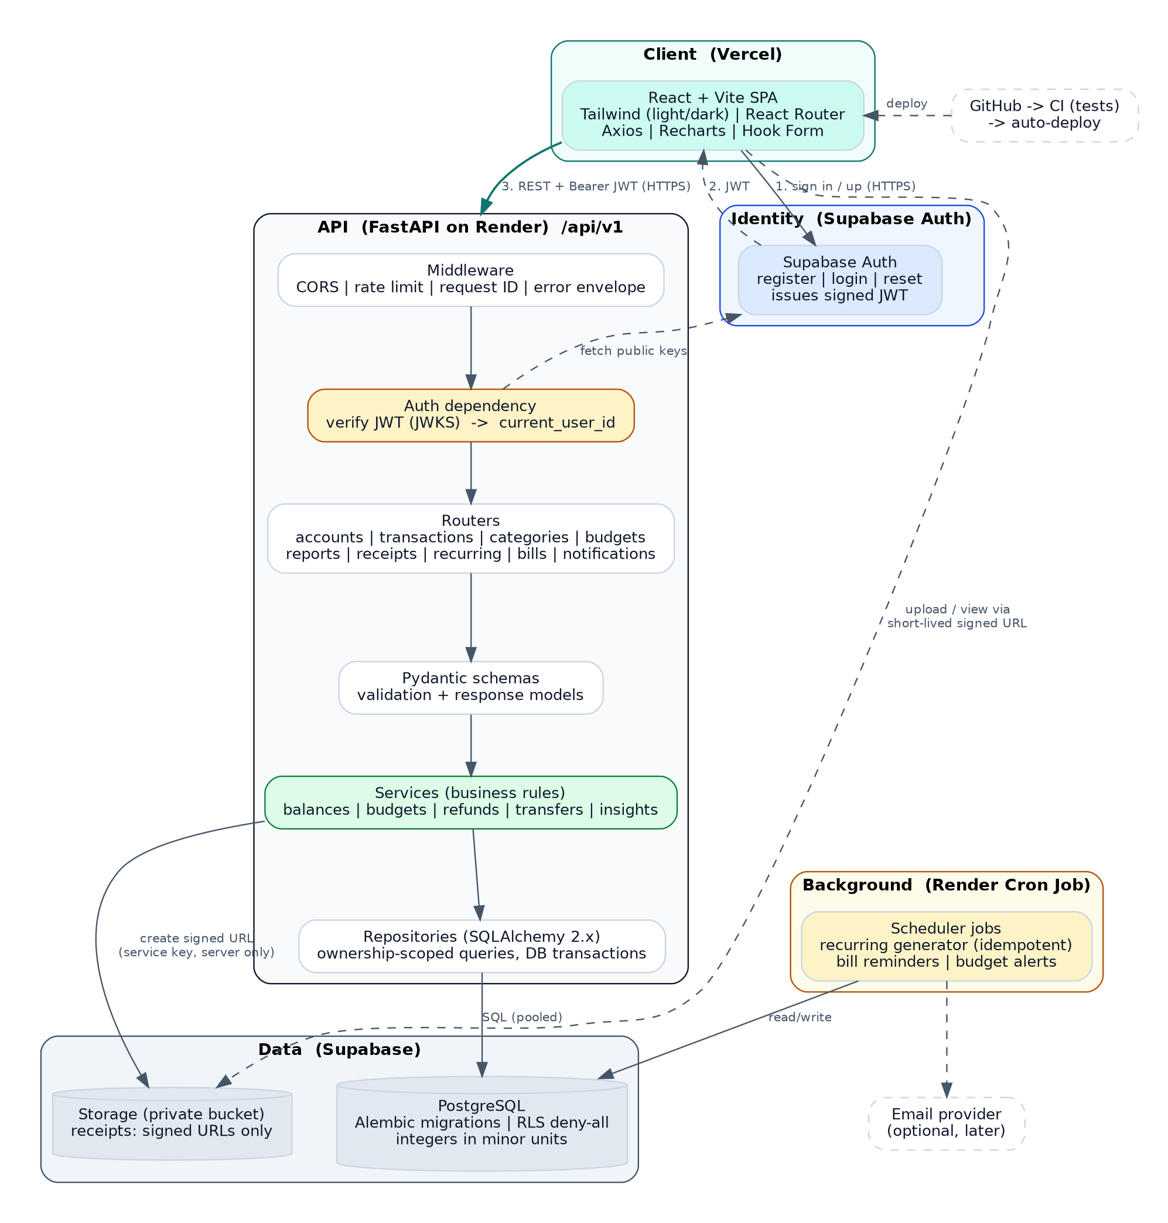
Figure 1. System architecture: client, identity, API layers, data, and background jobs

A2. Application flowchart
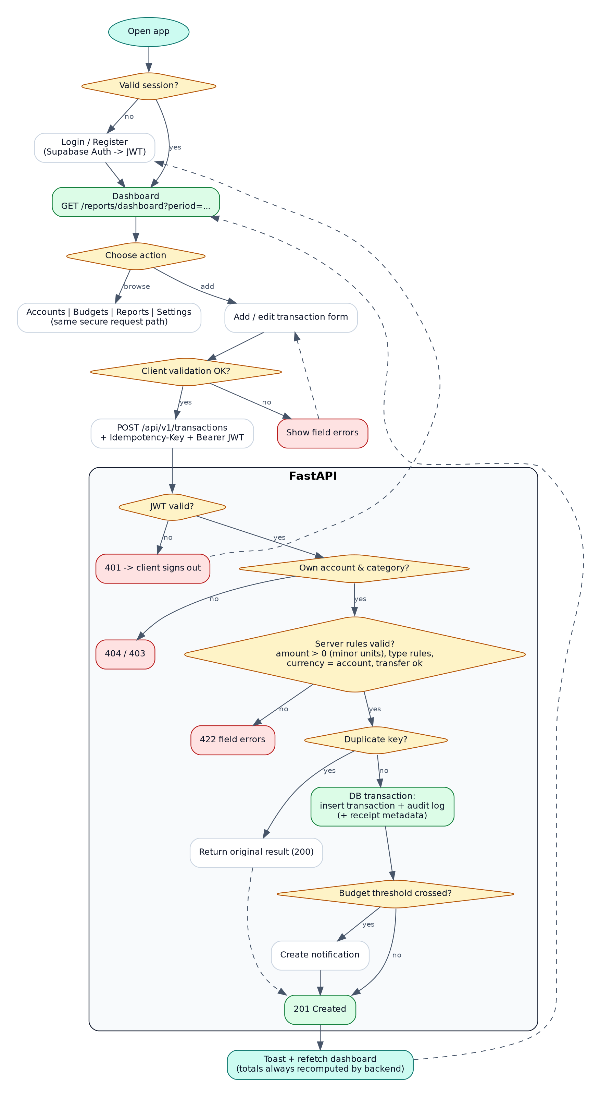
Figure 2. User journey and secure transaction request flow

A3. Build workflow and phase gate
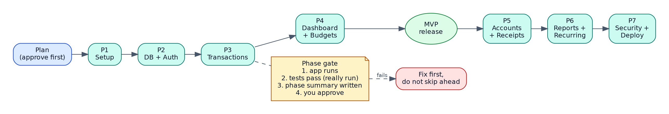
Figure 3. Phase order and the gate every phase must pass

APPENDIX B: WHAT CHANGED FROM VERSION 1
Change | Why it matters
Added Section 4, Fixed Technical Decisions | The original left auth, money storage, currencies, refunds, credit cards, time zones, and scheduling open. An AI assistant would pick differently in each phase and create inconsistencies.
Auth decision: Supabase Auth + JWT verification in FastAPI | The original said “choose one,” which risks mixing two systems. This is the simplest option for a learner.
Added scope tiers (MVP, V1, Later) | The original asked for everything at once. Tiers keep the first release small and verifiable.
Moved basic accounts into Phase 3 | Transactions need an account, and the dashboard shows balances in Phase 4, but accounts were not built until Phase 5.
First task now ends with “stop and wait for approval” | The original asked for a plan and then said to begin Phase 1 in the same reply, which produces a huge, unreviewed response.
Added savings_goals, audit_logs, idempotency_keys, currencies tables | The dashboard shows savings progress, security requires audit logs, and duplicate protection and decimal places need somewhere to live.
Clarified recurring templates vs. bills | “Recurring transactions” and “bills” overlapped. Templates generate bill occurrences.
Defined API envelopes, pagination, idempotency, 404-over-403 | The original asked for a “consistent format” without defining it.
Defined test tooling and test database | Vitest, React Testing Library, pytest, and httpx were not named; “run the tests” was ambiguous.
Specified a scheduler that works on free hosting | Free Render web services sleep, so in-process schedulers miss jobs.
Added the light/dark color system and theme implementation | Tokens, WCAG-checked contrast, chart palette, Tailwind config, and a no-flash theme script.
Added never-color-alone rule, soft-delete rules, receipt limits, RLS decision | Accessibility, financial data integrity, and storage security were previously unspecified or ambiguous.
Added “send at most 3–5 files per message” and phase gate | Keeps AI output reviewable and stops errors from compounding.
Added “How to use” and a resume prompt tip | Long chats lose rules; a short restart recipe keeps the build on track.

