Reject offer in aggregate data.

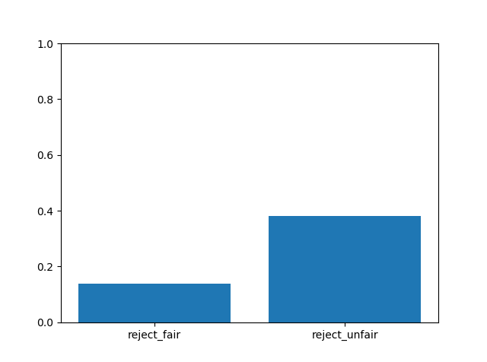

Demographics description (aggregate)

|  |  |  |  |  |  |  |
| --- | --- | --- | --- | --- | --- | --- |
|  | AGE | MAXLETHALITY | GENDER | RACE | EDUCATION | MARITAL |
| count | 102 | 105 | 105 | 105 | 101 | 105 |
| unique |  |  | 2 | 4 |  | 6 |
| top |  |  | MALE | WHITE |  | MARRIED |
| freq |  |  | 58 | 88 |  | 48 |
| mean | 64.70588235 | 1.314285714 |  |  | 14.7029703 |  |
| std | 7.477475398 | 2.23311737 |  |  | 2.711252679 |  |
| min | 51 | 0 |  |  | 8 |  |
| 25% | 59 | 0 |  |  | 12 |  |
| 50% | 63.5 | 0 |  |  | 15 |  |
| 75% | 70.75 | 3 |  |  | 16 |  |
| max | 79 | 8 |  |  | 24 |  |