Abstract

Introduction

Raw Data analysis

Here we have a piece of 520 faces as our raw data, each of which is present in a 56*46 grayscale format. Among those faces, we found that every successive ten faces belong to a single person, referring to 100faces.jpg. As a result, we decided to choose the first nine faces out of ten faces belonging to the same person as training set, and the remaining ones as testing set.

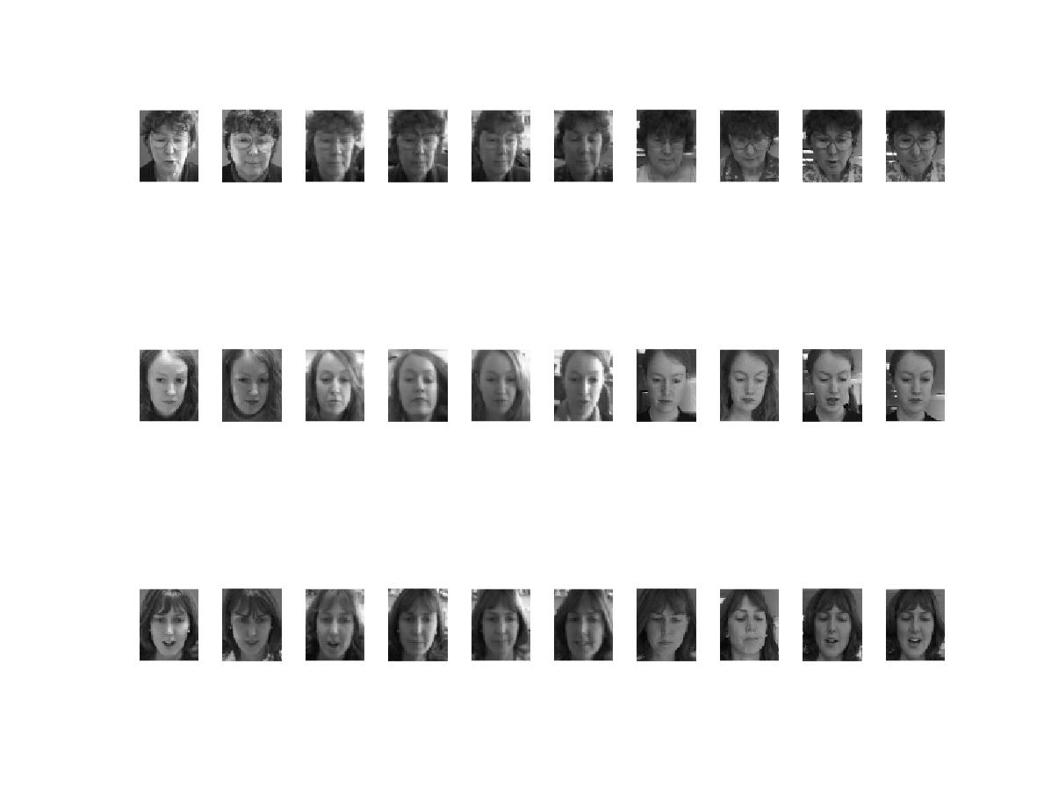  
Figure 1

Principal components analysis

we first applied Principal components analysis to our training set. Here to obtain the eigenfaces among training set, we calculated the eigenvectors and eigenvalues of the data covariance matrix S, where

S= 1/N A A’T

A is the difference of each face vector from the mean face. Here we obtained the mean face by

xbar = 1/N sum1~N(Xn)

We can plot the mean face image, as shown in Figure 2.

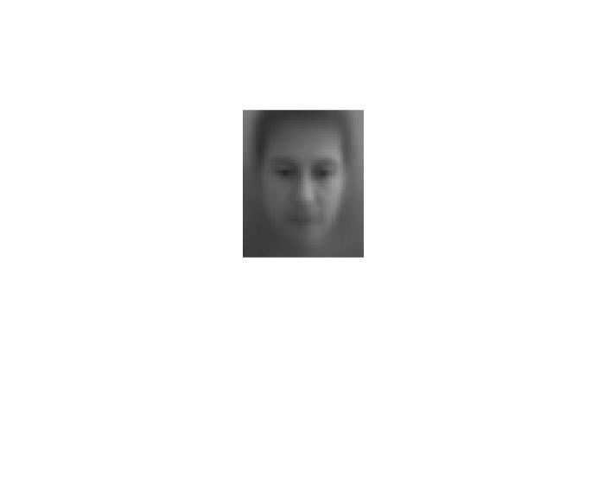  
Figure 2

Then we got a total number of 2576 eigenvectors and eigenvalues. If we plot those eigenvalues, we have

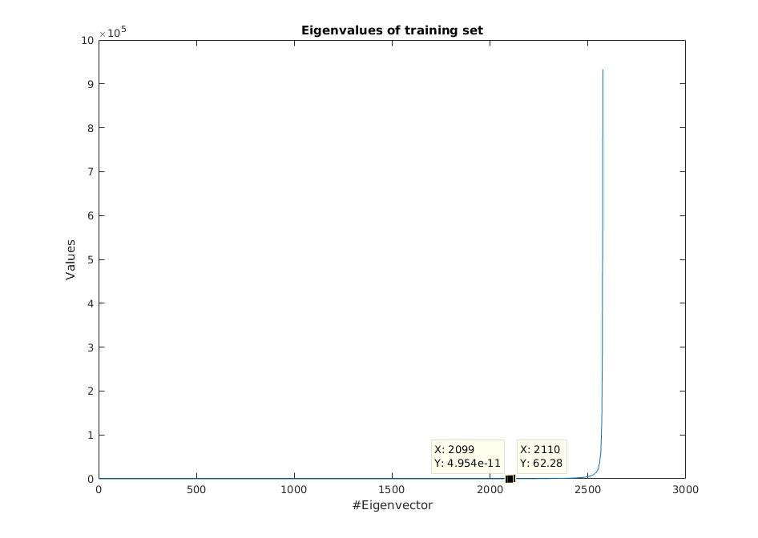  
Figure 3

From Figure 3, we found that there is a eigenvalue drop between the 2099th and 2110th eigenvector, from 62.28 down to 4.95e-11. As eigenvalue is important measure of strength of the associated eigenvector, we selected those eigenvectors where their eigenvalues are larger than or equal to 62.28 as our base eigenfaces set using for face recognition. In total there are 467 eigenfaces.

Reduce the covariance matrix dimension

Normally we have a covariance matrix whose dimension equals to the number of attributes. In our case we have 2576 pixels in each image and thus 2576 attributes. Computing such a large dimension matrix consumes a lot of computational power. Instead, we can construct the covariance matrix with much smaller size. More specifically, rather than calculating AA’T, we compute S’=A’TA and the same previous eigenfaces can be obtained by

u=Av

Here we obtained 468 eigenvectors and eigenvalues which are exactly identical as the largest 468 eigenvectors and eigenvalues in last sections. Table 1 summaries the average time consumed on calculating eigenvectors out of ten trials.

|  |  |
| --- | --- |
| Strategy | Time consumed |
| AA’T | 1.511074 s |
| A’TA | 0.042874 s |

From Table 1 we can easily deduce that the second strategy is much more efficient. However it must be noted that the second strategy can only derive a number of eigenvectors equal to the number of data we have. Consider the case that the number of significant eigenvectors (eigenfaces) exceeds the data count by much, we are suffering from a loss in number of eigenfaces obtained if the second strategy is applied.