|  |  |
| --- | --- |
| **Practicum Case** |  |
| COMP6140 | COMP6140001 | COMP6140049  Data Mining |
| **Computer Science** | **O191-COMP6140-NP01-02** |
| ***Valid on*** *Even Semester Year 2019/2020* | **Revision 00** |

**Learning Outcome**

* LO1 – explain concept of data and data preprocessing

**Topic**

* Session 02 – Data Visualization Using R

## Sub Topics

* Data Visualization

## Soal

*Case*

**Bluejack University**

A currently running poll is being held by Bluejack University to predict the current **student satisfaction** of the provided education. They are given 10 questions, where **questions 1 – 5** are **Likert Scale Questions** (questions which answers are chosen from a range), and **questions 6 – 10** are **Multiple Choice Questions** of **TRUE** and **FALSE**.

To support the data analysis, you are asked to visualize the poll data of the students into various charts from the documents provided. The documents given consist of the **participants’ data** (**Participant.csv**), the **questionnaire result** (**Result.csv**), and **list of the questions** (**Question.csv**).

|  |  |  |
| --- | --- | --- |
| **Participant Number** | **Age** | **Gender** |
| 1 | 24 | Male |
| 2 | 26 | Male |
| 3 | 22 | Male |
| 4 | 19 | Male |
| 5 | 32 | Female |
| 6 | 35 | Male |
| 7 | 21 | Female |
| … | … | … |

**Figure 1. Participant Data**



**Figure 2. Result Data**

|  |  |
| --- | --- |
| **Question Number** | **Question** |
| 1 | The education materials provided by Bluejack University is up to date and promises a great potential for my future. |
| 2 | The lecturers of Bluejack University are masters of the corresponding courses taught to me. |
| 3 | Bluejack University provides advanced facilities which contributes to my learning process. |
| 4 | The staffs of Bluejack University are polite, respectful, and welcoming. |
| 5 | I am satisfied with the overall education quality Bluejack University provides. |
| 6 | The sanitation facility of Bluejack University is well maintained and hygienic. |
| 7 | The environment of Bluejack University is education-friendly and healthy. |
| 8 | I am well informed of lecture schedules and other important informations. |
| 9 | Bluejack University's website, BluejackMaya is well-developed and well-maintained. |
| 10 | BluejackMaya is user friendly, and is very easy to operate for non-technological individuals. |

**Figure 3. Question Data**

However, a misinterpretation of the questionnaire filling guidelines has caused some of the answers for the first question to be **invalid** and **omitted** from the document. Do the following **visualizations**, considering that the data included must only be **valid data**.

1. Visualize a **pie** **chart** with its **legend**, illustrating the result of the **second question**.

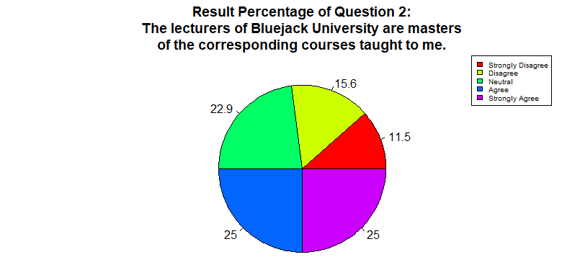

**Figure 4. Answer 1**

1. Visualize a **pie** **chart** with its **legend**, illustrating the result of the **sixth question** for **female participants**.

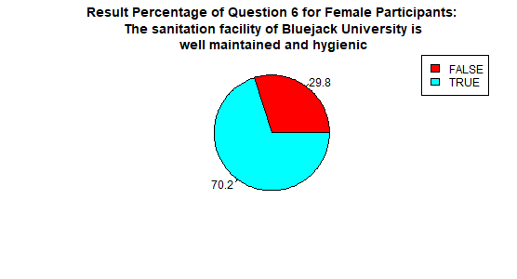

**Figure 5. Answer 2**

1. Visualize a **group** **bar chart** with its **legend**, illustrating the result of the **first question** and the **gender** of the participant.

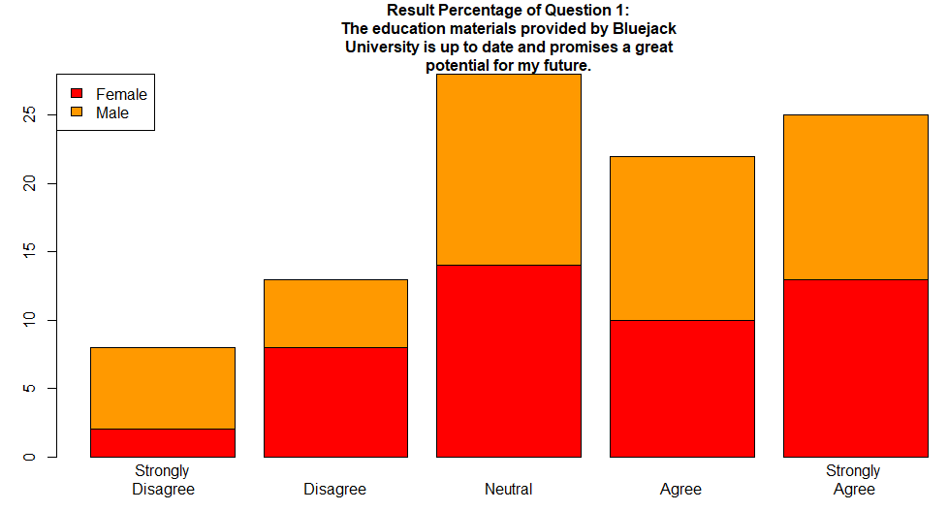

**Figure 6. Answer 3**

1. Visualize a **boxplot**, illustrating the relationship between the result of the **first question** and the **gender** of the participant.

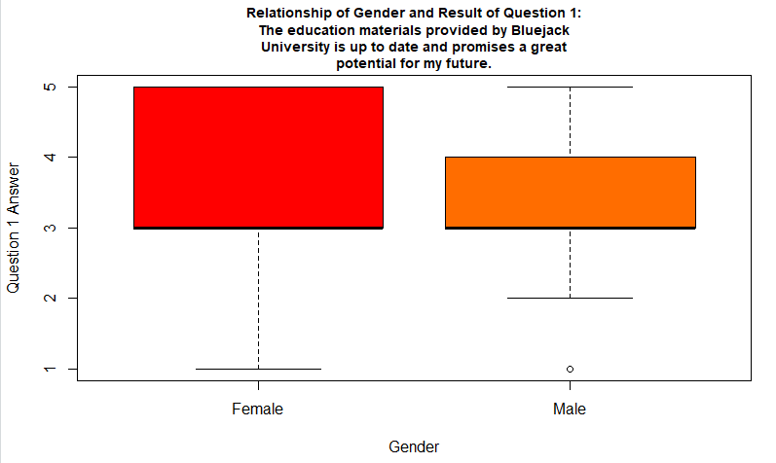

**Figure 7. Answer 4**

1. Visualize a **histogram**, illustrating the result of the **fourth question**.

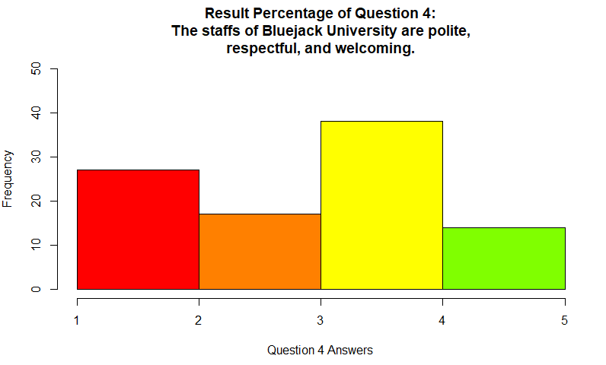

**Figure 8. Answer 5**

1. Visualize a **stacked bar chart**, illustrating the **results of question 1 to 5**.

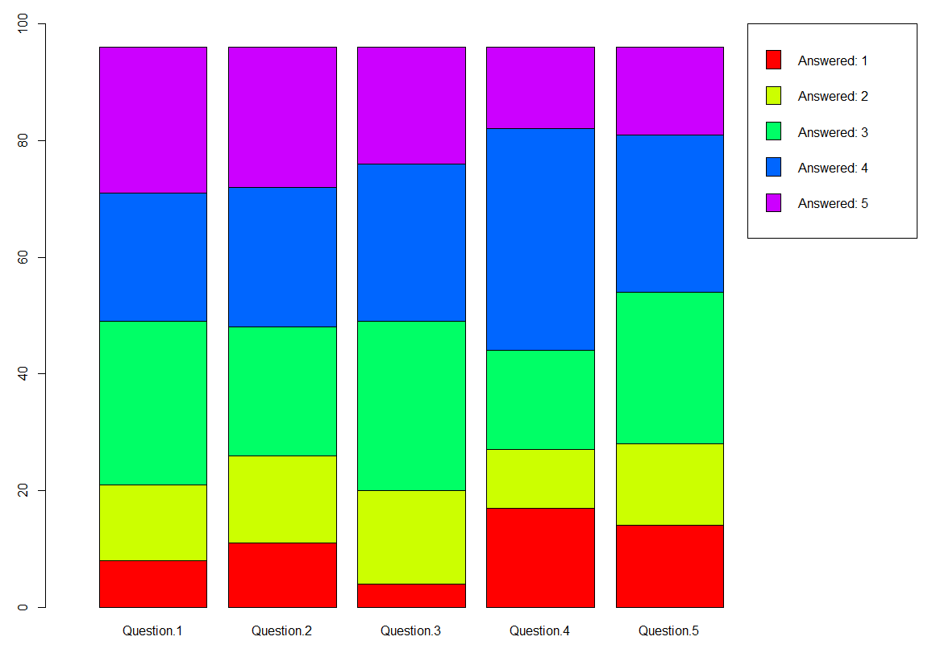

**Figure 9. Answer 6**

1. Visualize a **dot chart** and a **line chart**, illustrating the **amount of survey participants each day**.

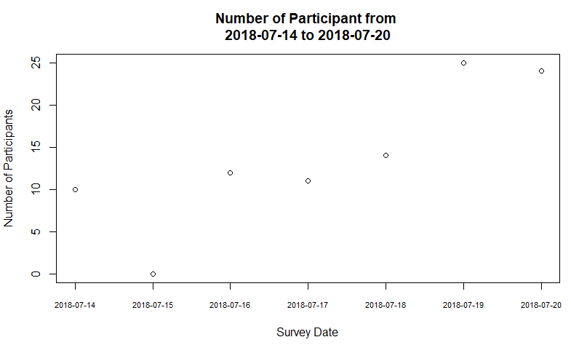

**Figure 10. Answer 7 (part 1)**

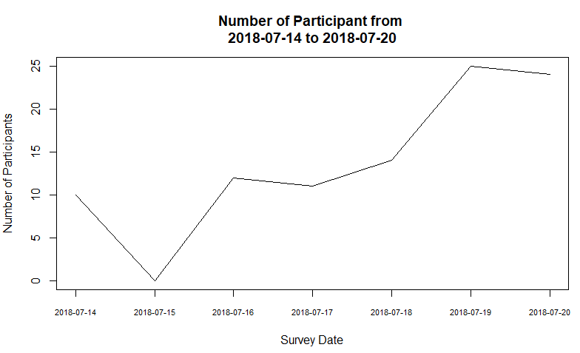

**Figure 11. Answer 7 (part 2)**

1. Visualize a **dotted line chart**, illustrating the **amount of survey participants each day**, and **save the visualization** as **result.png**.

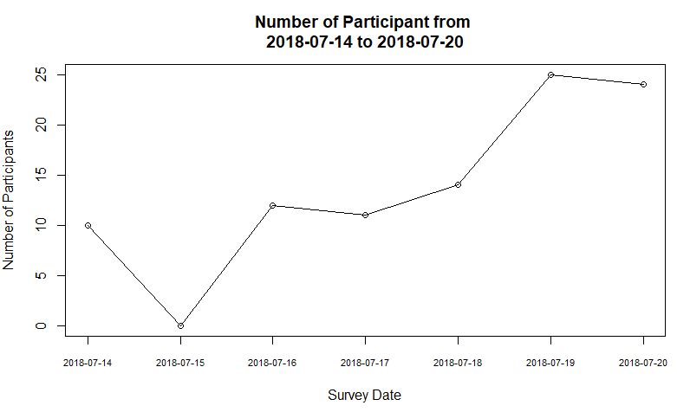

**Figure 12. Answer 8**