docker container run -dit --name techpro2nd alpine ash

docker network inspect bridge | less

docker container inspect techpro2nd | grep IPAddress

docker container exec -it techpro2nd ash

ping -c 4 google.com

docker network create --driver bridge techpronet

docker container run -dit --network techpronet --name techpro1st alpine ash

docker container stop techpro1st techpro2nd techpro3rd techpro4th

docker container rm techpro1st techpro2nd techpro3rd techpro4th

docker network rm techpronet

docker container run --rm -d -p 8080:80 --name ng nginx

http://ec2-18-232-70-124.compute-1.amazonaws.com:8080

docker container run --rm -dit --network host --name my_nginx nginx

docker container exec -it my_nginx sh

ifconfig

apt-get update

apt-get install net-tools

ifconfig

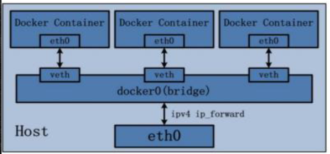

Oluşan her bir ağın veya contairin eth0 noktası oluyor.docker0 ise docker kurulu olduğunda gelen default bridge gösteriyor.

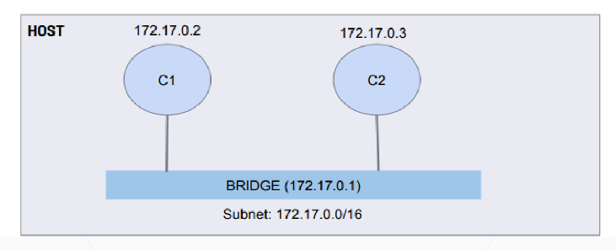

Oluşturulan 172.17.0.2 ip adlı bridge networklü konteynere girilip ifconfig yapıldığında

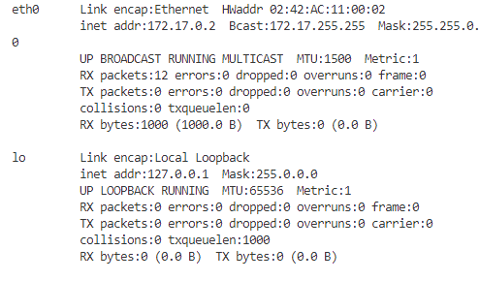

Aşaüıdaki açıklamalar ise hostta ifconfig yazıldığında.Docker kurulu olduğu için docker0(Bridge).eth0 ise hostun kendi private ip.

docker0: flags=4163<UP,BROADCAST,RUNNING,MULTICAST> mtu 1500

inet 172.17.0.1 netmask 255.255.0.0 broadcast 172.17.255.255

inet6 fe80::42:d8ff:fed7:637c prefixlen 64 scopeid 0x20<link>

ether 02:42:d8:d7:63:7c txqueuelen 0 (Ethernet)

RX packets 0 bytes 0 (0.0 B)

RX errors 0 dropped 0 overruns 0 frame 0

TX packets 6 bytes 660 (660.0 B)

TX errors 0 dropped 0 overruns 0 carrier 0 collisions 0

eth0: flags=4163<UP,BROADCAST,RUNNING,MULTICAST> mtu 9001

inet 172.31.25.143 netmask 255.255.240.0 broadcast 172.31.31.255

inet6 fe80::8e0:f5ff:fe64:6417 prefixlen 64 scopeid 0x20<link>

ether 0a:e0:f5:64:64:17 txqueuelen 1000 (Ethernet)

RX packets 274209 bytes 358368060 (341.7 MiB)

RX errors 0 dropped 0 overruns 0 frame 0

TX packets 46441 bytes 6291804 (6.0 MiB)

TX errors 0 dropped 0 overruns 0 carrier 0 collisions 0

lo: flags=73<UP,LOOPBACK,RUNNING> mtu 65536

inet 127.0.0.1 netmask 255.0.0.0

inet6 ::1 prefixlen 128 scopeid 0x10<host>

loop txqueuelen 1000 (Local Loopback)

RX packets 67988 bytes 6873108 (6.5 MiB)

RX errors 0 dropped 0 overruns 0 frame 0

TX packets 67988 bytes 6873108 (6.5 MiB)

TX errors 0 dropped 0 overruns 0 carrier 0 collisions 0

veth579c599: flags=4163<UP,BROADCAST,RUNNING,MULTICAST> mtu 1500

inet6 fe80::9c02:a1ff:feb8:7513 prefixlen 64 scopeid 0x20<link>

ether 9e:02:a1:b8:75:13 txqueuelen 0 (Ethernet)

RX packets 0 bytes 0 (0.0 B)

RX errors 0 dropped 0 overruns 0 frame 0

TX packets 14 bytes 1140 (1.1 KiB)

TX errors 0 dropped 0 overruns 0 carrier 0 collisions 0

docker container run --rm -it --network none --name nullcontainer alpine

Container’a girilip bağlanıldığında ifconfig aşağıdaki gibi sonuç döndürür.Sadece loopback olur.

/ # ifconfig

lo Link encap:Local Loopback

inet addr:127.0.0.1 Mask:255.0.0.0

UP LOOPBACK RUNNING MTU:65536 Metric:1

RX packets:0 errors:0 dropped:0 overruns:0 frame:0

TX packets:0 errors:0 dropped:0 overruns:0 carrier:0

collisions:0 txqueuelen:1000

RX bytes:0 (0.0 B) TX bytes:0 (0.0 B)

docker container rm -f $(docker ps -aq)