The Largest NFT Airdrop Ever
Each of the 1.5 quindecillion Ethereum addresses that exist or could ever exist received a unique free NFT earlier this week, in what constitutes the largest non-fungible token airdrop in blockchain history. To give you a sense of scale – there is one token for every ten atoms in the Earth.

The feat was accomplished by a British and a French software developer on 12 January 2021, as part of an exercise to illustrate some of the oddities of the Ethereum blockchain ecosystem.

The site for the project can be found at https://orthoverse.io and a complete account of how Keir Finlow-Bates and Richard Piacentini managed to ensure that every single Ethereum wallet now holds one of their NFTs, and what the implications are, is detailed in this Medium article: https://kf106.medium.com/this-is-the-biggest-nft-airdrop-ever-24b0f5cd646b

Interest in NFTs continues to grow, with the market surpassing $40 Billion in 2021. As result there is ever more competition, with new collections launching daily. However, none of them reach the scale of this collection, which can also be seen on the leading NFT marketplace OpenSea at https://opensea.io/collection/the-orthoverse-land-collection

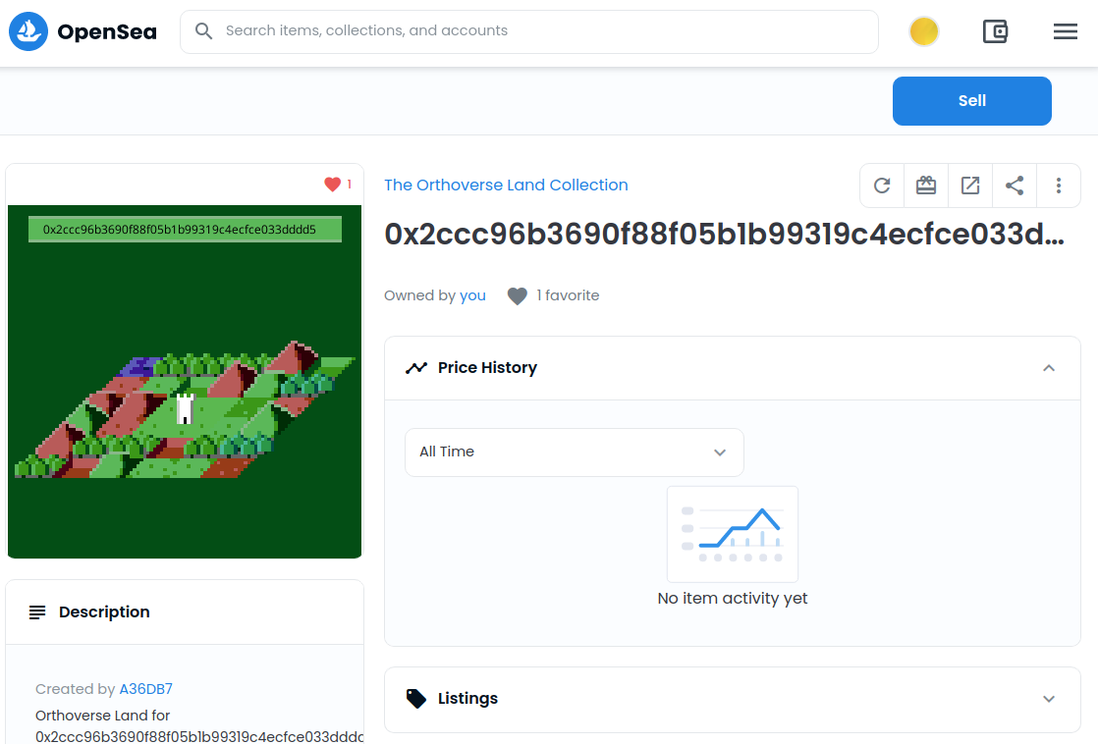

“Every token is different, as the image is generated from the address it was dropped into,” says Finlow-Bates. “To give the project a theme we created a website, with the token image representing a patch of land in a virtual world. As a generative art concept the scale is quite mind-blowing.”

“The underlying smart contract contains quite a few embellishments - Easter eggs if you will,” says Piacentini. “Although each token is already in its respective address, to see it on OpenSea you need to transfer it, or even better, submit a reveal transaction on our website. At normal gas prices of 50-100 gwei this works out at about 8$ to 16$, which is a fraction of the cost of minting a normal ERC721 or ERC1155 token.”

The tokens can be sent to other people or even smart contracts just like familiar tokens such as the Cryptopunks or Bored Apes. However, unlike those tokens, anyone can get their own Orthoverse NFT by creating an Ethereum address, making it the cheapest and most accessible non-fungible token available.

The pair have further plans for the future, including providing the possibility of improving the token by building bigger and bigger castles on it, and with a second futuristic theme in the works.

About Keir Finlow-Bates
Keir Finlow-Bates is a blockchain researcher, a prolific inventor with over 40 patents to his name, and the author of the book Move Over Brokers Here Comes The Blockchain – an educational, entertaining, and irreverent exploration of the significance of blockchain technology. Although he is British, he lives in Finland for its gentle climate, low taxes, and cheap alcohol.

About Richard Piacentini
Richard Piacentini is a software developer and CEO of Sharkaroo Asia, He lives in Thailand because it isn't as stupidly cold as Finland.

For more information contact:
email: keir@chainfrog.com
linkedin: https://www.linkedin.com/in/keirf/

See https://etherscan.io/address/0xedde09c51343252fc83b9e5b6de195a055aacb56 for the smart contract.

Full details are at https://kf106.medium.com/this-is-the-biggest-nft-airdrop-ever-24b0f5cd646b

