CS 3630

Database Design and Implementation

Spring 2021

 **Assignment 4** 

**Goals**

1. Be able to convert between English statements, Relational Algebra expressions, Relational Calculus formulae, and SQL code.

**Note**

You are not allowed to communicate in any form with other classmates on this assignment. A

grade of zero may be given if any communication takes place.

**Introduction:**

The Lego Rebrickable database contains a catalog of Lego parts and their relationship with sets. Sets are a combination of Lego parts that will allow you to create your desired Lego creation. One usage of the Rebrickable database is to identify any missing parts you may have when repurposing one set of Lego parts to construct a creation from another set. More information about the Rebrickable database can be found at <https://rebrickable.com/about/>.

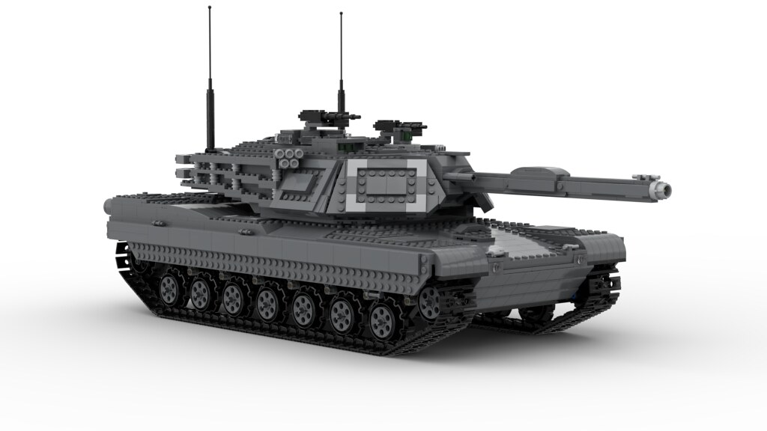

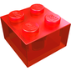**Database:**

The database that will be used for this assignment is the Lego Rebrickable database shared on the Kaggle website ([https://www.kaggle.com/rtatman/lego-database/data#](https://www.kaggle.com/rtatman/lego-database/data)). Kaggle is a popular data mining and machine-learning competition website. The database contains Lego parts, sets, colors, and inventories from every Lego set in the Rebrickable database from July 2017. I have made some small modifications to this database to make it easier for use.

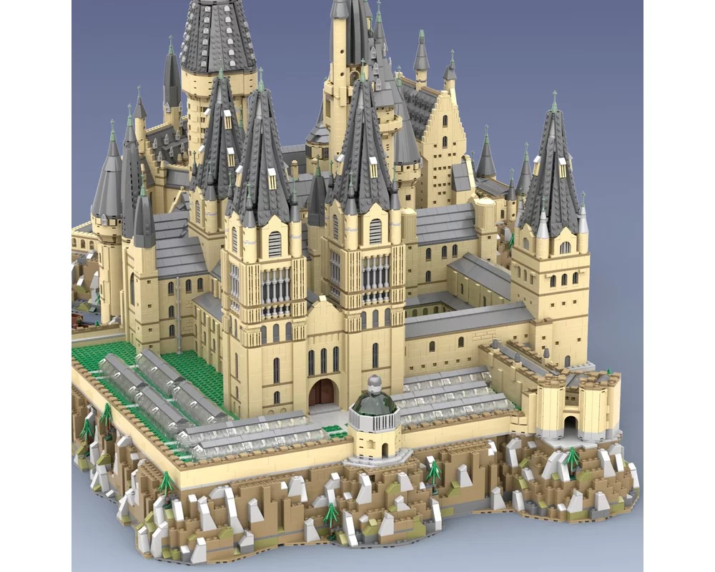 

 **Database Setup**

I have provided my database creation and population script for you as well as the CSV files containing the data. You will only have to import the file using import file wizard. A description of the tables and attributes are provided as comments in the database creation script.



 **ER-Diagram**

 **Useful Symbols**

⟕ ⟖ ⟗ ⨝ σ 𝛑 ≠ ∃ ∧ ∨ 𝞡 𝞮 ¬

σ = Same as “WHERE” Example: σ(customerNumber>200) (customers)

𝛑 = Same as “SELECT” EXAMPLE: 𝛑(cusomerNumber, phone) (customers)

∪ = Same as “Union”

⟕ = Same as “Left outer join”

⟖ = Same as “Right outer join”

⟗ = Same as “Full Outer Join”

⨝ = Same as “Inner Join”

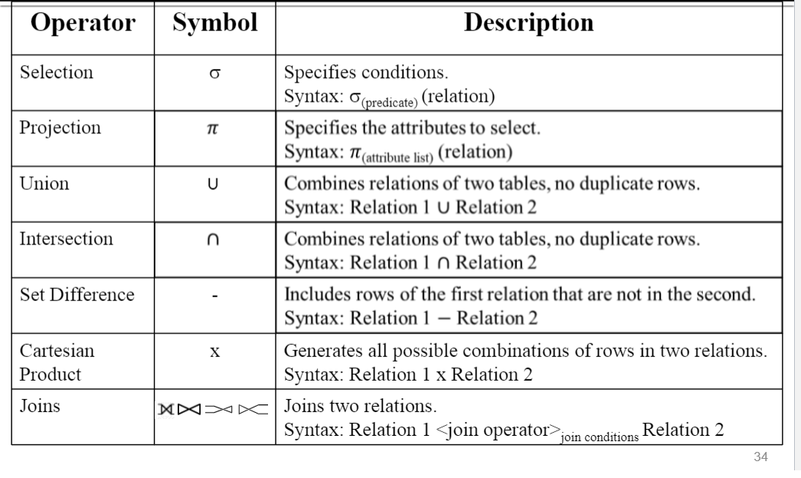

**Generate the SQL code, relational algebra expression, and relational calculus formula for the English statements provided.**

1.

|  |  |
| --- | --- |
| English | Select all the part numbers that are associated with the part category named “Bricks Printed” |
| SQL | SELECT parts.part_number, part_categories.category_name  FROM parts,part_categories  WHERE part_categories.category_name = 'Bricks Printed'  AND parts.part_category_id = part_categories.id; |
| Relational Algebra | 𝛑(parts.part_number, part_categories.category_name)(σ(category_name = “Bricks Printed”) (part_categories) AND σ(category_id, id)(part_categories, parts)) |
| Relational Calculus | {P | P parts C part_categories ^ P.part_number ^ (C.category_name = “Bricks Printed”) ^ (C.id = P.part_category_id)} |

2.

|  |  |
| --- | --- |
| English | Select all part names that belong to the “Minnie Mouse” set. |
| SQL | Select parts.part_name, sets.set_name  From parts,sets  Where sets.set_name = 'Minnie Mouse' AND sets.num_parts = parts.id; |
| Relational Algebra | 𝛑(part_number,category_name)(σ(set_name = ‘Minnie Mouse’)(sets) AND σ(num_parts = id)(sets, parts)) |
| Relational Calculus | {P | P parts, S sets ^ (S.set_name = ‘Minnie Mouse’) ^ (S.num_parts = P.id) } |

**Generate the English statements, relational algebra expressions, and relational calculus formula for the SQL code provided.**

3.

|  |  |
| --- | --- |
| English | Select the part name and color name from the parts, inner joined with the inventory parts which is inner joined by colors and order the data by part name and color name. |
| SQL | SELECT part_name, color_name  FROM parts  INNER JOIN inventory_parts ON parts.id = inventory_parts.part_id  INNER JOIN colors ON inventory_parts.color_id = colors.id  ORDER BY part_name, color_name; |
| Relational Algebra | 𝛑(part_name,color_name)(parts ⨝ parts.id = inventory_parts.part_id inventory_parts ⨝ inventory_parts.colorid=color.id colors) Order By part_name, color_name) |
| Relational Calculus | {P | ∃P parts ∃ C ∈ colors ∃ I ∈ inventory_parts (parts.id = I.part_id ^ I.color_id = C.id))} |

4.

|  |  |
| --- | --- |
| English | Select the set ids as set_id and theme ids as themes_id from sets and left outer join with themes if sets theme id is equal to themes id. |
| SQL | SELECT sets.id AS set_id, themes.id AS themes_id  FROM sets LEFT OUTER JOIN themes ON sets.theme_id = themes.id; |
| Relational Algebra | π(sets.id, themes.id) ((⍴sets.id set_id) ⟕(sets.theme_id = (⍴themes.id themes_id) themes (sets)) |
| Relational Calculus | {P | ∃S ∈ sets ∃T ∈ themes (sets.theme_id = themes.id ^ themes.theme_name ^ themes.parent_id) } |

**Generate the English statements, SQL code, and relational calculus formula for the relational algebra expressions provided.**

5.

|  |  |
| --- | --- |
| English | Select the child theme id and parent theme id and name them “themes”. Left outer join child themes with the parent themes whenever the childs parent theme is equal tot the parent theme id. |
| SQL | SELECT child_theme.id AS themes, parent_theme.id AS themes  FROM themes LEFT OUTER JOIN child_theme ON child_theme.id = parent_theme.id |
| Relational Algebra | π(child_theme.id, parent_theme.id) (  (⍴child_theme themes) ⟕child_theme.parent_id = parent_theme.id (⍴parent_theme themes) ) |
| Relational Calculus | {P | ∃T themes ∃C themes (T.id = C.parent_id ^ T.id = C.id ) |

6.

|  |  |
| --- | --- |
| English | Select the part name from parts where the spare is true, and the inventory parts quantity is greater than 1. Inner join inventory parts with parts id when inventory parts part id is equal to parts id. |
| SQL | Select parts.part_name  From parts INNER JOIN inventory_parts ON inventory_parts.part_id = parts.id  Where inventory_parts.is_spare = true AND inventory_parts.quantity > 1 |
| Relational Algebra | πpart_name ((inventory_parts.is_spare = TRUE and inventory_parts.quantity > 1) (  inventory_parts ⨝inventory_parts.part_id = parts.id parts ) |
| Relational Calculus | { P | ∃P ∈ parts ∃ I∈ inventory_parts (P.id = I.part_id (I.is_spare = TRUE ^ I.quantity > 1)(parts,inventory_parts)} |

**Generate the English statements, SQL code, and relational algebra expression for the relational calculus formula provided.**

7.

|  |  |
| --- | --- |
| English | Select the set id and inventory id for all inventory sets and outer join the inventory sets when the inventory set ids are not equal. |
| SQL | Select inventory_sets.inventory_id, inventory_sets.set_id  From inventory_sets OUTER JOIN inventory_sets ON inventoryset1.set_id ≠ inventoryset2.set_id  Where inventory_sets1.inventory_id1 = inventory_sets2.inventory_id AND inventory_set1.id = inventory_set2.id |
| Relational Algebra | π(inventory_sets.inventory_id, inventory_sets.set_id) (inventory_sets⟗ inventoryset1.set_id ≠ inventoryset2.set_id inventory_sets ^ σ(inventory_sets1.inventory_id1 = inventory_sets2.inventory_id AND inventory_set1.id = inventory_set2.id) (inventory_sets)) |
| Relational Calculus | {*P* | ∃IS1 inventory_sets ∃IS2 inventory_sets  (IS1.inventory_id = IS2.inventory_id ∧ IS1.set_id ≠ IS2.set_id ∧ *P*.id = IS1.id)}  2 inventory_sets with same inventory_id, but different set id’s |

8.

|  |  |
| --- | --- |
| English | Select the parts, inventory parts, inventory sets, and sets where part id equals the inventory parts part id, the inventory parts inventory id equals the inventory sets inventory id, and sets id equals the inventory sets set id, and the sets’ year < 1990, and the part name of the object is equal to the part name of the parts. |
| SQL | Select parts.id, inventory_parts.id, inventory_sets.id, sets.id  From parts,inventory_parts,inventory_sets,sets  Where parts.part_id = inventory_parts.part_id AND inventory_parts.inventory_id = inventory_set.inventory_id AND sets.id = inventory_sets.set_id AND year < ‘1990’ AND parts.part_name = parts.part_name |
| Relational Algebra | 𝛑(parts.id, inventory_parts.id, inventory_sets.id, sets.id)( σ(parts.part_id = inventory_parts.part_id AND inventory_parts.inventory_id = inventory_set.inventory_id AND sets.id = inventory_sets.set_id AND year < ‘1990’ AND parts.part_name = parts.part_name) (parts,inventory_parts,inventory_sets,sets) |
| Relational Calculus | {*P* | ∃Part parts ∃IP inventory_parts ∃IS inventory_sets ∃S sets  (Part.id = IP.part_id ∧ IP.inventory_id = IS.inventory_id ∧ S.id = IS.set_id ∧  S.year < 1990 ∧ *P*.part_name = Parts.part_name)} |

**Submission**

Submit the completed word document on Canvas.

Name this file <your last name>_assignment_04.

**Grading**

|  |  |
| --- | --- |
| **Criteria** | **Possible Points** |
| Problem 1 | 12.5 |
| Problem 2 | 12.5 |
| Problem 3 | 12.5 |
| Problem 4 | 12.5 |
| Problem 5 | 12.5 |
| Problem 6 | 12.5 |
| Problem 7 | 12.5 |
| Problem 8 | 12.5 |
|  |  |
| **Total** | 100 |