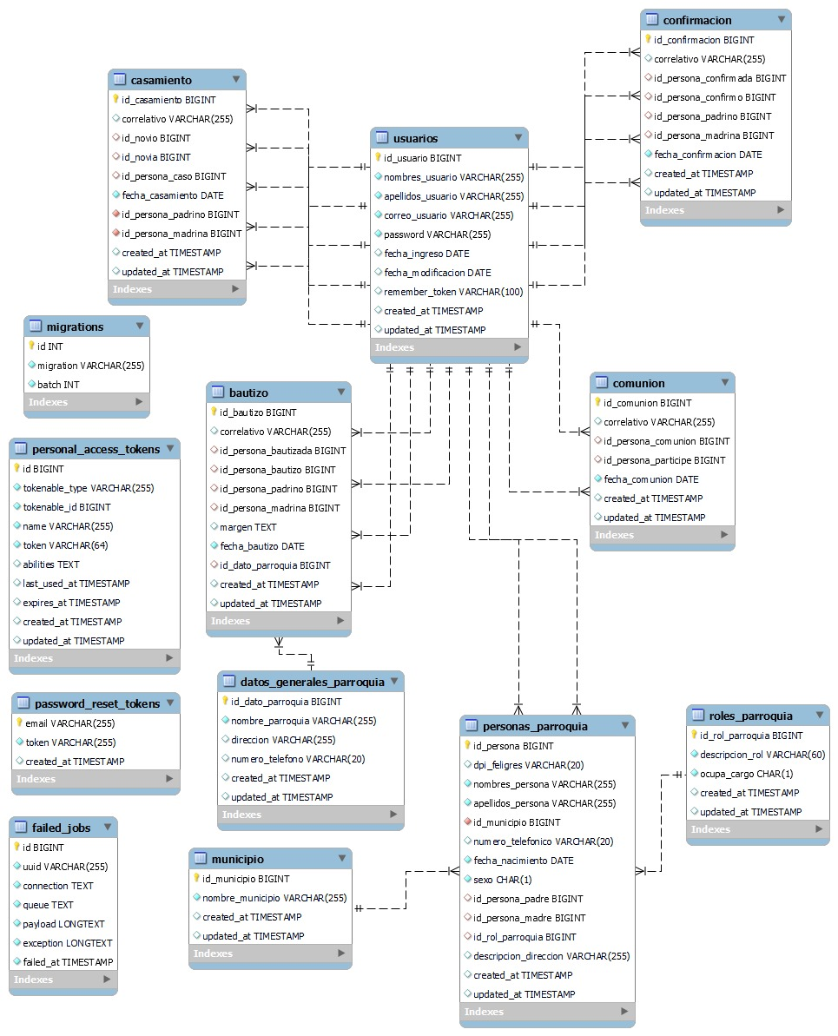

4.2 Script de la base de datos (SQL)

Para descargar el script, clic [aquí](https://drive.google.com/file/d/1kHAadTNa_IpgA92Z2qgOMuRgyXRdvJ1u/view?usp=sharing) o sobre la imagen.

](https://drive.google.com/file/d/1kHAadTNa_IpgA92Z2qgOMuRgyXRdvJ1u/view?usp=sharing)