Kinematics of linear accelerations in fishes

Running title: Swimming acceleration kinematics

Kara L. Feilich, Valentina di Santo, and George V. Lauder

Harvard University, Dept. of Organismic and Evolutionary Biology, 26 Oxford Street,

Cambridge, MA 02138 USA

Author for correspondence, email: [kfeilich@gmail.com](mailto:kfeilich@gmail.com)

Key words:

**Summary statement**

**ABSTRACT**

**INTRODUCTION**

**MATERIALS AND METHODS**

**Animal care and maintenance**

**Swimming trials and behavior encoding**

**Measurement of kinematic parameters and finbeat-parameter estimation**

**Statistical analysis of kinematic parameters**

**Fourier Transforms and sinusoidal regression as estimate of steadiness**

**RESULTS**

**Period and amplitude variation with initial speed**

**Period and amplitude variation with maximum instantaneous speed and acceleration**

**Kinematic signatures of acceleration behaviors**

**DISCUSSION**

**Acknowledgements**

**Competing Interests**

The authors declare no competing interests.

**Author Contributions**

G.V.L. and V.D.S. collected fish swimming trial videos. K.L.F. digitized the video, designed and wrote programs for all analyses, ran all analyses, and wrote the first draft of the manuscript.

**Funding**

K.L.F. received funding from an NSF Graduate Research Fellowship under grant DGE- to Harvard University, and a Chapman Memorial Fellowship from the Harvard Museum of Comparative Zoology. V.S. and G.V.L received funding from ONR-MURI ____.

**References**

**Feilich, K. L.** (2017).

**Figures and Tables**

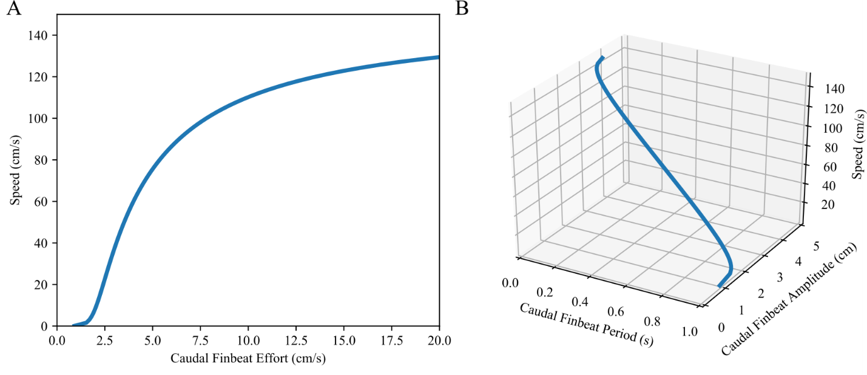

**Figure 1. Schematic diagram with simulated data showing multiple kinematic pathways to accelerate to the same final speed, assuming caudal fin propulsion only**. A. Relationship between steady swimming speed and caudal finbeat effort as defined in Feilich, 2017. B. The relationship between period, amplitude, and speed. Data are simulated such that finbeat period has an inverse linear relationship with swimming speed, and amplitude has a sigmoidal relationship with speed. These hypothesized relationships are in keeping with the experimental observations that speed varies linearly with finbeat frequency (i.e. 1/period), and amplitude is mostly invariant with speed.

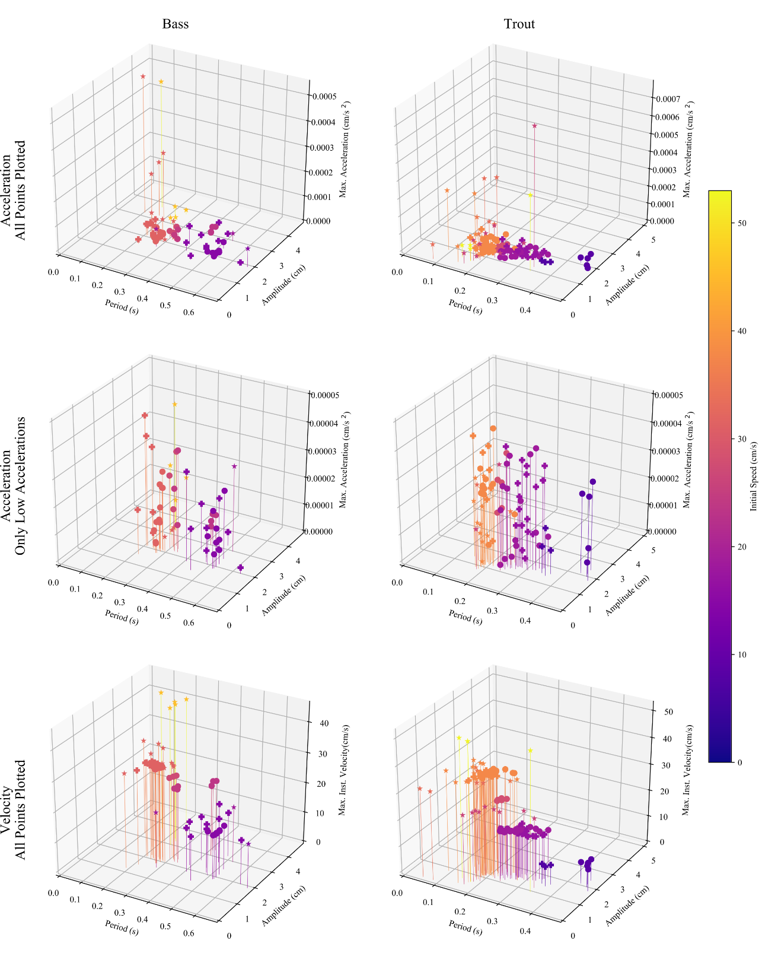

**Figure 2. Observed caudal finbeat kinematics for steady swimming, linear accelerations, and burst accelerations as encoded by the observer.** Left Column: Largemouth Bass (n=1, SL =15 cm, n_trials = ), Right Column: Rainbow Trout (n = 2; SL = 9 cm, 8.5 cm, 8 cm; n_trials = ). Top: All finbeats against maximum instantaneous acceleration. Middle: Finbeats with maximum instantaneous accelerations < 5x10-4 cm/s2, to show variation. Bottom: Finbeats against maximum instantaneous velocity. (Circles: steady swimming trials, +: linear acceleration trials, Star: burst acceleration trials). Points are colored by initial speed of trial.)

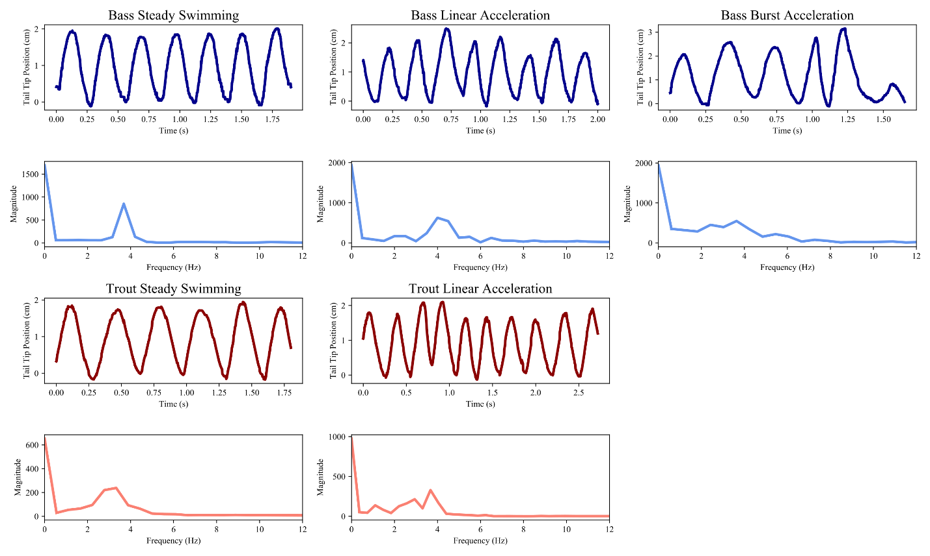

**Figure 3. Representative traces of de-trended tail tip motion during three swimming behaviors with initial speeds of 2 BL/s, and the FFTs of those traces.** Blue: Largemouth Bass (SL = 15 cm), Red: Rainbow Trout (mean SL = 8.75 cm). Top row of each species shows tail tip position in the axis perpendicular to the direction of swimming, with background trend removed. Bottom row for each species shows the FFT of the tail tip trace immediately above. There is no representative trace for trout burst acceleration with an initial speed of 2 BL/s, as we were unable to elicit this behavior in trout at initial speeds below 3 BL/s.

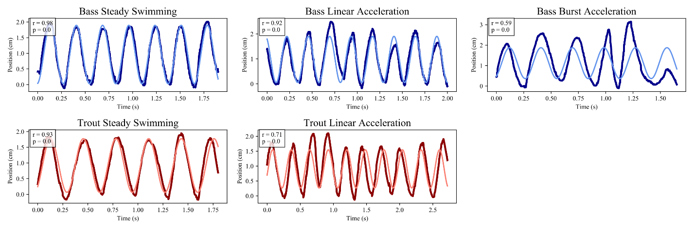

**Figure 4. Representative traces of de-trended tail tip motion during three swimming behaviors with initial speeds of 2 BL/s, and the best fit sine-waves for those traces.** Blue: Largemouth Bass (SL = 15 cm), Red: Rainbow Trout (mean SL = 8.75 cm). The dark curve is the detrended raw data for that trial (as in Figure 3), and the light curve is the sine wave fitted to that trial using least squares optimization. The correlation coefficient between the detrended raw position data and the best fit sine wave is shown in the top left corner of each plot, with its associated p-value. There is no representative trace for trout burst acceleration with an initial speed of 2 BL/s, as we were unable to elicit this behavior in trout at initial speeds below 3 BL/s.

**Table 1. Maximum pairwise cross-correlations between FFTs of each trial, with values grouped by species and behavior.**

**Table 2. Pearson’s correlation coefficients of trials and their best fit sine curves grouped by behavior and initial speed.**

**Table 2. Pearson’s correlation coefficients and associated p-values for each trial, grouped by speed and behavior.**