Kinematics of the caudal fin during acceleration in swimming fishes

Running title: Swimming acceleration kinematics

Kara L. Feilich, Valentina di Santo, and George V. Lauder

Harvard University, Dept. of Organismic and Evolutionary Biology, 26 Oxford Street,

Cambridge, MA 02138 USA

Author for correspondence, email: [kfeilich@gmail.com](mailto:kfeilich@gmail.com)

Key words: fish swimming acceleration kinematics

**Summary statement**

**ABSTRACT**

**INTRODUCTION**

Studies of fish swimming kinematics have, with good reason, chiefly focused on steady swimming biomechanics. Steady swimming can be used as a baseline for other hydrodynamic behaviors (CITE); it can be (relatively) easily elicited in a laboratory setting; and by virtue of its steadiness, it can be parameterized with minimal difficulty (Gray, 1933, Bainbridge, 1958, Webb, 1973, Eloy, 2012). Alternatively, studies of unsteady kinematic behaviors (except for the well-studied C-start, which is very consistent/stereotypical across fishes, reviewed in Domenici and Blake, 1997) are more scarce, and more difficult. Though the importance of unsteady performance is recognized (Langerhans and Reznick, 2010), the transient nature and variability of unsteady behaviors makes it difficult to come up with descriptive parameters of kinematics. Without a means of consistently describing unsteady acceleratory behaviors, it is also difficult to study acceleratory kinematics in comparative contexts.

Acceleration performance—as a probable subject of natural selection—is undoubtedly important, and variation in acceleration performance raises the follow-up question of how do fishes vary in the production of those accelerations? For instance, one may ask whether all fishes use the same acceleration kinematics, or is there a many-to-one mapping of kinematics on performance. Further study of acceleration kinematics may shed light on the flexibility of underlying motor control systems, and inform the design of biomimetic propulsion. In addition, having a means of parameterizing kinematics during these behaviors would facilitate, eventually, answering questions of how different traits (e.g. kinematics, morphology, physiology) each individually affect performance. The major challenges to parameterizing acceleration stem from its inherent variability. Unlike steady swimming, it is inappropriate to ascribe a single average value in frequency and amplitude to any given sequence of fin beats, as these vary over the duration of the behavior. The time-course of fin beat variation is also of interest, in the case of acceleration, it is ignored to one’s peril. However, to account for each fin beat as an individual unit also makes comparison “parametrically expensive” (I made that phrase up), even though acceleratory behaviors may be most effectively described as kinematic time series.

The goal of this study was to use a suite of methods to examine kinematic strategies for two purposes: (1) to determine their utility in describing and comparing unsteady kinematics (including with reference to steady kinematics), and (2) to see if there are potentially kinematic signatures of different unsteady behaviors, i.e., is there more than one way, kinematically, to produce a given acceleration. These methods were inspired by methods of parameterizing steady swimming behavior, and by methods for analyzing degree of variation in signals of cyclical base.

**MATERIALS AND METHODS**

**Animal care and maintenance**

**Swimming trials and behavior categorization**

**Measurement of kinematics and finbeat-parameters**

For each trial, the positions of the tip of the snout and the tip of the caudal fin were digitized using DLTv6 (Hedrick, 2008). For the tip of the snout, automatic tracking with the default parameters (Autotrack predictor: extended Kalman, Autotrack search area: 9, Autotrack threshold: 9) was sufficient for accurate tracking, as confirmed by manual assessment of the tracked position. In the few cases where the autotracking algorithm was inaccurate, frames were digitized manually within DLTv6. For the tail tip, autotracking was almost never sufficient, and the frames were all manually digitized. Data were saved from DLT in flat format, and all subsequent processing was done using custom written code (Supp. Materials, available in the associated git-hub repository) in Python 3 (Python Software Foundation, <http://www.python.org>).

To permit the calculation of velocity and acceleration from the slightly noisy position data, position traces were smoothed using a 2nd order Savitzky-Golay filter with a window length corresponding to 121 ms. This procedure was found to smooth the data enough for differentiation without diminishing maxima and minima more that [ x] %. For each trial, net instantaneous velocity and acceleration of the swimming fish were calculated as the first- and second-derivative of the snout position data. A second smoothing with the same parameters was used in between the velocity and the acceleration differentiation.

To determine the period and amplitude for each finbeat in every trial, we isolated the y-axis position (yaw-axis) of the caudal fin tip. These position traces were de-trended by fitting a 3rd order polynomial to the position data before using the peak-detection algorithm implemented in the open-source python package PeakUtils v.1.0.3 (L. Negri. available at <https://bitbucket.org/lucashnegri/peakutils>). Each peak was designated the start of a caudal fin beat. However, this choice is arbitrary, so all analyses were also conducted using each trough as the start of a fin beat. The y-position data were multiplied by -1, and the peak finding process repeated to find the troughs in the data. Doing the analyses with peaks-first and with troughs-first allowed us to get a sense of the effect of finbeat cycle start choice on the relationships between measured finbeat parameters and performance. There was minimal difference between the peak-first and the trough-first finbeat analyses, so for the rest of this manuscript, we refer only to the peaks-first data. Troughs-first data are presented for comparison in the supplemental materials.

Finbeat period was calculated as the time from the starting peak to the subsequent peak for each finbeat. Amplitude was calculated as the y-position distance between the starting peak, and the subsequent trough for each finbeat.

In order to later associate each finbeat with performance measures, the maximum instantaneous velocity and acceleration during the duration of each finbeat was also recorded.

**Statistical analysis of kinematic parameters**

Multiple linear regression models were fit to the data to relate finbeat period and amplitude to the maximum instantaneous speed and acceleration for each fish, for a total of 3 models. The data did not match the assumption of normality of residuals, so we used 2000 bootstrap analyses by resampling residuals to estimate 95% confidence intervals of the regression coefficients and their pseudo-p values. Where interaction terms were found to be insignificant, a second model (with bootstrapping) was fitted without the interaction term.

**Sinusoidal regression as estimate of steadiness**

In order to compare the “steadiness” of the caudal kinematics in different behaviors, it was necessary to devise a means of measuring steadiness. One potential means of doing this is to compare the kinematics to a perfectly steady signal, such as a perfect sine wave, as the lateral movement of the tail tip during steady swimming is very nearly a sine wave.

To assess the degree to which any given kinematic series matched “perfect steadiness”, first we needed an estimate of what perfectly steady would look like for that series. To do this, we used least squares optimization to estimate the three parameters of a sine wave: amplitude (A), frequency (*f*), phase (φ); and offset (C), to best fit the data using the following equation for optimization:

(1) ,

where *y(t)* is the de-trended lateral tail-tip position used for peak finding. Then, the Pearson’s calculation coefficient (*r*) between the detrended position data and the best fit sine wave was calculated for each trial. This provided a crude but effective measure of steadiness, where trials with r = 1 are perfectly modeled by a sine wave (and presumably “perfectly steady”, and are less steady with decreasing r—though this is an unpredictable relationship at low r. Anything with r less than about 0.5 is fairly removed from a perfect sine wave. This calculation, however, is entirely dependent on how well-fit the sine wave approximation is. Least-squares optimization is notoriously sensitive to initial conditions, which could result in a spuriously low correlation coefficient. To avoid this, initial guesses for the sine wave amplitude and frequency (A0 and f0, respectively) were obtained empirically from the data:

(2)

(3) ,

where τ is fin beat period and A is tail beat amplitude as measured above. For trials with greater than four available finbeats, the finbeats with the lowest and highes values of period and amplitude were excluded from the calculation of the initial conditions – this always increased the fit in trials with more heterogeneous finbeats, and did not change the best fit parameters in other trials. For trials with less than four available finbeats, all finbeats were used to calculate these initial values.

**Cross-correlation of Fourier transforms to compare across and within behaviors**

In addition to estimating overall steadiness of the three behaviors studied, we wanted to know if the behaviors might have specific kinematic signatures. Examining the shapes of the Fourier transform of the de-trended tailbeat data was one way to test this hypothesis. If Fourier transforms of trials of a given behavior exhibited high maximum cross correlations, but trials of different behaviors exhibited low maximum cross-correlations, that would indicate specific characteristics of the shape of the frequency distribution were specific to each behavior. Shape of the Fourier transform contains information about the number of frequencies found in a signal, so one might expect steady trials to have single narrow peaks, but burst accelerations to have broad peaks.

Because Fourier transforms were to be used in pairwise cross-correlations, the de-trended tail tip position data for the smaller trial in each pairwise comparison was padded with the mean value to equal length of the longer trial. Fast Fourier transforms of these data were calculated, and the first portion of the transformed data, corresponding to the 0-1 Hz frequency domain was discarded. This was a necessary pre-processing step, as every trace has its largest peak at 0 Hz, and without removing this part of the Fourier transformed data, any cross-correlation would be dominated by that peak in the trace, instead of those parts of the transform resulting from finbeat motion. Cross-correlations were conducted on these modified transforms of each pair of trials. The maximum cross-correlation is reported for each comparison.

**RESULTS**

**General observations of acceleratory kinematics**

Between the three behaviors studied, there was little difference between the kinematics of steady swimming versus a linear acceleration, and even the maximum instantaneous accelerations across the two behaviors were similar. The highest maximum accelerations were only achieved during bursts, which had more variable tail beat kinematics across and within trials (CITE). Qualitatively, the three different behaviors appeared kinematically consistent between the three fishes (two species) studied.

**Period and amplitude variation with maximum instantaneous speed and acceleration**

Qualitatively, there was to be a negative relationship between period and maximum instantaneous speed—in keeping with the well-established relationship between frequency and steady swimming speed (CITE). Mulitple linear regression analyses indicated that, for two of three fishes studied, one of both species) there was no significant interaction effect between period and amplitude on speed, and the effect of period on speed agreed with the qualitative observation (Tables 1, 2). For the a third fish, there was a significant interaction between period and amplitude. H

**Correlation with best-fit sine waves as indicator of steadiness**

**Fourier transform shape is not a good indicator of behavior**

**DISCUSSION**

**Acknowledgements**

**Competing Interests**

The authors declare no competing interests.

**Author Contributions**

G.V.L. and V.D.S. collected fish swimming trial videos. K.L.F. digitized the video, designed and wrote programs for all analyses, ran all analyses, and wrote the first draft of the manuscript.

**Funding**

K.L.F. received funding from an NSF Graduate Research Fellowship under grant DGE- to Harvard University, and a Chapman Memorial Fellowship from the Harvard Museum of Comparative Zoology. V.S. and G.V.L received funding from ONR-MURI ____.

**References**

**Bainbridge, R.** (1958) The speed of swimming of fish as related to size and to the frequency and amplitude of the tail beat. *J. Exp. Biol.* 35: 109-133.

**Domenici, P. and R. W. Blake.** (1997) The kinematics and performance of fish fast start swimming. *J. Exp. Biol.* 200: 1165-1178.

**Eloy, C.** (2012) Optimal Strouhal number for swimming animals. *J. Fluids. Struct.* 30: 205-218.

**Feilich, K. L.** (2017).

**Langerhans, R.** **B.** **and D. N. Reznick.** (2010). Ecology and evolution of swimming performance in fishes: predicting evolution with biomechanics. In Fish Locomotion: an Eco-Ethological Perspective. (eds. P. Domenici and B. G. Kapoor). Enfield, NH: Science Publishers. pp. 484-512. doi: 10.1201/b10190-16

**Webb, P.** **W.** (1973) Kinematics of pectoral fin propulsion in *Cymatogaster aggregata*. *J. Exp. Biol*. 59: 697-710.

**Figures and Tables**

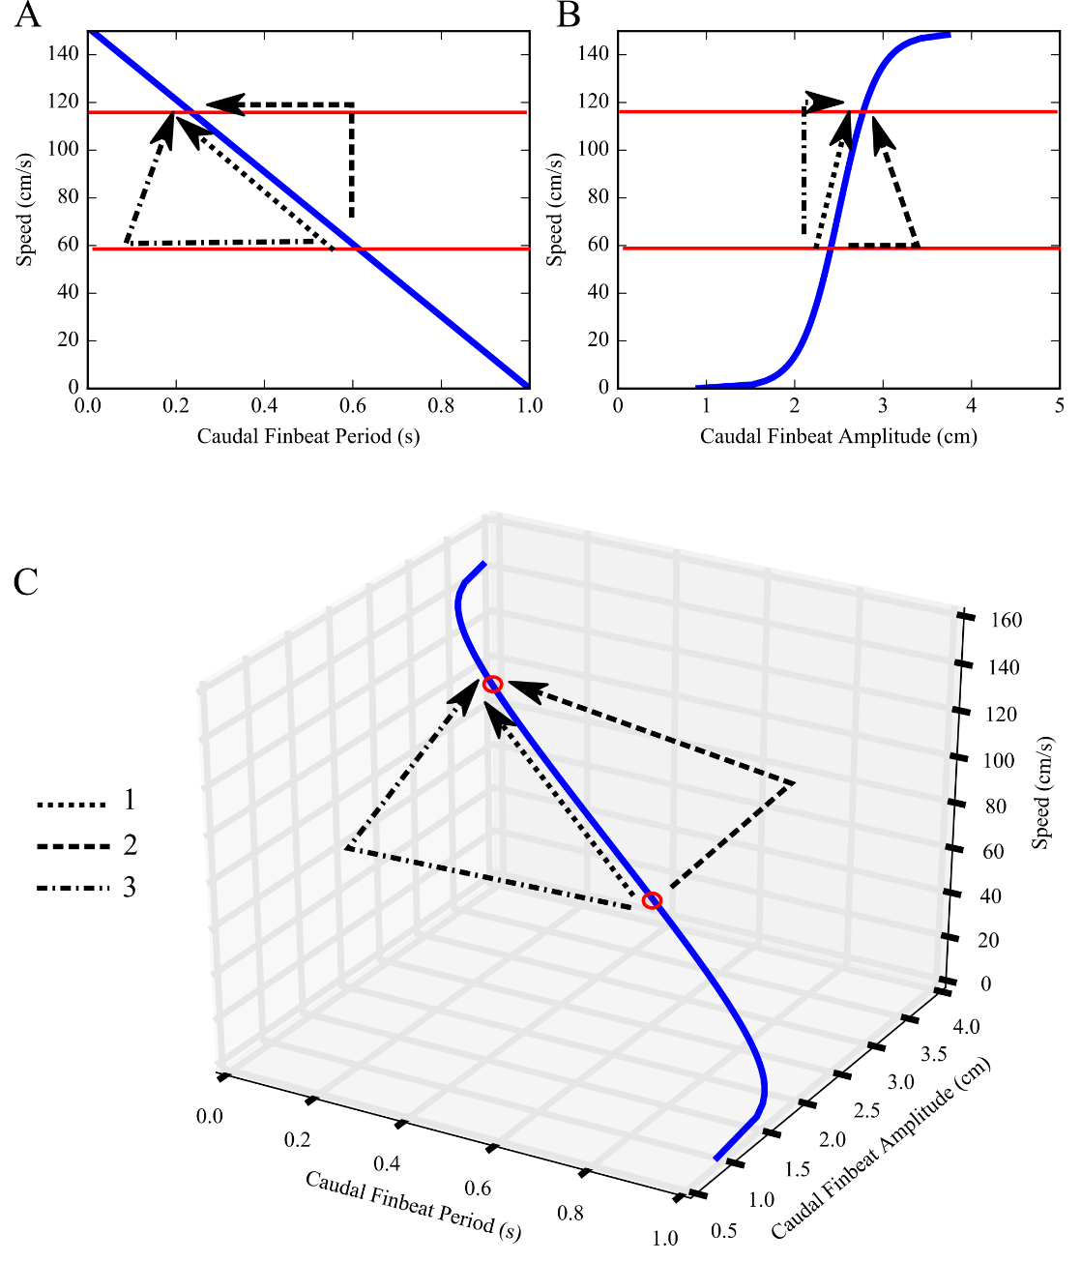

**Figure 1. Schematic diagram with simulated data showing multiple kinematic pathways to accelerate to the same final speed, assuming caudal fin propulsion only**. A. Relationship between steady swimming speed and caudal finbeat period. B. The relationship between steady swimming speed and caudal finbeat amplitude. C. A three-dimensional representation of a caudal steady swimming gait trajectory. Paths 1, 2, and 3, are a few of infinitely many different kinematic possibilities for accelerating between the two speeds highlighted in red. Path 1 represents a gradual kinematic transition where acceleration kinematics mirror the kinematics used during steady locomotion at the intermediate speeds. Path 2 represents acceleration by keeping period constant, jumping to a larger caudal fin beat amplitude to speed up, before decreasing amplitude slightly to settle in to the new steady swimming speed. Path 3 represents acceleration by keeping finbeat amplitude constant, jumping to a shorter fin beat period to accelerate, before increasing period slightly to settle into the new steady swimming speed. Data are simulated such that finbeat period has an inverse linear relationship with swimming speed, and amplitude has a sigmoidal relationship with speed. These hypothesized relationships are in keeping with the experimental observations that speed varies linearly with finbeat frequency (i.e. 1/period), and amplitude is mostly invariant with speed.

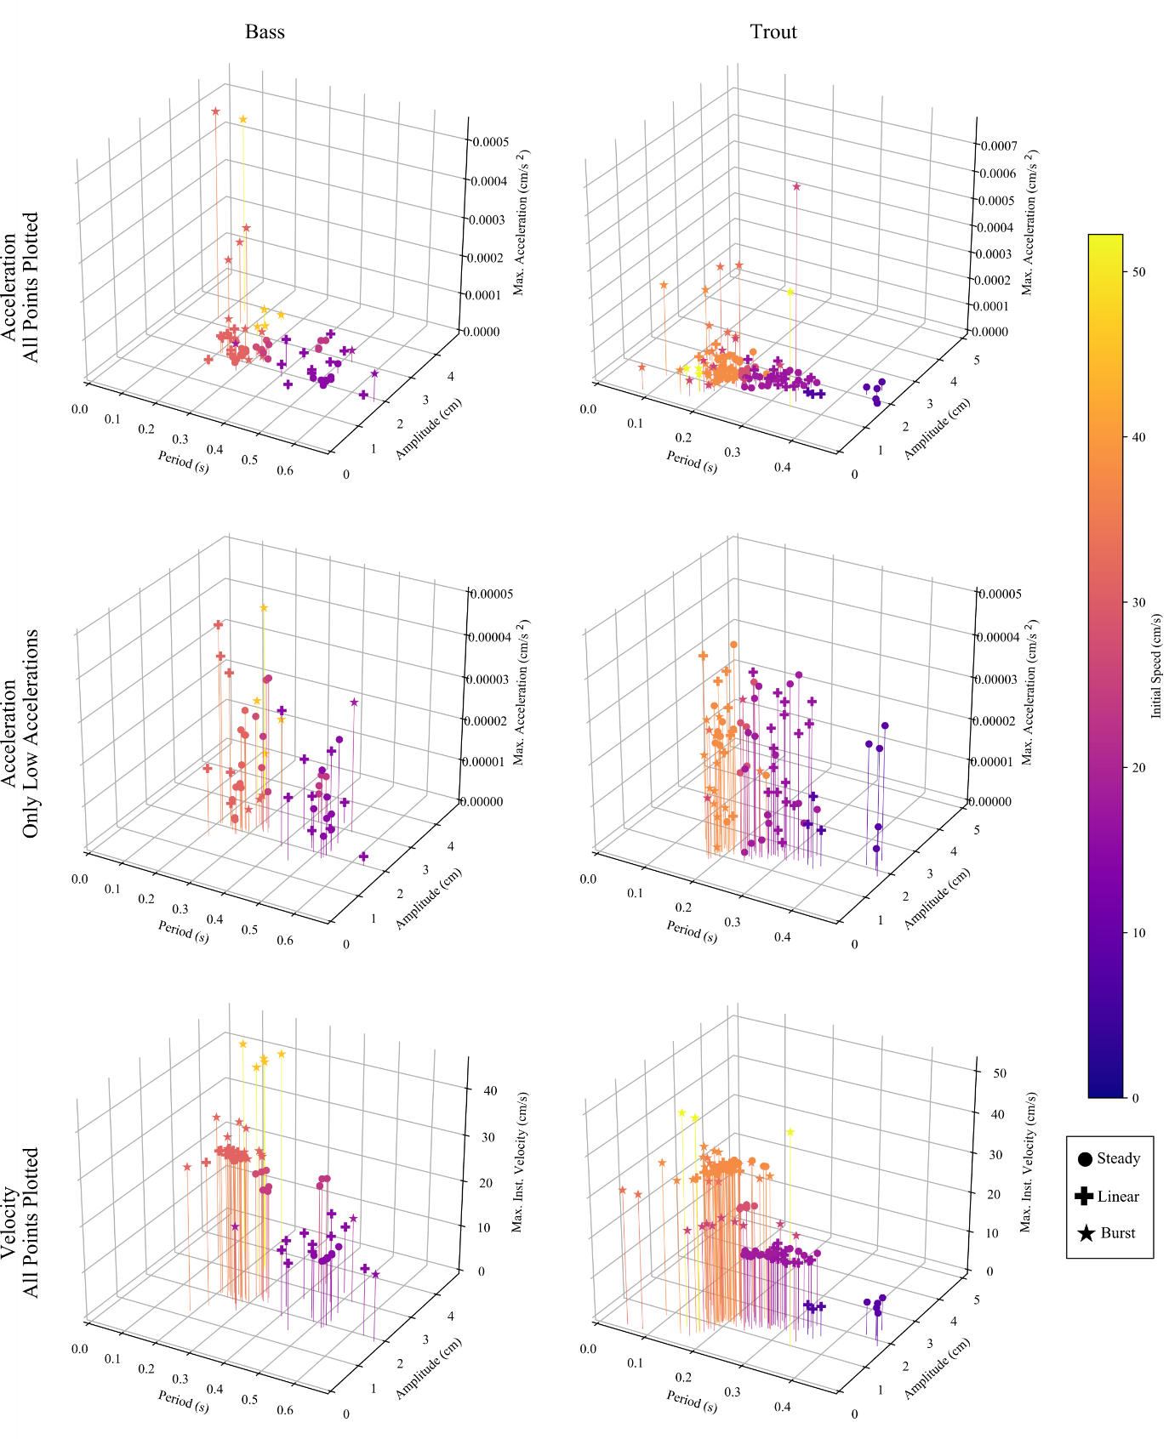

**Figure 2. Observed caudal finbeat kinematics for steady swimming, linear accelerations, and burst accelerations as encoded by the observer.** Left Column: Largemouth Bass (n=1, SL =15 cm, n_trials = 23), Right Column: Rainbow Trout (n = 2; SL = 9 cm, 8.5 cm, 8 cm; n_trials = 21). Top: All finbeats against maximum instantaneous acceleration. Middle: Finbeats with maximum instantaneous accelerations < 5x10-4 cm/s2, to show variation. Bottom: Finbeats against maximum instantaneous velocity. (Circles: steady swimming trials, +: linear acceleration trials, Star: burst acceleration trials. Points are colored by initial speed of trial.)

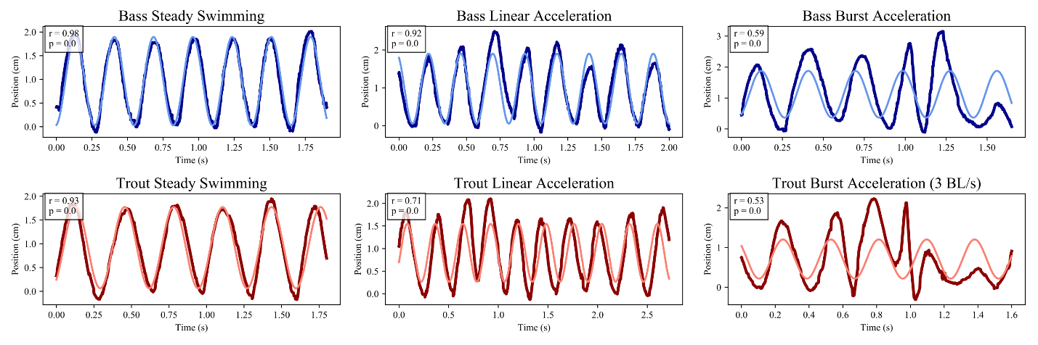

**Figure 3. Representative traces of de-trended tail tip motion during three swimming behaviors with initial speeds of 2 BL/s, and the best fit sine-waves for those traces.** Blue: Largemouth Bass (SL = 15 cm), Red: Rainbow Trout (mean SL = 8.75 cm). The dark curve is the detrended raw data for that trial (as in Figure 3), and the light curve is the sine wave fitted to that trial using least squares optimization. The correlation coefficient between the detrended raw position data and the best fit sine wave is shown in the top left corner of each plot, with its associated p-value. The burst acceleration trace for trout is from a trial at a speed of 3 BL/s, as we were unable to elicit burst accelerations below this speed.

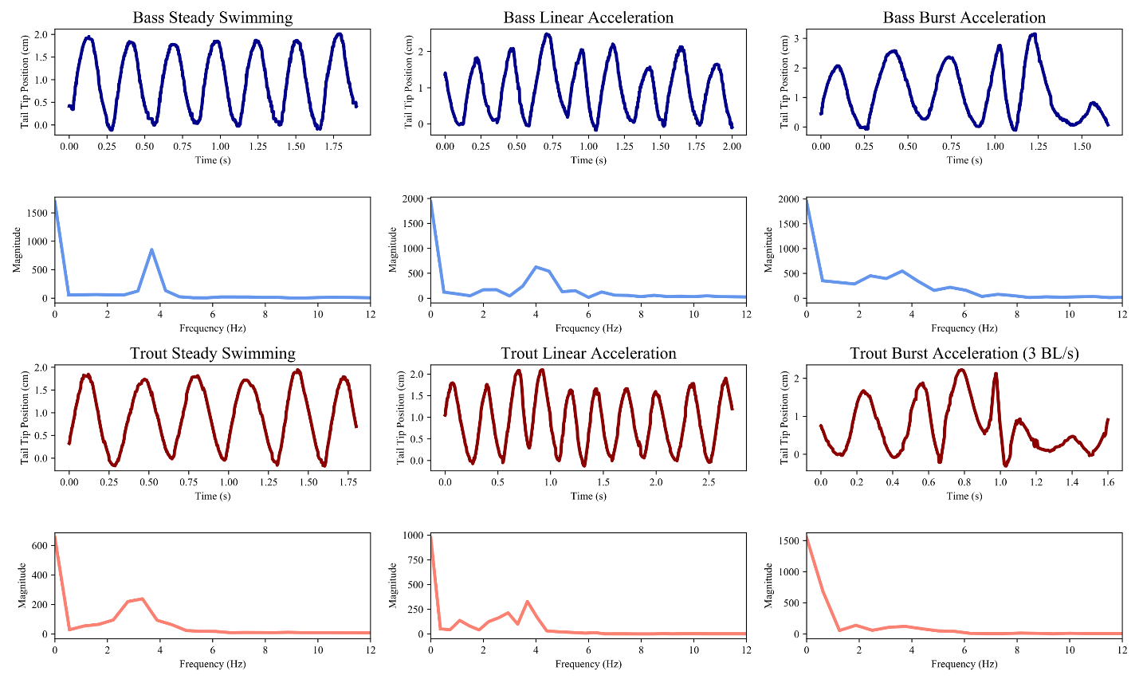

**Figure 4. Representative traces of de-trended tail tip motion during three swimming behaviors with initial speeds of 2 BL/s, and the FFTs of those traces.** Blue: Largemouth Bass (SL = 15 cm), Red: Rainbow Trout (mean SL = 8.75 cm). Top row of each species shows tail tip position in the axis perpendicular to the direction of swimming, with background trend removed. Bottom row for each species shows the FFT of the tail tip trace immediately above. The burst acceleration trace for trout is from a trial at a speed of 3 BL/s, as we were unable to elicit burst accelerations below this speed.

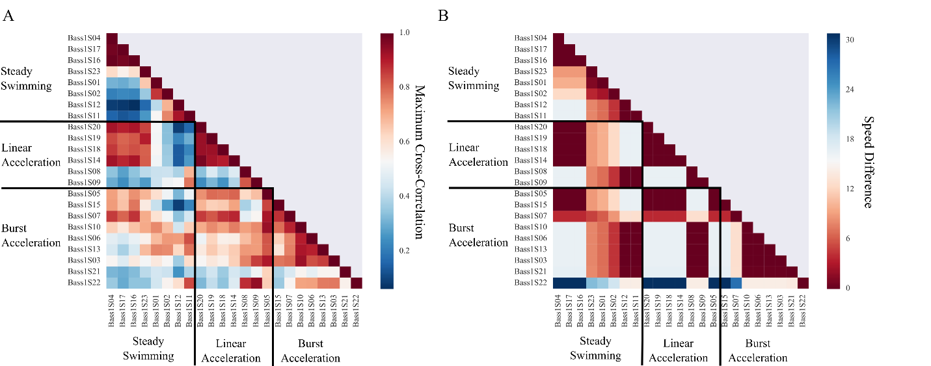

**Figure 5. Heat-map showing maximum normalized pairwise cross-correlations between the Fourier transforms of detrended tailbeat motions for all bass trials, and pairwise initial speed differences between trials.** For each pairwise comparison, the detrended raw tail-tip position data (as shown in Figure 3) for the shorter length of the two trials was padded on either end with its mean value to equal the length of the longer trial before Fourier transform convolution. This made the lengths of the two Fourier transforms suitable for the purposes of cross-correlation. A: Maximum cross-correlations of FFTs. B: Pairwise speed differences between trials. The correspondence between A and B indicates that swimming speed is a major factor driving the shape of the finbeat frequency distribution.

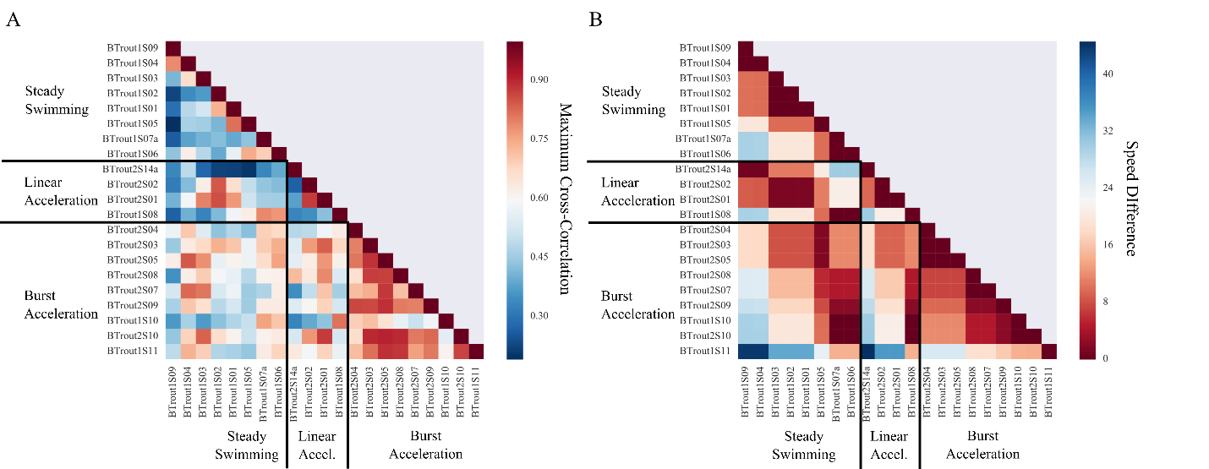

**Figure 6. Heat-map showing maximum normalized pairwise cross-correlations between the Fourier transforms of detrended tailbeat motions for all trout trials and pairwise initial speed differences between trials.** For each pairwise comparison, the detrended raw tail-tip position data (as shown in Figure 3) for the shorter length of the two trials was padded on either end with its mean value to equal the length of the longer trial before Fourier transform convolution. This made the lengths of the two Fourier transforms suitable for the purposes of cross-correlation. A: Maximum cross-correlations of FFTs. B: Pairwise speed differences between trials. The correspondence between A and B indicates that swimming speed is a major factor driving the shape of the finbeat frequency distribution.

**Table 1. Maximum instantaneous speed related to caudal finbeat period and amplitude in a largemouth bass** Model 1: Max_Spd ~ Period * Amplitude; F = 63.62; p = 0.002; df = 3, 65; n=69; bootstraps: 2000

Model 2: Max_Spd ~ Period + Amplitude; F = 91.81; p = 0.000; df = 2, 66; n=69; bootstraps: 2000

|  |  |  |  |  |  |  |
| --- | --- | --- | --- | --- | --- | --- |
| **Model 2** | **Correlations** | | **β**  **(boot 95% CI)** | **SEB** | **t** | **p**  **(boot)** |
| **Variable** | Period | Amplitude |
| Intercept | - | - | (34.8, 46.4) | 2.949 | 13.74 | 0.000 |
| Period | - | -0.10 | (-68.3, -50.3) | 4.579 | -12.93 | 0.000 |
| Amplitude | -0.10 | - | (0.9, 4.9) | 1.029 | 2.813 | 0.004 |
|  |  |  |  |  |  |  |
| **Mean** | 0.34 | 2.22 |  |  |  |  |
| **SD** | 0.12 | 0.55 |  |  | **Adj. R2** | 0.728 |

**Table 2. Maximum instantaneous speed related to caudal finbeat period and amplitude rainbow trout 1** Model 1: Max_Spd ~ Period * Amplitude; F = 44.56; p_boot = 0.004; df = 3, 76; n=80; bootstraps: 2000

Model 2: Max_Spd ~ Period + Amplitude; F = 67.48; p_boot = 0.003; df = 2. 77; n=80; bootstraps : 2000

|  |  |  |  |  |  |  |
| --- | --- | --- | --- | --- | --- | --- |
| **Model 2** | **Correlations** | | **β**  **(boot 95% CI)** | **SEB** | **t** | **p**  **(boot)** |
| **Variable** | Period | Amplitude |
| Intercept | - | - | (57.1, 67.3) | 2.73 | 22.74 | 0.000 |
| Period | - | 0.75 | (-125.7, -63.4) | 15.69 | -6.00 | 0.000 |
| Amplitude | 0.75 | - | (-37.8, 12.7) | 3.10 | -2.15 | 0.035 |
|  |  |  |  |  |  |  |
| **Mean** | 0.24 | 2.22 |  |  |  |  |
| **SD** | 0.12 | 0.55 |  |  | **Adj. R2** | 0.627 |

**Table 3. Maximum instantaneous speed related to caudal finbeat period and amplitude rainbow trout 2**

Model 1: Max_Spd ~ Period * Amplitude; F = 40.70; p = 0.009; df = 3, 46; n = 50; bootstraps: 2000

|  |  |  |  |  |  |  |
| --- | --- | --- | --- | --- | --- | --- |
| **Model 1** | **Correlations** | | **β**  **(boot 95% CI)** | **SEB** | **t** | **p**  **(boot)** |
| **Variable** | Period | Amplitude |
| Intercept | - | - | (22.01, 41.31) | 5.10 | 6.47 | 0.000 |
| Period | - | 0.37 | (-73.72, 39.50) | 30.57 | -0.68 | 0.436 |
| Amplitude | 0.37 | - | (6.46, 21.48) | 3.98 | 3.36 | 0.002 |
| Period:Amplitude | - | - | (-108.30, -25.81) | 22.33 | -2.86 | 0.011 |
|  |  |  |  |  |  |  |
| **Mean** | 0.24 | 1.32 |  |  |  |  |
| **SD** | 0.08 | 0.46 |  |  | **Adj. R2** | 0.709 |

**Table 4. Maximum instantaneous acceleration related to caudal finbeat period and amplitude in a largemouth bass**

Model 1: Max_Acc ~ Period * Amplitude; F = 32.77; p =0.009; df = 3, 65; n=69; bootstraps: 2000

|  |  |  |  |  |  |  |
| --- | --- | --- | --- | --- | --- | --- |
| **Model 1** | **Correlations** | | **β**  **(boot 95% CI)** | **SEB** | **t** | **p**  **(boot)** |
| **Variable** | Period | Amplitude |
| Intercept | - | - | (-66.8, -34.3)*10-5 | 8.4*10-5 | -6.06 | 0.000 |
| Period | - | -0.10 | (85.4, 178.6)*10-5 | 0.000 | 5.50 | 0.000 |
| Amplitude | -0.10 | - | (22.5, 36.5)*10-5 | 3.6*10-5 | 8.21 | 0.000 |
| Period:Amplitude | - | - | (-94.0, -52.6)*10-5 | 0.000 | -6.96 | 0.000 |
|  |  |  |  |  |  |  |
| **Mean** | 0.34 | 2.22 |  |  |  |  |
| **SD** | 0.12 | 0.55 |  |  | **Adj. R2** | 0.728 |

**Table 5. Maximum instantaneous acceleration related to caudal finbeat period and amplitude rainbow trout1** Model 1: Max_Acc ~ Period * Amplitude; F = 5.61; p_boot = 0.100; df = 3, 76; n=80; bootstraps: 2000

|  |  |  |  |  |  |  |
| --- | --- | --- | --- | --- | --- | --- |
| **Model 2** | **Correlations** | | **β**  **(boot 95% CI)** | **SEB** | **t** | **p**  **(boot)** |
| **Variable** | Period | Amplitude |
| Intercept | - | - | (-23.7, 4.34) * 10-5 | 7.1*10-5 | -1.38 | 0.178 |
| Period | - | 0.75 | (38.4, 168.8) * 10-5 | 0.000 | 2.96 | 0.006 |
| Amplitude | 0.75 | - | (-8.1, 10.7) * 10-5 | 4.62*10-5 | 0.14 | 0.870 |
| Period:Amplitude | - | - | (-81.8, -7.5) *10-5 | 0.000 | -2.25 | 0.030 |
|  |  |  |  |  |  |  |
| **Mean** | 0.24 | 2.22 |  |  |  |  |
| **SD** | 0.12 | 0.55 |  |  | **Adj. R2** | 0.149 |

**Table 6. Maximum instantaneous acceleration related to caudal finbeat period and amplitude rainbow trout2**

Model 1: Max_Acc ~ Period * Amplitude; F =2.329; p = 0. 0.261; df = 3, 46; n = 50; bootstraps: 2000

|  |  |  |  |  |  |  |
| --- | --- | --- | --- | --- | --- | --- |
| **Model 1** | **Correlations** | | **β**  **(boot 95% CI)** | **SEB** | **t** | **p**  **(boot)** |
| **Variable** | Period | Amplitude |
| Intercept | - | - | (-46.1, 5.7) *10-5 | 0.000 | -1.05 | 0.198 |
| Period | - | 0.37 | (8.5, 322.1) *10-5 | 0.001 | 1.94 | 0.059 |
| Amplitude | 0.37 | - | (5.3, 45.6) *10-5 | 0.000 | 2.25 | 0.047 |
| Period:Amplitude | - | - | (-257.9, -34.5) *10-5 | 0.001 | -2.41 | 0.031 |
|  |  |  |  |  |  |  |
| **Mean** | 0.24 | 1.32 |  |  |  |  |
| **SD** | 0.08 | 0.46 |  |  | **Adj. R2** | 0.075 |

**Table 7. Pearson’s correlation coefficients and associated p-values for each trial when correlated with its best fit sine wave, grouped by speed and behavior.**

|  |  |  |  |  |  |  |  |  |
| --- | --- | --- | --- | --- | --- | --- | --- | --- |
| **Bass** | | | | | | | | |
| **Steady Swimming** | | | **Linear Acceleration** | | | **Burst Acceleration** | | |
| **Trial** | **Initial Speed** | **r** | **Trial** | **Initial Speed** | **r** | **Trial** | **Initial Speed** | **r** |
| Bass1S04 | 14.7 | 0.91 | Bass1S19 | 14.7 | 0.94 | Bass1S05 | 14.7 | - |
| Bass1S16 | 14.7 | 0.93 | Bass1S20 | 14.7 | 0.88 | Bass1S15 | 14.7 | 0.82 |
| Bass1S17 | 14.7 | 0.98 | Bass1S14 | 14.7 | 0.85 | Bass1S07 | 18.5 | 0.60 |
| Bass1S23 | 23.5 | 0.98 | Bass1S18 | 14.7 | 0.69 | Bass1S03 | 31.4 | 0.49 |
| Bass1S01 | 24.6 | 0.96 | Bass1S08 | 31.4 | 0.92 | Bass1S06 | 31.4 | 0.70 |
| Bass1S02 | 27.1 | 0.99 | Bass1S09 | 31.4 | 0.77 | Bass1S10 | 31.4 | 0.32 |
| Bass1S11 | 31.4 | 0.98 |  |  |  | Bass1S13 | 31.4 | 0.59 |
| Bass1S12 | 31.4 | 0.99 |  |  |  | Bass1S21 | 31.5 | 0.65 |
|  |  |  |  |  |  | Bass1S22 | 45.6 | 0.74 |

|  |  |  |  |  |  |  |  |  |
| --- | --- | --- | --- | --- | --- | --- | --- | --- |
| **Trout** | | | | | | | | |
| **Steady Swimming** | | | **Linear Acceleration** | | | **Burst Acceleration** | | |
| **Trial** | **Initial Speed** | **r** | **Trial** | **Initial Speed** | **r** | **Trial** | **Initial Speed** | **r** |
| BTrout1S09 | 8.2 | 0.99 | BTrout2S14 | 7.5 | 0.97 | BTrout2S03 | 26.3 | 0.53 |
| BTrout1S04 | 8.37 | 0.97 | BTrout2S02 | 17.0 | 0.84 | BTrout2S04 | 26.3 | 0.33 |
| BTrout1S01 | 18.2 | 0.91 | BTrout2S01 | 17.0 | 0.71 | BTrout2S05 | 26.3 | - |
| BTrout1S02 | 18.2 | 0.97 | BTrout1S08 | 37.9 | 0.78 | BTrout2S07 | 33.5 | 0.37 |
| BTrout1S03 | 18.2 | 0.93 |  |  |  | BTrout2S08 | 33.5 | 0.49 |
| BTrout1S05 | 28.0 | 0.97 |  |  |  | BTrout2S09 | 35.7 | 0.49 |
| BTrout1S06 | 37.9 | 0.84 |  |  |  | BTrout1S10 | 37.9 | 0.80 |
| BTrout1S07 | 37.9 | 0.83 |  |  |  | BTrout2S10 | 38.0 | 0.50 |
|  |  |  |  |  |  | BTrout1S11 | 52.2 | 0.26 |