HomeWork-2

20180301029- FURKAN KILIÇ

20190301022- İHSAN EMRE DOĞAN

20190301012- EMRECAN ERKUŞ

Additional features have been added to our assignment as you wish.

1.Slider is available as 3 images on the homepage. Each image is linked to a page.

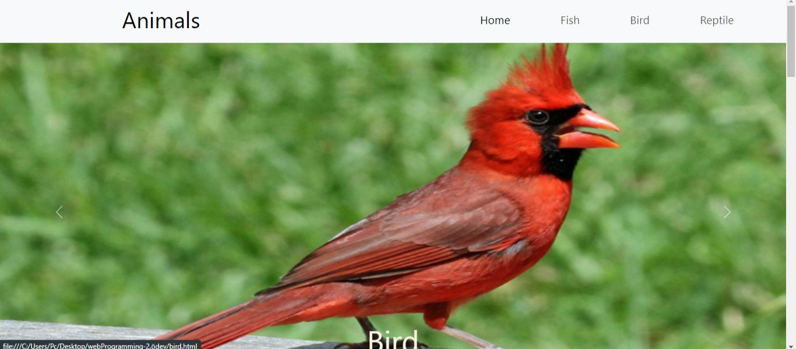

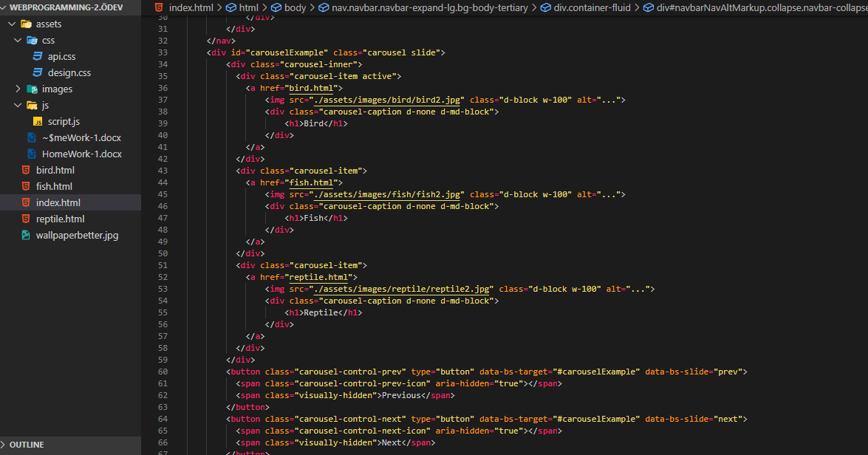

2. Dropdown has been added to the home page so that the user is directed to the pages again when he finishes browsing the home page.

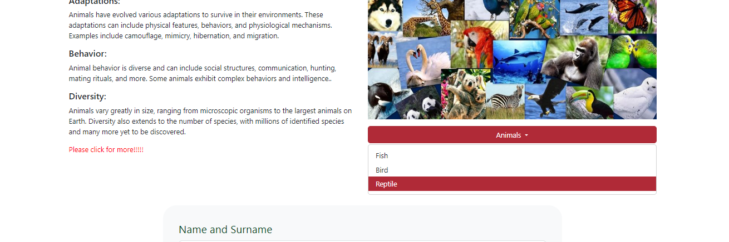

3. Deer visual favicon has been added. It is available on every page.

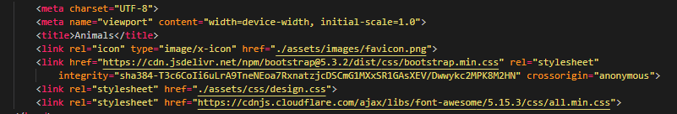

4. A star rating and button has been added at the bottom of the homepage, where the user can rate the website after browsing the website.

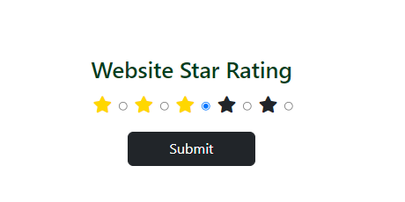

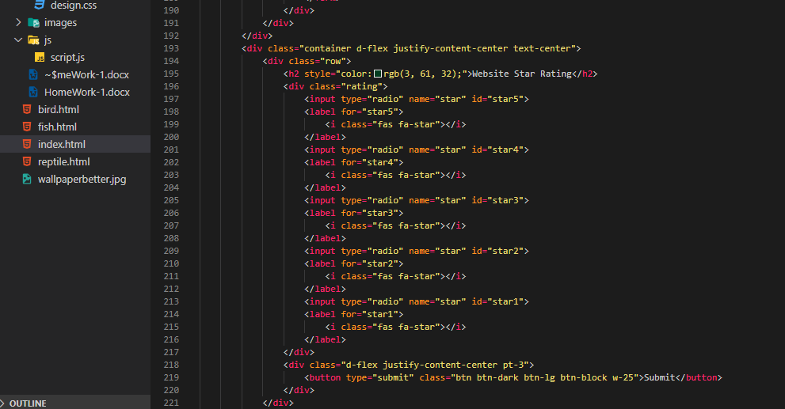

5.A weather section has been added to Bird, Fish and Animal pages using the weather API. The website https://openweathermap.org was used. It is coded in Javascript.

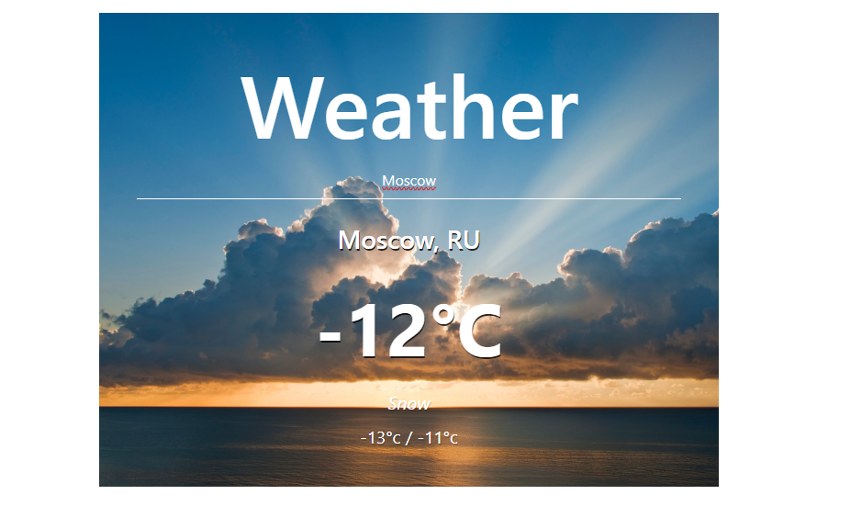

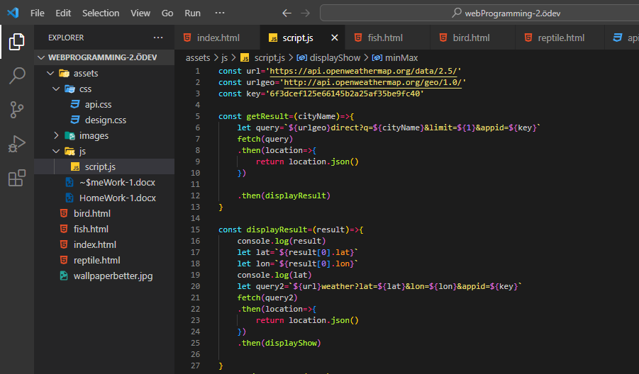

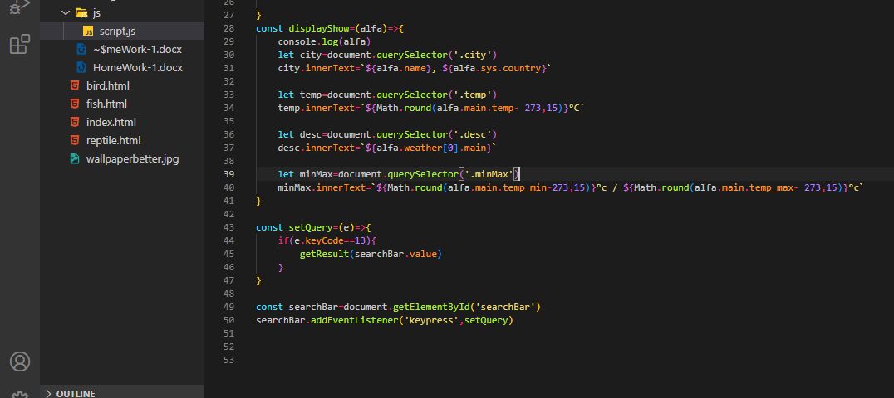

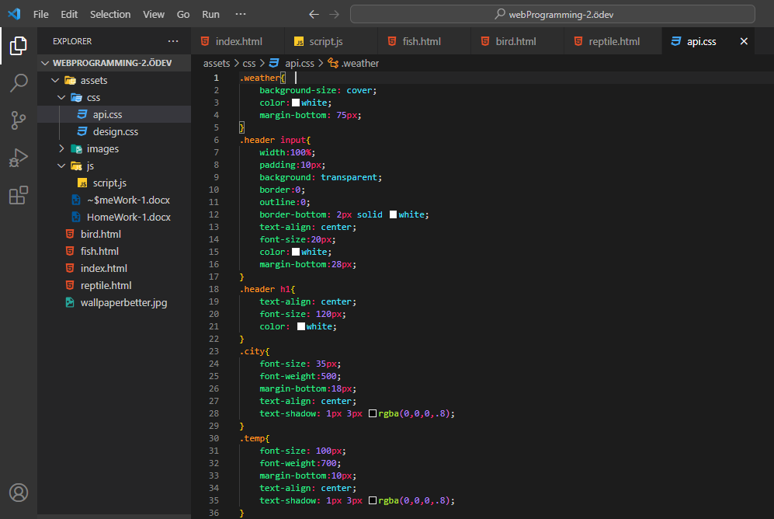

20180301029- FURKAN KILIÇ

20190301022- İHSAN EMRE DOĞAN

20190301012- EMRECAN ERKUŞ