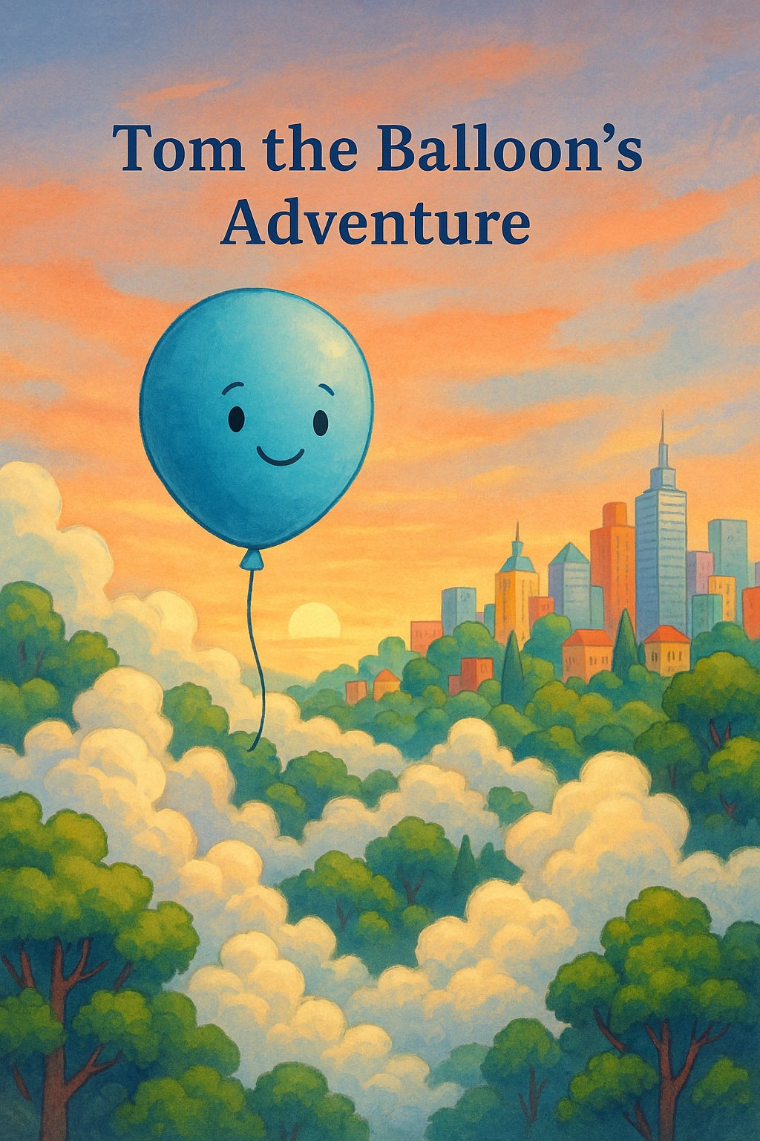

Tom the Balloon's Adventure

Tom was a happy blue balloon who loved flying high above the city. One sunny day, he floated away on a magical journey through the clouds.



As Tom flew lower, he met a kind boy named Max. Max took Tom home to cheer up his sick sister, Alice.

Alice smiled brightly when she saw Tom. It was the happiest she had felt in days.



Thanks to Max and Tom, Alice began to feel better. Soon, they were all running together through a field of flowers.

Tom the balloon bounced joyfully in the wind, proud to be part of their happiness.