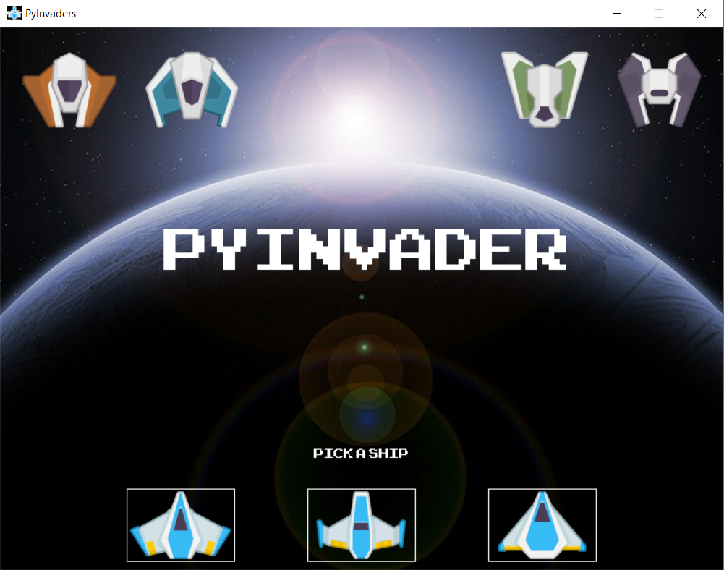

Tutorial Requirements:

* Download the zip files in the content section
  + PyInvader_Part1.zip – Starting point for this week, covers everything from last week
  + AdditionalAssets.zip – Assets for this week’s lecture and assignments

**\*\*** Homework at the bottom of this document **\*\***

Chapters: Note: times are for when the file is created, we may jump back and forth after that time.

1. [00:00] Button Class
   * Code Modified from: <https://www.youtube.com/watch?v=4_9twnEduFA>
   * Font loading from file
   * Multi-Purpose button class
     1. Image or Text
     2. Rectangle positioning
     3. Hover
     4. Click Action
2. [00:00] Intro Class: ( Welcome Screen / Player Choice )
   * Loading of background image and text areas
   * Creation of three image buttons for player choice
   * Modification of game.py to load welcome screen waiting for player choice
3. [00:00] Drone Class 🡪 Fighter Class & Diving Class
   * Demonstration of inheritance and then different images
4. [00:00] Level Class
5. [00:00] Meteor / UFO Class

**Homework:**

1. High Score Screen
   1. After game over is reached load screen
   2. Create a button which would bring user back to welcome screen.
   3. Display top 10 high scores
      1. Either load, sort, then truncate here or modify setHighScores() to only save the top 10 high scores and then here just display all 10.
2. Infinite Levels
   1. First create a setup for your own level to follow the first 3
   2. Then create a random level function and add a random level to the list.
   3. Add Boolean variable to the level constructor for infinite levels
      1. If True you should generate additional random levels after the initial ones are passed
      2. If False you should only play the 3 from the lecture, the 1 set one you made and 1 random level