Supplemental Material for

Critical-layered MoS₂ for the enhancement of supercontinuum generation in photonic crystal fibre
Jin Xie, Xu Cheng, Guodong Xue, Xiao Li, Ding Zhong, Wentao Yu, Yonggang Zuo, Chang Liu, Kaifeng Lin, Can Liu, Meng Pang, Xin Jiang, Zhipei Sun, Zhe Kang, Hao Hong, Kaihui Liu and Zhongfan Liu
The supplemental material includes:
Supplementary Figure 1-14
Supplementary Notes 1-2
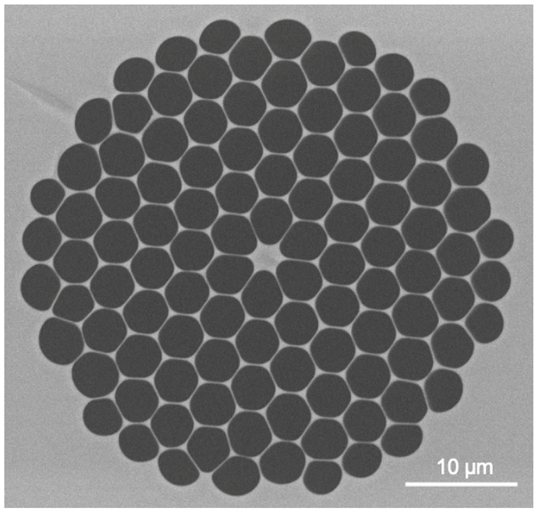
Fig. S1. The cross-section of the silica-based nonlinear PCF. Scanning electron microscopy (SEM) image of the detailed structure and size of the PCF, consisting of a small silica solid-core and five arrays of patterned air-holes. The core diameter is ~2.35 μm, the diameter of the innermost circle of grapefruit-shaped holes and the other four rows of analogue hexagonal circle holes are ~4.20 and ~3.47 μm, respectively.
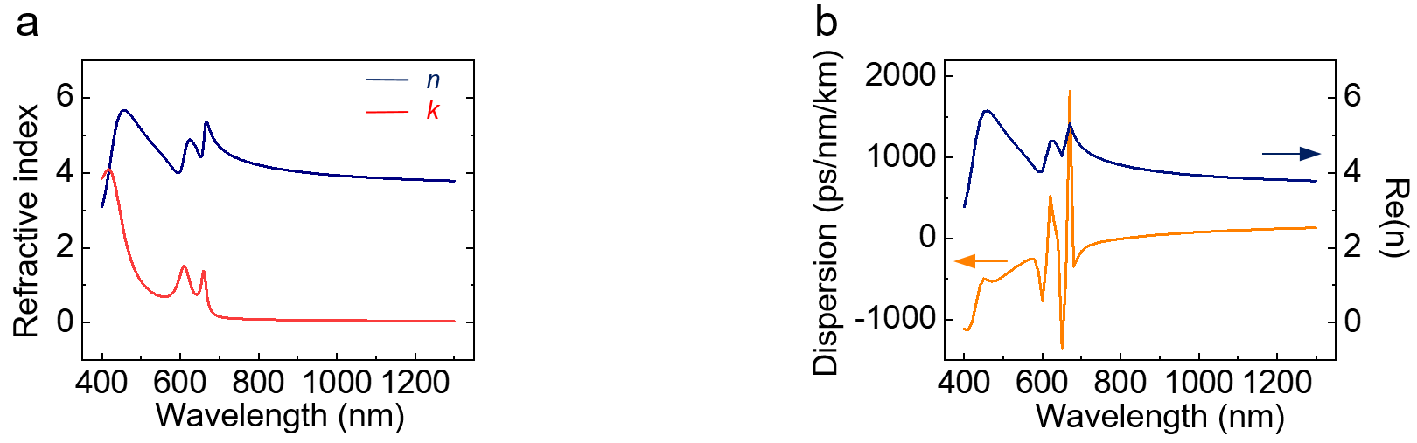
Fig. S2. The complex refractive index of monolayer MoS₂¹, and the influence of its real part on dispersion. a, The curves of real and imaginary parts keep smooth beyond the wavelength corresponding to the MoS₂ bandgap. With the wavelength decreases, the vibrations appear in these two curves originating from the excitonic effects around its bandgap. Meanwhile, the increased imaginary part directly induces the increasing of transmission loss in the MoS₂-PCF. b, The real part of refractive index of monolayer MoS₂ and dispersion curve of monolayer MoS₂-PCF. The corresponding peak positions in these two curves indicate the origin of the vibration in dispersion is from the influence of the refractive index of MoS₂ around its bandgap.
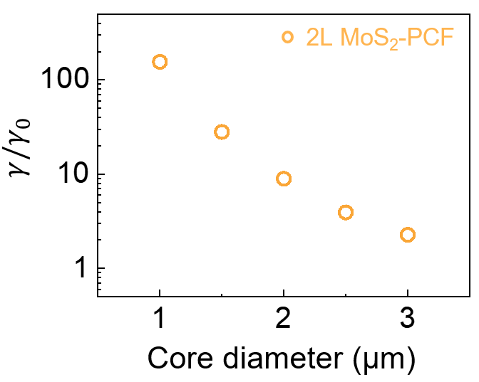
Fig. S3. The enhancement of nonlinear coefficient on 2L MoS₂-PCF core diameter. The ratio of the nonlinear coefficient of MoS₂-PCF to that of bare-PCF (γ₀) increases from 2.5 to 129.5 as the core diameter decreases from 3 to 1 μm.

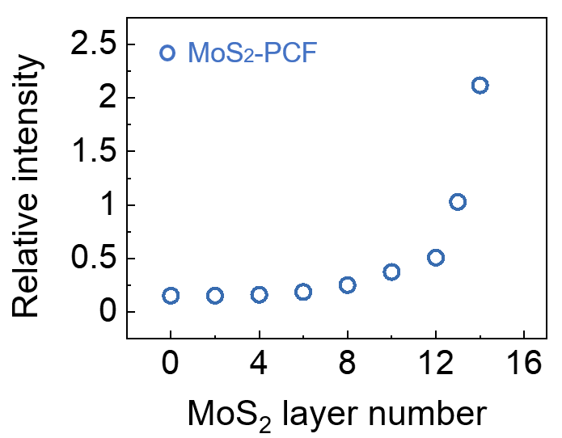
Fig. S4. The relative intensity of electric field (ratio of light intensity at innermost MoS₂ position to that at core centre) in different layers MoS₂-PCF. The relative intensity enhances gradually as the MoS₂ layer number increases, indicating a consequent increasing light-MoS₂ interaction.

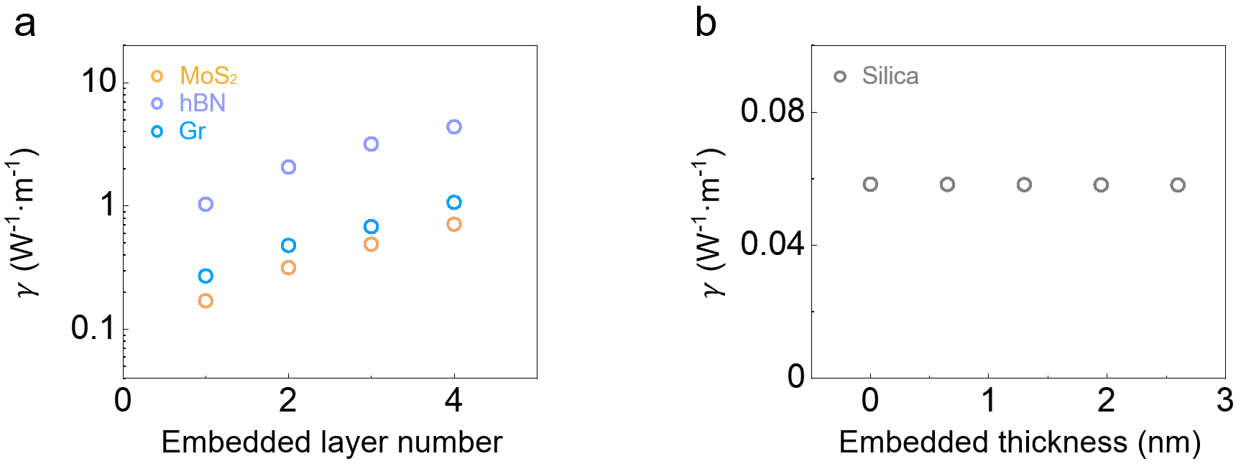
Fig. S5. The calculation of the nonlinear coefficient in the hybrid fibre embedded with different materials. a, The Gr-PCF and hBN-PCF show a higher nonlinear coefficient than that of the MoS₂-PCF with the number of embedded 2D material layers increases due to their larger third-order susceptibility. b, The nonlinear coefficient for silica replacement decreases weakly as the thickness increasing would slightly enhance the effective mode area of fibre.

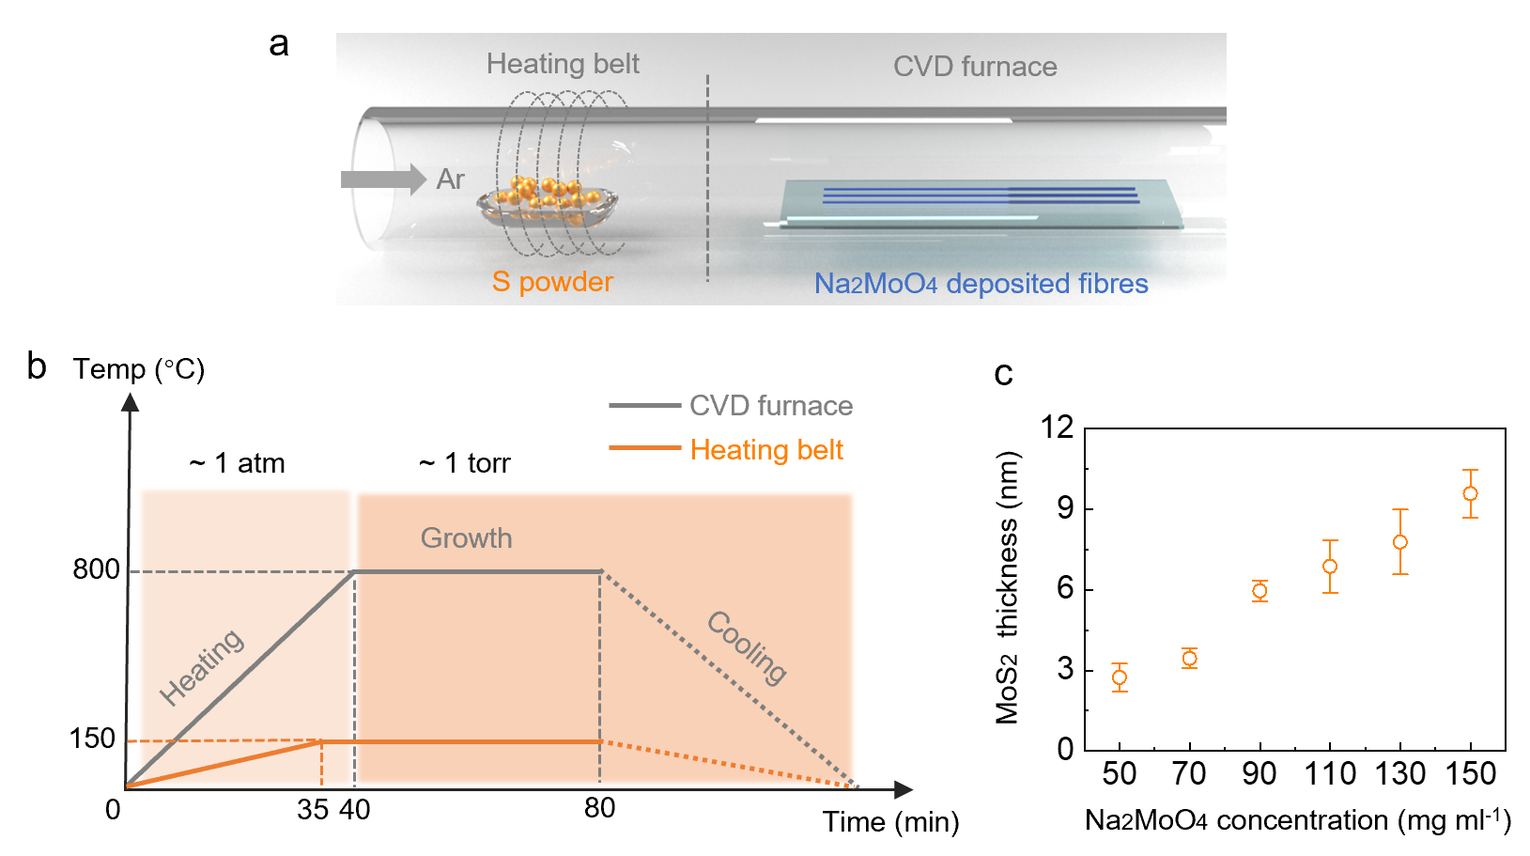
Fig. S6. Preparation of MoS₂-PCF with controlled MoS₂ thickness. a, The schematic illustration of the CVD setup for fabrication of MoS₂-PCF. b, The scheme of pressure varied strategy during MoS₂ growth process in PCF to avoid the molten Na₂MoO₄ diffusing. c, The average thickness of MoS₂ film gradually increases from ~2.7 nm to ~10 nm thick-layer while varying the Na₂MoO₄ concentration from 50 mg ml⁻¹ to 150 mg ml⁻¹.

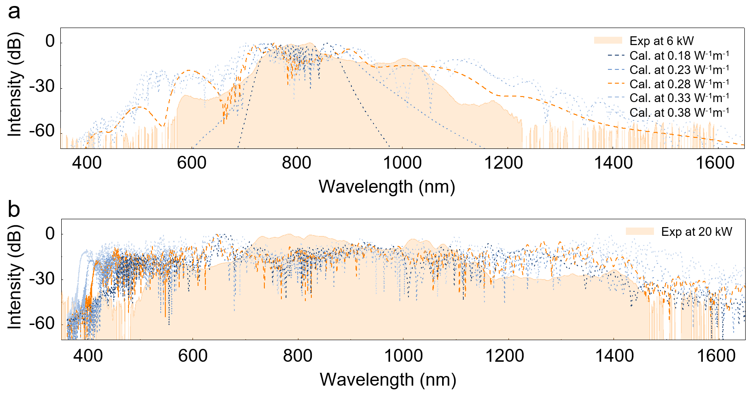
Fig. S7. Calculation of nonlinear coefficients of MoS₂-PCF. The orange shaded regions are the spectral broadening data for the pump peak powers of 6 kW (a) and 20 kW (b), and the dashed lines are the spectral broadening simulations with the nonlinear coefficient set to 0.18 W⁻¹ m⁻¹~0.38 W⁻¹ m⁻¹. The simulating results revealed that the spectrum at 0.28 W⁻¹ m⁻¹ was the closest to the experimental result, indicating 4.8 times enhancement compared to that of bare-PCF.
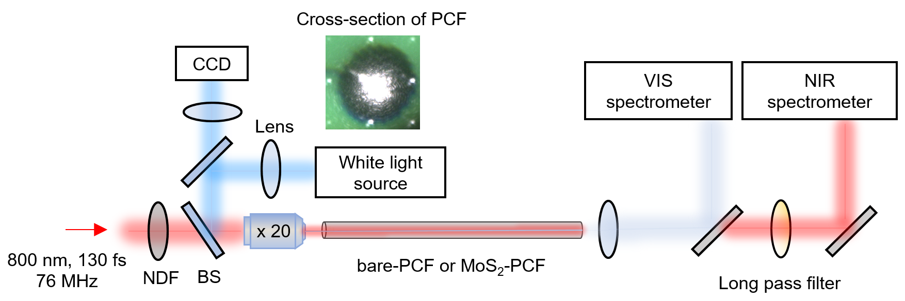
Fig. S8. Experimental setup for generating and measuring the supercontinuum of bare- and MoS₂-PCF. Here, NDF and BS stand for neutral density filter and beam splitter, respectively. More details can be found in Methods.

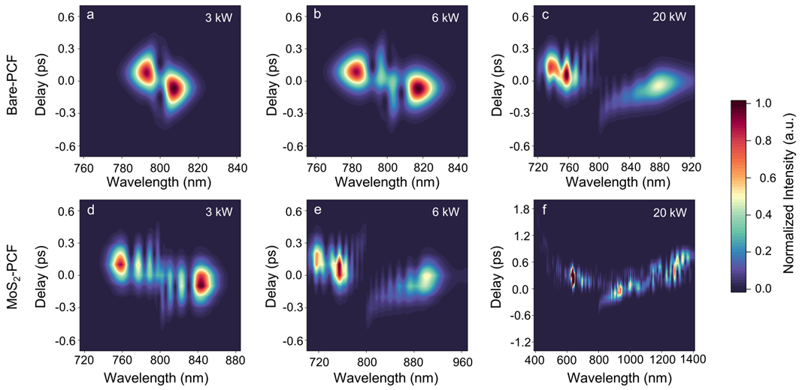
Fig. S9. Spectrograms of the bare-PCF (a-c) and the MoS₂-PCF (d-f) at pump peak power at 3 kW, 6 kW, and 20 kW, respectively. From the pulse duration in the time domain, for the bare-PCF, it clearly exhibits the evolution from the initial SPM stage at both 3 and 6 kW to the soliton fission stage at 20 kW. On the MoS₂-PCF, it demonstrates stronger spectral broadening and splitting due to the increased nonlinear coefficient of MoS₂-PCF initially at 3 kW and enters the soliton fission process much quicker than bare-PCF at 6 kW. Then, it experiences complex processes at 20 kW, including the Kerr nonlinear effect and dispersive wave generation.
Due to the lack of experimental devices, we characterized the pulse duration with simulations. We calculated the spectrogram by the model of X-FROG trace to compare the time-frequency dynamic in the bare- and MoS₂-PCF. The model of X-FROG trace is given by,
$$Ψ\left(τ, ω\right)={\left|\int_{-∞}^{+∞}{E\left(t,z=L\right)F_{gate}\left(t-τ\right)e^{-iωt}dt}\right|}^{2}$$
where E(t, z = L) is the temporal envelope of the optical field at the propagation length L. F_{gate} is a variable-delay gate function, which is a 100 fs hyperbolic secant pulse in the simulation, with the delay value $τ$.
Fig. S9a-f show the spectrograms at three selected pump peak power of 3 kW, 6 kW, and 20 kW, respectively, at which the spectrograms show typical evolution dynamics. Fig. S9a clearly shows the chirped characteristic of the pump pulse, indicating the initial evolution in the bare-PCF. The leading and trailing edges of the pulse are red-shifted and blue-shifted in the frequency domain, respectively. The pulse duration in the time domain almost remains unchanged. This is a typical pulse evolution dynamic during the initial SPM stage in a normal dispersion regime. Fig. S9d shows that, although the pulse duration changes slightly, the spectral broadening and splitting are stronger than those of bare-PCF. This is a benefit from the increased nonlinearity of MoS₂-PCF. When the pump peak power is increased to 6 kW, Fig. S9b shows that the evolution in the bare-PCF remains in the SPM stage. In contrast, Fig. S9e shows that the evolution in the MoS₂-PCF experiences soliton fission process, just passing through the high-order soliton compression stage. The energy is concentrated in the middle, belonging to the compressed soliton pulses. The fundamental soliton is compressed to a ~9 fs few-cycle pulse which is superimposed on a broad residue pulse. The broad residue pulse is the product of normal dispersion evolution because a portion of the broadened pump spectrum remains in the normal dispersion regime. One sub-soliton belonging to the wavelength around 710 nm is ejected from the fundamental soliton. The sub-soliton is retarded and interfered with the fundamental soliton. When the pump peak power is further increased to 20 kW, Fig. S9c shows that the evolution in the bare-PCF just enters the soliton fission stage, similar to that in Fig. S9e. While in contrast, Fig. S9f shows that evolution in the MoS₂-PCF already becomes complex. The spectrum is extremely broadened because of the joint contribution of Kerr nonlinear effects and dispersive wave generation. The ejected sub-solitons and resonant dispersive wave emission are retarded and interfere with each other in the time domain, resulting in constructive and destructive spectral profiles. The definition of pulse duration is meaningless in this stage because there is no pure pulse in the time domain.
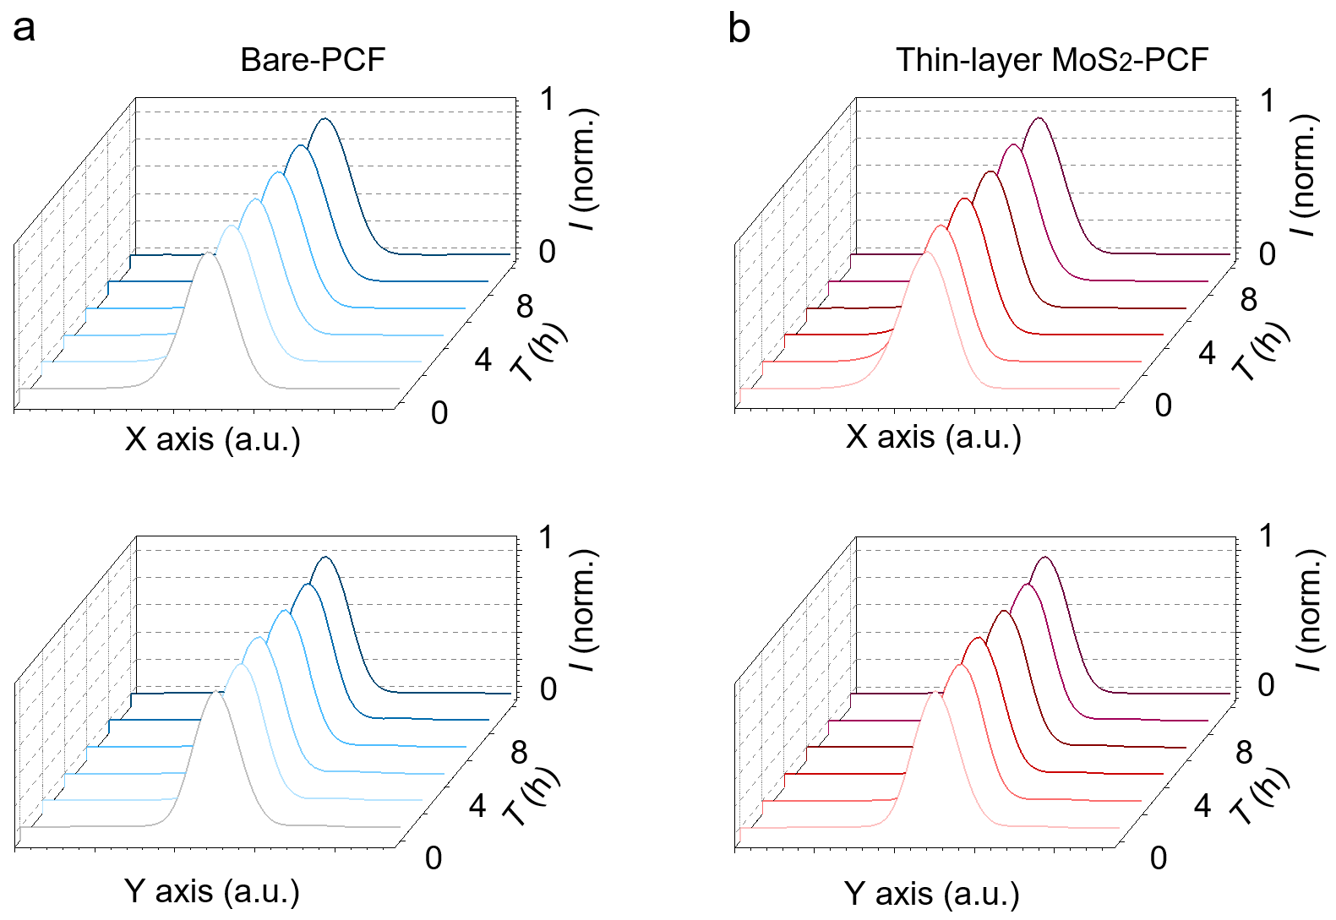
Fig. S10. The stability comparison of the output beam intensity distribution in bare- and MoS₂-PCF. The bare-PCF (a) and MoS₂-PCF (b) demonstrated a similar Gaussian-like output beam profile from both the observed X and Y axes. Moreover, these profiles kept stable within 10 hours prior to the instability of the laser.

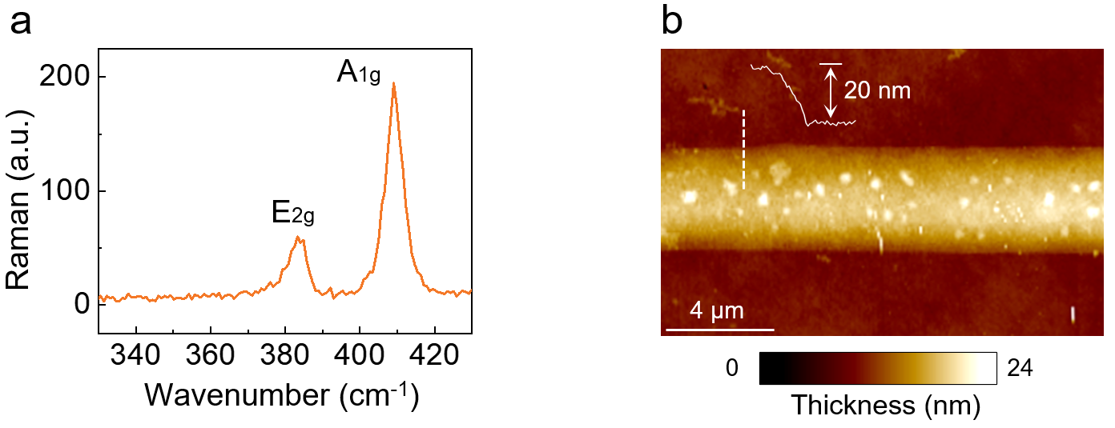
Fig. S11. Characterization of thick-layer MoS₂-PCF. a, Raman spectra of the thick-layer MoS₂-PCF. The frequency difference between A_{1g} and E_{2g} modes is ~25 cm⁻¹, which indicates the thickness of MoS₂ is larger than 10 layers. b, The AFM mapping of the collapsed MoS₂ tube film obtained after etching silica of MoS₂-PCF and transferring the left MoS₂ tube film onto the substrate. With an average layer thickness of ~20 nm and considering the probable influence of wrinkles or air-gap inside the tube, the grown thick MoS₂ film is around 13 layers.
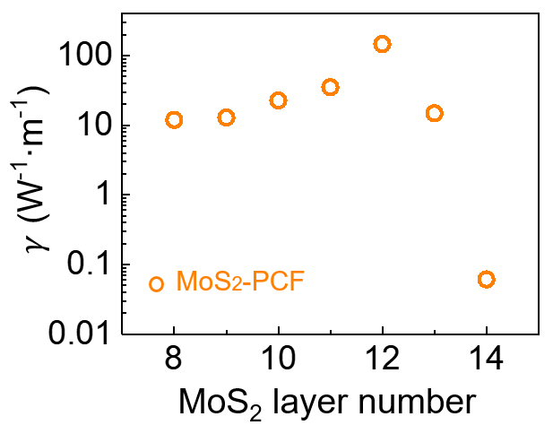
Fig. S12. The calculated nonlinear coefficient versus thick-layer number of embedded MoS₂. As the number of MoS₂ layers increases, the nonlinear coefficient gradually increases and reaches the maximum value at the 12 layers. After that, due to the outward diffusion of the mode field, the nonlinear coefficient decreases rapidly.

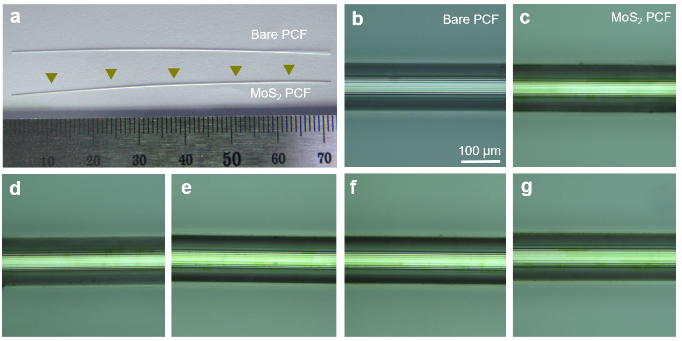
Fig. S13. The as-prepared fibre with full MoS₂ coverage within 6-7 cm. a, The photographs of the bare-PCF and thin-layer MoS₂-PCF, with clear consistent contrast. b, The optical image of the bare-PCF as a comparison. c-g, The optical images of as-grown MoS₂-PCF that carried out from different positions marked in a. All the optical images are of the same size.
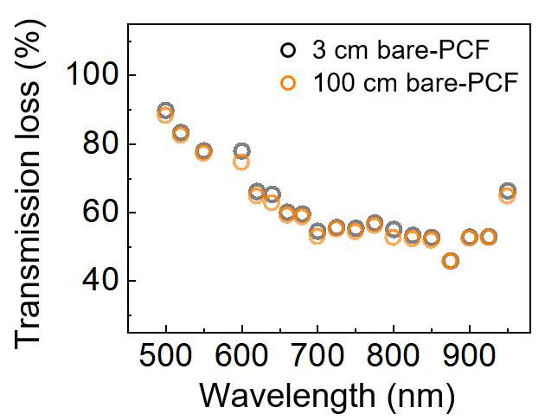
Fig. S14. Transmission loss of bare-PCF with different lengths. The transmittance of bare-PCF with length of 3 cm and 100 cm is used to calibrate the coupling loss from the objective lens. It varies with the wavelength due to the different spot areas of the light selected by the wavelength selector from the supercontinuum white light source. Comparing the transmittance of 3 cm and 10 cm bare-PCF, the transmission loss of the bare-PCF is less than 0.001 dB cm⁻¹.

Supplementary Note 1: Calculations of the nonlinear coefficient in the bare- and MoS₂-PCF
For traditional step-index single-mode fibre, the nonlinear coefficient $γ$ is given by^{2,3}:
$γ=\frac{2π}{λ}\frac{n_{2}\iint_{-∞}^{∞}{{\left|F\left(x,y\right)\right|}^{4}}dxdy}{{\left(\iint_{-∞}^{∞}{{\left|F\left(x,y\right)\right|}^{2}}dxdy\right)}^{2}}$, (S1.1)
where $λ$ is the pump wavelength, $\left|F(x,y)\right|$ is the amplitude of electric field distribution of fundamental mode, the domain of integral area is the cross-section of the fibre, $n_{2}$ is the nonlinear refractive index, which is determined by the linear refractive index $n_{0}$ and third-order susceptibility $χ^{\left(3\right)}$⁴:
$n_{2}=\frac{3}{4n_{0}^{2}ϵ_{0}c}χ^{\left(3\right)}$ , (S1.2)
In the above formula, it is usually assumed that the fibre is composed of homogeneous material, ignoring the small refractive index difference between the fibre core and cladding. A more general expression of $γ$ without this assumption is given by:
$γ=\frac{2π}{λ}\frac{\sum_{i}{\iint_{D_{i}}{{\left(n_{2}\right)}_{i}{\left(n_{0}\right)}_{i}^{2}{\left|F\left(x,y\right)\right|}^{4}dxdy}}}{{\left(\sum_{i}{\iint_{D_{i}}{{\left(n_{0}\right)}_{i}{\left|F\left(x,y\right)\right|}^{2}dxdy}}\right)}^{2}}$ , (S1.3)
where $D_{i}$ represents different integral areas.
By embedding the MoS₂ film into the patterned air-holes of PCF, a hybrid MoS₂-PCF is formed. In this case, the nonlinear coefficient $γ_{{MoS}_{2}-PCF}$ should be calculated by unfolding the integral areas:
$\iint_{-∞}^{∞}{dσ}=\iint_{\text{air }}{dσ}+\iint_{{SiO}_{2}}{dσ}+\iint_{{MoS}_{2}}{dσ}$ , (S1.4)
Considering the quite weak electric field intensity distribution and small $χ^{\left(3\right)}$ in the air region, we can ignore its influence on $γ_{{MoS}_{2}-PCF}$. Thus, the nonlinear coefficient of MoS₂-PCF is given by:
$γ=\frac{2π}{λ}\left({\left(n_{2}\right)}_{M}\frac{\iint_{M}{{\left(n_{0}\right)}_{M}^{2}{\left|F\left(x,y\right)\right|}^{4}dxdy}}{{\left(\iint_{S+M}{{\left(n_{0}\right)}_{i}{\left|F\left(x,y\right)\right|}^{2}dxdy}\right)}^{2}}+{\left(n_{2}\right)}_{S}\frac{\iint_{S}{{\left(n_{0}\right)}_{S}^{2}{\left|F\left(x,y\right)\right|}^{4}dxdy}}{{\left(\iint_{S+M}{{\left(n_{0}\right)}_{i}{\left|F\left(x,y\right)\right|}^{2}}dxdy\right)}^{2}}\right)$ , (S1.5)
To simplify the expression of $γ_{{MoS}_{2}-PCF}$, we define the effective mode area as a reference:
$A_{D_{i}}=\frac{{\left(\sum_{i}{\iint_{D_{i}}{{\left(n_{0}\right)}_{i}{\left|F\left(x,y\right)\right|}^{2}dxdy}}\right)}^{2}}{\iint_{D_{i}}{{\left(n_{2}\right)}_{i}{\left(n_{0}\right)}_{i}^{2}{\left|F\left(x,y\right)\right|}^{4}dxdy}}$ , (S1.6)
Therefore, $γ_{{MoS}_{2}-PCF}$can be simplified to:
$γ=\frac{2π}{λ}\left({\left(n_{2}\right)}_{M}/A_{D_{M}}+{\left(n_{2}\right)}_{S}/A_{D_{S}}\right)$ , (S1.7)
Supplementary Note 2: Numerical simulation of supercontinuum generation in the bare- and MoS₂-fibre.
The dynamic of optical pulse propagation in the bare- and MoS₂-fibre is governed by the generalized nonlinear Schrödinger equation (GNLSE), which in the frequency domain is given by^{5,6}
$$\frac{∂\tilde{E}}{∂z}=\left(-\frac{α\left(ω\right)}{2}+β_{int}\left(ω\right)\right)\tilde{E}+$$$iγ\left(ω\right)\left(1+\frac{ω-ω_{0}}{ω_{0}}\right)F\left(E\left(z,t\right)\left[\left(1-f_{R}\right){\left|E\left(z,t\right)\right|}^{2}+f_{R}\int_{0}^{∞}{h_{R}\left(τ\right){\left|E\left(z,t-τ\right)\right|}^{2}dτ}\right]\right)$, (S2.1)
where $\tilde{E}\left(z,ω-ω_{0}\right)$ and $E\left(z,t\right)$ are the complex spectral and temporal envelope of the optical field, respectively, $α$ is the linear loss, $γ$ is the nonlinear coefficient, $β_{int}$ is the integrated dispersion which is given by,
$β_{int}\left(ω\right)=β\left(ω\right)-β\left(ω_{0}\right)-β_{1}\left(ω_{0}\right)\left[ω-ω_{0}\right]=F\left(\sum_{n=2}^{∞}{i}\frac{i^{n}β_{n}}{n!}\frac{∂^{n}}{∂t^{n}}\right)$, (S2.2)
where $β_{n}=d^{n}β/dω^{n}$ is the n-th order dispersion parameter, $F\left(∙\right)$ is the Fourier transform operator.
The integral term on the right-hand side of Eq. (1) is the contribution of non-instantaneous nonlinearity that determined by the stimulated Raman scattering effect. The parameter $f_{R}$ indicates the fractional contribution between the non-instantaneous Raman effect and the instantaneous Kerr effect. We can conveniently handle this convolution integral in the frequency domain,
$\int_{0}^{∞}{h_{R}\left(τ\right){\left|E\left(z,t-τ\right)\right|}^{2}dτ}=h_{R}\left(t\right)⨂{\left|E\left(z,t\right)\right|}^{2}=F^{-1}\left(F\left(h_{R}\left(t\right)\right)∙F\left({\left|E\left(z,t\right)\right|}^{2}\right)\right)$, (S2.3)
where $h_{R}\left(t\right)$ is the Raman response function. We utilize a boson peak model of $h_{R}\left(t\right)$ in the simulation, as given by³,
$h_{R}\left(t\right)=\left(1-f_{b}\right)\frac{τ_{1}^{2}+τ_{2}^{2}}{τ_{1}τ_{2}^{2}}\text{exp}\left(-\frac{t}{τ_{2}}\right)\text{sin}\left(\frac{t}{τ_{1}}\right)Θ\left(t\right)+f_{b}\left(\frac{2τ_{b}-t}{τ_{b}^{2}}\right)\text{exp}\left(-\frac{t}{τ_{b}}\right)Θ\left(t\right)$, (S2.4)
where $f_{b}$ indicates the fractional contribution of the boson peak,$Θ\left(t\right)$ is the Heaviside step function. The parameters$f_{R}=0.245$, $f_{b}=0.21$, $τ_{1}=12.2$ fs, $τ_{2}=32$ fs, and $τ_{b}=96$ fs reasonably fit the Raman gain spectrum of silica fibre.
We numerically calculate Eq. (1) by using 4th-order Runge-Kutta algorithm. The change of variables $\tilde{E}'\left(z,ω-ω_{0}\right)=\tilde{E}\left(z,ω-ω_{0}\right)\text{exp}\left[-\left(iβ_{int}-α/2\right)z\right]$ is adopted to change the partial differential equation Eq. (1) to an ordinary differential equation. The pump seed has the hyperbolic secant profile $E\left(z=0,t\right)=\sqrt{P_{0}}\text{sech}\left(t/t_{0}\right)$ with $P_{0}$ the peak power of the pump. The pulse width is $t_{0}=t_{\text{FWHM}}/2\text{ln}\left(1+2^{1/2}\right)=130$ fs. We add quantum noise to the pump seed in the time domain. The quantum noise is assumed to be single photon per mode across the whole spectrum with the variance of $〈σ\left(z,t\right)σ^{*}\left(z',t'\right)〉=\left(ℏv/Ndt\right)δ\left(z-z'\right)δ\left(t-t'\right)$. Here, $ℏ$ is the Planck constant, N is the number of numerical sampling bins, $dt$ is the temporal resolution of the time window in the numerical simulation. The random phase is also included by using $\text{exp}\left(i2π\check{U}\right)$ with $\check{U}$ a uniformly distributed random variable between 0 and 1. The linear loss, dispersion parameters, and nonlinear coefficient are tested or calculated from the mode analysis of the fibres. The $β_{int}$ can be directly used to fulfil an approximation-free simulation of dispersion. Nevertheless, we find that the numerically calculated supercontinuum matches the experimental results very well when the order of dispersion parameters is not less than 6. For the contribution of the stimulated Raman scattering effect, simulation results of the MoS₂-PCF with only the Raman effect of silica reasonably match the experimental results, which confirms the barely stimulated Raman characteristic of the MoS₂.
References
- Song, B. et al. Layer-dependent dielectric function of wafer-scale 2D MoS₂. Adv. Opt. Mater. 7, 1801250 (2019).
- Yang, Y. et al. Enhanced four-wave mixing in waveguides integrated with graphene oxide. APL Photon. 3, 120803 (2018).
- Wu, J. et al. 2D Layered graphene oxide films integrated with micro-ring resonators for enhanced nonlinear optics. Small 16, 1906563 (2020).
- Agrawal, G. P., Nonlinear fibre optics (Academic Press, 2019).
- Dudley, J. M., Genty, G. & Coen, S. Supercontinuum generation in photonic crystal fibre. Rev. Mod. Phys. 78, 1135-1184 (2006).
- Dudley, J. M. & Taylor, J. R. Supercontinuum generation in optical fibres. (Cambridge Univ. Press, 2010).

