’A comparison of statistical models used to characterize species-habitat associations with movement data: Appendix 3

Katie Florko

31/07/2023

Table of Contents

# Overview

This document contains a coding tutorial that demonstrates how to perform the analyses associated with the case study in “*A comparison of statistical models used to characterize species-habitat associations with movement data*”. All analyses link the movement data of a ringed seal in eastern Hudson Bay, Canada, to modeled prey diversity.

# Set-up

## Load packages

# data wrangling  
library(here)  
library(tidyverse)  
library(lubridate)  
  
# mapping  
library(rnaturalearth)  
library(rgdal)  
library(terra)  
library(sf)  
library(viridis)  
  
# fitting models  
library(amt) # for selection functions  
library(momentuHMM) # for hidden Markov model  
  
# plotting  
library(ggplot2)

## Fish data

Next we load in the fish data, which contains the spatial distribution of prey diversity in 2012. This is a subset of the data from Florko et al. (2021a, 2021b).

# load fish data  
fish <- read.csv(here("data/preydiv.csv"))

Using Visualize the fish data. *MAM: I think here you want to use sf rather than sp, sp is pretty much getting removed. The sf function for spTransform is st_transform I think. I think also that now instead of using CRS, all R functions use another system. That’s why you are getting warnings. R now uses EPSG, I think the number you want is 3573 or something like that:* [*https://epsg.io/3573*](https://epsg.io/3573) *But please check.*

# prepare world data for mapping  
natearth <- ne_countries(scale = "medium",returnclass = "sp")  
natearth <- natearth[which(natearth$continent!="Antarctica"),]  
# projection: Lambert azimuthal equal area - Hudson Bay   
nat_trans <- spTransform(natearth,CRS("+proj=laea +lat_0=60 +lon_0=-85 +x_0=0 +y_0=0 +datum=WGS84 +units=m +no_defs +ellps=WGS84 +towgs84=0,0,0"))

## Warning in spTransform(xSP, CRSobj, ...): NULL source CRS comment, falling back  
## to PROJ string

## Warning in wkt(obj): CRS object has no comment

# plot fish map  
fishmap <- ggplot() +   
 geom_tile(data = fish, aes(x = lon,y = lat,fill = preydiv)) +  
 scale_fill_viridis(option = "mako", limits = c(0.5, 0.75), name = "Prey\ndiversity") +  
 geom_polygon(data = nat_trans, aes(x=long,y=lat,group=group), fill = "grey80", color = "white") +  
 coord_cartesian(xlim = c(150000,550000), ylim = c(-500000,-50000), expand = F)   
fishmap

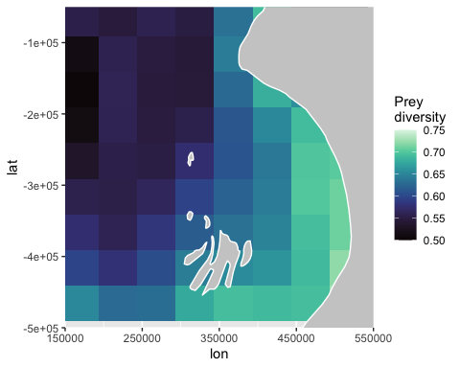

## Seal data

Next we load in one movement track from a ringed seal equipped with an ARGOS satellite telemetry transmitter over the course of over four months in the winter of 2012-2013. This is a subset of the data from Florko et al. (2023a).

# load seal data  
seal <- read.csv(here("data/seal_track_m.csv"))   
head(seal)

## lon lat date id  
## 1 357940.9 -368949.6 2012-10-29 14:00 116484_1  
## 2 371594.3 -353092.9 2012-10-30 14:00 116484_1  
## 3 388429.2 -361478.4 2012-10-31 14:00 116484_1  
## 4 399326.2 -357288.1 2012-11-01 14:00 116484_1  
## 5 411788.2 -349500.7 2012-11-02 14:00 116484_1  
## 6 407708.1 -372564.6 2012-11-03 14:00 116484_1

# ensure the data is in the correct format  
seal <- seal %>%  
 mutate(id = as.character(id),  
 date = as.Date(date))

Visualize the seal data on top of the fish data.

# plot seal and fish data together  
sealfishmap <- fishmap +   
 geom_point(data=seal, aes(x=lon, y=lat), alpha = 0.6, color = "#FCEEAE") +   
 geom_path(data=seal, aes(x=lon, y=lat), color = "#FCEEAE")   
  
sealfishmap

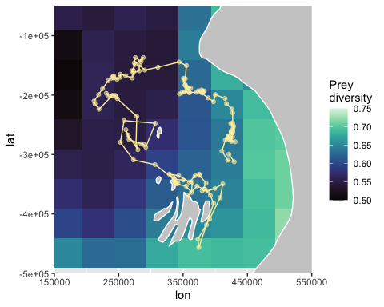

# Fit models

We will fit four models: 1) a resource selection function (RSF), 2) a step selection function (SSF) without habitat covariates in the movement kernel, 3) a SSF with a habitat covariate modifying the movement kernel, and 4) a hidden Markov model (HMM). All four of these models will include prey diversity as a covariate.

All of the step selection functions (both the RSF and two SSFs) will be fit using the amt package (Signer et al. 2019), while the HMM will use the functions from the momentuHMM package (McClintok and Michelot 2018).

## RSF

The RSF is the simplest of the four models. Fitting an RSF to movement data first requires us to generate a sample of availability points and extract covariates for the used and available locations.

# prep data and generate availability sample  
set.seed(2023)  
data_rsf <- seal %>%  
 make_track(lon, lat, date) %>% # convert data to track format  
 random_points() # generate availability sample; default is ten times as many available points as observed points  
  
# plot used vs available locations on-top of prey diversity  
data_rsf_map <- sealfishmap +  
 geom_point(data=data_rsf, aes(x=x_, y=y_, color = case_), alpha = 0.6) +  
 scale_color_manual(values = c("black", "#FCEEAE"),   
 label = c("Available", "Observed"), name = "Data type")   
data_rsf_map

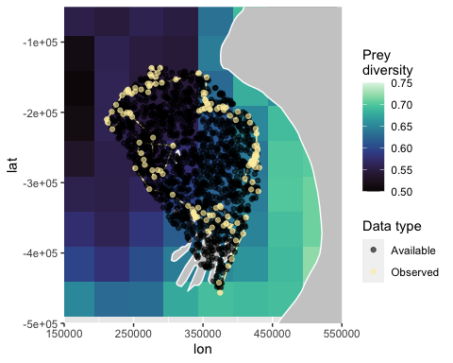

We can see that the availability sample is generated within the minimum convex polygon of the used samples. *MAM: if you are using the fish as a rater in all analyses, I would move that up in the set-up section. Also, why are you using WSG$ here, but LAEA above? Is there a mismatch in your projections?*

We now extract covariates for the used and available locations.

# rasterize and extract prey diversity covariate  
fish_raster <- terra::rast(fish, crs = "+proj=longlat +ellps=WGS84 +datum=WGS84 +no_defs")  
  
data_rsf <- data_rsf %>%  
 extract_covariates(fish_raster)

Next, we will fit the model. The response, case_, is used or available location, and preydiv is the covariate for prey diversity.

# fit rsf (a binomial logistic regression)  
rsf1 <- data_rsf %>%  
 amt::fit_rsf(case_ ~ preydiv, model = TRUE)

View the summary.

# see model summary  
summary(rsf1)

##   
## Call:  
## stats::glm(formula = formula, family = stats::binomial(link = "logit"),   
## data = data, model = TRUE)  
##   
## Deviance Residuals:   
## Min 1Q Median 3Q Max   
## -0.5753 -0.4729 -0.4294 -0.3754 2.3363   
##   
## Coefficients:  
## Estimate Std. Error z value Pr(>|z|)   
## (Intercept) -6.118 1.400 -4.369 1.25e-05 ***  
## preydiv 6.353 2.312 2.748 0.006 **   
## ---  
## Signif. codes: 0 '***' 0.001 '**' 0.01 '*' 0.05 '.' 0.1 ' ' 1  
##   
## (Dispersion parameter for binomial family taken to be 1)  
##   
## Null deviance: 938.28 on 1539 degrees of freedom  
## Residual deviance: 930.60 on 1538 degrees of freedom  
## AIC: 934.6  
##   
## Number of Fisher Scoring iterations: 5

We see that prey diversity is a significant positive covariate. We do not interpret the intercept, since it is not ecologically meaningful in a RSF. See Fieberg et al. (2021) for a detailed discussion on how to interpret parameters.

## SSF

Next we will fit our two SSFs. The workflow is similar to that of the RSF, however, the availability sample is generated differently. We transform the seal locations into a track format, then convert the track data into step format (i.e., with a start and an end), and then generate the availability sample.

# prep data and generate availability sample  
set.seed(2023)  
data_ssf <- seal %>%  
 make_track(lon, lat, date) %>% # convert data to track format  
 steps() %>% # convert track data to step format (i.e., with a start and an end)  
 random_steps() # generate availability sample

It always helps to visualized the sample created.

# plot used vs available locations on-top of prey diversity  
data_ssf_map <- sealfishmap +  
 geom_point(data=data_ssf, aes(x=x2_, y=y2_, color = case_), alpha = 0.6) +  
 scale_color_manual(values = c("black", "#FCEEAE"),   
 label = c("Available", "Observed"), name = "Data type")   
data_ssf_map

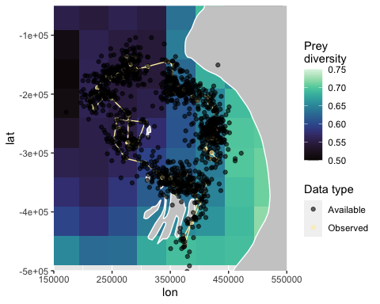

We can see that the availability sample is generated at each step and is not restricted to the minimum convex polygon.

We now extract prey diversity values for the used and available locations.

# extract prey diversity covariate  
data_ssf <- data_ssf %>%  
 extract_covariates(fish_raster, where = "end") #sample at end of step

We will transform both the step length and turning angle using log and cosine transformations, respectively.

# transform movement covariates  
data_ssf <- data_ssf %>%  
 mutate(cos_ta = cos(ta_),  
 log_sl = log(sl_))

Next, we will fit the models. The response, case_, is used or available location, and preydiv is the covariate for prey diversity. log_sl is the log transformation of step length, and cos_ta is the cosine transformation of turning angle. strata(step_id_) specifies that the this is a *conditional* logistic regression that groups data by step identification number.

We are fitting two SSFs, one without a movement-related covariate (called ssf1), and one with a movement-related covariate (called ssf2).

# fit ssfs  
## ssf1: ssf without covariate affecting movement kernel  
ssf1 <- data_ssf %>%  
 fit_clogit(case_ ~ preydiv + log_sl + cos_ta + strata(step_id_), model = TRUE)  
  
## ssf2: ssf with covariate affecting movement kernel  
ssf2 <- data_ssf %>%  
 fit_clogit(case_ ~ preydiv*log_sl + cos_ta + strata(step_id_), model = TRUE)

First we will interpret ssf1.

# see model summary  
summary(ssf1)

## Call:  
## coxph(formula = Surv(rep(1, 1518L), case_) ~ preydiv + log_sl +   
## cos_ta + strata(step_id_), data = data, model = TRUE, method = "exact")  
##   
## n= 1516, number of events= 138   
## (2 observations deleted due to missingness)  
##   
## coef exp(coef) se(coef) z Pr(>|z|)  
## preydiv 0.957799 2.605953 6.772711 0.141 0.888  
## log_sl -0.008404 0.991631 0.083328 -0.101 0.920  
## cos_ta 0.031707 1.032215 0.130643 0.243 0.808  
##   
## exp(coef) exp(-coef) lower .95 upper .95  
## preydiv 2.6060 0.3837 4.477e-06 1.517e+06  
## log_sl 0.9916 1.0084 8.422e-01 1.168e+00  
## cos_ta 1.0322 0.9688 7.990e-01 1.333e+00  
##   
## Concordance= 0.494 (se = 0.029 )  
## Likelihood ratio test= 0.09 on 3 df, p=1  
## Wald test = 0.09 on 3 df, p=1  
## Score (logrank) test = 0.09 on 3 df, p=1

This model estimates the coefficients (coef) as well as the exponent of the coefficient (exp(coef)). The coefficients are as in our regular logistic regression (the RSF), and the exp(coef) quantifies the relative intensity of use of two locations that differ by 1 unit of prey diversity but are otherwise the same. The model suggests our seal would be 2.6 times more likely to choose a location with 1 unit higher prey diversity (see Fieberg et al. 2021). However, this is not significant (p = 0.888), and we see that the scale of prey diversity is much smaller (range = 0.5-0.75), and thus an increase in of 2.6 times per 1 unit prey diversity is not a meaningful increase.

We don’t interpret the values of log_sl or cos_ta, since we don’t expect those to affect occurrence since the availability sample is generated using the step length and turning angle from the observed track.

We also see that we get a warning “2 observations deleted due to missingness”, due to two of our available locations being found on land, where we do not have fish values. This could be mitigated by generating more than 10 (i.e., 15) available locations per used location, omitting the samples without prey diversity values, and then randomly selecting 10 available locations per used location of those that have values for prey diversity.

Next we will interpret ssf2.

# see model summary  
summary(ssf2)

## Call:  
## coxph(formula = Surv(rep(1, 1518L), case_) ~ preydiv * log_sl +   
## cos_ta + strata(step_id_), data = data, model = TRUE, method = "exact")  
##   
## n= 1516, number of events= 138   
## (2 observations deleted due to missingness)  
##   
## coef exp(coef) se(coef) z Pr(>|z|)  
## preydiv 2.791e+01 1.318e+12 2.177e+01 1.282 0.200  
## log_sl 1.663e+00 5.273e+00 1.286e+00 1.293 0.196  
## cos_ta 2.338e-02 1.024e+00 1.311e-01 0.178 0.858  
## preydiv:log_sl -2.744e+00 6.433e-02 2.101e+00 -1.306 0.192  
##   
## exp(coef) exp(-coef) lower .95 upper .95  
## preydiv 1.318e+12 7.589e-13 3.919e-07 4.430e+30  
## log_sl 5.273e+00 1.897e-01 4.241e-01 6.556e+01  
## cos_ta 1.024e+00 9.769e-01 7.917e-01 1.324e+00  
## preydiv:log_sl 6.433e-02 1.555e+01 1.046e-03 3.955e+00  
##   
## Concordance= 0.555 (se = 0.029 )  
## Likelihood ratio test= 1.81 on 4 df, p=0.8  
## Wald test = 1.81 on 4 df, p=0.8  
## Score (logrank) test = 1.81 on 4 df, p=0.8

Similar to ssf1, we don’t see any significant relationships. Note that we also included a term for preydiv*log_sl. Since we have this interaction, preydiv and log_sl can not be interpreted indepently, thus we interpret the interaction. The interaction is not signficant, so this model does not suggest that prey diversity affects the movement speed of our ringed seal.

## HMM

Finally, we will fit the HMM using momentuHMM (McClintock and Michelot, 2018). In preparation, we define initial parameters, and then update the parameters using our fit model, to ultimately fit a more refined model.

*MAM: you need to break this down and explain the steps. I would include the two-state HMM that you fitted and show how you decided that it should be 3 states. Also, really you’d want to have it in km in the first time. The HMM is mostly dividing the state based on speed, so km would make more sense. This also means that the SSF would make more sense in KM. I would do the KM transformation above (I thought that’s what you were doing with you projection, and do all analysis in km).*

## prep data in lat/lon and refit model (so step length is in kilometers)  
data_hmm <- seal %>%  
 make_track(lon, lat, date) %>%  
 extract_covariates(fish_raster) %>%  
 mutate(ID = 1,  
 x = x_,  
 y = y_,  
 date = t_) %>%  
 dplyr::select(ID, x, y, date, preydiv) %>%  
 as.data.frame() %>%  
 st_as_sf(coords = c("x", "y")) %>%  
 st_set_crs("+proj=laea +lat_0=60 +lon_0=-85 +x_0=0 +y_0=0 +datum=WGS84 +units=m +no_defs +ellps=WGS84 +towgs84=0,0,0") %>%  
 st_transform("+proj=longlat +datum=WGS84") %>%  
 mutate(long = unlist(map(geometry,1)),  
 lat = unlist(map(geometry,2))) %>%  
 st_drop_geometry()  
  
# do momentuhmm which calculates step length in KM  
data_hmm <- momentuHMM::prepData(data_hmm, coordNames = c("long", "lat"), type = "LL", covNames = c("preydiv"))  
  
# first let us try fitting a two-state HMM  
# define parameters  
nbStates <- 2 # number of states  
stepDist <- "gamma" # step distribution  
angleDist <- "vm" # turning angle distribution  
  
mu0 <- c(5, 38) # mean step length for each state  
sigma0 <- c(3, 8) # sd step length for each state  
stepPar0 <- c(mu0, sigma0)  
kappa0 <- c(0.35, 0.5) # turning angle for each state  
  
formula = ~ preydiv # identify covariates  
  
# fit HMM (with step in km)  
set.seed(2023)  
hmm1_km <- momentuHMM::fitHMM(data=data_hmm, nbStates=nbStates,  
 dist=list(step=stepDist,angle=angleDist),  
 Par0=list(step=stepPar0,angle=kappa0))  
  
# retrieve parameters to refine model  
Par0_hmm1_km <- momentuHMM::getPar0(hmm1_km, formula=formula)  
  
# fit a refined HMM with parameters from hmm1_km  
set.seed(2023)  
hmm2_km <- momentuHMM::fitHMM(data=data_hmm, nbStates=2,  
 dist=list(step=stepDist,angle=angleDist),  
 Par0=Par0_hmm1_km$Par,  
 delta0 = Par0_hmm1_km$delta,   
 beta0 = Par0_hmm1_km$beta,  
 formula=formula)  
plot(hmm2_km)

## Decoding state sequence... DONE

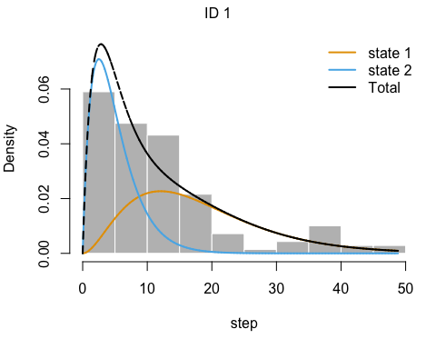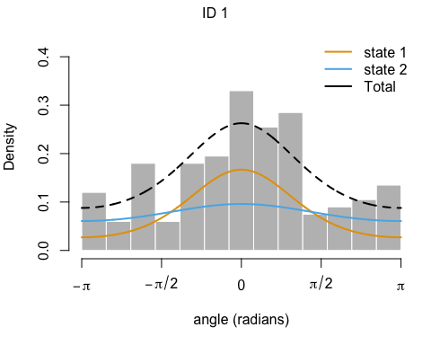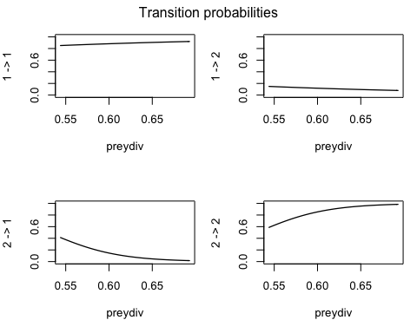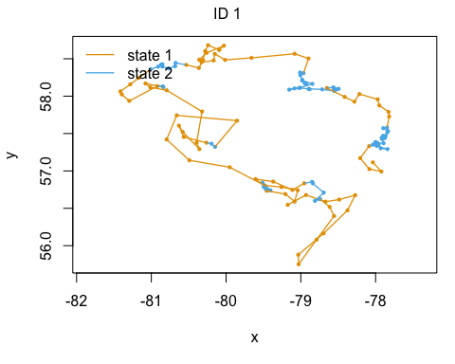

# we can see from the step-length histogram and the map that it doesn't look like this HMM is capturing the long step length movements as their own state. We will try fitting a three-state HMM to see if this better captures those movements.  
  
  
# let us try fitting a three-state HMM  
  
# define parameters  
nbStates <- 3 # number of states  
stepDist <- "gamma" # step distribution  
angleDist <- "vm" # turning angle distribution  
  
mu0 <- c(5, 12, 38) # mean step length for each state  
sigma0 <- c(3, 5, 8) # sd step length for each state  
stepPar0 <- c(mu0, sigma0)  
kappa0 <- c(0.35, 0.55, 0.5) # turning angle for each state  
  
formula = ~ preydiv # identify covariates  
  
# fit HMM (with step in km)  
set.seed(2023)  
hmm3_km <- momentuHMM::fitHMM(data=data_hmm, nbStates=nbStates,  
 dist=list(step=stepDist,angle=angleDist),  
 Par0=list(step=stepPar0,angle=kappa0))  
  
# retrieve parameters to refine model  
Par0_hmm3_km <- momentuHMM::getPar0(hmm3_km, formula=formula)  
  
# fit a refined HMM with parameters from hmm1_km  
set.seed(2023)  
hmm4_km <- momentuHMM::fitHMM(data=data_hmm, nbStates=3,  
 dist=list(step=stepDist,angle=angleDist),  
 Par0=Par0_hmm3_km$Par,  
 delta0 = Par0_hmm3_km$delta,   
 beta0 = Par0_hmm3_km$beta,  
 formula=formula)  
  
plot(hmm4_km)

## Decoding state sequence... DONE

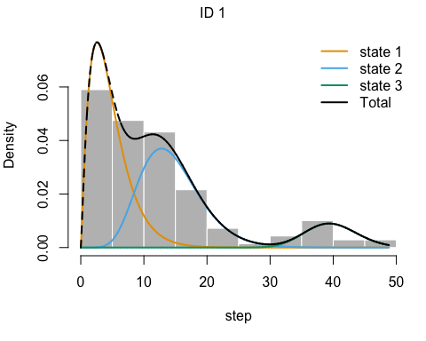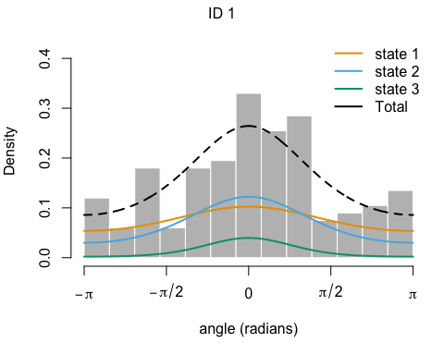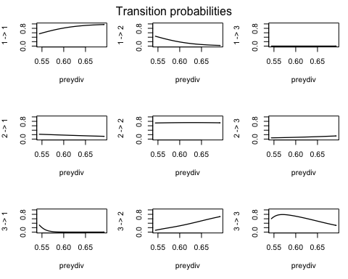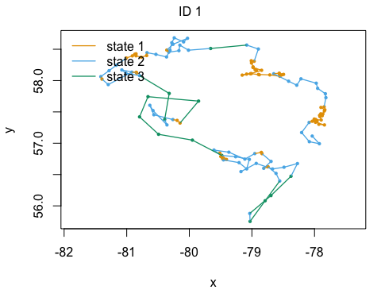

# Much better! We can see that those long step-lengths are captured in state 3, and the map of the decoded states appears to group different looking movement patterns as different states.  
  
# add the state estimate from the HMM  
data_hmm$state <- as.factor(momentuHMM::viterbi(hmm4_km))  
  
  
# view the regression coeffients for the transition probabilities  
print(hmm2_km)

## Value of the maximum log-likelihood: -700.7697   
##   
##   
## step parameters:  
## ----------------  
## state 1 state 2  
## mean 18.29472 5.038059  
## sd 10.67237 3.568961  
##   
## angle parameters:  
## -----------------  
## state 1 state 2  
## mean 0.0000000 0.0000000  
## concentration 0.9087117 0.2285965  
##   
## Regression coeffs for the transition probabilities:  
## ---------------------------------------------------  
## 1 -> 2 2 -> 1  
## (Intercept) 0.8567755 13.34018  
## preydiv -4.7800885 -25.17205  
##   
## Transition probability matrix (based on mean covariate values):  
## ---------------------------------------------------------------  
## state 1 state 2  
## state 1 0.8845774 0.1154226  
## state 2 0.1305702 0.8694298  
##   
## Initial distribution:  
## ---------------------  
## state 1 state 2   
## 9.999998e-01 2.380845e-07

We plot the decoded states (estimated behaviours).

# plot decoded states  
data_hmm$state <- as.factor(momentuHMM::viterbi(hmm2_km))  
hmmstate_plot <- ggplot() +   
 scale_fill_viridis(option = "mako", limits = c(0.5, 0.75), name = "Prey\ndiversity") +  
 geom_path(data=data_hmm, aes(x=x, y=y, color = state, group =ID)) +   
 geom_point(data=data_hmm, aes(x=x, y=y, color = state, shape = state), size=2, alpha = 0.8) +   
 scale_color_manual(values = c("#99DDB6", "#539D9C", "#312C66"),   
 labels = c("Localized\nsearch", "Area-restricted\nsearch", "Travelling"),   
 name = "HMM state") +  
 scale_shape_manual(values = c(15, 16, 17),   
 labels=c("Localized\nsearch", "Area-restricted\nsearch", "Travelling"),   
 name = "HMM state") +  
 geom_polygon(data = nat_trans, aes(x=long,y=lat,group=group), fill = "grey80", color = "white") +  
 coord_cartesian(xlim = c(150000,550000), ylim = c(-500000,-50000), expand = F)  
hmmstate_plot

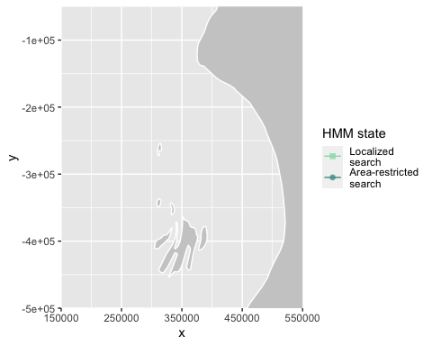

Plot a histogram of step lengths for each state. In order to do this, we need to transform the movement data to UTM and refit our HMM in order to get step length in a meaningful unit (i.e., kilometers).

*MAM: see comment above re km. Also, this needs to be broken down and explained. You need to talk about what you are doing, the arguments of the main functions, and interpret the results. As for main text, please change the name of the 3 behaviours. Also, it may be more straightforward if for some of these figures you just use the functions from momentuHMM, rather than you own plot functions (less code). I don’t think it matters if the colours don’t match the paper, and you can refer the reader to another script with the details to recreate your exact figures.*

## prep data in lat/lon and refit model (so step length is in kilometers)  
data_hmm <- seal %>%  
 make_track(lon, lat, date) %>%  
 extract_covariates(fish_raster) %>%  
 mutate(ID = 1,  
 x = x_,  
 y = y_,  
 date = t_) %>%  
 dplyr::select(ID, x, y, date, preydiv) %>%  
 as.data.frame() %>%  
 st_as_sf(coords = c("x", "y")) %>%  
 st_set_crs("+proj=laea +lat_0=60 +lon_0=-85 +x_0=0 +y_0=0 +datum=WGS84 +units=m +no_defs +ellps=WGS84 +towgs84=0,0,0") %>%  
 st_transform("+proj=longlat +datum=WGS84") %>%  
 mutate(long = unlist(map(geometry,1)),  
 lat = unlist(map(geometry,2))) %>%  
 st_drop_geometry()  
  
# do momentuhmm which calculates step length in KM  
data_hmm <- momentuHMM::prepData(data_hmm, coordNames = c("long", "lat"), type = "LL", covNames = c("preydiv"))  
  
  
# define parameters  
nbStates <- 3  
stepDist <- "gamma" # step distribution  
angleDist <- "vm" # turning angle distribution  
  
mu0 <- c(5, 12, 38)  
sigma0 <- c(3, 5, 8)  
stepPar0 <- c(mu0, sigma0)  
kappa0 <- c(0.35, 0.55, 0.5)  
  
# fit HMM (with step in km)  
set.seed(2023)  
hmm1_km <- momentuHMM::fitHMM(data=data_hmm, nbStates=nbStates,  
 dist=list(step=stepDist,angle=angleDist),  
 Par0=list(step=stepPar0,angle=kappa0))  
  
# get parameters   
Par0_hmm1_km <- momentuHMM::getPar0(hmm1_km, formula=formula)  
  
# fit HMM with parameters from hmm1_km  
set.seed(2023)  
hmm2_km <- momentuHMM::fitHMM(data=data_hmm, nbStates=3,  
 dist=list(step=stepDist,angle=angleDist),  
 Par0=Par0_hmm1_km$Par,  
 delta0 = Par0_hmm1_km$delta,   
 beta0 = Par0_hmm1_km$beta,  
 formula=formula)  
  
# add the state estimate from the HMM  
data_hmm$state <- as.factor(momentuHMM::viterbi(hmm2_km))  
  
# calculate frequencies of states  
v <- momentuHMM::viterbi(hmm2_km)  
stateFreq <- table(v) / length(v)  
  
# plot colours  
colours.states <- c("#99DDB6", "#539D9C", "#312C66")  
  
# generate sequence for x axis of density functions  
x <- seq(0, 50, length=1000)  
  
# get converged mean and sd for each state   
meanARS <- hmm2_km$mle$step[1,1]   
sdARS <- hmm2_km$mle$step[2,1]   
  
meanCR <- hmm2_km$mle$step[1,2]   
sdCR <- hmm2_km$mle$step[2,2]   
  
meanTR <- hmm2_km$mle$step[1,3]   
sdTR <- hmm2_km$mle$step[2,3]   
  
# calculate shape and scale of the gamma distributions from mean and sd  
sh <- function(mean, sd) { return(mean^2 / sd^2)}  
sc <- function(mean, sd) { return(sd^2 / mean)}  
  
# get density functions of the distributions  
y_ARS <- dgamma(x, shape=sh(meanARS,sdARS), scale=sc(meanARS,sdARS)) * stateFreq[[1]]  
y_CR <- dgamma(x, shape=sh(meanCR,sdCR), scale=sc(meanCR,sdCR)) * stateFreq[[2]]  
y_TR <- dgamma(x, shape=sh(meanTR,sdTR), scale=sc(meanTR,sdTR)) * stateFreq[[3]]  
  
  
# combine densities in a single dataframe for more convenient plotting  
df.y_ARS <- data.frame(dens=y_ARS, State="Foraging", x=x)  
df.y_CR <- data.frame(dens=y_CR, State="ARS", x=x)  
df.y_TR <- data.frame(dens=y_TR, State="Travelling", x=x)  
statedis <- rbind(df.y_ARS, df.y_CR, df.y_TR)  
  
# plot distributions  
hmm_stepdist_plot <- ggplot() +  
 geom_line(data=statedis,aes(x=x,y=dens,colour=State,linetype=State), size=1.2) +  
 scale_colour_manual(values=c(colours.states,"#000000"),   
 breaks = c('Foraging', 'ARS', 'Travelling'),   
 labels=c("Localized search", "Area-restricted search", "Travelling")) +  
 scale_linetype_manual(values=c("solid","solid", "solid"),   
 breaks = c('Foraging', 'ARS', 'Travelling'),   
 labels=c("Localized search", "Area-restricted search", "Travelling")) +  
 ylab("Density") +   
 xlab("Step length (kms)") +  
 theme_minimal()

## Warning: Using `size` aesthetic for lines was deprecated in ggplot2 3.4.0.  
  
## Warning: Please use `linewidth` instead.

hmm_stepdist_plot

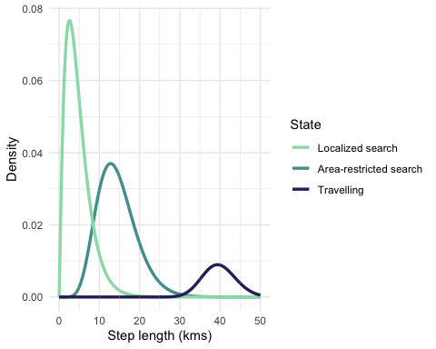

Plot a histogram of turning angle for each state.

# generate sequence for x axis of density functions  
x <- seq(-pi, pi,length=1000)  
  
# get converged mean and concentration for each state   
meanARS <- hmm2_km$mle$angle[1,1]   
sdARS <- hmm2_km$mle$angle[2,1]   
  
meanCR <- hmm2_km$mle$angle[1,2]   
sdCR <- hmm2_km$mle$angle[2,2]   
  
meanTR <- hmm2_km$mle$angle[1,3]   
sdTR <- hmm2_km$mle$angle[2,3]   
  
# get density functions of the distributions  
y_ARS <- CircStats::dvm(x, mu=meanARS, kappa=sdARS) * stateFreq[[1]]  
y_CR <- CircStats::dvm(x, mu=meanCR, kappa=sdCR) * stateFreq[[2]]  
y_TR <- CircStats::dvm(x, mu=meanTR, kappa=sdTR) * stateFreq[[3]]  
  
  
# combine densities in a single dataframe for more convenient plotting  
df.y_ARS <- data.frame(dens=y_ARS, State="Foraging",x=x)  
df.y_CR <- data.frame(dens=y_CR, State="ARS",x=x)  
df.y_TR <- data.frame(dens=y_TR, State="Travelling",x=x)  
  
cmb <- rbind(df.y_TR, df.y_CR, df.y_ARS)  
  
# plot distributions  
hmm_angledist_plot <- ggplot() +  
 geom_line(data=cmb,aes(x=x,y=dens,colour=State), size = 1.2) +  
 scale_colour_manual(values=c(colours.states), breaks = c('Foraging', 'ARS', 'Travelling'), labels=c("Localized search", "Area-restricted search", "Travelling")) +  
 scale_x_continuous(limits=c(-pi,pi))+  
 ylab("Density") +   
 xlab("Turn angle (radians) ") +  
 theme_minimal()  
hmm_angledist_plot

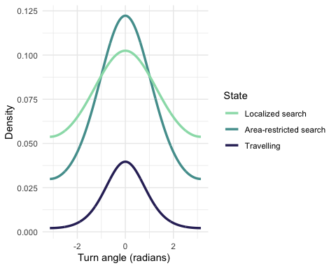

# Plots of predicted relationships with the covariate

Here we are plotting a model’s estimated relationship between the resource covariate and probability of selection can be useful for general ecological inference. We will calculate the log of the relative selection strength (log-RSS) for each selection function model. The log-RSS is a measure of how likely a location (for the RSF) or step (for SSFs) is to end in a proposed location (x1) to a single reference location (x2, the mean prey diversity), where zero indicates no preference, >1 indicates selection, and <1 indicates avoidance (Avgar et al. 2017, Fieberg et al. 2021).

First, we prepare a dataframe to predict on.

# prep the fish data  
newfish <- fish_raster %>%  
 terra::as.data.frame(xy = TRUE) %>%  
 filter(x > 100000 & x < 600000 & y > -550000 & y < 0)

## RSF

Since the RSF does not incorporate movement, we will calculate the log-RSS of the movement-free habitat selection kernel. This is easily done using log_rss() from amt.

First, we make a base dataframe to create x1 and x2 from. The values of log_sl and cos_ta do not matter, but we need populated columns in order for the log_rss function to work.

base <- newfish %>%   
 mutate(log_sl = log(45),  
 cos_ta = cos(1))  
  
# x1 is our base dataframe  
x1 <- base

Next, we modify the base data frame, where prey diversity is held at its mean

x2 <- base %>%   
 mutate(preydiv = mean(base$preydiv))

Now we will apply log_rss() to each row. Since log_rss() only assessed one location relative to a reference point, we will use lapply to iterate through all locations.

log_rss_list <- lapply(1:nrow(x1), function(i) {  
 # Calculate log-RSS for that row  
 xx <- log_rss(rsf1, x1[i,], x2[i,], ci = "se")  
 # Return the element $df  
 return(xx$df)  
})  
  
# combine rows  
res1 <- dplyr::bind_rows(log_rss_list)

Visualize results.

# plot  
line_rsf <- ggplot(res1, aes(x = preydiv_x1, y = (log_rss))) +  
 geom_hline(yintercept = 0, linetype = "dashed", color = "gray") +  
 geom_line(size = 1, color = "#F8D59F",linetype = 2) +  
 geom_ribbon(aes(ymin=lwr, ymax=upr, x=preydiv_x1), alpha = 0.4, fill = "#F8D59F") +  
 xlab("Prey diversity") +  
 ylab("log-RSS") +  
 theme_minimal()  
line_rsf

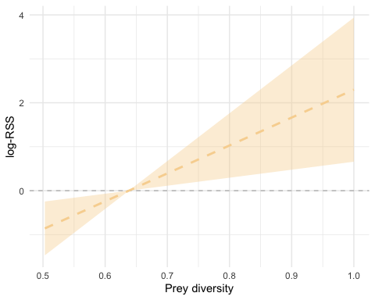

We see a positive relationship between prey diversity and log-RSS, which suggests that our seal are more likely to be present in areas with higher prey diversity than areas with low prey diversity.

## SSF

We can also calculate the log-RSS for our SSFs following the same workflow as for the RSF. Since log_rss() passes to predict(), it is important that the fit SSF includes model = TRUE.

First, we will calculate log-RSS for ssf1. *MAM: you have to break this down and explain*

## log-RSS prediction for ssf1  
# apply log_rss() to each row  
log_rss_list <- lapply(1:nrow(x1), function(i) {  
 # Calculate log-RSS for that row  
 xx <- log_rss(ssf1, x1[i,], x2[i,], ci = "se")  
 # Return the element $df  
 return(xx$df)  
})  
  
# combine rows  
res2 <- dplyr::bind_rows(log_rss_list) %>%  
 mutate(Speed = "without int.")

Visualize results.

# plot  
line_ssf1 <- ggplot() +  
 geom_hline(yintercept = 0, linetype = "dashed", color = "grey") +  
 geom_line(data = res2, aes(x = preydiv_x1, y = log_rss, color = Speed, group = Speed), size = 1, linetype = 3, color = "black") +   
 geom_ribbon(data = res2, aes(ymin=lwr, ymax=upr, x=preydiv_x1, fill = Speed, group = Speed), alpha = 0.3, fill = "black") +  
 xlab("Prey diversity") +  
 ylab("log-RSS") +  
 theme_minimal()  
line_ssf1

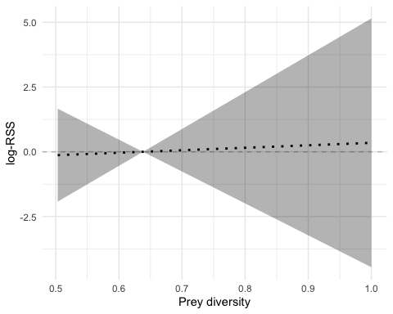

We see no relationship between prey diversity and log-RSS, which suggests that our seal is similarily likely to be present in areas with higher prey diversity and areas with low prey diversity.

Now we will calculate log-RSS for ssf2. We will estimate the log-RSS for three different step-lengths (slow, moderate, fast). We set these speeds as the 25th, 50th, and 75th percentiles of step-length, then loop the log-RSS for each speed. First, identify what the percentiles are.

## log-RSS prediction for ssf2  
# determine the 25th (slow), 50th (moderate), and 75th (fast) percentiles of step-length  
nums <- seal %>%  
 make_track(lon, lat, date) %>%  
 steps %>%  
 mutate(log_sl = log(sl_)) %>%  
 summarize(quants = quantile(log_sl, c(0.25, 0.5, 0.75))) %>%  
 pull()

## Warning: Returning more (or less) than 1 row per `summarise()` group was  
## deprecated in dplyr 1.1.0.  
  
## Warning: Please use `reframe()` instead.  
  
## Warning: When switching from `summarise()` to `reframe()`, remember that  
## `reframe()` always returns an ungrouped data frame and adjust accordingly.

nums

## 25% 50% 75%   
## 8.394073 9.190435 9.615853

Now apply log-RSS to each row, for each speed (step length percentile).

# set-up to run function for each speed  
results_ssf2 <- lapply(nums, function(i) {  
x1$log_sl <- i  
  
# calculate log-RSS  
 log_rss_list <- lapply(1:nrow(x1), function(i) {  
 # Calculate log-RSS for that row  
 xx <- log_rss(ssf2, x1[i,], x2[i,], ci = "se")  
 # Return the element $df  
 return(xx$df)  
 })  
 # bind rows within each speed's prediction  
 res3 <- dplyr::bind_rows(log_rss_list)  
} )

Bind the output together.

# bind rows of all speed's prediction  
results_ssf2 <- dplyr::bind_rows(results_ssf2) %>%  
 mutate(log_sl_x1 = as.factor(round(log_sl_x1,1)),  
 Speed = dplyr::case_when(as.factor(log_sl_x1) == '8.4' ~ "slow",  
 as.factor(log_sl_x1) == "9.2" ~ "moderate",  
 as.factor(log_sl_x1) == "9.6" ~ "fast"))

Visualize results.

# plot  
line_ssf2 <- ggplot(results_ssf2, aes(x = preydiv_x1, y = (log_rss))) +  
 geom_hline(yintercept = 0, linetype = "dashed", color = "gray") +  
 geom_line(size = 1, aes(color = Speed, group = Speed, linetype = Speed)) +  
 geom_ribbon(aes(ymin=lwr, ymax=upr, x=preydiv_x1, fill = Speed, group = Speed), alpha = 0.3) +  
 scale_colour_manual(values=c(colours.states,"#000000")) +  
 scale_fill_manual(values=c(colours.states,"#000000")) +  
 scale_linetype_manual(values = c("solid", "solid", "solid")) +  
 xlab("Prey diversity") +  
 ylab("log-RSS") +  
 theme_minimal()  
line_ssf2

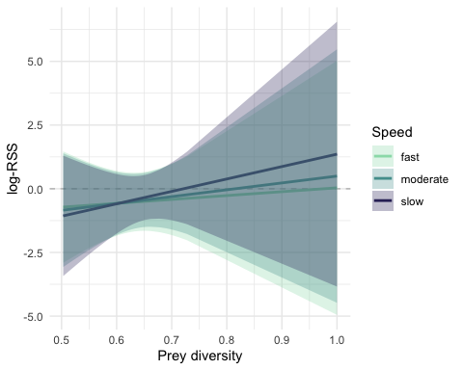

We can see a weak positive relationship between prey diversity and log-RSS, however, with confidence intervals (shading) covering zero, suggesting no significant relationship between prey diversity and log-RSS. We also see that the confidence intervals cover each other, suggesting that different speeds do not have different relationships between prey diversity and log-RSS.

Typically these models would be interpreted independently. But it’s worth noting that while the effects are minimal and the confidence intervals overlap, when comparing ssf1 and ssf2, ssf2 provides more information about the animal’s relationship with prey diversity.

# Plot  
ggplot(results_ssf2, aes(x = preydiv_x1, y = (log_rss))) +  
 geom_hline(yintercept = 0, linetype = "dashed", color = "gray") +  
 geom_line(size = 1, aes(color = Speed, group = Speed, linetype = Speed)) +  
 geom_ribbon(aes(ymin=lwr, ymax=upr, x=preydiv_x1, fill = Speed, group = Speed), alpha = 0.3) +  
 xlab("Prey diversity") +  
 ylab("log-RSS") +  
 theme_minimal() +  
 geom_hline(yintercept = 0, linetype = "dashed", color = "gray") +  
 geom_line(data = res2, aes(x = preydiv_x1, y = log_rss, color = Speed, group = Speed, linetype = Speed), size = 1) +   
 geom_ribbon(data = res2, aes(ymin=lwr, ymax=upr, x=preydiv_x1, fill = Speed, group = Speed), alpha = 0.2) +  
 scale_color_manual(values = c("#99DDB6", "#539D9C", "#312C66", "black"),   
 labels = c("Fast", "Moderate", "Slow", "Not consid."),   
 name = "Speed") +  
 scale_fill_manual(values = c("#99DDB6", "#539D9C", "#312C66", "black"),   
 labels = c("Fast", "Moderate", "Slow", "Not consid."),   
 name = "Speed") +  
 scale_linetype_manual(values = c("solid", "solid", "solid", "dotted"),   
 labels = c("Fast", "Moderate", "Slow", "Not consid."),   
 name = "Speed")

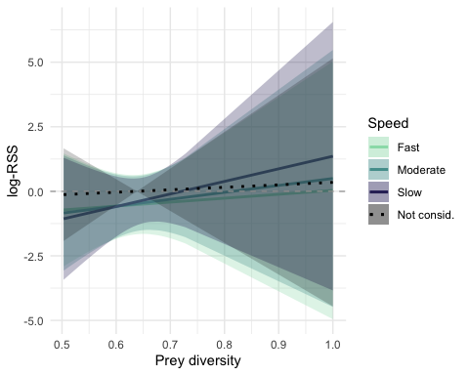 Here, we see that adding the interaction between prey diversity and step length did not better explain our data or provide additional ecological insight about our seal.

## HMM

Exploring the insight on the relationship between our seal and prey diversity is fundamentally different for the HMM. Here, we will grab and plot the stationary state probabilities. This is easily done using plotStationary() from momentuHMM.

# grab stationary probabilities  
ps <- momentuHMM::plotStationary(hmm4_km, plotCI= TRUE, return = TRUE)

# grab values for data frame  
state1 <- ps$preydiv$'state 1' %>% mutate(state = 1)  
state2 <- ps$preydiv$'state 2' %>% mutate(state = 2)  
state3 <- ps$preydiv$'state 3' %>% mutate(state = 3)  
  
# bind to one data frame  
pdat <- rbind(state1, state2, state3) %>%  
 mutate(state = as.character(state))

Visualize results.

# plot  
line_hmm <- ggplot() +   
 geom_line(data = pdat, aes(x = cov, y = est, color = state)) +  
 geom_ribbon(data = pdat, aes(x=cov, y=est, ymax=est+se, ymin=est-se, fill = state),   
 alpha = 0.4, show.legend = TRUE) +  
 ylab("Stationary state probabilties") +  
 xlab("Prey diversity") +  
 scale_color_manual(values = c("#99DDB6", "#539D9C", "#312C66"), name = "HMM state",  
 labels=c("Slow movement", "Moderate movement", "Fast movement")) +  
 scale_fill_manual(values = c("#99DDB6", "#539D9C", "#312C66"), name = "HMM state",  
 labels=c("Slow movement", "Moderate movement", "Fast movement")) +  
 theme_minimal()  
  
line_hmm

Here we can see that each state has a different relationship between the stationary state probability and prey diversity. The slow movement state has a positive relationship between stationary state probability and prey diversity, the moderate movement state has a negative relationship with prey diversity, and the fast movement state does not appear to have a directional relationship with prey diversity.

# Prediction maps

Now we will estimate the utilization distributions from each model to demonstrate how differences in the relationships with a covariate can results in vastly different spatial patterns. The utilization distribution is defined as the two-dimensional relative frequency distribution of space use of an animal (Van Winkle 1975). This is a simple calculation for the RSF, where we multiply the model coefficient with the resource (prey diversity), exponentiate (since it is a logistic regression), and normalize the estimate. The calculations are more complex for the SSFs since they are conditional models that integrate the movement process. Thus, for the SSFs we calculate the steady-state utilization distribution (SSUD), which is the long-term expectation of the space-use distribution across the landscape (Signer et al. 2017). amt has functions to estimate the SSUD.

## RSF

We can predict the estimated probability of use from the RSF by hand. First, grab the model coefficients and predict for each cell.

# grab model coefficients  
modcoef <- summary(rsf1)$coef  
  
# prediction for each cell  
x <- exp(modcoef[2] * newfish$preydiv)

We will normalize the results next.

# range fn  
range01 <- function(x){(x-min(x))/(max(x)-min(x))}  
  
# set the range from zero to one  
newfish$rsf_prediction <- range01(x)

Visualize results.

# plot  
map_rsf <- ggplot() +   
 geom_tile(data = newfish, aes(x = x,y = y, fill = rsf_prediction)) +  
 scale_fill_viridis(option = "mako", name = "RSF prediction",limits = c(0,0.14)) +  
 geom_polygon(data = nat_trans, aes(x=long,y=lat,group=group), fill = "grey80", color = "white") +  
 coord_cartesian(xlim = c(150000,550000), ylim = c(-500000,-50000), expand = F) +  
 theme_void()

## Regions defined for each Polygons

map_rsf

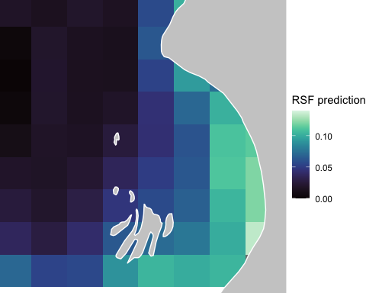

## SSF

We can use the amt functions to estimate the SSUDs from the simple SSF that does not allow prey diversity to affect the movement kernel.

*MAM: you need to explain why you are fitting it again*

# generate availability sample  
set.seed(2023)  
data_ssf <- seal %>%  
 mutate(date = as.POSIXct(date)) %>%  
 make_track(lon, lat, date) %>%  
 steps() %>%  
 random_steps() %>%   
 arrange(case_) %>%  
 amt::extract_covariates(fish_raster, where = "both") # %>%  
 #na.omit()   
  
# fit SSF1 model  
m1 <- data_ssf |>   
 fit_clogit(case_ ~ preydiv_end + cos(ta_) + log(sl_) +   
 strata(step_id_))

We will now simulate a track and visually observe it.

*MAM: break it down and explain, e.g. why burn in, etc*

# set starting position for the simulation  
start <- make_start((seal %>%  
 mutate(date = as.POSIXct(date)) %>%  
 make_track(lon, lat, date))[1,])   
  
# Set constants  
n_steps = 1e3 # number of steps  
n_steps1 = n_steps + 1 # number of steps +1  
burnin <- n_steps/50 # number of locations to remove for burn-in  
  
# generate redistribution kernel  
k1 <- redistribution_kernel(m1, map = fish_raster, start = start,  
 stochastic = TRUE,  
 tolerance.outside = 1,  
 n.control = 1e3)  
  
# simulate path  
set.seed(2023)  
p1 <- amt::simulate_path(x = k1, n = n_steps, start = start, verbose = TRUE)  
  
# burn-in  
p1_burnt <- p1 %>% slice(-c(1:burnin))  
  
# plot simulated track  
ssf_track_1 <- fishmap +  
 geom_polygon(data = nat_trans, aes(x=long,y=lat,group=group), fill = "grey80", color = "white") +  
 geom_point(data = p1_burnt, aes(x = x_,y = y_), alpha = 0.61) +  
 geom_path(data = p1_burnt, aes(x = x_,y = y_)) +  
 theme_void()

## Regions defined for each Polygons

ssf_track_1

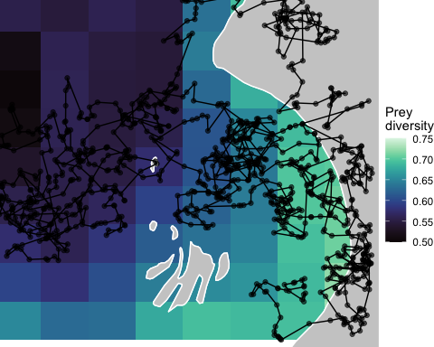

We can see that it mostly stays within the study area. We will use this track to estimate the SSUD, and visualize the results.

*MAM: You also need to state above that you are not using the same number of simulations for the tutorial, because it would take too long to run. Add a warning for anything that takes more than 1-2 min. (e.g. this will likely take time to run).*

# estimate SSUD  
uds_ssf1 <- tibble(rep = 1:n_steps1,   
 x_ = p1$x_, y_ = p1$y_,  
 t_ = p1$t_, dt = p1$dt) |>   
 filter(!is.na(x_)) |>   
 make_track(x_, y_) |>   
 hr_kde(trast = fish_raster, which_min = "global") %>%  
 hr_ud() %>%   
 terra::as.data.frame(xy = TRUE)  
  
# plot SSUD  
map_ssf1 <- ggplot() +   
 geom_tile(data = uds_ssf1, aes(x = x,y = y, fill = preydiv)) +  
 scale_fill_viridis(option = "mako", name = "SSF1 prediction") +  
 geom_polygon(data = nat_trans, aes(x=long,y=lat,group=group), fill = "grey80", color = "white") +  
 coord_cartesian(xlim = c(150000,550000), ylim = c(-500000,-50000), expand = F) +  
 theme_void()

## Regions defined for each Polygons

map_ssf1

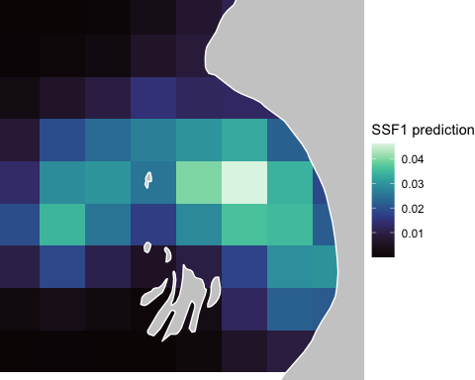

We will follow the same steps to generate a SSUD for the SSF that allows prey diversity to affect the movement kernel.

*MAM: please ask J. Signer about the tolerance.outside = 1 in the discussion chain on Github. And then explain what it means here, because it’s pretty weird. You need to break this down and explain.*

# fit SSF2 model  
m2 <- data_ssf |>   
 fit_clogit(case_ ~ preydiv_end + cos(ta_)+  
 preydiv_end:log(sl_) +   
 strata(step_id_))  
  
  
# set starting position for the simulation  
set.seed(2023)  
start <- make_start((seal %>%  
 mutate(date = as.POSIXct(date)) %>%  
 make_track(lon, lat, date))[1,])  
  
# generate redistribution kernel  
k2 <- redistribution_kernel(m2, map = fish_raster, start = start,  
 stochastic = TRUE,   
 tolerance.outside = 1,  
 n.control = 1e3)  
  
# Now simulate a path of length 1e3  
n_steps = 1e3  
n_steps1 = n_steps + 1  
set.seed(2023)  
p2 <- amt::simulate_path(x = k2, n = n_steps, start = start)  
  
# plot simulated track  
ssf_track_2 <- fishmap +  
 geom_polygon(data = nat_trans, aes(x=long,y=lat,group=group), fill = "grey80", color = "white") +  
 geom_point(data = p2, aes(x = x_,y = y_), alpha = 0.61) +  
 geom_path(data = p2, aes(x = x_,y = y_)) +  
 theme_void()

## Regions defined for each Polygons

ssf_track_2

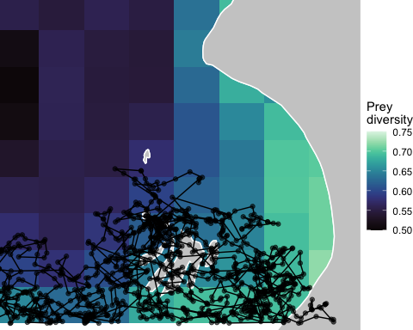

# estimate SSUD  
uds_ssf2 <- tibble(rep = 1:n_steps1,   
 x_ = p2$x_, y_ = p2$y_,  
 t_ = p2$t_, dt = p2$dt) |>   
 filter(!is.na(x_)) |>   
 make_track(x_, y_) |>   
 hr_kde(trast = fish_raster, which_min = "local") %>%  
 hr_ud() %>%   
 terra::as.data.frame(xy = TRUE)  
  
# plot SSUD  
map_ss2 <- ggplot() +   
 geom_tile(data = uds_ssf2, aes(x = x,y = y, fill = preydiv)) +  
 scale_fill_viridis(option = "mako", name = "SSF2 prediction") +  
 geom_polygon(data = nat_trans, aes(x=long,y=lat,group=group), fill = "grey80", color = "white") +  
 coord_cartesian(xlim = c(150000,550000), ylim = c(-500000,-50000), expand = F) +  
 theme_void()

## Regions defined for each Polygons

map_ss2

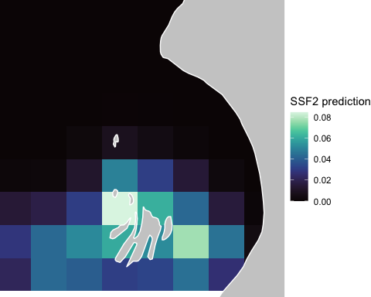

## HMM

We will first estimate the stationary state probabilities of each state based on prey diversity. This is easily done using the momentuHMM function stationary().

*MAM: is some of this done above? Maybe you could combine? You need to break down and explain (e.g. what’s the new fish data, etc. Note that the new fish data could be explained at the top somewhere since you are using it in all predictions.)*

# grab estimated stationary state probabilities from our fitted HMM  
x <- as.data.frame(momentuHMM::stationary(hmm4_km, data.frame(preydiv = newfish$preydiv)))  
newfish$hmm_state1 <- x$state.1  
newfish$hmm_state2 <- x$state.2  
newfish$hmm_state3 <- x$state.3   
  
# prepare data  
newfish_long <- newfish %>%  
 tidyr::pivot_longer(cols = hmm_state1:hmm_state3,   
 names_to = "model", values_to = "prediction") %>%  
 mutate(dplyr::across(model, factor, levels=  
 c("hmm_state1", "hmm_state2", "hmm_state3")))

## Warning: There was 1 warning in `mutate()`.  
## ℹ In argument: `dplyr::across(...)`.  
## Caused by warning:  
## ! The `...` argument of `across()` is deprecated as of dplyr 1.1.0.  
## Supply arguments directly to `.fns` through an anonymous function instead.  
##   
## # Previously  
## across(a:b, mean, na.rm = TRUE)  
##   
## # Now  
## across(a:b, \(x) mean(x, na.rm = TRUE))

# plot  
map_hmm <- ggplot() +   
 geom_tile(data = newfish_long, aes(x = x, y = y, fill = prediction)) +  
 scale_fill_viridis(option = "mako", limits = c(0,1)) +  
 labs(fill = 'HMM predicted\nprobability') +  
 geom_polygon(data = nat_trans, aes(x=long,y=lat,group=group), colour = "white", fill = "grey90", size = 0.3) +  
 coord_cartesian(xlim = c(150000,550000), ylim = c(-500000,-50000), expand = F) +  
 facet_wrap(~model, labeller = as_labeller(c('hmm_state1' = "Slow movement",  
 'hmm_state2' = "Moderate movement",  
 'hmm_state3' = "Fast movement"))) +  
 theme_void()

## Regions defined for each Polygons

map_hmm

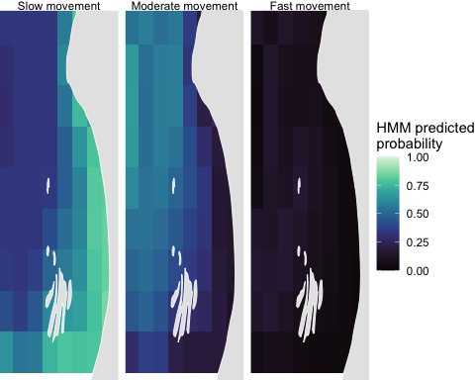

*MAM: interpret the results.*

# References

Avgar, T., Lele, S. R., Keim, J. L., & Boyce, M. S. (2017). Relative selection strength: Quantifying effect size in habitat‐and step‐selection inference. Ecology and Evolution, 7(14). 5322-5330.https://doi.org/10.1002/ece3.3122

Fieberg, J., Signer, J., Smith, B., & Avgar, T. (2021). A ‘How to’guide for interpreting parameters in habitat‐selection analyses. Journal of Animal Ecology, 90(5), 1027-1043. <https://doi.org/10.1111/1365-2656.13441>

Florko, K.R.N., Tai, T.C., Cheung, W.W.L., Sumaila, U.R., Ferguson, S.H., Yurkowski, D.J., Auger-Méthé, M. (2021). Predicting how climate change threatens the prey base of Arctic marine predators. Ecology Letters, 24: 2563-2575. <https://doi.org/10.1111/ele.13866>

Florko, K.R.N., Tai, T.C., Cheung, W.W.L., Sumaila, U.R., Ferguson, S.H., Yurkowski, D.J., Auger-Méthé, M. (2021b), Predicting how climate change threatens the prey base of Arctic marine predators, Dryad, Dataset, <https://doi.org/10.5061/dryad.x69p8czjs>

Florko, K.R.N., Shuert, C.R., Cheung, W.W.L., Ferguson, S.H., Jonsen, I.D., Rosen, D.A.S., Sumaila, U.R., Tai, T.C., Yurkowski, D.J., Auger-Méthé, M. (2023). Linking movement and dive data to prey distribution models: new insights in foraging behavior and potential pitfalls of movement analyses. Movement Ecology, 11:17 <https://doi.org/10.1186/s40462-023-00377-2>

McClintock, B.T., Michelot, T. (2018). momentuHMM: R package for generalized hidden markov models of animal movement. Methods in Ecology and Evolution, 9, 1518-1530. <https://doi.org/10.1111/2041-210X.12995>

Signer, J., Fieberg, J., & Avgar, T. (2017). Estimating utilization distributions from fitted step‐selection functions. Ecosphere, 8(4), e01771. <https://doi.org/10.1002/ecs2.1771>

Signer, J., J. Fieberg, and T. Avgar. (2019). Animal movement tools (amt): R package for managing tracking data and conducting habitat selection analyses. Ecology and Evolution, 9:880–890. <https://doi.org/10.1002/ece3.4823>

Van Winkle, W. (1975). Comparison of several probabilistic home-range models. The Journal of wildlife Management, 118-123. <https://doi.org/10.2307/3800474>