**Web_Lesson3: Bootstrap, JavaScript**

# **Lesson Overview:**

It covers Bootstrap's basics, especially the Grid Layout in Bootstrap, the fundamentals of RWD (Responsive Web Design), and some JavaScript.

# **Use Case Description:**

A basic calculator. It can perform all the arithmetic operations using the necessary JavaScript (loops, conditions, switch statements).

# **Programming elements:**

Bootstrap, JavaScript

# **Source Code:**

<https://umkc.box.com/s/kvy6reimrsiko2taj7fuqo9q2obd7xvw>

# **In Class Programming (ICP):**

1. **Rock-Paper-Scissors**(<https://en.wikipedia.org/wiki/Rock–paper–scissors>)
   1. Build the game of rock paper scissors using JavaScript
   2. A basic [UI](https://umkc.box.com/s/8nexozcv3uw59zmy4xffdjjkvkuol43s) will be necessary
   3. **Hint**: You can use a random number generator and conditional statements to build the application (by comparing the numbers)
   4. Example UI: [A drawing of a face

      Description automatically generated](https://umkc.box.com/s/h2mdl2hmaly7lr0t6h4fz4479146aqy7)
2. **RWD Task**
   1. Create a page that looks like the below mockup
   2. Download the starter code([source code](https://umkc.box.com/s/lg0vdmq6y8c76kuvuhk4j26bt3kyqc5q))
   3. Follow the TODO instructions in the 'input.html' file
   4. Make the page responsive and check its responsiveness as the screen size increases or decreases
   5. The font in the mockup looks different from what we have in the code now
   6. Find the closest possible font to the one in the mockup and replace the existing font with it (**Hint**: Visit <https://fonts.google.com/> and look for "Play," "Rambla," "Lato," "Orbitron." One of them might be the font we need!)
   7. Two colored squares and their respective hexadecimal numbers are given on the left side serve as only a reference for the colors used for the text content in the mockup
   8. They are not a part of the final page that we build. Make the page as close as possible to the mockup. You can use your images, though.
   9. **Mockup:** [Link to the mockup](https://umkc.box.com/s/5krjnvqlgbrixrwch26ajm67pwhdbi70) (in the case below image is not clear)[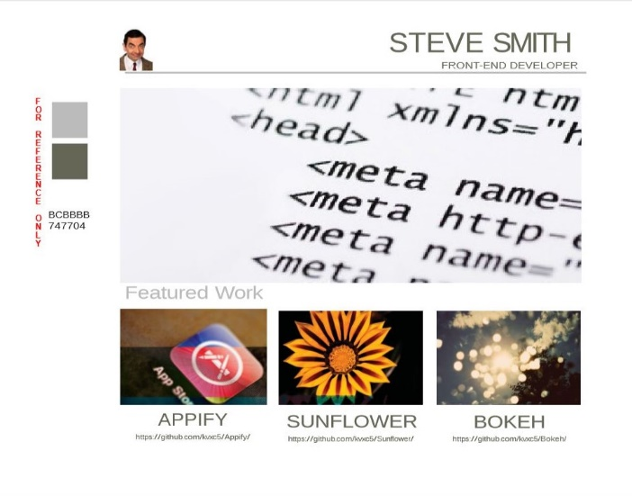](https://umkc.box.com/s/4nslned289wrc2dxub08va3qz8g59l1r)

# **ICP Submission Guidelines**

1. ICP submission is an individual or Group contribution.
2. Submit your source code (comment your codes) and documentation to GitHub and represent the work through the report accurately (at least 250 words) (submit your screenshots as well. The screenshot should have both the code and the output)
3. Comment your code appropriately
4. Present your work to the TAs before you leave
5. Submission after the due date is considered a late submission. (Check the 'Late Submission Policy on Assignments' in the syllabus)
6. Use the related Canvas assginement submission; Assignments => ICP#

# **ICP Rubric Details**

You can find ICP Rubric Details in the Syllabus.

**Note:** Cheating, plagiarism, disruptive behavior, and other forms of unacceptable conduct are subject to strong sanctions under university policy. See detailed description of university policy at the following URL: <https://catalog.umkc.edu/special-notices/academic-honesty/>