**Web_Lesson5: Angular**

# **Lesson Overview:**

In this lesson, we are going to discuss the importance of Angular and elements of Angular (components, string interpolation, property binding, event, and two-way data binding, NgModules, and directives)

# **Use Case Description:**

Memory Game: Whenever matching tiles are selected, the user will get a congratulations message. Otherwise, the user will get a chance to try next time.

# **Programming elements:**

Angular (components, string interpolation, property binding, event, and two-way data binding, NgModules, and directives)

# **Source Code:**

Without node modules: <https://umkc.box.com/s/tnnyf6bc659tfl91o7mfv35uavc3tici>

With node modules: <https://umkc.box.com/s/m6cvgljnegrto61u73c5vnedixd19bjx>

# **Note:** Install Node.js and Angular CLI before the class/executing the source code

# **In Class Programming (ICP):**

There is no limit on details and creativity, and you can add as many details as you can and create an attractive and interactive web page. The below images are only for reference.

1. **To-do application:**

Develop a basic [to-do list](https://umkc.box.com/s/7yhqzafm1yehx0mr6osbkwin3g7ik80u) application using **Angular (not AngularJS)** elements, which are discussed and used in Use Case

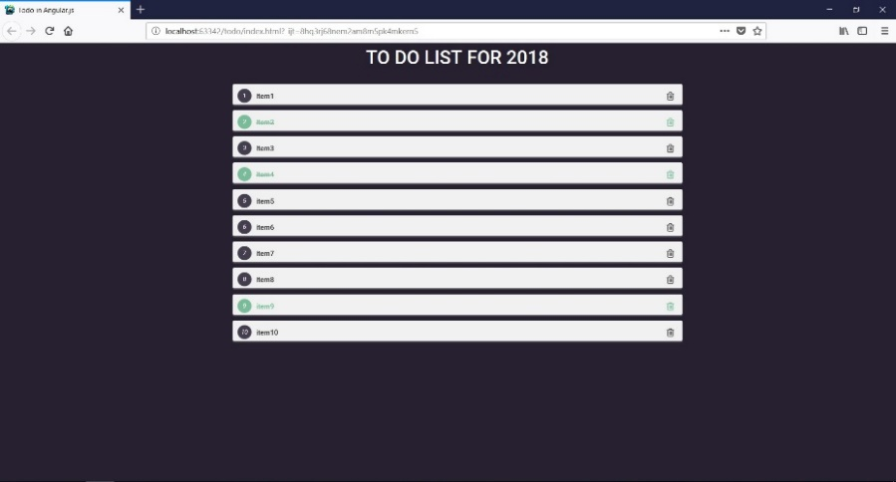

1. **Countdown Timer:**

Develop a basic [countdown timer](https://umkc.box.com/s/xe1zr9c8l3yuwbl2y8eguaynf62a82za) application using **Angular (not AngularJS)** elements discussed and used in Use Case. The Countdown Timer's objective is to provide a continuously decrementing display of the months, days, hours, minutes, and seconds to a user-entered event.

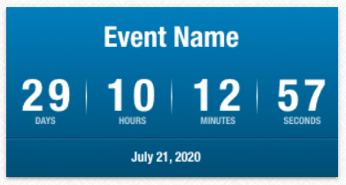

If possible, combine both the To-do and Countdown Timer in a single application.

Helpful resources:

<https://developer.mozilla.org/en-US/docs/Web/JavaScript/Reference/Global_Objects/Date>

<https://www.youtube.com/watch?v=AaNZBrP26LQ>

# **ICP Submission Guidelines**

1. ICP submission is an individual or Group contribution.
2. Submit your source code (comment your codes) and documentation to GitHub and represent the work through the report accurately (at least 250 words) (submit your screenshots as well. The screenshot should have both the code and the output)
3. Comment your code appropriately
4. Present your work to the TAs before you leave
5. Submission after the due date is considered a late submission. (Check the 'Late Submission Policy on Assignments' in the syllabus)
6. Use the related Canvas assignment submission; Assignments => ICP#

# **ICP Rubric Details**

You can find ICP Rubric Details in the syllabus.

**Note:** Cheating, plagiarism, disruptive behavior, and other forms of unacceptable conduct are subject to strong sanctions under university policy. See detailed description of university policy at the following URL: <https://catalog.umkc.edu/special-notices/academic-honesty/>