1. Open Codeblocks

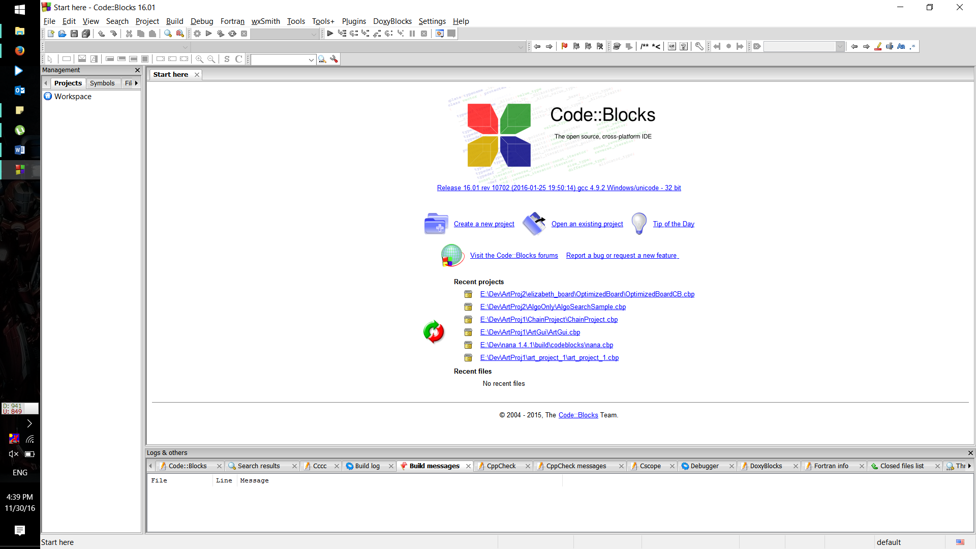

1. Open Project
2. Then select OptimizedBoardCB.cbp

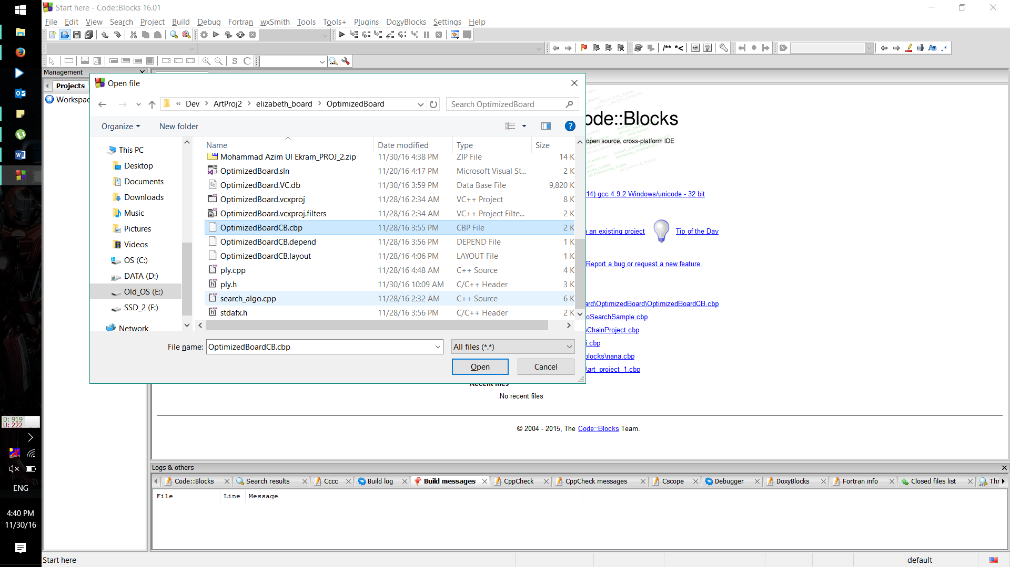

1. Select Build and Run

