GUI

The GUI has three parts divided using groups. At the top, band matrix creation group is located, then band matrix compression, after that, band matrix decompression as shown in figure X.

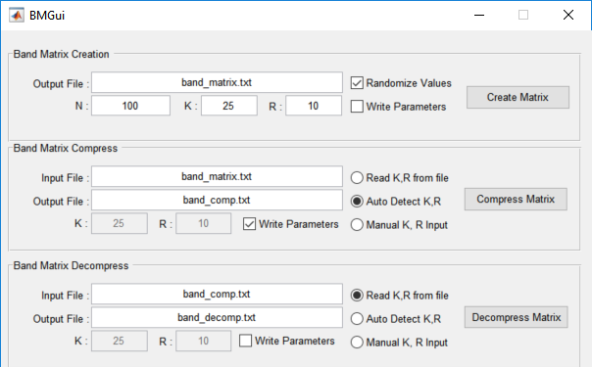

# Band Matrix Creation:

Contains Text Box input for N, K, R and Output file and check box option for Value Randomization and parameter writing in the file. If “Write Parameters” is selected, the parameter of K, R will be written in the file as well as matrix data. The output file is generated by clicking “Create Matrix” button.

# Band Matrix Compress:

Text box for Input File, Output file can be used for specifying input band matrix and output band matrix. Value of K and R can be auto detected from file if “Auto Detect K, R” is selected. Reading K and R from file or manually specifying them is also available as options. Band matrix file is compressed by clicking “Compress Matrix”

# Band Matrix Decompress:

Same as compression group above, input File, output file can be specified using text box. Value of K and R can be also auto detected from file if “Auto Detect K, R” is selected. Reading K and R from file or manually specifying them is also available as options. Band matrix file is compressed by clicking “Compress Matrix”

Codes

Band Matrix Compression

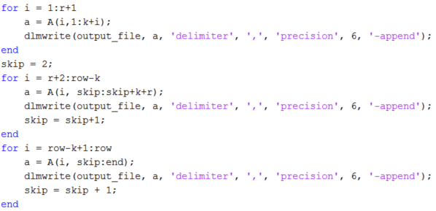

Band Matrix Decompression

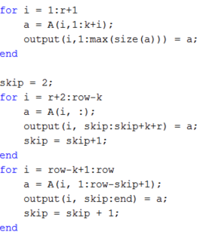

# Band Matrix Create Button Callback

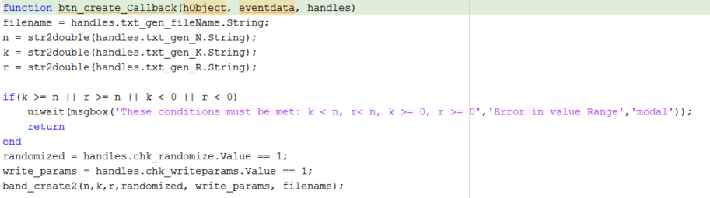

# Band Matrix Compress GUI Button Callback

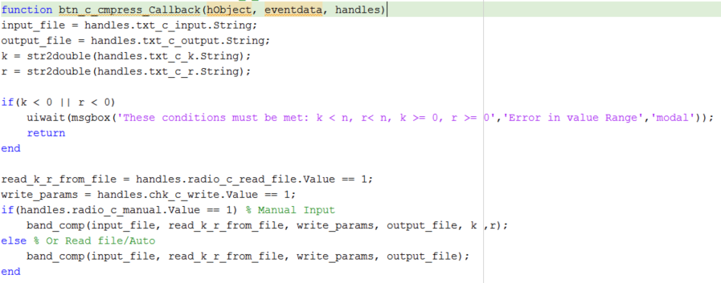

# Band Matrix Decompress Button Callback

