

PT. KIMIA FARMA (PERSERO) TBK

PLANT BANJARAN

Jl. Raya Banjaran KM. 16, Banjaran – Kab. Bandung

TEMPERATURE AND HUMIDITY MAPPING OF STORAGE AREAS
REPORT

EMPTY CAPSULE SELECTION ROOM
1511012

Document No : VKB-KR-4001/01
Revision No : 00

Approval
Prepared By
Company | Name | Designation | Signature | Date
Kimia Farma |  | Qualification and Calibration Supervisor

Reviewed By
Company | Name | Designation | Signature | Date
Kimia Farma |  | Validation and Qualification Assistant Manager
Kimia Farma |  | Engineering and Maintenance Assistant Manager
Kimia Farma |  | Warehouse Assistant Manager

Approved By
Company | Name | Designation | Signature | Date
Kimia Farma |  | Quality Assurance Manager

Revision History

Revision Number | Date | Revision History
00 |  | New Document

Table of Contents

Approval 2
Revision History 3
Table of Contents 4
1.0 Introduction 5
2.0 Responsibility 6
3.0 Personnel Identification List 6
4.0 Pre-requisite 7
5.0 Mapping Study Overview 8
6.0 Mapping Preparation 9
6.1 Calibration Certificate Verification 9
6.2 Data Logger Configuration 10
6.3 Data Logger Placement 11
7.0 Mapping Results Summary 12
7.1 Temperature Distribution 12
7.2 Relative Humidity Distribution (if applies) 15
8.0 Recommendations 17
9.0 Deviation 18
10.0 Abbreviation List 18
11.0 Mapping Result Summary 18
12.0 Conclusion 18
13.0 Attachment List 19

Introduction

Objective
This mapping study aims to document storage conditions in the stated facility and includes analysis of the results. The study determines where hot and cold spots appear and indicates recommendations for continuous monitoring.

Scope
This document applies for mapping study on Empty Capsule Selection Room 1511012, which contains:
    - Storage facility’s mapping results on parameter(s):
- Temperature.
- Humidity (if applies).
    - Data processing.
    - Evaluation of results and deviation if discrepancies are found.

Data Recording
Data observed during mapping study shall be recorded on the test sheet as part of this protocol. Supporting data or reference may be attached as supplement to the test sheet. The test sheet can be copied as needed during execution and marked with number of copies. Date of mapping study should be recorded using “DD/MMM/YYYY” format. The mapping study should follow Temperature and Humidity Mapping of Storage Areas Procedure (PEM-05-004/00).

Reference Document
Reference | Document Title
Badan Pengawas Obat dan Makanan, Republik Indonesia | Cara Pembuatan Obat yang Baik Tahun 2018.
Badan Pengawas Obat dan Makanan, Republik Indonesia | Cara Pembuatan Obat Tradisional yang Baik Tahun 2011.
Badan Pengawas Obat dan Makanan, Republik Indonesia | Petunjuk Teknis Sarana Penunjang Kritis Industri Farmasi Tahun 2013.
World Health Organization | WHO Technical Report Series, No. 992, Annex 5: Supplement 8, Temperature Mapping of Storage Areas Tahun 2015.
International Society for Pharmaceutical Engineering | ISPE: Good Practice Guide, Controlled Temperature Chamber Mapping and Monitoring.

Responsibility

Qualification and Calibration Supervisor
    - Prepare mapping study protocol.
    - Execute mapping study protocol.
    - Record mapping study data.
    - Report deviation (if any).
    - Propose and execute corrective action for deviation.
    - Prepare summary report of mapping study.

Validation and Qualification Assistant Manager
    - Review protocol and summary report to ensure that mapping study complies with VMP.
    - Approve corrective action to close deviation (if any).

Engineering and Maintenance Assistant Manager
    - Review protocol and summary report to ensure mapping study is conducted to consider the intended use of facility and related equipment.

  - Warehouse Assistant Manager
    - Review protocol and summary report to ensure the mapping study is conducted to consider the intended use of facility and related equipment.

QA Manager
    - Review and approve protocol and summary report to ensure that mapping study is aligned with implementation of quality management system
    - Review and approve protocol and summary report to ensure that mapping study is aligned with implementation of quality management system.

- Personnel Identification List
The person involved in the mapping study should be recorded on the table below and give his/her initial for intended use on testing parameter in advance.

No | Name | Designation | Initial
1. | Hamdani Hidayat | Qualification Officer | HH
2. | Moch Ridwan Nugraha | Qualification and Calibration Supervisor | MRN

- Pre-requisite
Prior to execute this protocol, pre-requisites should be fulfilled below:
  - Execution of Pre-Requisite Study
The previous related utilities protocol should be approved, and the report should be approved or at least drafted.
Pre-Requisite | Acceptance Criteria | Doc. Ref No | Pass/Fail
Temperature and Humidity Mapping | Protocol should be available and approved. | - | Pass

  - Critical Pending Item
Punch List from previous testing which effecting this mapping study shall be verified. Test sheet of pending items in mapping study pre-requisite that planned to be extended will be copied and included as part of mapping study.

Pre-Requisite | Acceptance Criteria | Doc. Ref No | Attachment No. | Remarks
 | NA HH 07/APR/2022

Mapping Study Overview
  - Area/ Equipment Profile
Facility Type | Warehouse
Room / Equipment Name | Selection Room Empty Capsule
Room / Equipment Number | 1511012
Season | Rainy season
Load State | Normal Loaded
Mapping Started | 31/03/2022
Mapping Ended | 05/04/2022
Required Temperature Range | Max. 25^{O}C
Required Humidity Range  (if applies) | Max. 65%
Equipment Set Point | 19,00℃

Electronic Data Logging Monitor Specification
Data Logger Type | Testo – 174 H
Operating Environment | -20 to 70℃
Sensor Measurement Range | -20 to 70℃  0 to 100% RH

- Mapping Preparation

  - Calibration Certificate Verification
Purpose |  | : |  | To verify that the calibration has been completed.
Procedure |  | : |  | EDLM (Electronic Data Logging Monitor) that will be used for mapping study should be calibrated and verified by attaching the certificates listed in the table below.
Acceptance Criteria |  | : |  | Calibration has been successfully completed and the certificates are recorded.
Model / Serial No. | Calibration |  |  |  |  |  |  |  | Certificate No. |  |  | Executed by |  |  |  | Verified by | Pass/Fail
 | Done on |  |  |  |  |  |  | Due on
37252993(19) | 09/04/2021 |  |  |  |  |  |  | 09/04/2021 | CAL/TH019/IV/21 |  |  | HH |  |  |  | MRN | PASS
37251942(25) | 09/04/2021 |  |  |  |  |  |  | 09/04/2021 | CAL/TH025/IV/21 |  |  | HH |  |  |  | MRN | PASS
37251071(29) | 09/04/2021 |  |  |  |  |  |  | 09/04/2021 | CAL/TH029/IV/21 |  |  | HH |  |  |  | MRN | PASS
37242825(31) | 19/04/2021 |  |  |  |  |  |  | 19/04/2021 | CAL/TH031/IV/21 |  |  | HH |  |  |  | MRN | PASS
37252019(27) | 09/04/2021 |  |  |  |  |  |  | 09/04/2021 | CAL/TH027/IV/21 |  |  | HH |  |  |  | MRN | PASS
37251971(28) | 09/04/2021 |  |  |  |  |  |  | 09/04/2021 | CAL/TH028/IV/21 |  |  | HH |  |  |  | MRN | PASS
37242884(37) | 19/04/2021 |  |  |  |  |  |  | 19/04/2021 | CAL/TH037/IV/21 |  |  | HH |  |  |  | MRN | PASS
37243991(38) | 19/04/2021 |  |  |  |  |  |  | 19/04/2021 | CAL/TH038/IV/21 |  |  | HH |  |  |  | MRN | PASS
37242806(39) | 19/04/2021 |  |  |  |  |  |  | 19/04/2021 | CAL/TH039/IV/21 |  |  | HH |  |  |  | MRN | PASS
Comment(s):

NA HH 07/APR/2022

Attachment No.: |  |  |  |  |  | Attachment Title:
Deviation Ref. No.:
Executed by: HH |  |  |  |  |  | Date: 07/APR/2022 |  |  |  | Result: Pass |  |  | Signature:
Verified by: MRN |  |  |  |  |  | Date: 07/APR/2022 |  |  |  | Result: Pass |  |  | Signature:
  - Data Logger Configuration
Purpose |  |  | : |  | To verify that all EDLMs are set configured properly.
Procedure |  |  | : |  | Configuration applied on all electronic data logging monitors (EDLM) should be recorded and verified on the table below.
Acceptance Criteria |  |  | : |  | All configuration and settings required for the mapping exercise is recorded.
Configuration |  |  |  |  |  |  |  |  |  |  |  |  |  |  | Executed by |  |  | Verified by
Recording Interval |  |  | : |  | 1440 |  |  |  |  |  |  |  |  |  | HH |  |  | MRN
Alarm Range |  |  | : |  | NA |  |  |  |  |  |  |  |  |  | HH |  |  | MRN
Start Up Delay |  |  | : |  | 5 Minutes |  |  |  |  |  |  |  |  |  | HH |  |  | MRN
Other Configuration |  |  | : |  | 5 Days |  |  |  |  |  |  |  |  |  | HH |  |  | MRN
Comment(s):

NA HH 07/APR/2022

Attachment No.: |  |  |  |  |  |  | Attachment Title:
Deviation Ref. No.:
Executed by: HH |  |  |  |  |  |  | Date: 07/APR/2022 |  |  |  | Result: Pass |  |  | Signature:
Verified by: MRN |  |  |  |  |  |  | Date: 07/APR/2022 |  |  |  | Result: Pass |  |  | Signature:

  - Data Logger Placement
Purpose |  | : | To verify that the EDLMs plotting and placement is done properly.
Procedure |  | : | The placement of all data loggers that have been set and configured should be recorded and verified on the table below.
Acceptance Criteria |  | : | Actual EDLMs placement are recorded and verified.
No. | Logger Serial Number |  |  | Logger Location / Mapping Point |  |  | Mounting ht (meters) | Executed by |  | Verified by
1. | 37252993(19) |  |  | Quarantine Raw Material (1.A) |  |  | 1 | HH |  | MRN
2. | 37251942(25) |  |  | Quarantine Raw Material (1.B) |  |  | 3 | HH |  | MRN
3. | 37251071(29) |  |  | Quarantine Raw Material (2.A) |  |  | 1 | HH |  | MRN
4. | 37242825(31) |  |  | Quarantine Raw Material (2.B) |  |  | 3 | HH |  | MRN
5. | 37252019(27) |  |  | Quarantine Raw Material (3.A) |  |  | 1 | HH |  | MRN
6. | 37251971(28) |  |  | Quarantine Raw Material (3.B) |  |  | 3 | HH |  | MRN
7. | 37242884(37) |  |  | Quarantine Raw Material (4.A) |  |  | 1 | HH |  | MRN
8. | 37243991(38) |  |  | Quarantine Raw Material (4.B) |  |  | 3 | HH |  | MRN
9. | 37242806(39) |  |  | Quarantine Raw Material (5.A) |  |  | 1 | HH |  | MRN
Comment(s):

NA HH 07/APR/2022

Attachment No.: |  |  |  |  | Attachment Title:

Deviation Ref. No.:
Executed by: HH |  |  |  |  | Date: 07/APR/2022 | Result: Pass |  |  | Signature:
Verified by: MRN |  |  |  |  | Date: 07/APR/2022 | Result: Pass |  |  | Signature:

- Mapping Results Summary
  - Temperature Distribution
Purpose |  |  | : | To define temperature distribution characteristic throughout the mapping area.
Procedure |  |  | : | - Set Data Loggers on each pre-determined mapping points to record data.  - Conduct the mapping exercise for 5 (five) consecutive days.  - Extract and attach all data obtained from each data logger.  - Define average, minimum, and maximum temperature on each mapping point.  - Define the total time out of specification on each mapping point.
Acceptance Criteria |  |  | : | Maximum temperature of 19℃.  With maximum total time out of specification is 1 hour.

Area/ Equipment Layout and Mapping Points:

Mapping exercise is conducted by placing EDLMs as shown on the Data Logger Placement table, also on drawing below:

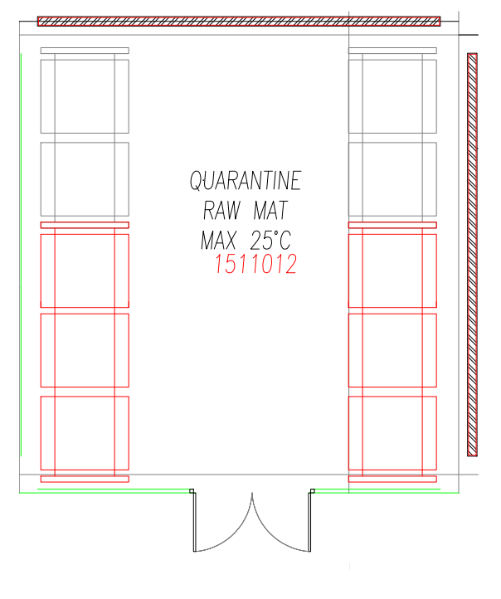
EMPTY CAPSULE SELECTION ROOM
Mapping point number 1 to 4 are arranged of two different heights, which is located at the bottom and top levels.
Mapping point number 5 is arranged of one heights, which is located at the bottom levels.
Mapping point heights are described on figure below.
5
3
4
2

121

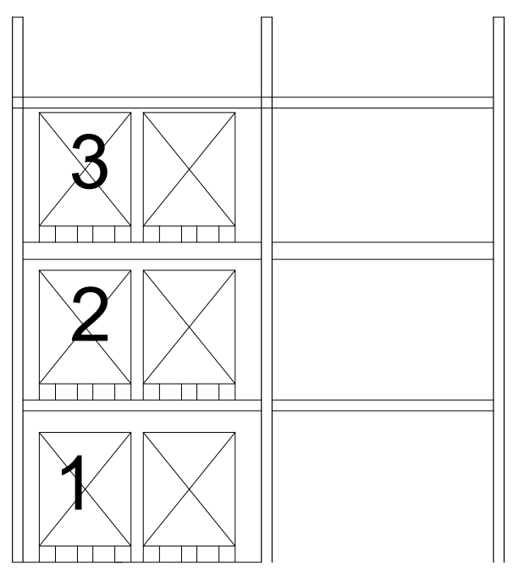
2.B

2.A
1.A

1.B
Note:
x.a : Bottom level
x.b : Top level

No. | Mapping Point | Temperature Mapping Result (℃) |  |  |  |  |  | Total Time Out of Specification |  | Executed by |  | Verified by | Pass/ Fail
 |  | Average |  |  | Minimum |  | Maximum
1. | 1.A | 19,21 |  |  | 18,90 |  | 19,80 | NA |  | HH |  | MRN | Pass
2. | 1.B | 19,15 |  |  | 18,80 |  | 19,70 | NA |  | HH |  | MRN | Pass
3. | 2.A | 19,12 |  |  | 18,80 |  | 19,70 | NA |  | HH |  | MRN | Pass
4. | 2.B | 19,19 |  |  | 18,80 |  | 19,70 | NA |  | HH |  | MRN | Pass
5. | 3.A | 19,00 |  |  | 18,60 |  | 19,60 | NA |  | HH |  | MRN | Pass
6. | 3.B | 19,10 |  |  | 18,70 |  | 19,70 | NA |  | HH |  | MRN | Pass
7. | 4.A | 19,10 |  |  | 18,70 |  | 19,70 | NA |  | HH |  | MRN | Pass
8. | 4.B | 19,23 |  |  | 18,90 |  | 19,80 | NA |  | HH |  | MRN | Pass
9. | 5.A | 19,34 |  |  | 19,00 |  | 19,90 | NA |  | HH |  | MRN | Pass
Average |  | 19,16 |  |  | 18,80 |  | 19,73 | NA
Minimum |  | 19,00 |  |  | 18,60 |  | 19,60 | NA
Maximum |  | 19,34 |  |  | 19,00 |  | 19,90 | NA
Comment(s):

- The lowest temperature contained in the mapping point 3.A is at the required limit (max 25^{O}C) of 18,60 (complete data attached).

- The higest temperature contained in the mappimg point 5.A is at the required limit (max 25^{O}C) of 19,90 (Complete data attached).

- The average temperature in the Quarantine Raw Material is at the required limit (max 25^{O}C) of 19,16 (complete data attached).

Attachment No.: |  |  |  |  |  | Attachment Title:

Deviation Ref. No.:
Executed by: HH |  |  |  |  |  | Date: 07/APR/2022 |  |  | Result: Pass |  | Signature:
Verified by: MRN |  |  |  |  |  | Date: 07/APR/2022 |  |  | Result: Pass |  | Signature:
  - Relative Humidity Distribution
Purpose |  |  | : | To define humidity distribution characteristic throughout the mapping area.
Procedure |  |  | : | - Set Data Loggers on each pre-determined mapping points to record data.  - Conduct the mapping exercise for 5 (five) consecutive days.  - Extract and attach all data obtained from each data logger.  - Define average, minimum, and maximum humidity on each mapping point.  Define the total time out of specification on each mapping point.
Acceptance Criteria |  |  | : | Maximum Humidity of 65%.  With maximum total time out of specification is 1 hour.

Area/ Equipment Layout and Mapping Points:

Mapping exercise is conducted by placing EDLMs as shown on the Data Logger Placement table, also on drawing below:

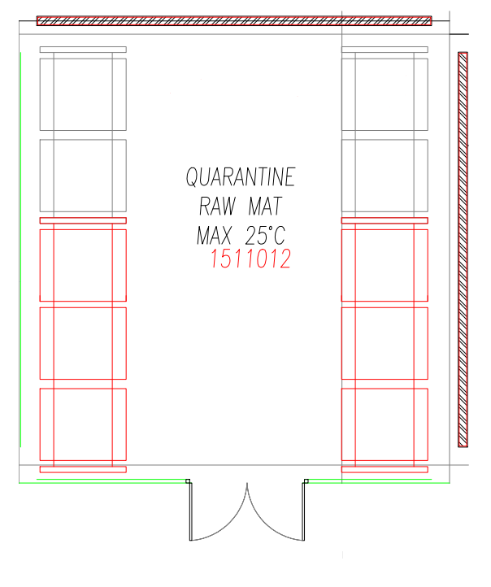
Mapping point number 1 to 4 are arranged of two different heights, which is located at the bottom and top levels.
Mapping point number 5 is arranged of one heights, which is located at the bottom levels.
Mapping point heights are described on figure below.
EMPTY CAPSULE SELECTION ROOM
5
3
4
2

1


2.B

2.A
1.A

1.B
Note:
x.a : Bottom level
x.b : Top level

No. | Mapping Point | Humidity Mapping Result (%) |  |  |  |  |  | Total Time Out of Specification |  | Executed by |  | Verified by | Pass/ Fail
 |  | Average |  |  | Minimum |  | Maximum
1. | 1.A | 62,38 |  |  | 60,10 |  | 65,30 | NA |  | HH |  | MRN | Pass
2. | 1.B | 61,78 |  |  | 59,30 |  | 64,80 | NA |  | HH |  | MRN | Pass
3. | 2.A | 61,94 |  |  | 59,80 |  | 64,30 | NA |  | HH |  | MRN | Pass
4. | 2.B | 61,98 |  |  | 59,90 |  | 64,40 | NA |  | HH |  | MRN | Pass
5. | 3.A | 61,63 |  |  | 59,30 |  | 63,90 | NA |  | HH |  | MRN | Pass
6. | 3.B | 62,64 |  |  | 60,30 |  | 64,90 | NA |  | HH |  | MRN | Pass
7. | 4.A | 62,38 |  |  | 60,10 |  | 64,70 | NA |  | HH |  | MRN | Pass
8. | 4.B | 61,72 |  |  | 59,50 |  | 64,10 | NA |  | HH |  | MRN | Pass
9. | 5.A | 61,44 |  |  | 59,30 |  | 63,80 | NA |  | HH |  | MRN | Pass
Average |  | 61,99 |  |  | 59,73 |  | 64,47 | NA
Minimum |  | 61,44 |  |  | 59,30 |  | 63,80 | NA
Maximum |  | 62,64 |  |  | 60,30 |  | 65,30 | NA
Comment(s):

- The lowest humidity contained in the mapping point 1.B, 3.A, and 5.A is at the required limit (max 65%) of 59,30 (Complete data attached).

- The higest humidity contained in the mapping point 1.A is at the required limit (max 65%) of 65,30 (time out of specification under 1 hour).

- The average humidity in the Empty Capsule Selection Room is at the required limit (max 65%) of 61,99 (complete data attached).

Attachment No.: |  |  |  |  |  | Attachment Title:

Deviation Ref. No.:
Executed by: HH |  |  |  |  |  | Date: 07/APR/2022 |  |  | Result: Pass |  | Signature:
Verified by: MRN |  |  |  |  |  | Date: 07/APR/2022 |  |  | Result: Pass |  | Signature:

- Recommendations
The following locations are recommendations only and aimed at providing consistent coverage of the facility for the purpose of ongoing monitoring. In addition, this includes recommendations for goods storage positioning.

Mapping Point | Logger S/N | Description | Recommendations
1.A | 37252993 | Cold Spot  Humid Spot | NA
1.B | 37251942 | Cold Spot  Humid Spot | NA
2.A | 37251071 | Cold Spot  Humid Spot | NA
2.B | 37242825 | Cold Spot  Humid Spot | NA
3.A | 37252019 | Cold Spot  Humid Spot | NA
3.B | 37251971 | Cold Spot  Humid Spot | NA
4.A | 37242884 | Cold Spot  Humid Spot | NA
4.B | 37243991 | Cold Spot  Humid Spot | NA
5.A | 37242806 | Cold Spot  Humid Spot | NA

- Deviation
Observation which requires further information shall be recorded as a comment. Comment which is referring to inadequacy of test result shall be escalated as a deviation. Refer to SOP Deviation Handling (Doc. No._____NA_____).
Deviation No. | Description | Impact of Deviation
 | NA HH 07/APR/2022

- Abbreviation List
Abbreviation | Description
EDLM | Electronic Data Logging Monitor
VMP | Validation Master Plan

- Mapping Result Summary
No | Parameter | Pass / Fail | Deviation No. | Comment
1 | Temperature Distribution | Pass | NA | NA
2 | Relative Humidity Distribution | Pass | NA | NA

- Conclusion

Based on mapping study performed on Empty Capsule Selection Room (1511012) from 31-Mar-2022 until 05-Apr-2022, the Temperature and Humidity Mapping of Storage Areas declared:
PASS
□ FAIL
With conditions detailed below:
- The result of temperature monitoring show that of all hight, 1 m, and 3 m sampling point are within the required limits.

- Attachment List

The following documents are attached:
Attachment No. | Attachment Title | Description
1 | Calibration Certificates | Calibration certificates provided for each Data Logger utilized in the study.
2 | Temperature and Humidity Data | Temperature and humidity raw data extracted from each data logger positioned in this mapping study.

