As the global human population increases, our understanding of human-associated impacts on wildlife will become more crucial. Direct causes of these impacts include habitat loss and modification (Hoekstra et al. 2005; Seabloom et al. 2002; Wilcove et al. 1998), increased disease transmission (Bradley and Altizer 2007; Brittingham and Temple 1986), exposure to toxicant contamination (Brasso and Cristol 2008; Roux and Marra 2007), and potentially complex interactions with introduced and invasive species (Borgmann and Rodewald 2004; Gleditsch and Carlo 2010; Mills *et al.* 1989). Invasive predators can be particularly detrimental to native species, and invasive mammalian predators alone were responsible for 58% of all mammal, bird, and reptile extinctions documented by the International Union for the Conservation of Nature (Doherty *et al.* 2016). One species, the domestic cat, *Felis catus* (hereafter, “cat”), was responsible for 26% of those extinctions (Doherty *et al.* 2016) and has been implicated in the endangerment of many more species (Doherty *et al.* 2016; Medina *et al.* 2011).

Since their domestication thousands of years ago, cats have been transported around the world by humans and have been released or escaped into the wild (e.g. Abbott 2002). Cats that live near humans are often provisioned with food and, in some cases, given veterinary care (Natoli et al. 1999), which allows females to maintain high reproductive rates (Nutter *et al.* 2004). The outcome of this human care and rapid reproduction is the potential for cats to exist at high densities (Coleman and Temple 1993; Sims et al. 2007), especially where they occur in colonies (Campos et al. 2007). Independent of whether they are fed by humans, cats also hunt instinctually (Adamec 1976). These qualities create the potential for devastating outcomes for native prey.

Loss *et al*. (2013) estimated direct mortality from cat predation in the United States alone at 1.3-4.0 billion birds and 6.3-22.3 billion mammals annually. Cats can also have indirect impacts on their prey. For example birds reduce provisioning of their young after a cat visits the nest, resulting in reduced fecundity (Bonnington *et al.* 2013). The results of these pressures have been well-documented on islands in particular. Cats contributed to an estimated 33 recent extinctions on islands (Medina *et al*. 2011). Native faunal declines often quickly follow the introduction of cats to islands (Burbidge and McKenzie 1989; Galbreath and Brown 2004), and removal of cats often leads to recovery of native fauna (Risbey *et al*. 2000).

The impacts of cats on mainland prey populations are more elusive. It is clear that cats kill substantial numbers of birds (Loss et al. 2013), and indirect evidence suggests cats do negatively impact birds. For example, extirpation of birds followed increases in cat abundance in fragmented habitats in Southern California (Crooks and Soulé 1999), and in a Washington, D.C. suburb, mortality of juvenile Gray Catbirds varied significantly with cat predation rates (Balogh *et al*. 2011). However, a crucial question that remains is whether this predation represents mortality that would have occurred anyway (compensatory mortality) or additional mortality above natural levels that affects population dynamics (additive mortality) (e.g. Baker et al. 2008; Balogh et al. 2011; Jarvis 1990; van Heezik et al. 2010). Addressing this question requires either manipulation of predation, which would be logistically difficult, or a large-scale study covering a wide spatial and urbanization range that allows for examination of interactions between cats and other variables that may influence bird populations dynamics.

In this study, I used a multiyear data set covering a wide spatial range in the Washington, D.C. metropolitan region to examine the effects of mainland free-ranging cats on native birds. I also used two independent methods to produce cat abundance estimates and examine the human demographic and land-use variables influencing variation in cat abundance.

Previous research suggests that top-down regulators, such as predation by coyotes (Crooks and Soulé 1999; Flockhart et al. 2016; Kays et al. 2015), and bottom-up processes, such as food availability (Flockhart et al. 2016), exert important population pressures on cats. Predation is likely to keep cat populations low in rural areas, and greater human density will likely mean more food provisioning in urban areas. These factors suggest that cat abundance will show a positive response to urbanization (Figure 1a). However, urban cats are subject to greater human-associated mortality risks, such as automobile collisions (Childs and Ross 1986). Urban cat owners may also be less likely to allow their cats outdoor access (Lepczyk et al. 2004). Therefore, an alternate hypothesis is that cat abundance will show a negative quadratic response to urbanization, with the greatest cat abundance occurring at intermediate urbanization levels (Figure 1b).

To test the alternate hypotheses that predation by cats represents compensatory or additive mortality for birds, I modeled survival probability for seven common breeding birds across an urbanization gradient in the Washington, D.C. region and compared the relative influences of cats and a priori predictor variables for survival. If cat predation represents a source of compensatory mortality, I would expect models that include only a priori avian survival variables to be best-supported. If cat predation represents a source of additive mortality, I would expect models that include cat abundance variables to receive the most support.

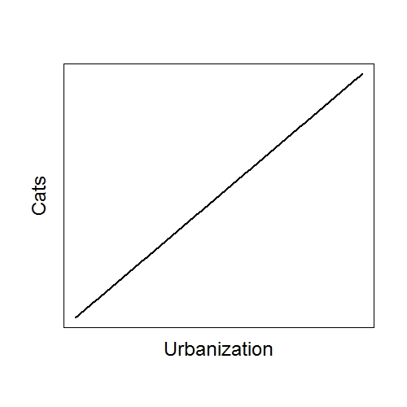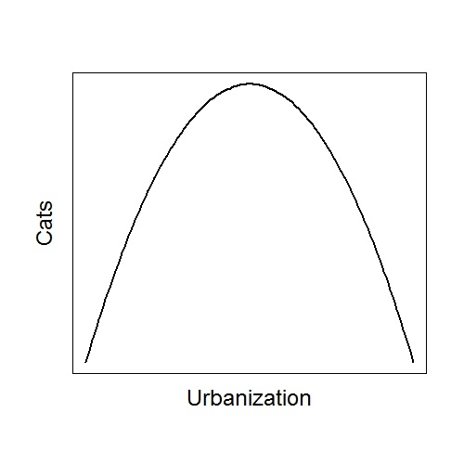

a

b

**Figure 1.** (**a**) Predicted linear relationship between urbanization and cat abundance if rural predation and urban provisioning are the most important drivers of abundance. (**b**) Predicted quadratic relationship between urbanization and cat abundance if pressures of urban mortality and owner habits oppose those of rural predation and urban provisioning.

Abbott, I., 2002. Origin and spread of the cat, Felis catus, on mainland Australia, with a discussion of the magnitude of its early impact on native fauna. Wildlife Research 29, 51-74.

Adamec, R.E., 1976. The interaction of hunger and preying in the domestic cat (Felis catus): an adaptive hierarchy? Behavioral Biology 18, 263-272.

Baker, P.J., Molony, S.E., Stone, E., Cuthill, I.C., Harris, S., 2008. Cats about town: is predation by free‐ranging pet cats Felis catus likely to affect urban bird populations? Ibis 150, 86-99.

Balogh, A.L., Ryder, T.B., Marra, P.P., 2011. Population demography of Gray Catbirds in the suburban matrix: sources, sinks and domestic cats. Journal of Ornithology 152, 717-726.

Bonnington, C., Gaston, K.J., Evans, K.L., 2013. Fearing the feline: domestic cats reduce avian fecundity through trait-mediated indirect effects that increase nest predation by other species. Journal of Applied Ecology 50, 15-24.

Borgmann, K.L., Rodewald, A.D., 2004. Nest predation in an urbanizing landscape: the role of exotic shrubs. Ecological Applications 14, 1757-1765.

Bradley, C.A., Altizer, S., 2007. Urbanization and the ecology of wildlife diseases. Trends in ecology & evolution 22, 95-102.

Brasso, R.L., Cristol, D.A., 2008. Effects of mercury exposure on the reproductive success of tree swallows (Tachycineta bicolor). Ecotoxicology 17, 133-141.

Brittingham, M.C., Temple, S.A., 1986. A survey of avian mortality at winter feeders. Wildlife Society Bulletin (1973-2006) 14, 445-450.

Burbidge, A.A., McKenzie, N., 1989. Patterns in the modern decline of Western Australia's vertebrate fauna: causes and conservation implications. Biological conservation 50, 143-198.

Campos, C., Esteves, C., Ferraz, K., Crawshaw, P., Verdade, L., 2007. Diet of free‐ranging cats and dogs in a suburban and rural environment, south‐eastern Brazil. Journal of Zoology 273, 14-20.

Childs, J., Ross, L., 1986. Urban cats: characteristics and estimation of mortality due to motor vehicles. American journal of veterinary research 47, 1643-1648.

Coleman, J.S., Temple, S.A., 1993. Rural residents' free-ranging domestic cats: a survey. Wildlife Society Bulletin (1973-2006) 21, 381-390.

Crooks, K.R., Soulé, M.E., 1999. Mesopredator release and avifaunal extinctions in a fragmented system. Nature 400, 563-566.

Doherty, T.S., Glen, A.S., Nimmo, D.G., Ritchie, E.G., Dickman, C.R., 2016. Invasive predators and global biodiversity loss. Proceedings of the National Academy of Sciences.

Flockhart, D., Norris, D., Coe, J., 2016. Predicting free‐roaming cat population densities in urban areas. Animal Conservation.

Galbreath, R., Brown, D., 2004. The tale of the lighthouse-keeper’s cat: discovery and extinction of the Stephens Island wren (Traversia lyalli). Notornis 51, 193-200.

Gleditsch, J.M., Carlo, T.A., 2010. Fruit quantity of invasive shrubs predicts the abundance of common native avian frugivores in central Pennsylvania. Diversity and Distributions 17, 244-253.

Hoekstra, J.M., Boucher, T.M., Ricketts, T.H., Roberts, C., 2005. Confronting a biome crisis: global disparities of habitat loss and protection. Ecology letters 8, 23-29.

Jarvis, P.J., 1990. Urban cats as pests and pets. Environmental Conservation 17, 169-171.

Kays, R., Costello, R., Forrester, T., Baker, M.C., Parsons, A.W., Kalies, E.L., Hess, G., Millspaugh, J.J., McShea, W., 2015. Cats are rare where coyotes roam. Journal of Mammalogy 96, 981-987.

Lepczyk, C.A., Mertig, A.G., Liu, J., 2004. Landowners and cat predation across rural-to-urban landscapes. Biological conservation 115, 191-201.

Loss, S.R., Will, T., Marra, P.P., 2013. The impact of free-ranging domestic cats on wildlife of the United States. Nature communications 4, 1396.

Medina, F.M., Bonnaud, E., Vidal, E., Tershy, B.R., Zavaleta, E.S., Josh Donlan, C., Keitt, B.S., Le Corre, M., Horwath, S.V., Nogales, M., 2011. A global review of the impacts of invasive cats on island endangered vertebrates. Global Change Biology 17, 3503-3510.

Mills, G.S., Dunning Jr, J.B., Bates, J.M., 1989. Effects of urbanization on breeding bird community structure in southwestern desert habitats. Condor, 416-428.

Natoli, E., Ferrari, M., Bolletti, E., Pontier, D., 1999. Relationships between cat lovers and feral cats in Rome. Anthrozoös 12, 16-23.

Nutter, F.B., Levine, J.F., Stoskopf, M.K., 2004. Reproductive capacity of free-roaming domestic cats and kitten survival rate. Journal of the American Veterinary Medical Association 225, 1399-1402.

Risbey, D.A., Calver, M.C., Short, J., Bradley, J.S., Wright, I.W., 2000. The impact of cats and foxes on the small vertebrate fauna of Heirisson Prong, Western Australia. II. A field experiment. Wildlife Research 27, 223-235.

Roux, K.E., Marra, P.P., 2007. The presence and impact of environmental lead in passerine birds along an urban to rural land use gradient. Archives of Environmental Contamination and Toxicology 53, 261-268.

Seabloom, E.W., Dobson, A.P., Stoms, D.M., 2002. Extinction rates under nonrandom patterns of habitat loss. Proceedings of the National Academy of Sciences 99, 11229-11234.

Sims, V., Evans, K.L., Newson, S.E., Tratalos, J.A., Gaston, K.J., 2007. Avian assemblage structure and domestic cat densities in urban environments. Diversity and Distributions 14, 387-399.

van Heezik, Y., Smyth, A., Adams, A., Gordon, J., 2010. Do domestic cats impose an unsustainable harvest on urban bird populations? Biological conservation 143, 121-130.

Wilcove, D.S., Rothstein, D., Dubow, J., Phillips, A., Losos, E., 1998. Quantifying threats to imperiled species in the United States. BioScience 48, 607-615.