Trinity Support Limited
SERVICE GUIDE & PROPOSAL
"Supporting Independence. Building Confidence. Creating Futures."
Company Number 13605039 | 40 South Park Road, Ilford, England, IG1 1SS
Email: placements@trinitysupport.uk | Web: www.trinitysupport.uk
Tel: +44 (0) 7506 692 885 | +44 (0) 7903 512 578

1. Executive Summary
Trinity Support Limited provides immediate placement supported accommodation for young people who need stability, structure, and tailored assistance as they move toward independence. We offer a safe and supportive environment where young people can settle, engage, and work toward positive long-term outcomes. Our service is designed for young people who may be facing homelessness, placement breakdown, family conflict, or difficulty sustaining independent living. We understand that each young person’s journey is different, which is why our support is responsive, person-centred, and outcome-focused.

Figure 1: Supported independence mentoring session.

2. Why Local Authorities Choose Us
- Immediate placement availability - rapid response for emergency or planned step-down transitions.
- 24-hour support provision - dedicated on-site staff available round-the-clock.
- Waking night staff - alert night cover ensures security and immediate incident management.
- Experienced key workers - supportive mentors conducting structured engagement sessions.
- Tailored independence programmes - building essential routines and living skills.
- Specialist mentoring support - expert guidance for boundary setting and life coaching.
- Strong safeguarding framework - robust risk management and agency liaison.
- Excellent transport links - convenient access to trains, buses, and local pathways.
- High-quality furnished accommodation - bedrooms with smart TVs, desks, and welcome packs.
- Outcome-focused support planning - goal-oriented pathways reviewable by placing authorities.

3. Our Support Model
Each young person is allocated a dedicated key worker who provides one-to-one support through planned engagement sessions. These sessions are tailored to the individual and help them build the skills and confidence needed for daily life and future independence. We support young people with budgeting, laundry, cooking, healthy living, routines, and other essential independence skills. Our team is also experienced in supporting challenging behaviour, using conflict resolution and solution-focused approaches to create a calm, structured environment.

4. Specialist Support & Safeguarding
Trinity Support Limited works with young people from a wide range of backgrounds and cultures, and we recognise the importance of inclusive, meaningful support. We provide a designated member of staff who focuses on events, activities, and cultural celebration. We also provide specialist mentoring and engagement support around gang affiliation and related risks, and we work alongside partner organisations that support young people affected by gangs. This allows us to offer practical, informed support that responds to complex needs.
Our staff team is trained and experienced in working with young people with complex needs. We provide waking night cover and day floating support to ensure help is available when needed. Safeguarding is central to everything we do, and we liaise with professionals daily to help make sure each young person receives the right support at the right time. We aim to maintain a consistent, well-managed service that gives reassurance to both the young person and the placing authority.

5. Accommodation & Setting: Southpark House
Trinity Support Limited currently offers supported accommodation and support services across the South London area, with access to housing facilities and partner organisations across all London boroughs. This wider network enables us to respond flexibly to referrals and support young people into the most suitable local pathways.
Southpark House is a quiet home with a calm atmosphere, located opposite South Park in Ilford. The property offers easy access to Seven Kings and Newbury Park stations, as well as 24-hour transport links. Residents benefit from fully furnished bedrooms with smart TVs, internet access, storage, desks, and welcome starter packs. The house also features a communal area at the back, with plans for a multi-gym, table tennis, and movie nights, helping to create a positive and engaging living environment. Complimentary meals are offered on arrival to help young people settle in comfortably.
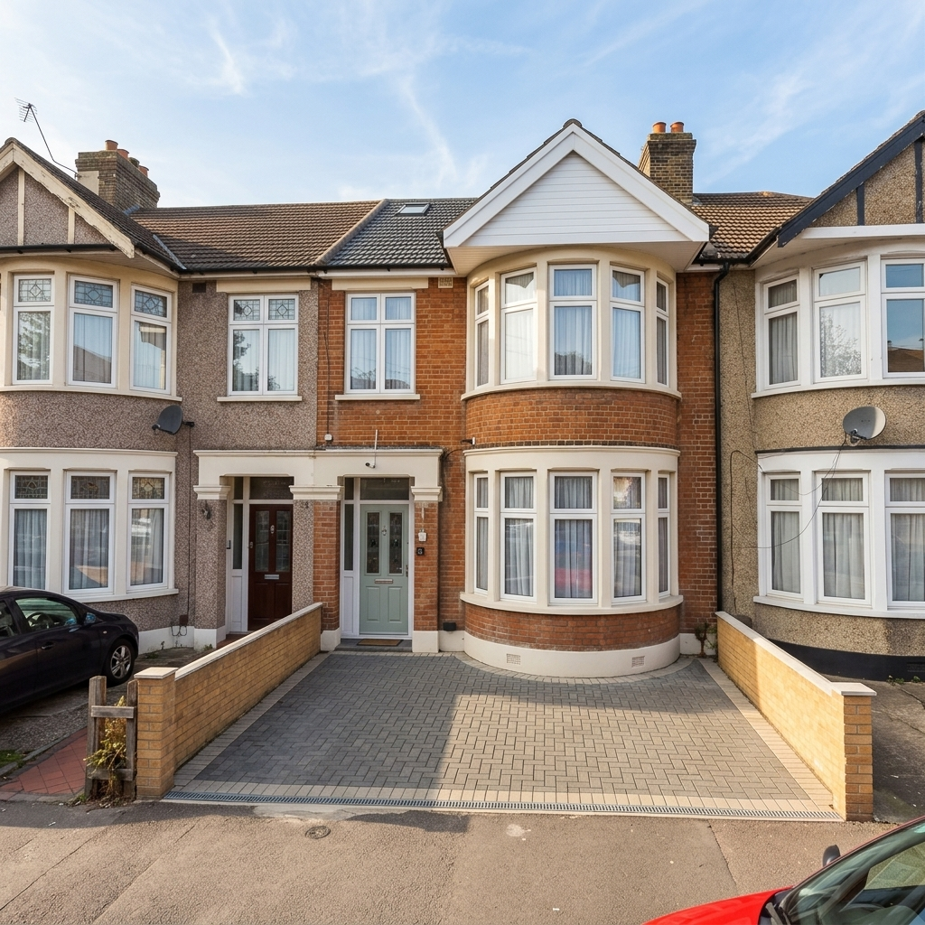
Figure 2: Southpark House exterior opposite a park in Ilford.
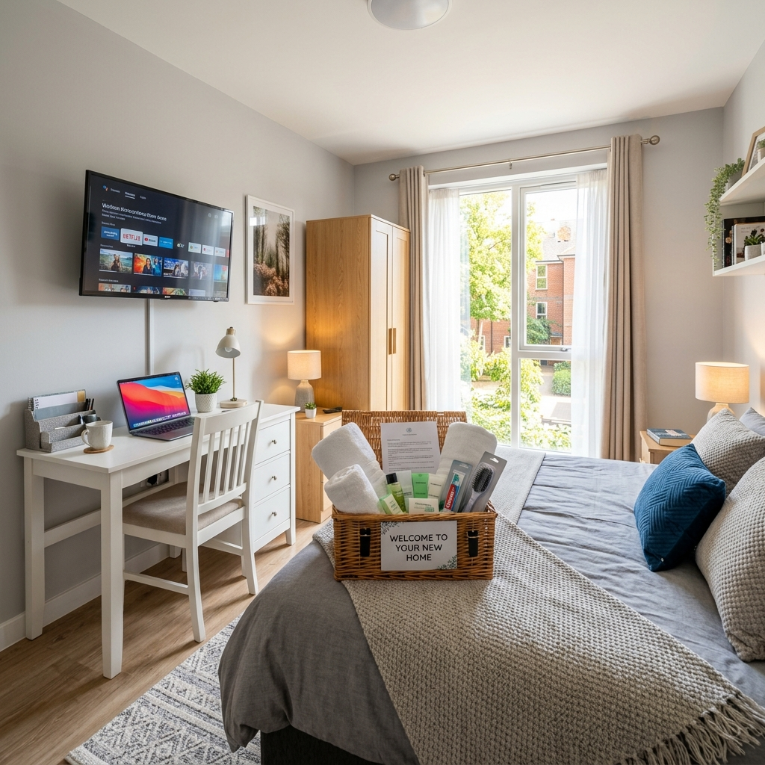
Figure 3: Modern, fully furnished bedroom with study desk and TV.
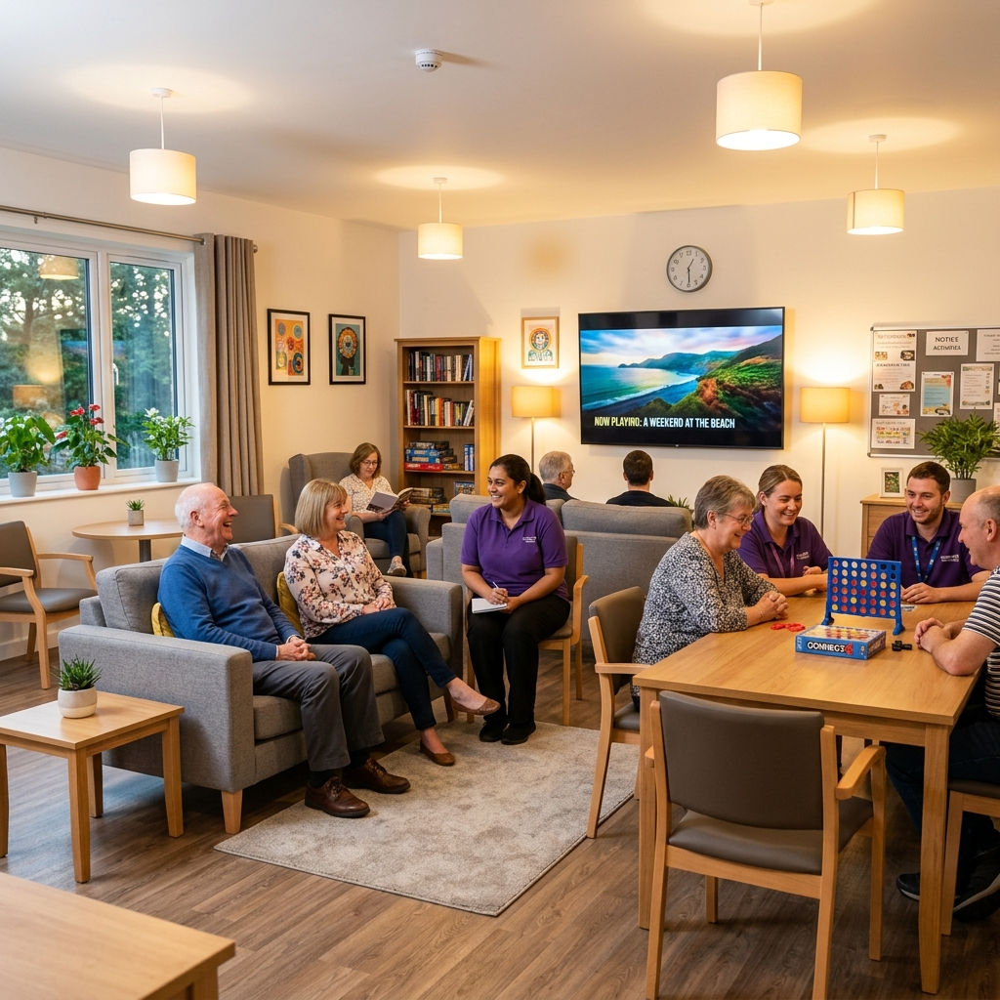
Figure 4: Bright, welcoming communal living area.

6. Placement & Pricing Information
Standard placements are charged at £650 per person per week, which includes 5 hours of core support and administration.
Any additional hours required are charged at £25 per hour.
We offer immediate placement within our step-down supported accommodation provision. Whether you require an emergency placement, a planned transition placement, or wish to discuss a young person’s individual needs, our experienced team is available to assist.

7. Contact Our Placements Team
Trinity Support Limited Placements
Address: 40 South Park Road, Ilford, England, IG1 1SS
Email: placements@trinitysupport.uk
Web: www.trinitysupport.uk
Tel: +44 (0) 7506 692 885 or +44 (0) 7903 512 578
Trinity Support Limited delivers supported accommodation that combines safety, structure, and practical progression. Our team is committed to helping young people build independence, confidence, and a stronger future through consistent support and high-quality placement.

