Karie Funk

Fund of JavaScript

Assignment 9.2

07/27/2019

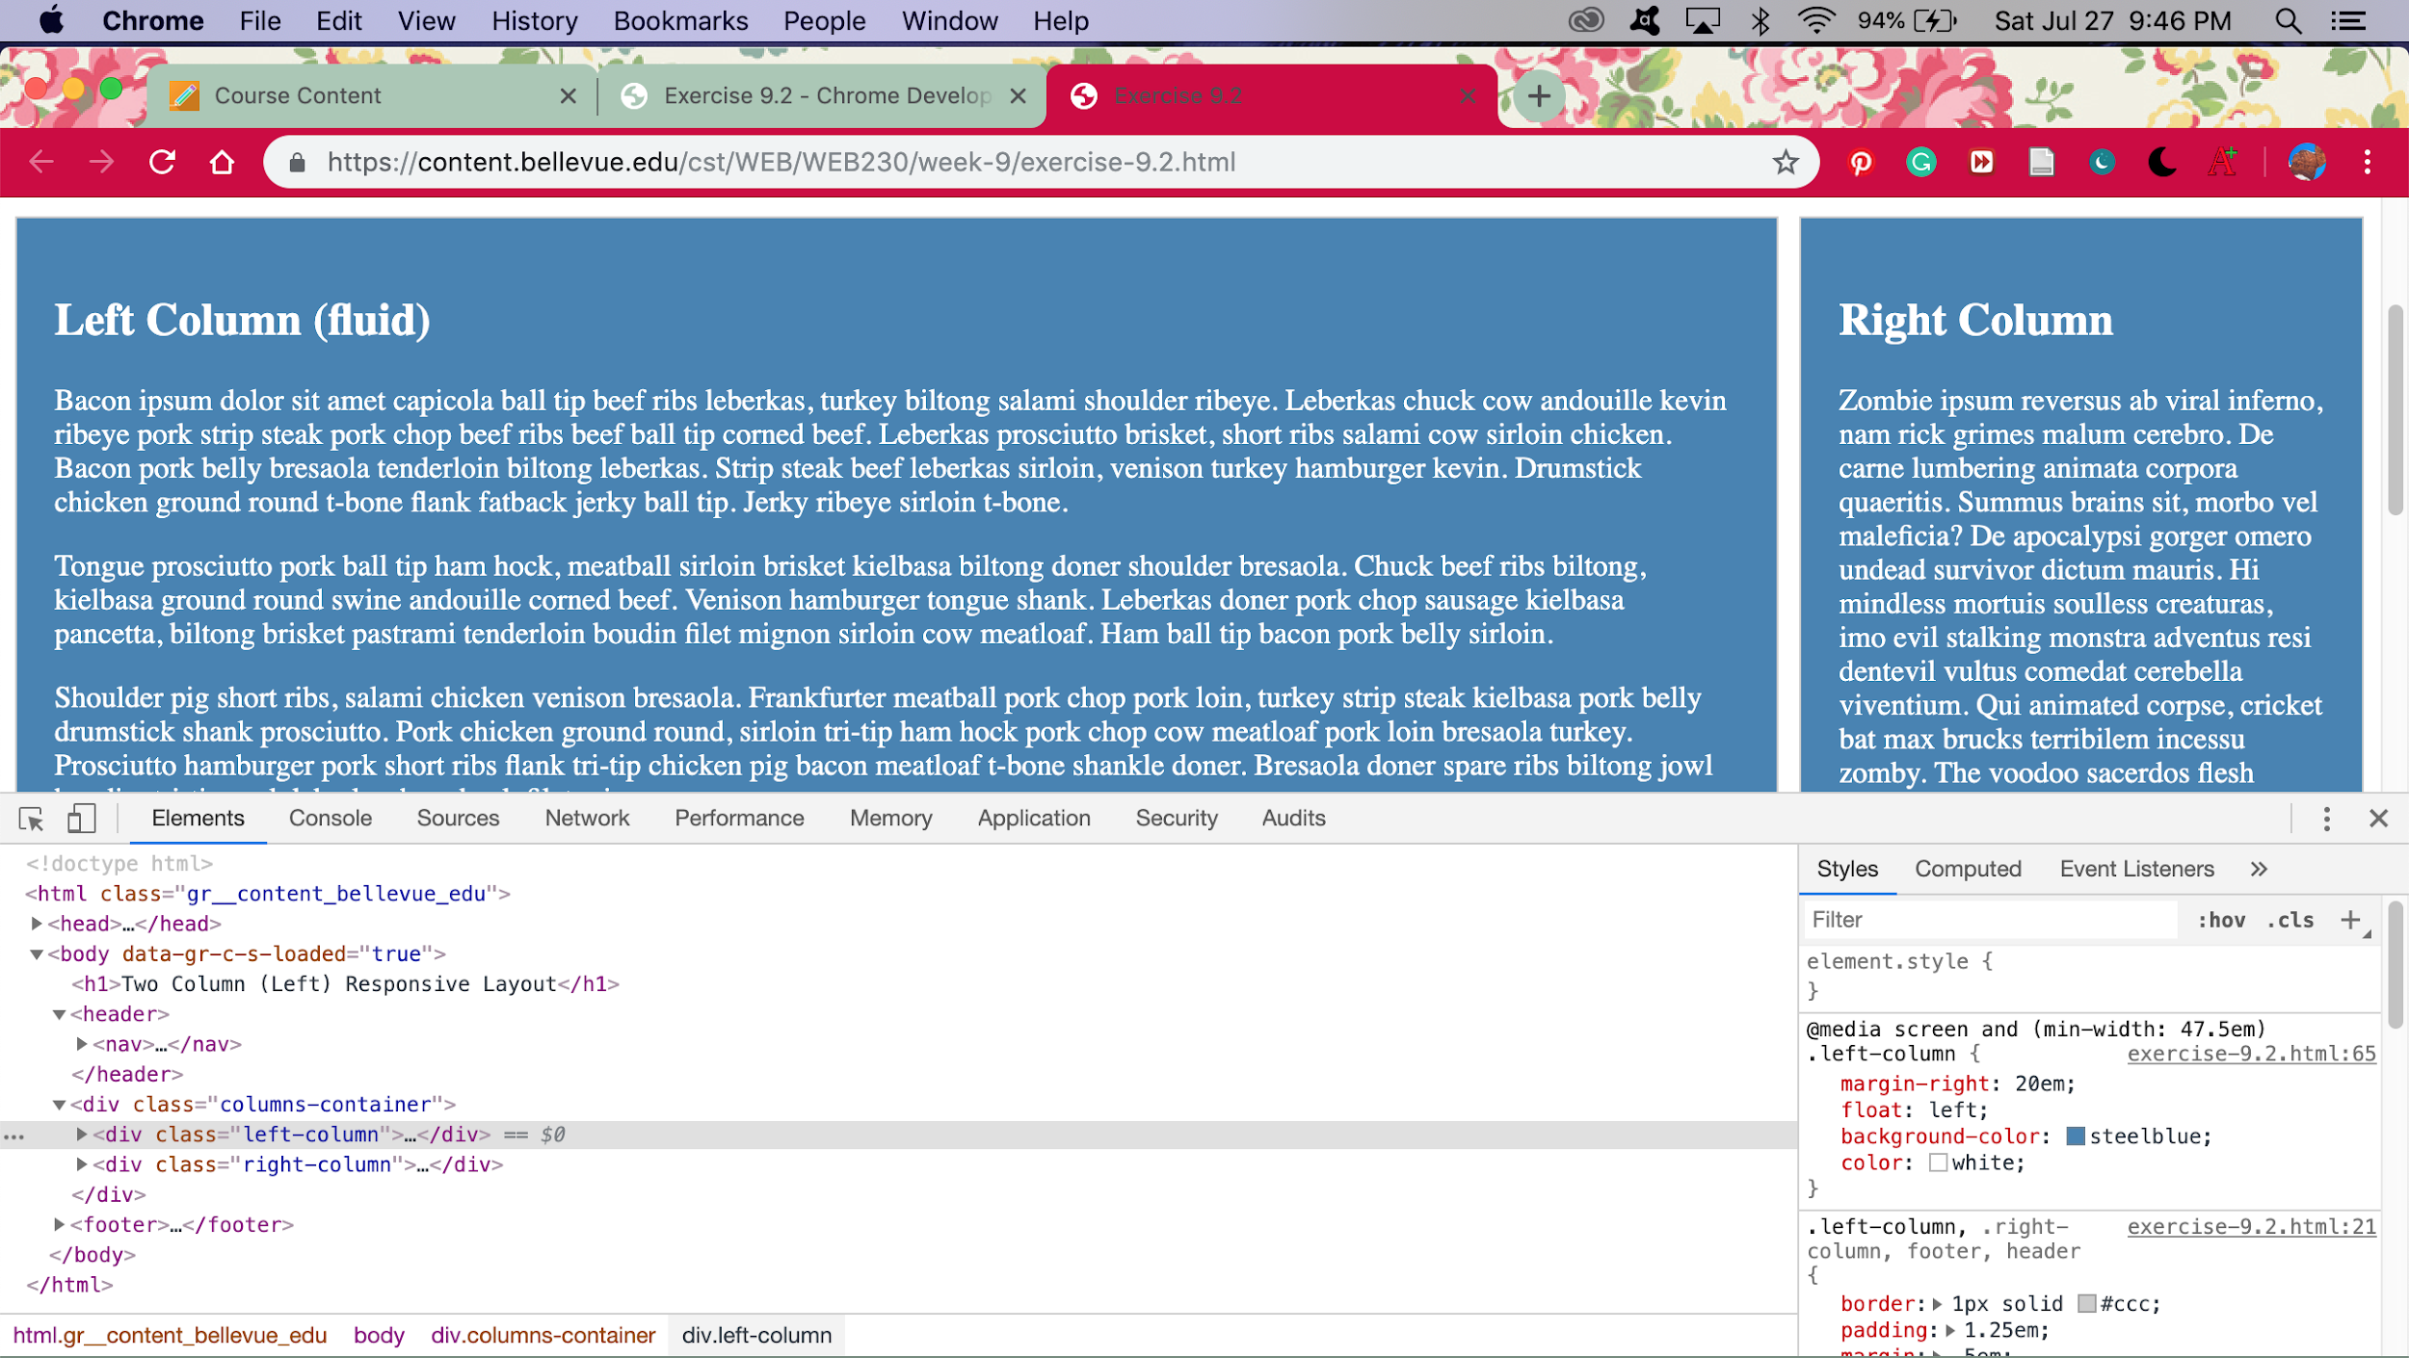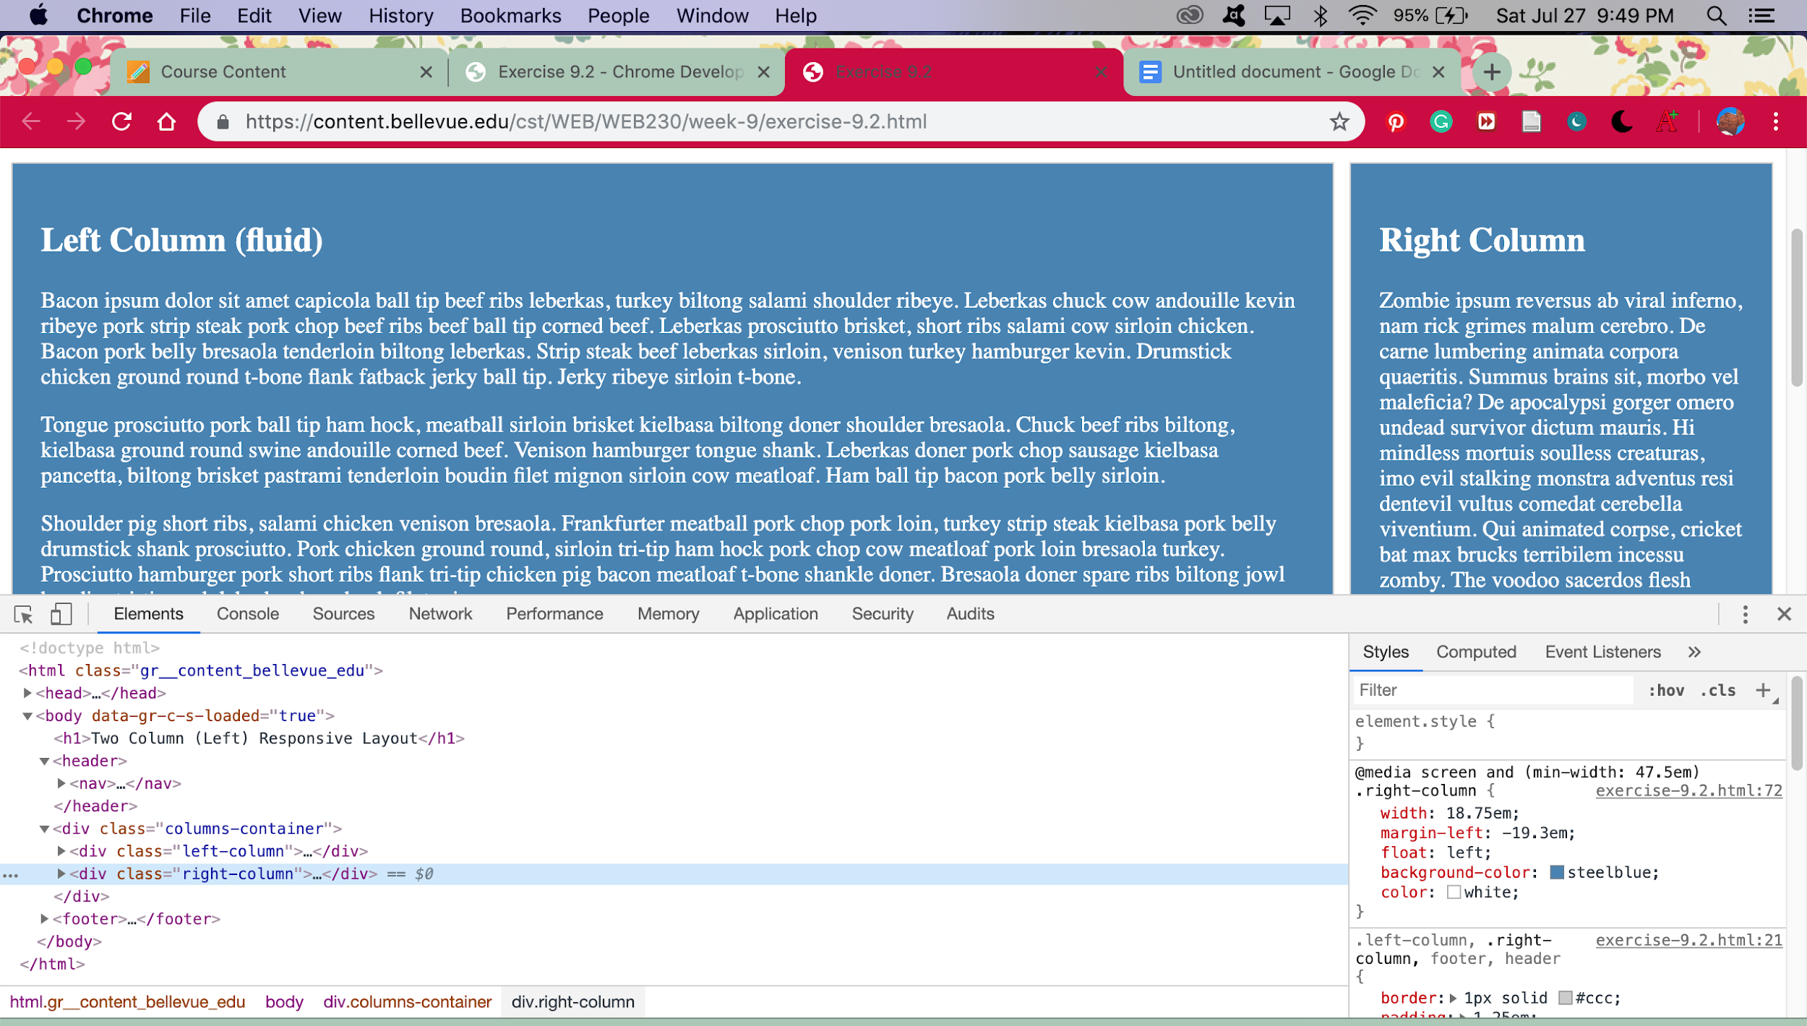

Step 1: I opened the link that said starter code.

Step 2: I pressed F12 on my keyboard.

Step 3: After pressing F12, the developer tools opened up on my screen.

Step 4: I then looked for the sources tab next to elements and console. I clicked on the sources tab.

Step 5: I then looked at bottom left part of dev tool screen and found the word ‘Call Stack’.

Step 6: I kept looking past that word and scrolling down till I found ‘Event Listener Breakpoints’.

Step 7: I clicked on the word ‘Event Listener Breakpoints’.

Step 8: After clicking on that, I scrolled down under ‘Event Listener Breakpoints’ and found the little arrow next to ‘Mouse’.

Step 9: I clicked on little arrow next to the word ‘Mouse’.

Step 10: After clicking on the ‘Mouse’ word a little list will pop up below and you will look at all the words that popped up below ‘Mouse’.

Step 11: After looking at the words below, you will see the one that says ‘click’ and then you will select the little box next to it, and then the box will change to a blue color.

Step 12: After that you will go back up to tab that says ‘elements’ (it was by the one you clicked that said ‘sources’.

Step 13: After you click the word that says ‘elements’ you will look back to the left of the computer screen at the starter code.

Step 14: After clicking ‘elements’ you will see HTML code below that.

Step 15: You will then search through that code and find code that says:

<body data-gr-c-s-loaded=”true”>== $0

Step 16: You will then click the arrow next to that code and below more code will pop up.

Step 17: You will then look for code that says <div class = “left-column”>...</div> and click on it.

It will then put a light blue highlight over it once you’ve clicked it.

Step 18: Below the code you will see a tab that says ‘styles’, you will click on that and CSS code will appear. Which is just the code that styles the code above that.

Step 19: Below the styles tab you will look at that code and find this :

**@media screen and (min-width: 47.5em)**

**.right-column {**

**width: 18.75em;**

**margin-left: -19.3em;**

**float: left;**

**}**

Step 20: Below the words float: left in that code; you will type in

**background-color: steelblue;**

**color: white;**

Step 21: After that, you will find the code that says

**@media screen and (min-width: 47.5em)**

**.left-column {**

**width: 18.75em;**

**margin-left: -19.3em;**

**float: left;**

**}**

Step 22: Below float: left; you type in

**background-color: steelblue;**

**color: white;**

Step 23: After doing that you will look at screen that previews the starter code make sure that there are two boxes in there that are blue with white text.

Step 24: If screen has two blue boxes with white text inside of them, you completed project. Good job!