Karie Funk

07/28/2019

Fund of JavaScript

Assignment 9.3

Step 1: Open Chrome Browser

Step 2: Press F12

Step 3: Press Elements on tab bar on bottom left side of dev tools



Step 4: Click little arrow next to header in code



Step 5: Keep clicking little arrows below header until you get to the <a href> code

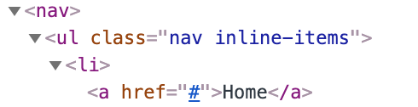

Step 6: Click on <a href=”#”>Home</a> till it is highlighted in light blue

Step 7: Look to bottom right of screen and find the styles panel, click styles.

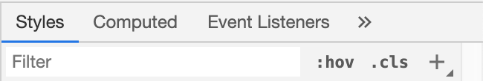

Step 8: Click the little + icon with arrow to create New Style Rule

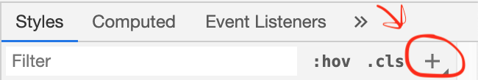

Step 9: After clicking that, this should pop up in code below styles:

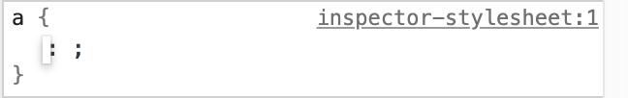

Step 10: Where cursor is blinking in a { : ; } type in **color: white;**

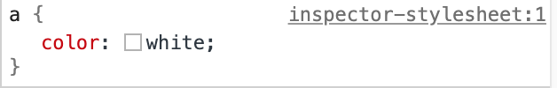

Step 11: Go back over to elements tab to see the HTML code

Step 12: Highlight the <header> code



Step 13: Look back over to your styles tab and find this code:

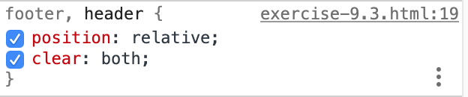

Step 14: Click cursor after clear: both; then when the blinking cursor appears type in **background-color: steelblue;** and below that **color: white;**

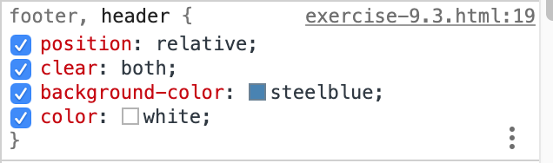

After following these steps you should achieve these results in the header and footer of the page:



