Karie Funk

07/28/2019

Fund of JavaScript

Assignment 9.4

**Step-by-step instructions on how one might set break points and "walk-through" a JavaScript application**

How to set an Event Listener Breakpoint:

Step 1: Go to the sources tab and click the arrow next to Event Listener Breakpoints to expand its section.

Step 2: Click arrow next to ‘Mouse’ word to expand its section.

Step 3: Selected box next to ‘click’

It should look like this:

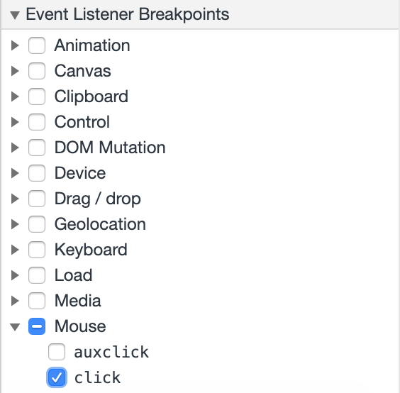

This causes an event-based breakpoint so when you click on something an event happens and the code execution pauses.

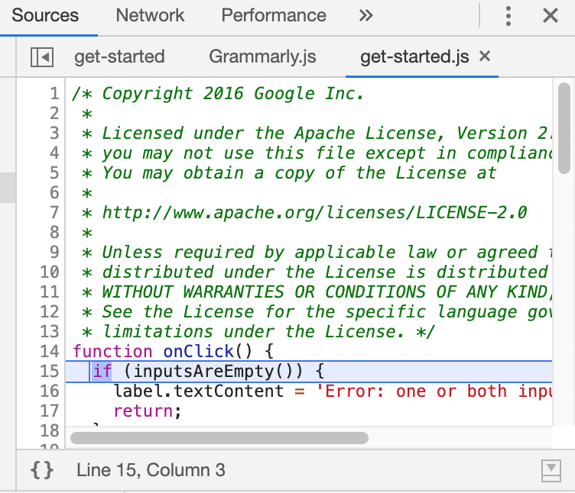

Step 4: **Step through the code**

Step 5: To step through the code go to the ‘Sources’ panel

Step 6: Then click the step into next function call 

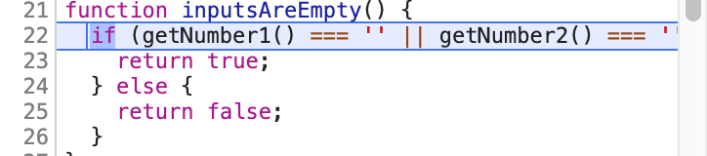

Step 7: Click Step over next function call Step over next function

call

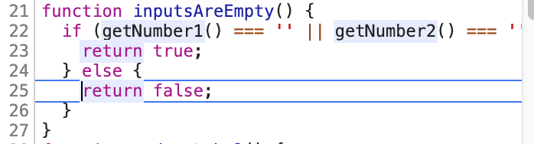

**Step-by-step instructions on how one might log and read messages from the JavaScript console window**

Step 1: Click console on tabs, then click log info, a message will appear of Hello, Console!

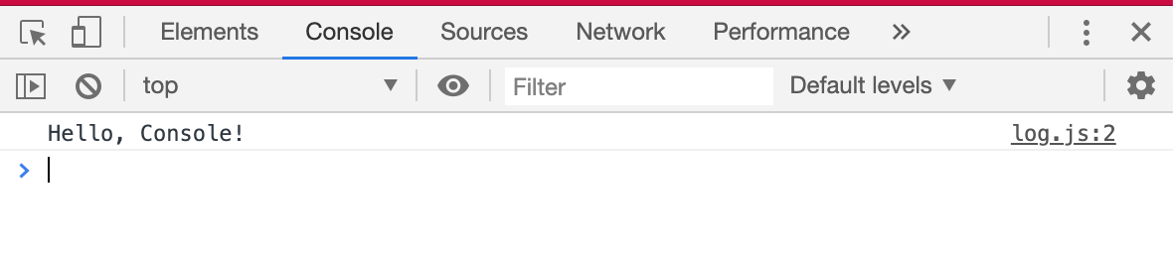

Step 2: Click **log.js:2** (this shows where message was logged)

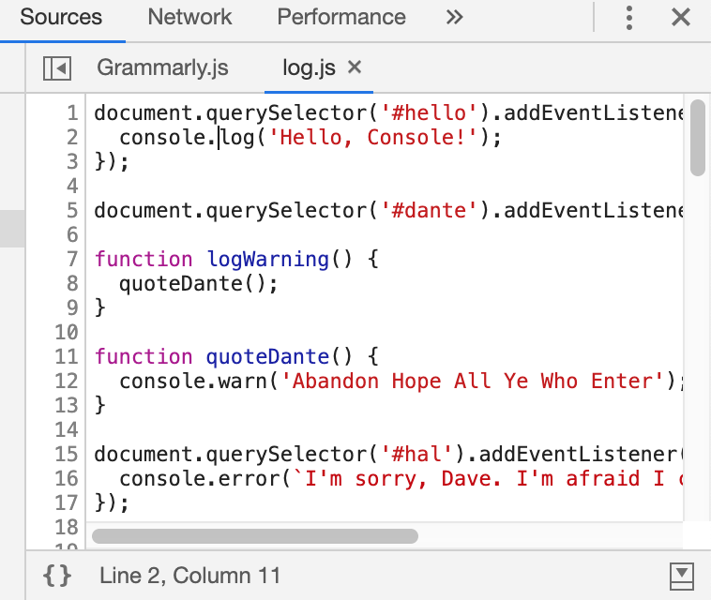

Step 3: Go back to console tab

Step 4: Click the ‘log info’ button in demo and this will appear

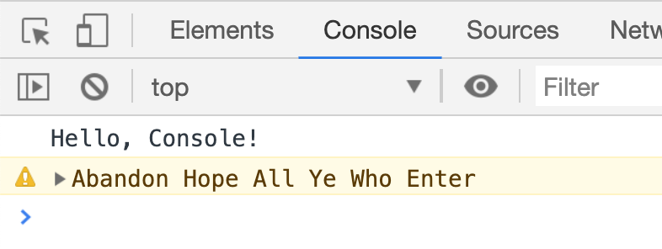

Step 5: Click arrow next to statement to see stack trace

Step 6: Click ‘log error’ to see error message from HAL 9000

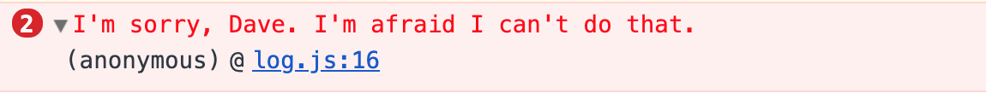

Step 7: Keep clicking different buttons in demo to see different messages.

**Step-by-step instructions on how one might select HTML elements in the JavaScript console window**

Step 1: Go to ‘elements’ tab in group of tabs

Step 2: After clicking ‘elements’ the HTML code will appear

Step 3: Click on code that you are looking for and it will highlight once clicked

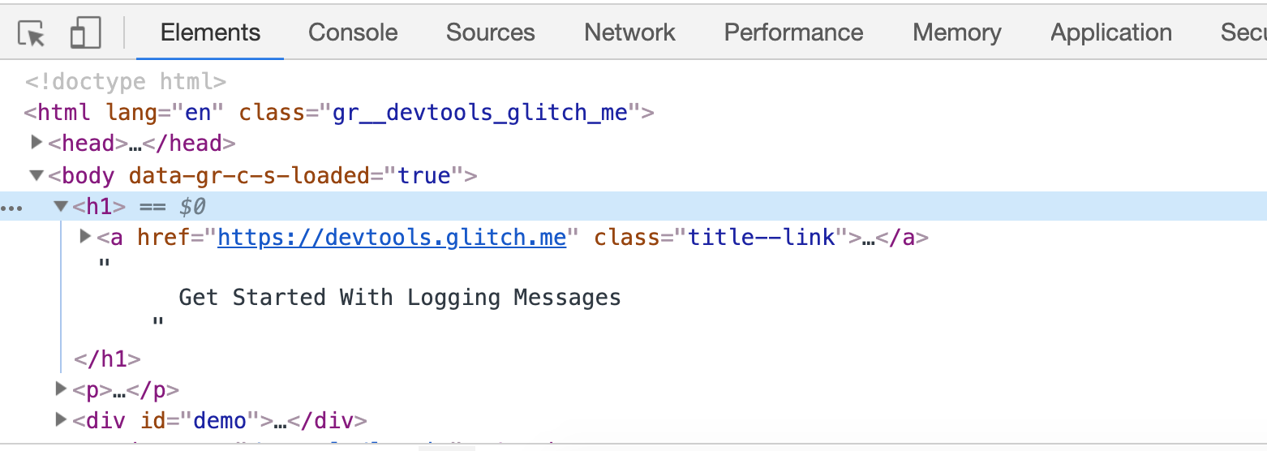

**Step-by-step instructions on how one might simulate CSS states (hover, focus) on live HTML elements**

Step 1: Go to ‘elements’ tab in group of tabs

Step 2: After clicking ‘elements’ the HTML code will appear

Step 3: Click on the <nav> and expand

Step 4: After expanding click expand on the <ul>

Step 5: Expand on the <li>

Step 6: Once you’ve reached the <a>, click it to highlight it

Step 7: Go over to styles panel

Step 8: Click ‘new style rule’ and once it pops up below type in a:hover { color: pink; }

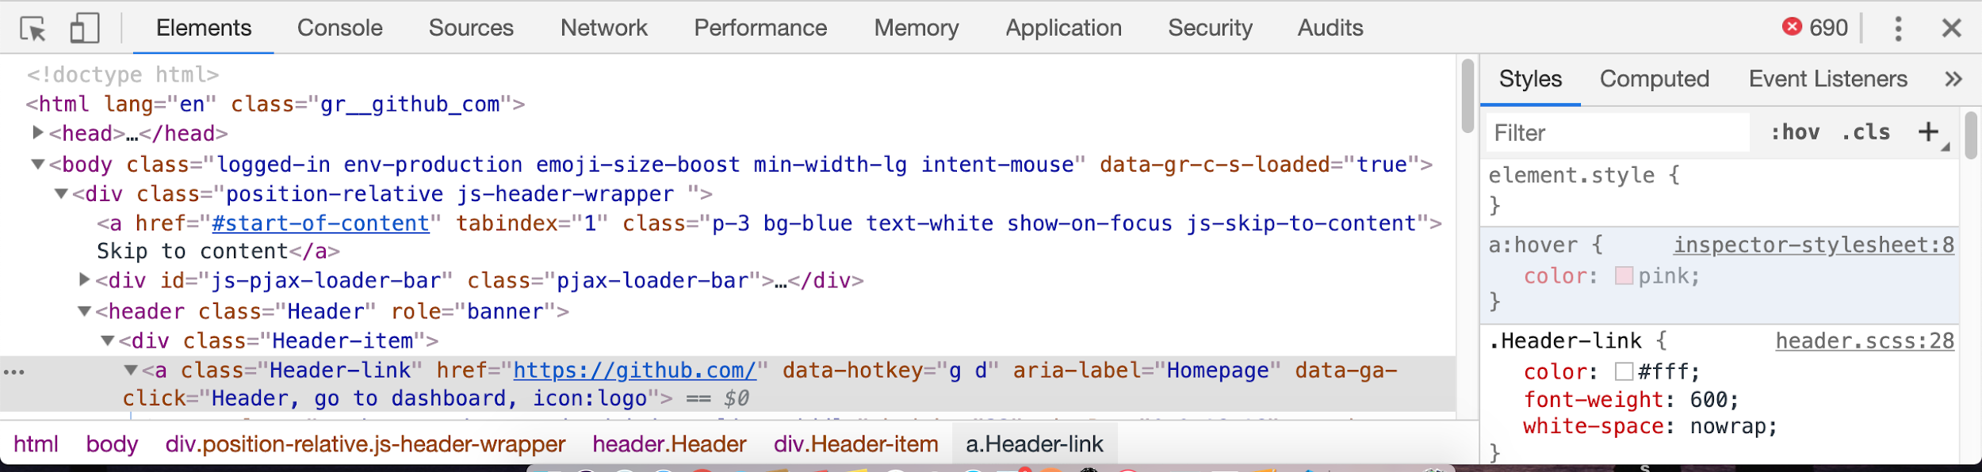

Below are the results of editing the HTML link to have a hover of pink

