Karie Funk

11/02/2019

Assignment 3.2

Intro to NoSQL

Business Rules:

A USER can have many LINK USER ROLE(s)

A ROLE can have many LINK USER ROLE(s)

A ROLE can have many LINK ROLE PERMISSION(s)

A PERMISSION can have many LINK ROLE PERMISSION(s)

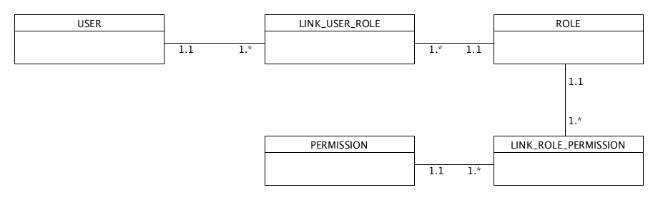

NoSQL data structure from rules:

