Karie Funk

11/03/2019

Assignment 3.3

Intro to NoSQL

Rules:

A publisher can have many book(s).

A book can have many author(s).

ORD

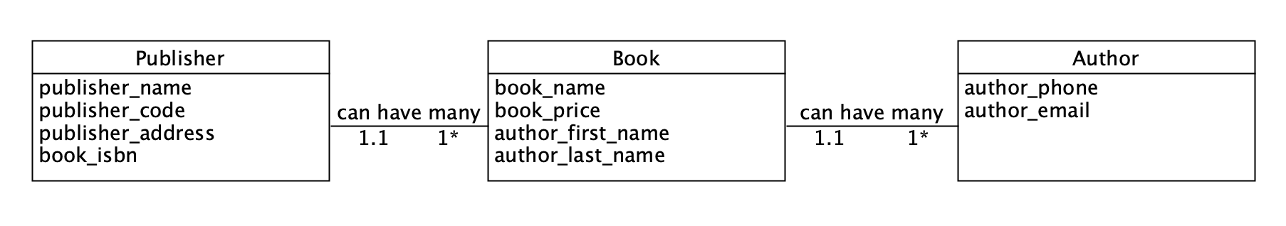

Document Diagram

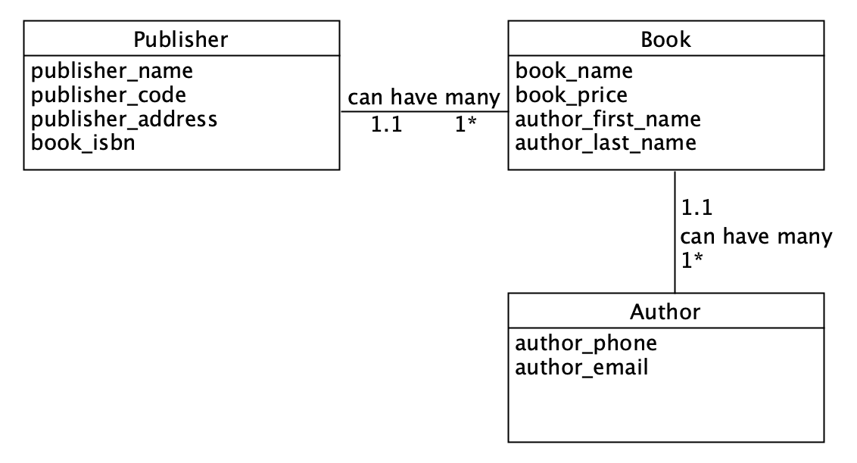

NoSQL Data Structure

