Karie Funk

11.20.2019

Intro to NoSQL  
Assignment 6.2

**Add a Unique Index to the “employee_id” field:**

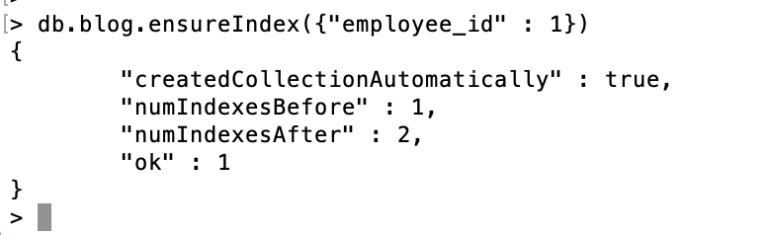

**Execute the insert() operation to validate the Unique Index was added correctly:**

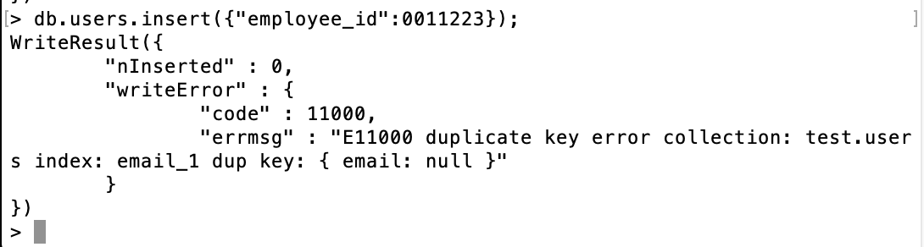

**Execute the insert() operation to validate the Unique Index was added correctly:**

