Karie Funk

Web 335

Week 7 Group Project



My name is Karie Funk and I am one of the developers on this project. I have a strong passion for designing and developing web pages. I have been practicing my graphic design skills for a long time now and have been working on my web development skills for a few years now. I plan to finish my B.S. in Web Development in fall of 2020 and hope to find an awesome career doing this. While I don’t consider myself as experienced as some developers, I’m willing to learn and put in the time it takes to become a successful web developer. When I’m not on the computer coding, I am usually hanging out with my fiancé, dressing my cat up in ridiculous outfits, listening to music, and reading. I also enjoy cars and the vehicle in my picture is a 1967 Ford Mustang Coupe that I restored with my dad and took drag racing in high school. Fun times. Anyway, thank you for taking the time to read this and if you have any questions for me please feel free to ask!

Personas:

1st persona:



Name: David Brown

Age: 39

Huge sports fan and wants pre-recorded sporting events on Nodeflix.

Will want unlimited shows and doesn’t want to watch commercials.

Wouldn’t use a DVR.

Will most likely use Plus access on NodeFlix.

2nd persona:



Name: Kendra Klein

Age: 25

Doesn’t watch TV all that much, just from time to time.

Wants unlimited movies and TV shows.

Doesn’t care about sports channels and doesn’t need to record.

Is okay with commercials.

Wants to be able to access content easily.

Will most likely want Basic access on NodeFlix.

3rd persona:

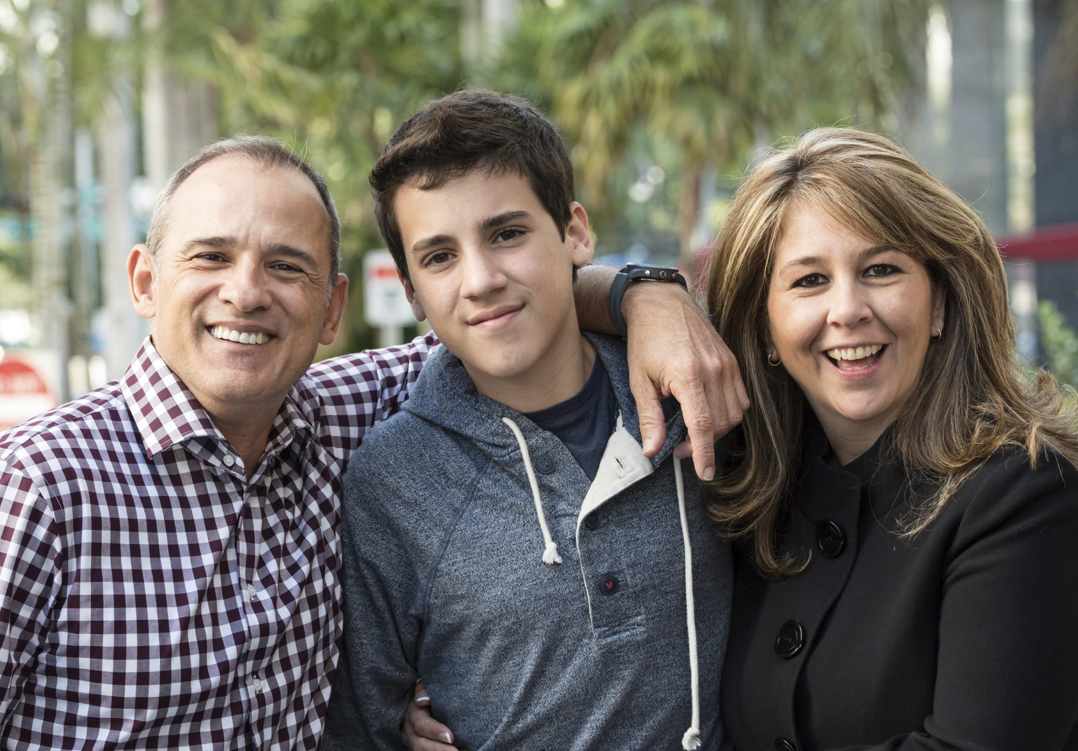

Name: Smith family

Family with a single child.

Mom will want unlimited TV shows and movies to watch.

Dad will want pre-recorded sporting events.

Will need at least two active streaming connections at a time.

Will most likely use the Plus access on NodeFlix.

4th persona:

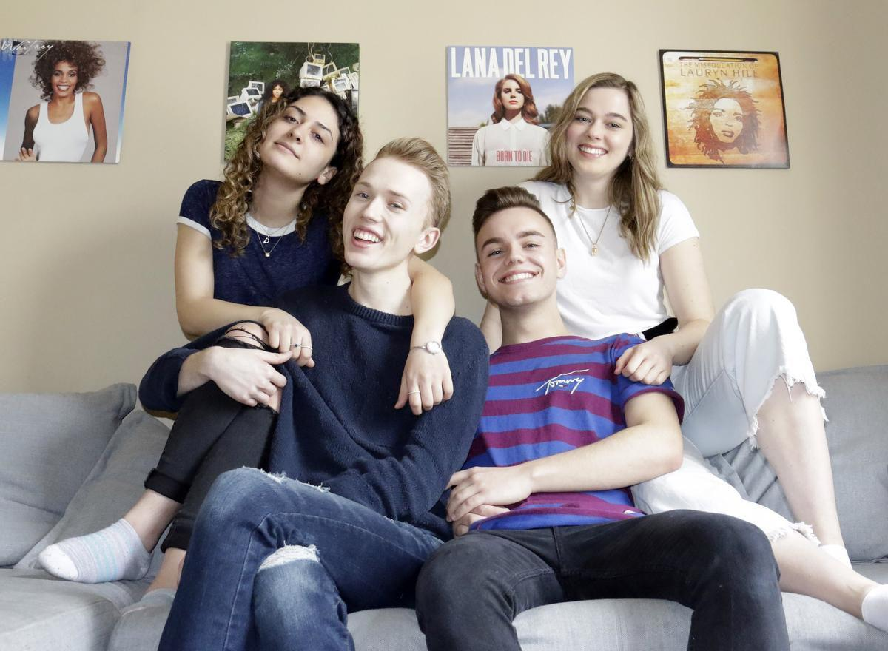

Four College Roommates

Ages: 20-23

Group of four friends that love watching unlimited TV shows and movies together.

Three of them will prefer to watch TV on their laptops from time to time.

One is a huge sports fan and will want the pre-recorded sports available to them.

One roommate hates commercials.

Will need up-to-four streaming connections at a time.

Will most likely need the Premium access plan on NodeFlix.

Will need to be able to easily access content.

5th persona:



Name: Mary Andersen

Age: 65

Wants to be able to watch unlimited movies.

Doesn’t care if she watches commercials.

Needs a menu and interface that is easy to understand and use because she is often confused with the TV.

Needs to be able to easily access her content.

Needs to easily manage her payments.

Will be fine with Basic plan on NodeFlix.