Karie Funk

11/03/2019

Assignment 3.2

Install SoapUI

**Installed Java:**

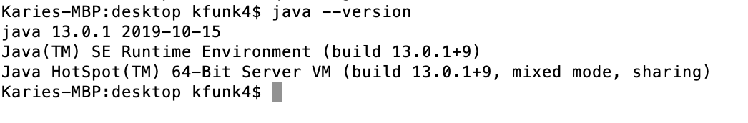

**Soap running on computer:**

